**\*SPARK**

1. **What was the highest number of people travelled in which year**

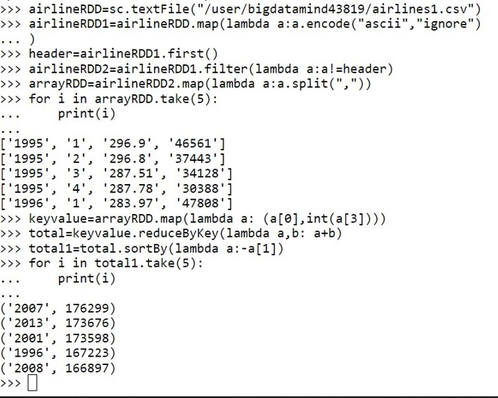

**2) Identifying the highest revenue generation for which year**

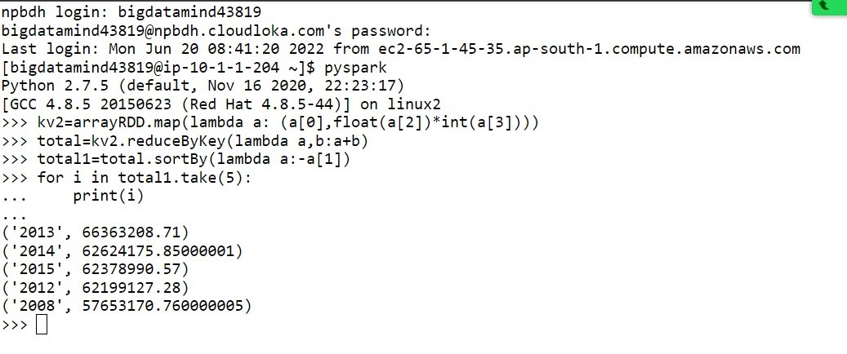

**3 Identifying the highest revenue generation for which year and quarter (Common group**

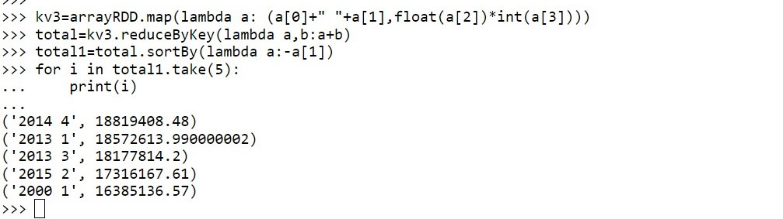

**\*Hive**

**1) Write a program to find the count of customers for each profession.**

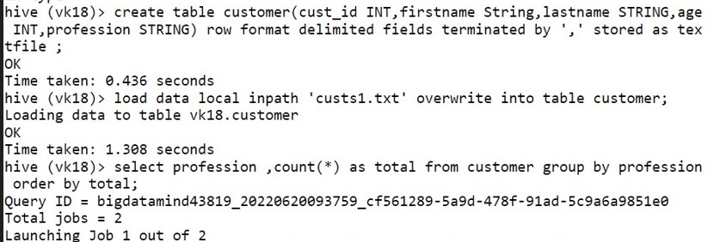

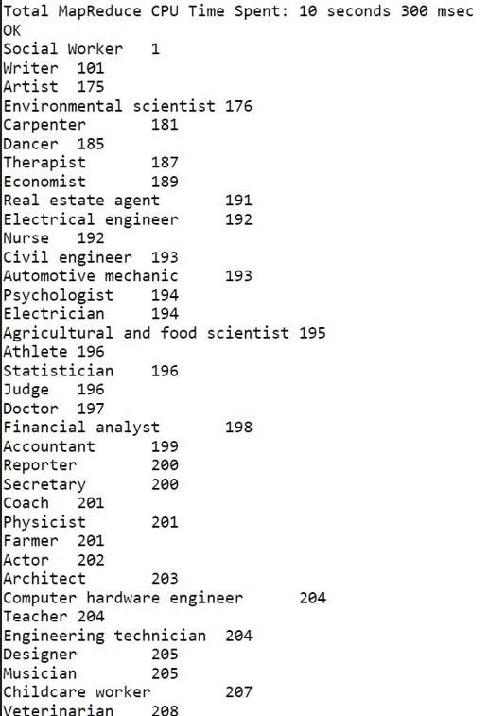

1. **Write a program to find the top 10 products sales wise**



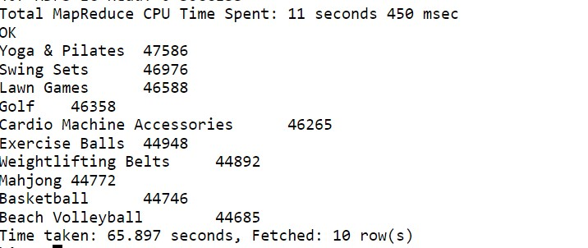

1. **Write a program to create partitioned table on category**

**6**

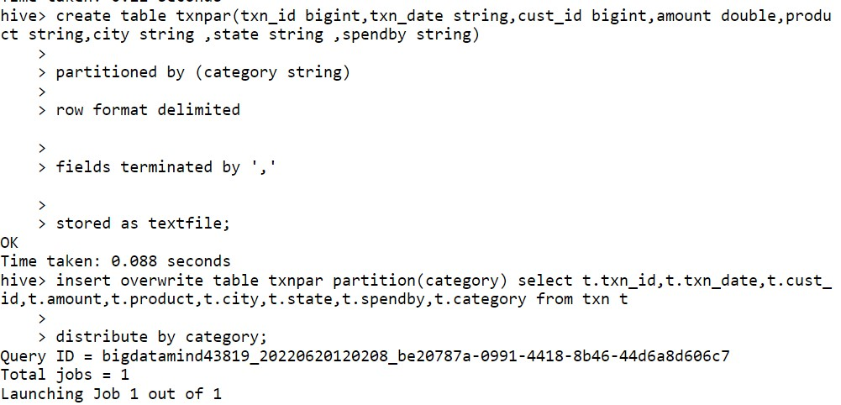

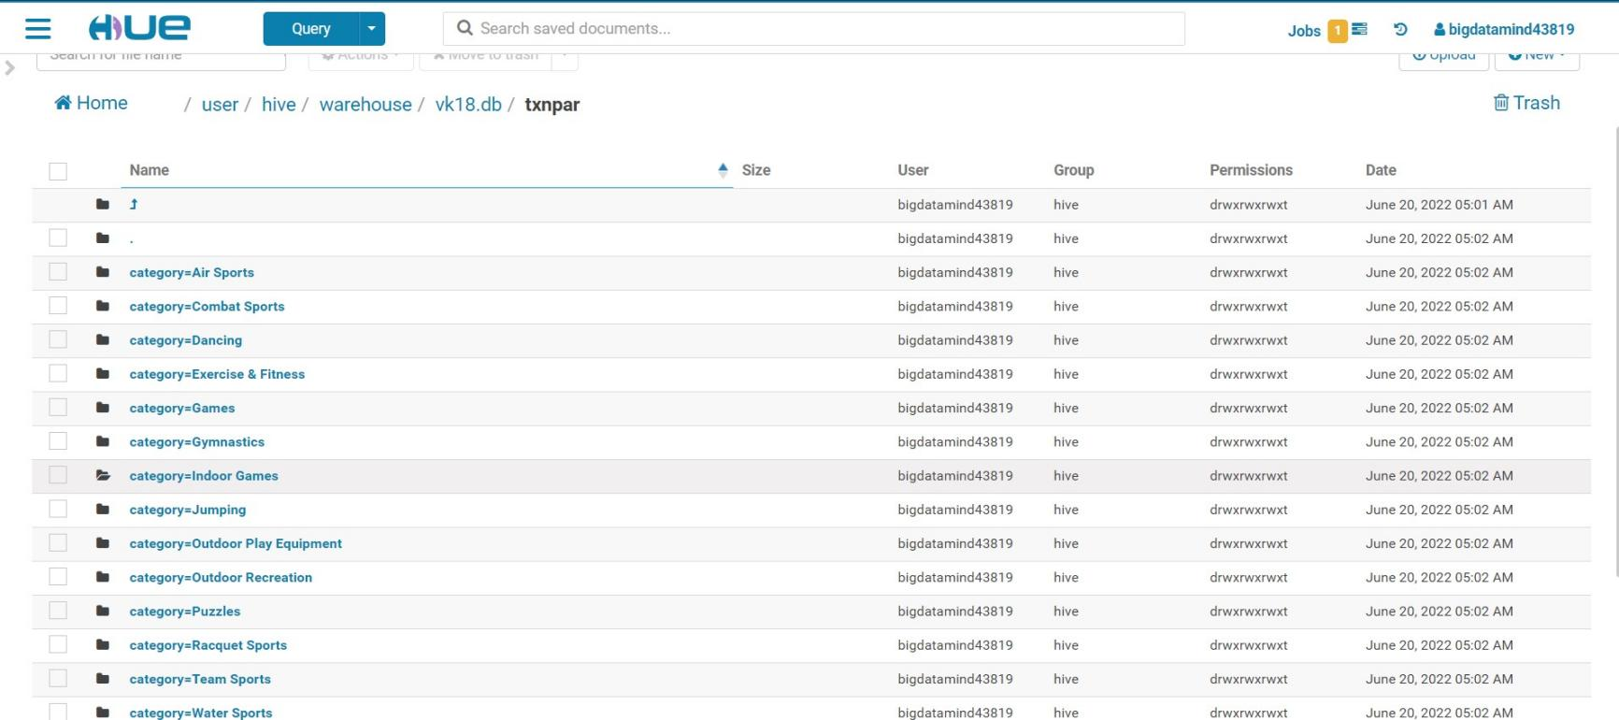

**MAPREDUCE**

**Q 1.Find all time High price for each stock**

**import** java.io.*;

**import** org.apache.hadoop.io.Text;

**import** org.apache.hadoop.io.LongWritable;

**import** org.apache.hadoop.io.DoubleWritable;

**import** org.apache.hadoop.mapreduce.Job;

**import** org.apache.hadoop.mapreduce.Mapper;

**import** org.apache.hadoop.mapreduce.Reducer;

**import** org.apache.hadoop.conf.*;

**import** org.apache.hadoop.fs.*;

**import** org.apache.hadoop.mapreduce.lib.input.*;

**import** org.apache.hadoop.mapreduce.lib.output.*;

**public** **class** AllTimeHigh {

**public** **static** **class** MapClass **extends** Mapper<LongWritable,Text,Text,DoubleWritable>

{

**private** Text stock_id = **new** Text();

**private** DoubleWritable High = **new** DoubleWritable();

**public** **void** map(LongWritable key, Text value, Context context)

{

**try**{

String[] str = value.toString().split(",");

**double** high = Double.*parseDouble*(str[4]);

stock_id.set(str[1]);

High.set(high);

//context.write(new Text(str[1]),new LongWritable(vol));

context.write(stock_id, High);

}

**catch**(Exception e)

{

System.***out***.println(e.getMessage());

}

}

}

**public** **static** **class** ReduceClass **extends** Reducer<Text,DoubleWritable,Text,DoubleWritable>

{

**private** DoubleWritable result = **new** DoubleWritable();

**public** **void** reduce(Text key, Iterable<DoubleWritable> values,Context context) **throws** IOException, InterruptedException {

**double** maxValue=0;

**double** temp_val=0;

**for** (DoubleWritable value : values) {

temp_val = value.get();

**if** (temp_val > maxValue) {

maxValue = temp_val;

}

}

result.set(maxValue);

context.write(key, result);

//context.write(key, new LongWritable(sum));

}

}

**public** **static** **void** main(String[] args) **throws** Exception {

Configuration conf = **new** Configuration();

//conf.set("name", "value")

//conf.set("mapreduce.input.fileinputformat.split.minsize", "134217728");

Job job = Job.*getInstance*(conf, "Highest Price for each stock");

job.setJarByClass(AllTimeHigh.**class**);

job.setMapperClass(MapClass.**class**);

//job.setCombinerClass(ReduceClass.class);

job.setReducerClass(ReduceClass.**class**);

job.setNumReduceTasks(1);

job.setOutputKeyClass(Text.**class**);

job.setOutputValueClass(DoubleWritable.**class**);

FileInputFormat.*addInputPath*(job, **new** Path(args[0]));

FileOutputFormat.*setOutputPath*(job, **new** Path(args[1]));

System.*exit*(job.waitForCompletion(**true**) ? 0 : 1);

}

}

6

