**Q.2 Write a SQL statement to create a simple table countries including columns country_id,country_name and region_id.**

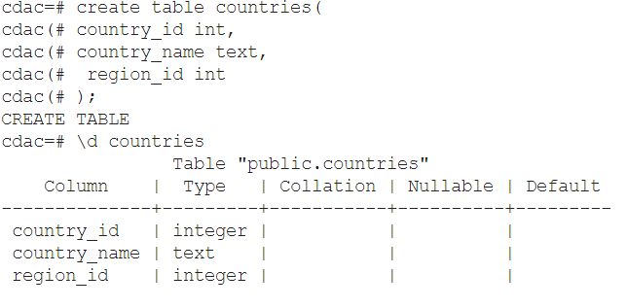

**Q.1 Write a SQL statement to create a simple table countries including columns country_id, country_name and region_id which already exist.**

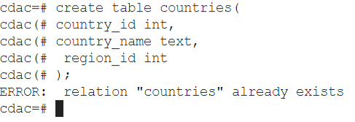

**Q.3 Write a SQL statement to create the structure of a table dup_countries similar to countries**.

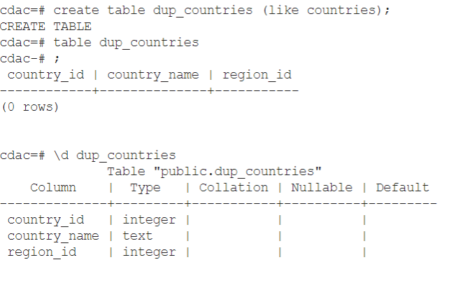

**Q.4 Write a SQL statement to create a duplicate copy of countries table including structure and data by name dup_countries.**

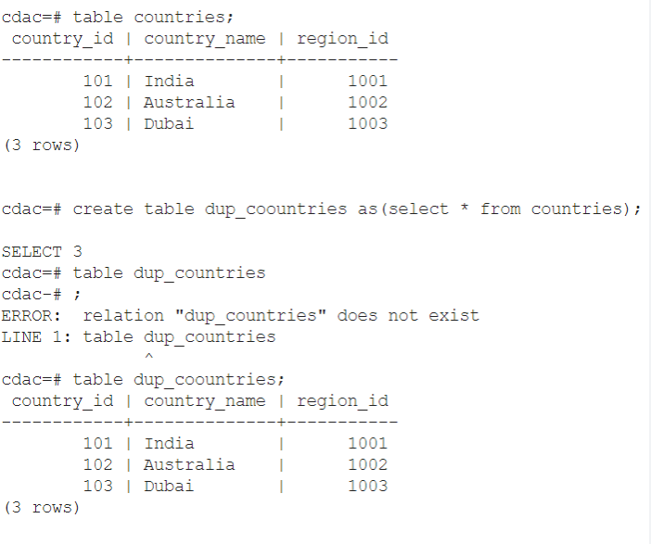

**Q.5 Write a SQL statement to create a table named countries, including country_id, country_name and region_id and make sure that no duplicate data against column country_id will be allowed at the time of insertion.**

