**Q.1 Write a SQL statement to rename the table countries to country_new.**

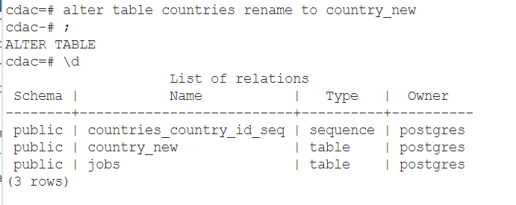

**Q.2 Write a SQL statement to add a column region_id to the table locations.**

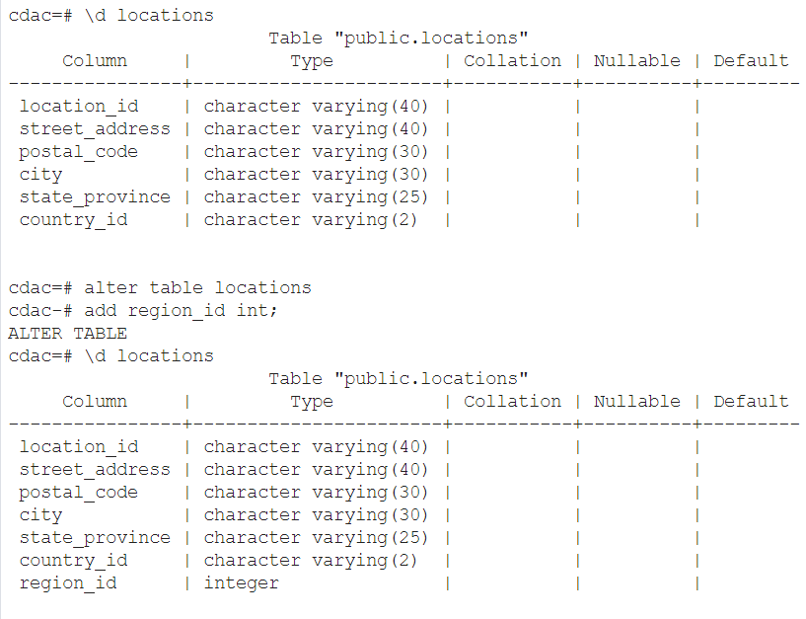

**Q.3 Write a SQL statement to change the data type of the column region_id to text in the table locations**

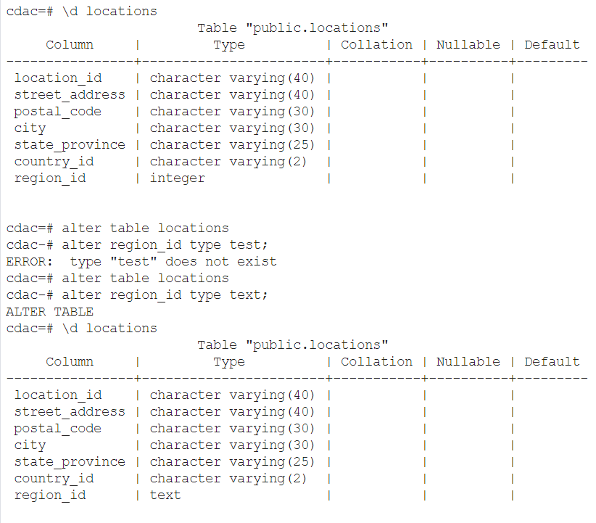

**Q.4 Write a SQL statement to drop the column city from the table locations.**

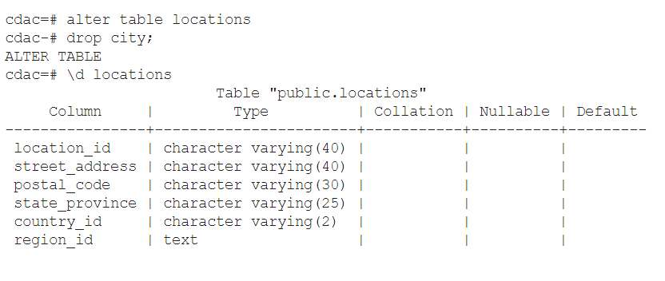

**Q.5 Write a SQL statement to add a primary key for the columns location_id in the locations table.**

