Question-1.

1. - use a command to show the current working directory - list the directory contents in the short and long format (with file permissions,owner,size etc,.). Explore attributes given in long format e.g. file type, file permissions, file size, file owner etc. - list all files along with hidden files in current working directory. - list only hidden files in the directory 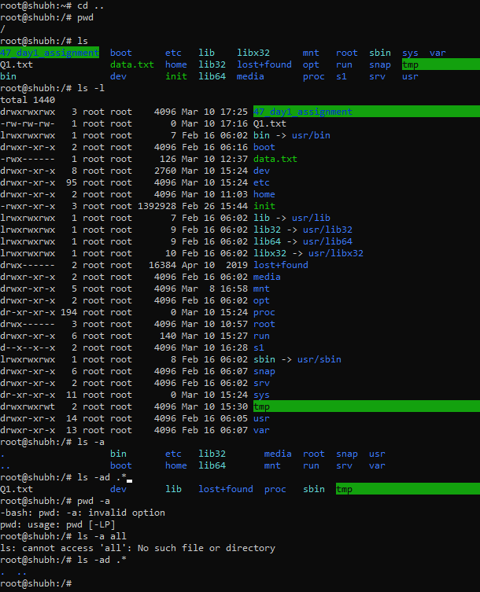

2. -Make a directory and name it as cdac-dir and change the current working directory to directory.

3. Create following nested directories inside current directory by invoking single command for only one time

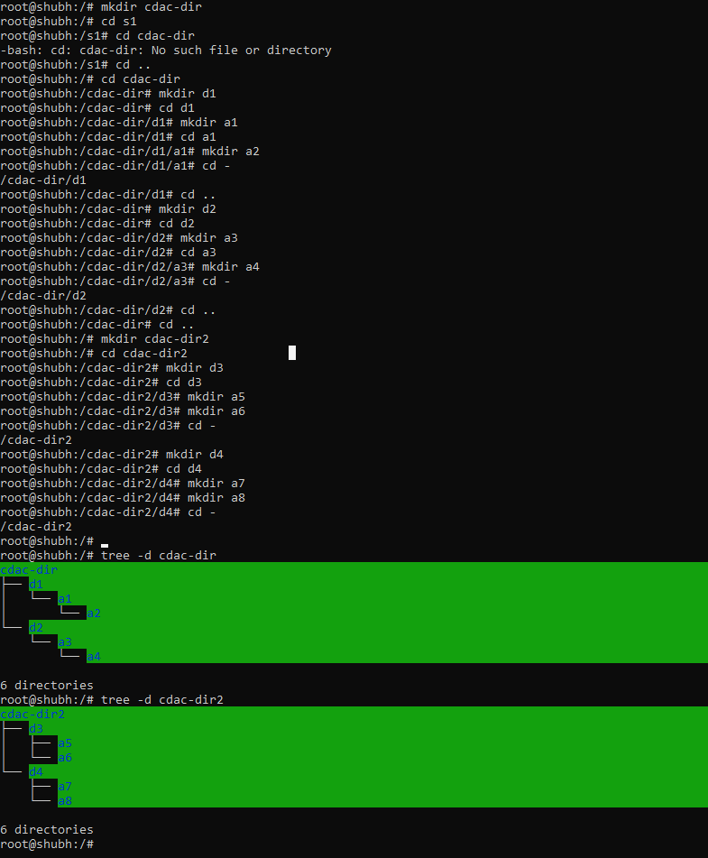

4. List the directories(folders), then remove the cdac-dir directory and list the

folders again to show that it is no longer present.

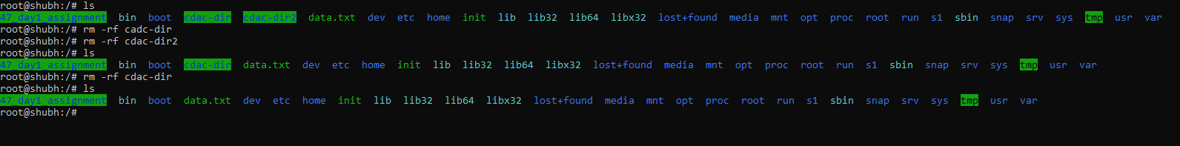

Question-2.

1. Display the man-page for ls, but redirect the output into temp.txt, then use the cat, less, and more commands to display the new file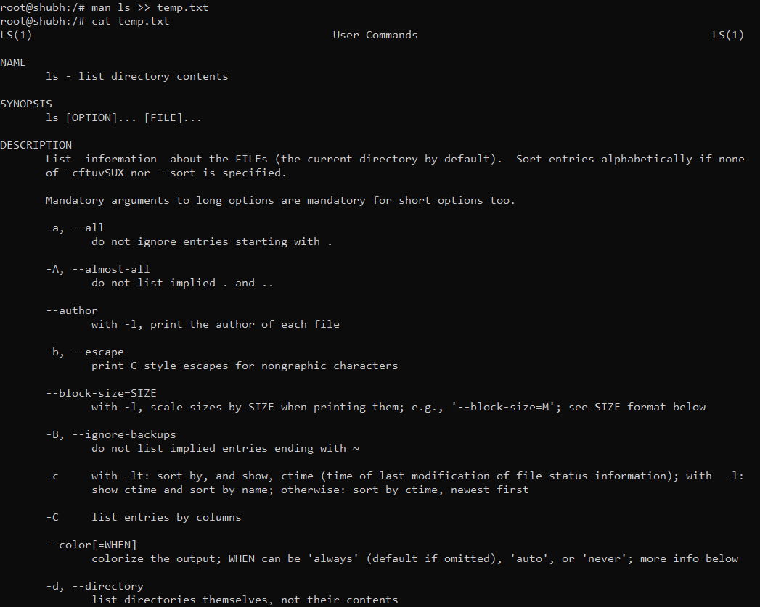
2. Display the initial 10 lines and final 5 lines of temp.txt with the obvious Linux commands

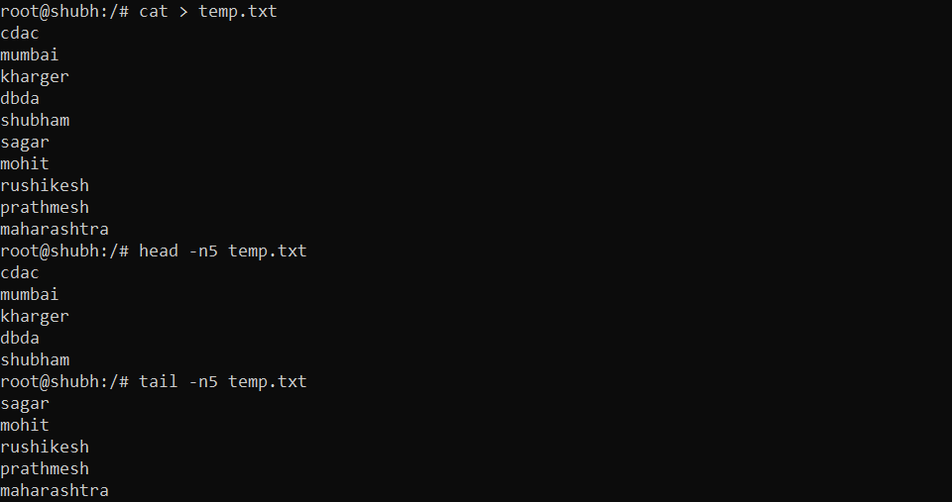

3.Copy temp.txt to another directory and rename it there 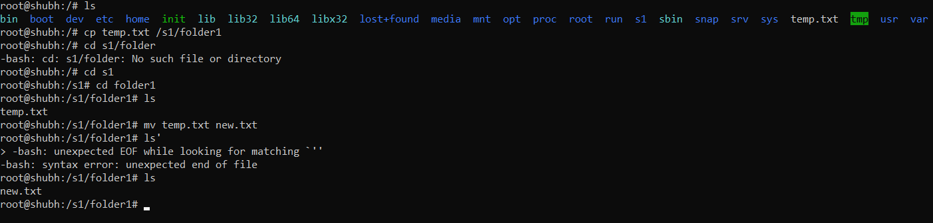

4. Display the number of lines, words and characters in file using Linux

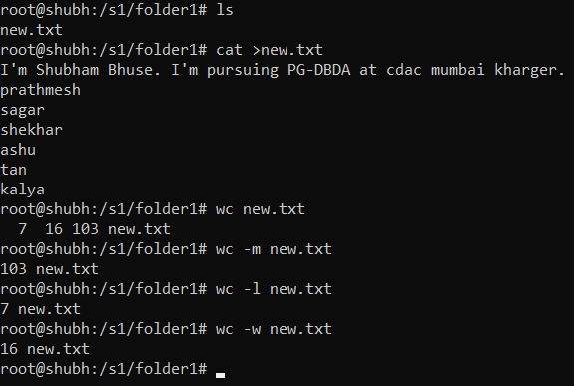

5. Use history command to display last 10 commands used

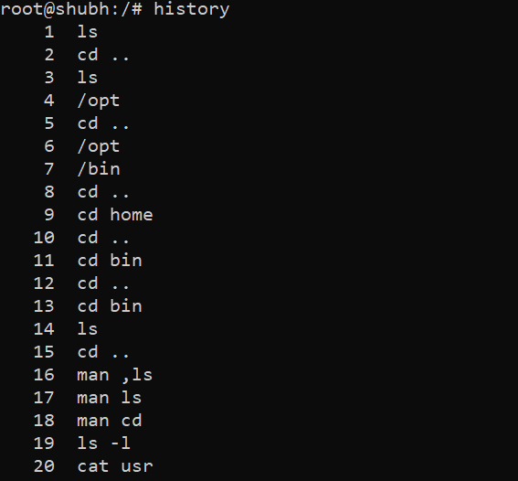

Question-3.

1. Create tar archive file of any directory present in your home directory.

contents of the archive file without extracting.

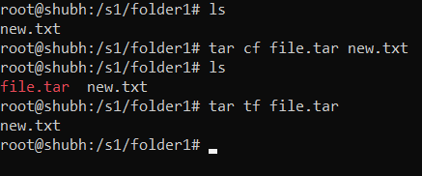

2. Create zip file of another directory. (Hint: use zip command) - list the contents of the zip file without extracting.

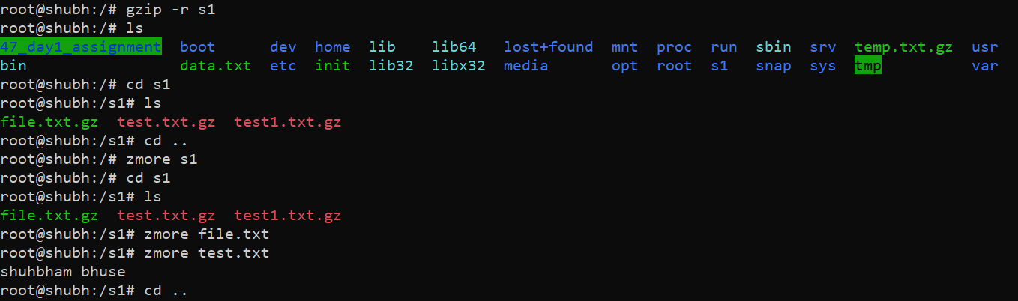

3.Give read, write & execute permissions to your file.

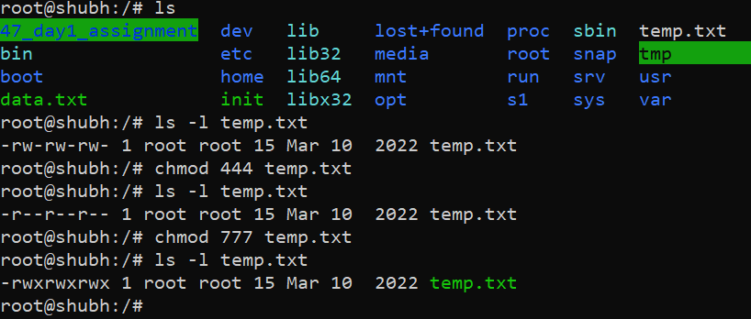

4. Change ownership of that file

5.List processes running in shell, all running processes. and show top processes in decreasing order of their resource utilization.

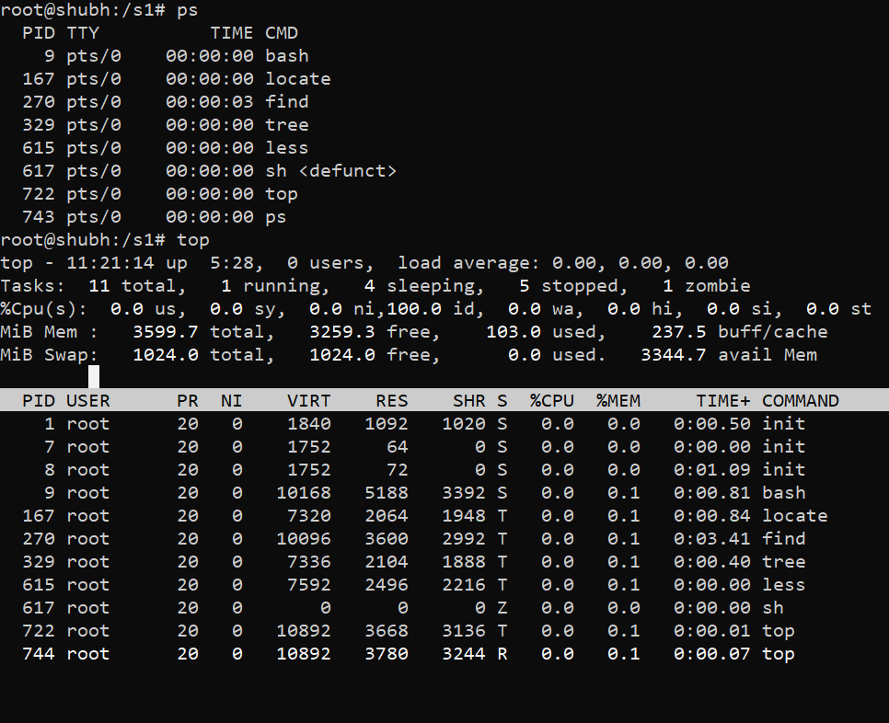

Question-4.

1. Display current time and calendar

2. Change the current date and time of the system to following 14th March 2017, 10:10 AM

3. Explore following commands who, whoami, whatis, whereis

