

**Python Project**

**Math Captcha**

**Submitted to:**

Mrs. Vishu

**Submitted By:**

|  |  |  |
| --- | --- | --- |
| Name | Roll No. | Registration no. |
| Pankaj Sharma | 11 | 11717745 |
| Shubham Chaudhary | 20 | 11704528 |
| Shubham Dua | 18 | 11702056 |

INTRODUCTION

We have designed a simple math based captcha using GUI in python. The permission will be granted to move to next page of the application only if user is authenticated based on math captcha. The math captcha will show in different forms like addition, subtraction, and multiplication. A pop up menu will be shown to demonstrate how many times left. Maximum 5 attempts will be given to user.

The permission should be granted to move to next page of the application only if user is authenticated based on text captcha.

According to us this math captcha is exactly the part of module we were looking for. But during some basic tests we found out, that it is not working very conveniently. However, the whole development of this math captcha module with all its details is not feasible in the available time, even though 3 people are working on that project. Nevertheless the goal of the project is to write down the ideas and to create a concept of the math captcha in a way that it could be understood easily. Therefore we came up with another idea, which can be realized by ourselves. In a feasible amount of time. So we decided to create a math captcha module by ourselves. Net with the programming language python, because we are familiar with this development environment and we are able to create this part within the available time.

**Overview:** The permission should be granted to move to next page of the application only if user is authenticated based on text captcha. A pop up menu will be shown to demonstrate how many times left. Maximum 5 attempts will be given to user. The math captcha will show in different forms like addition, subtraction, and multiplication.

**Display Options:**

* **Revisions:** A pop up menu will be shown to demonstrate how many times left. Maximum 5 attempts will be given to user.
* **Tabular Display:** You can decide how to organize the data: by student with a details of student, or in a tabular form where each student's responses are in a row, and each answer constitutes a column.
* **Formatting:** A reversible truncation feature lets you tailor the data and improve the readability of a summary data table.
* **Omitting Responses:** A popup window show you whether permission is granted or not.

* **Extracting Data:** The Create Data Table links generate unformatted blocks of data with column headings (separated by spaces), which can be copied. The data blocks are generated according to given details.

OBJECTIVES

* Aiding in language development with the based in the language alone.
* Aiding in the team building process.
* Being fun to participate in but with a competitive element.
* Provoking discussion and healthy debate amongst participating players / teams.
* Aiding to relieve the tension of the daily work routine.
* Promoting group harmony, whether in organizations, schools or just a group of friends.
* Making new friends, from different cultures at times.
* Likewise spelling bees improve the student’s spellings and vocabulary
* Math captcha competitions even help build the student’s soft skills
* To increase the efficiency of and knowledge of the user related to computer science and programming.
* To provide a good and Knowledge full interface to the users to sharp their skills.

**MATH CAPTCHA MODULE DESCRIPTION**

**Home Page: -** This page is the first page of our online math captcha module. In this page the users will have to fill their name, registration number. This page has a submit button to move further for captcha verification.

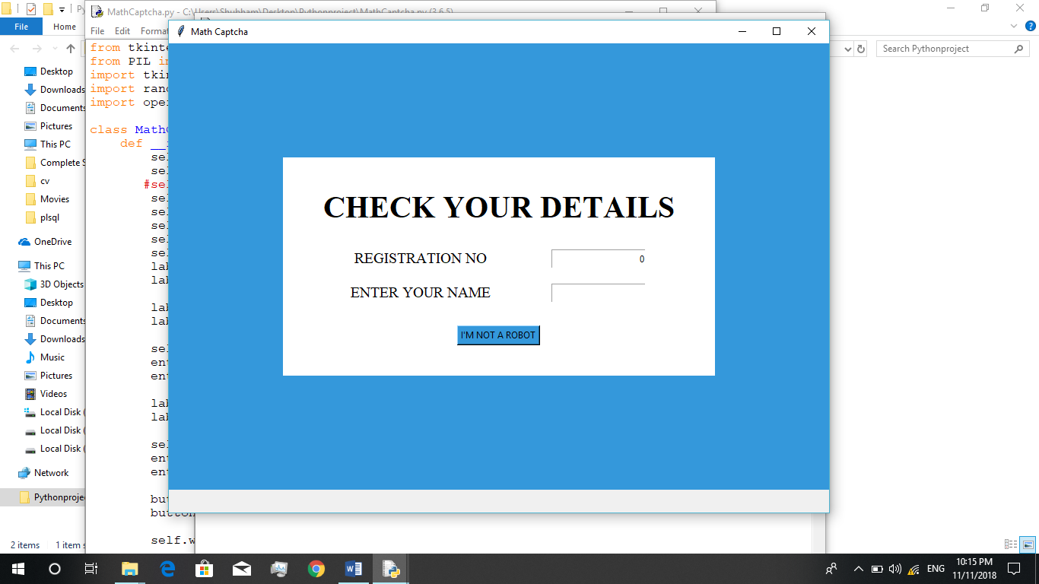

**Captcha Page: -** This page have the captcha. A next button to go to next page and an End button to end the math captcha that time instantly.

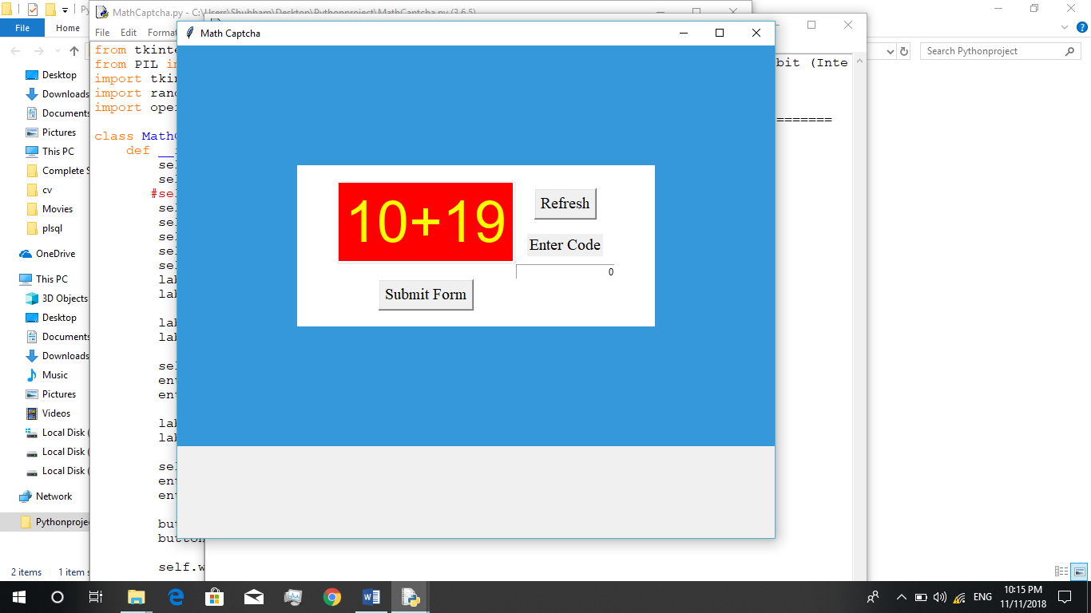

**Result Page: -** This page will have the result of the details by the user with their name, registration number. Overall it will we displayed to captcha verified user.

**CONCLUSION**

* This math captcha system module provides the service of attempting the math captcha.
* The project is user friendly. It is very handy to use.
* The backend coding which is in python is easy to read and understandable.
* It displays the captch effectively and performs the function very effectively in the backend.