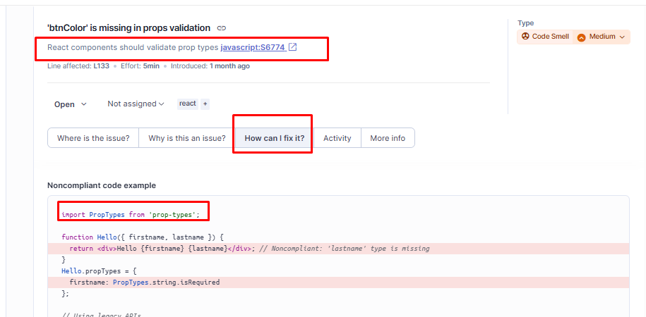

https://react.dev/blog/2024/04/25/react-19-upgrade-guide#removed-proptypes-and-defaultprops
