SELECT COUNT(SalesOrderID) AS 'Amount of orders', SUM( SubTotal) AS 'Volume'

FROM Sales.SalesOrderHeader



SELECT SalesOrderID, DATEDIFF(day, OrderDate, ShipDate) as "Number of days"

FROM Sales.SalesOrderHeader

GROUP BY SalesOrderID, OrderDate, ShipDate

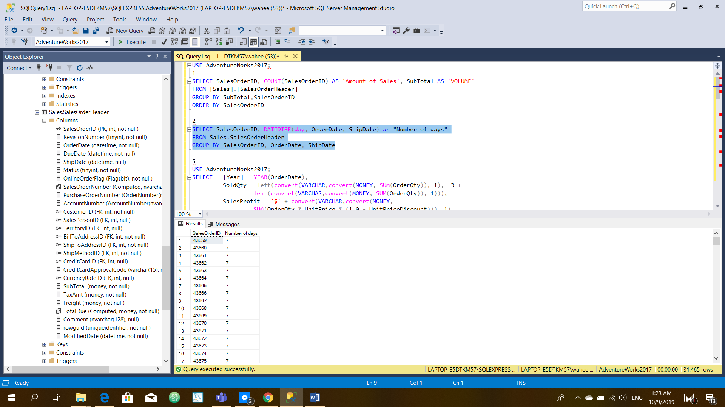

SELECT COUNT(SalesOrderID) AS NumberOfOrders, SUM(SubTotal) AS Volume, Year(OrderDate) as year

FROM Sales.SalesOrderHeader

GROUP BY Year(OrderDate)

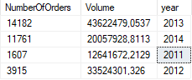

USE AdventureWorks2017;

SELECT TotalProfit = '$' + convert(VARCHAR,convert(MONEY,

SUM(OrderQty \* (UnitPrice \* (1.0 - UnitPriceDiscount))

- StandardCost)))

FROM Sales.SalesOrderHeader AS SOH

INNER JOIN Sales.SalesOrderDetail AS SOD

ON SOD.SalesOrderID = SOH.SalesOrderID

INNER JOIN Production.Product P

ON P.ProductID = SOD.ProductID

GO

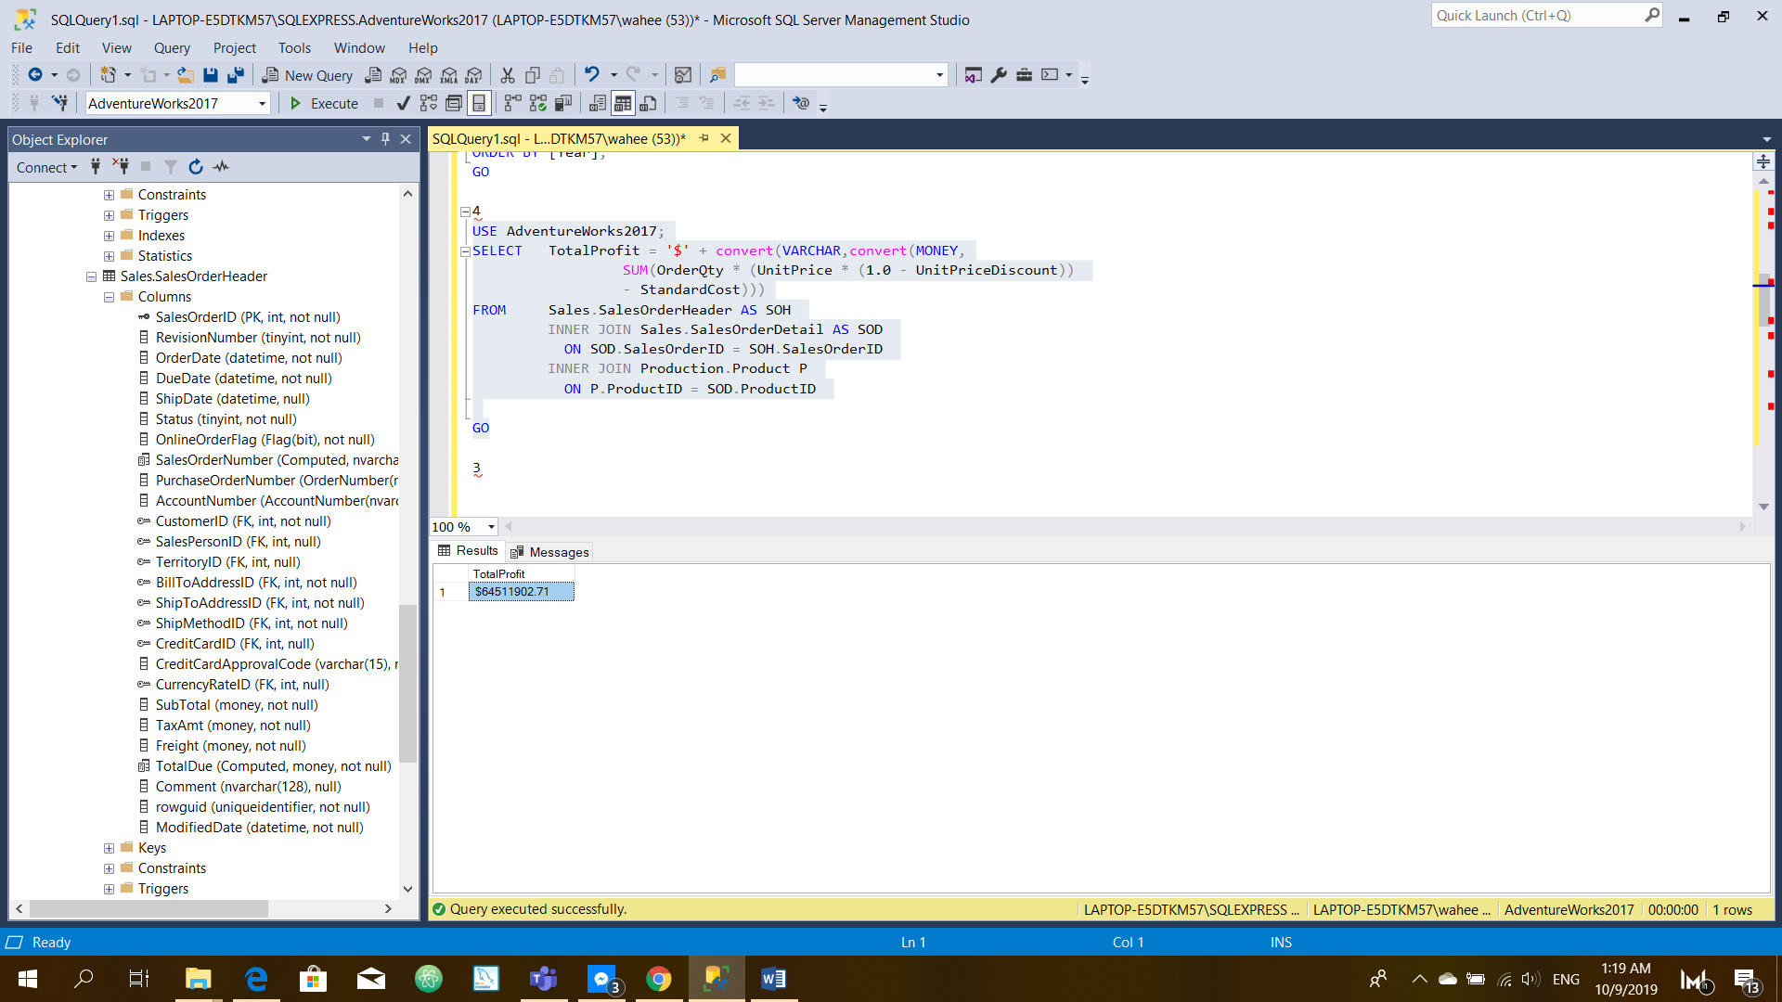

USE AdventureWorks2017;

SELECT [Year] = YEAR(OrderDate),

SoldQty = left(convert(VARCHAR,convert(MONEY, SUM(OrderQty)), 1), -3 +

len (convert(VARCHAR,convert(MONEY, SUM(OrderQty)), 1))),

SalesProfit = '$' + convert(VARCHAR,convert(MONEY,

SUM(OrderQty \* UnitPrice \* (1.0 - UnitPriceDiscount))), 1),

TotalProfit = '$' + convert(VARCHAR,convert(MONEY,

SUM(OrderQty \* (UnitPrice \* (1.0 - UnitPriceDiscount))

- StandardCost)), 1)

FROM Sales.SalesOrderHeader AS SOH

INNER JOIN Sales.SalesOrderDetail AS SOD

ON SOD.SalesOrderID = SOH.SalesOrderID

INNER JOIN Production.Product P

ON P.ProductID = SOD.ProductID

GROUP BY YEAR(OrderDate)

ORDER BY [Year];

GO

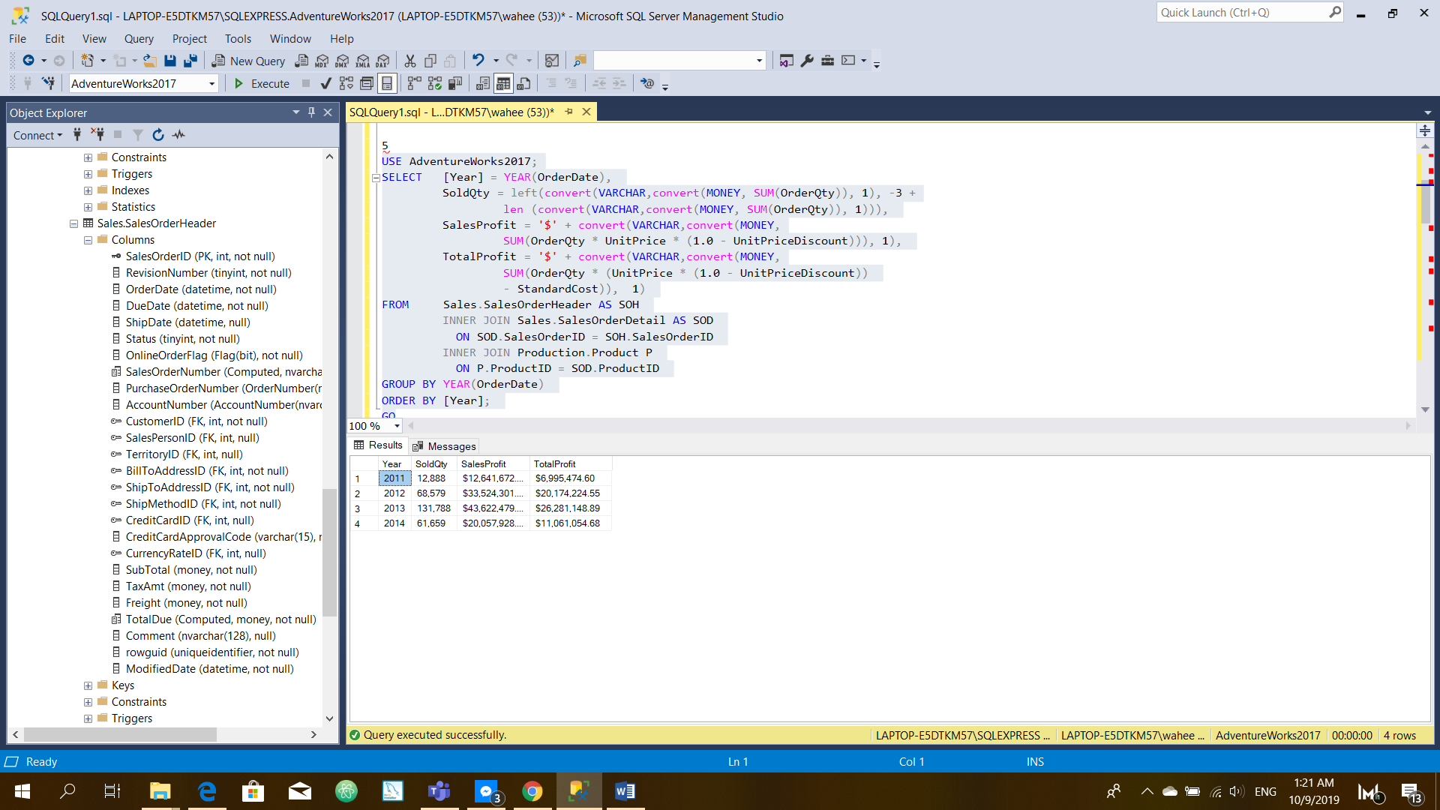

6.

WITH A AS(

SELECT CustomerID, COUNT(SalesOrderID) as 'Numer of orders', SUM(SubTotal) as summ

FROM Sales.SalesOrderHeader

GROUP BY CustomerID

)

SELECT TOP (10) \* FROM A

order by summ DESC

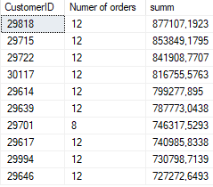

7.

WITH A AS(

SELECT CustomerID, COUNT(SalesOrderID) as 'SalesAmount'

FROM Sales.SalesOrderHeader

GROUP BY CustomerID

)

SELECT TOP (10) \* FROM A

order by SalesAmount DESC

