Name: Shubham Chemate

Roll No: 31118 (K-1 Batch)

Subject: DBSL

Assignment 04 Screenshots

Table Creation Code:

CREATE TABLE Borrower

(

    roll_no INT NOT NULL PRIMARY KEY,

    date_of_issue DATE NOT NULL,

    name_of_book VARCHAR(500),

    status VARCHAR(2)

);

CREATE TABLE FineTable

(

    roll_no INT NOT NULL,

    date_of_fine TIMESTAMP DEFAULT NOW(),

    amt INT

);

Data Insertion Code:

INSERT INTO Borrower(roll_no, date_of_issue, name_of_book, status)

VALUES

(1, '2021-08-19', 'Optical Illutions', 'I'),

(2, '2021-08-10', 'Optical Dimensions', 'I'),

(3, '2021-08-02', 'Optical Threads', 'I'),

(4, '2021-07-26', 'Optical Views', 'I'),

(5, '2021-08-25', 'Optical Phenomenons', 'I'),

(6, '2021-08-28', 'Optical Magic', 'I');

Procedure Code:

CREATE PROCEDURE calculateFine (

    IN cur_roll_no INT

)

BEGIN

    DECLARE days_passed INT DEFAULT 0;

    DECLARE fine INT DEFAULT 0;

    DECLARE EXIT HANDLER FOR 1062

    BEGIN

        SELECT 'This roll number has multiple entries in database.' AS 'EXCEPTION';

    END;

    DECLARE EXIT HANDLER FOR NOT FOUND

    BEGIN

        SELECT 'This user is not present in database.' AS 'EXCEPTION';

    END;

    SELECT DATEDIFF(NOW(), date_of_issue)

    INTO days_passed

    FROM Borrower

    WHERE roll_no=cur_roll_no;

    IF days_passed>30 THEN

        SET fine = (days_passed-30)*50 + 15*5;

    ELSEIF days_passed>=15 THEN

        SET fine = (days_passed-14)*5;

    ELSE

        SET fine = 0;

    END IF;

    UPDATE Borrower SET status = 'R'

    WHERE roll_no = cur_roll_no;

    IF fine > 0 THEN

        INSERT INTO FineTable(roll_no, amt)

        VALUES(cur_roll_no, fine);

    END IF;

END //

Output:

Tables:

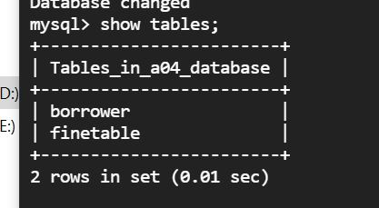

Schema:

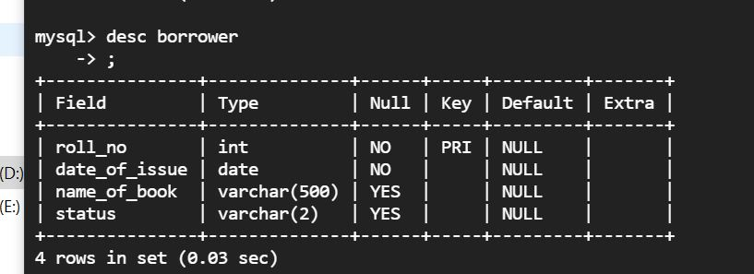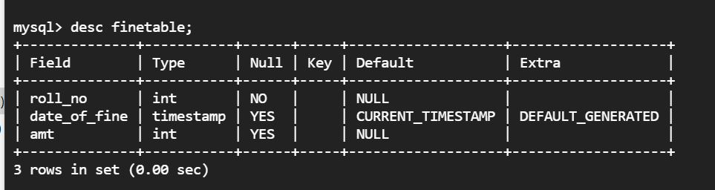

Stored Procedure in Database:

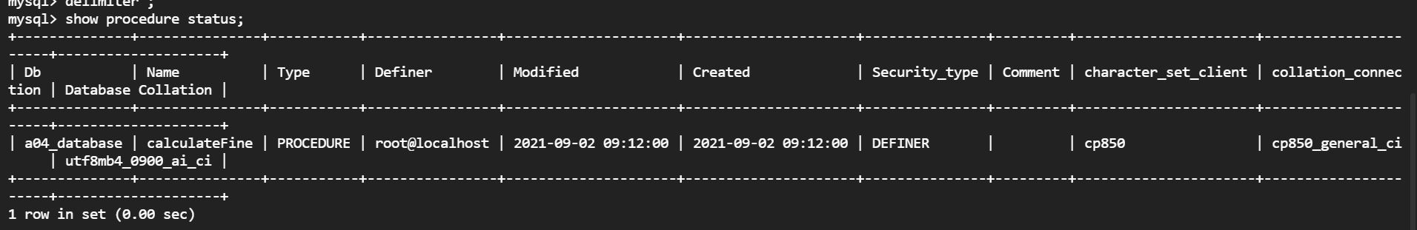

Initial Data:

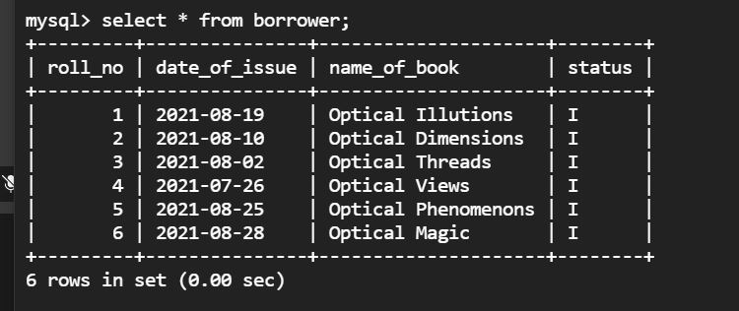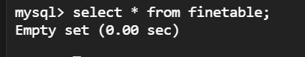

Calling procedure for roll number-1:

It has been 14 days from date of borrow for roll number 1.

Since days_passed are less than 15 no fine should be there for roll number-1.

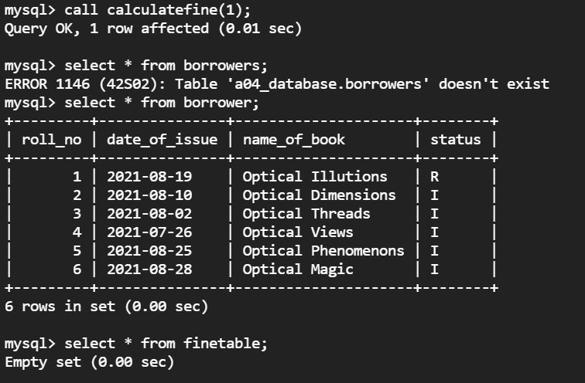

Calling procedure for roll number-2:

It has been 23 days from date of borrow for roll number 2.

Since days_passeed are greater than equal to 15 fine should be calculated for 23-14=9 days at 5 rs per day.

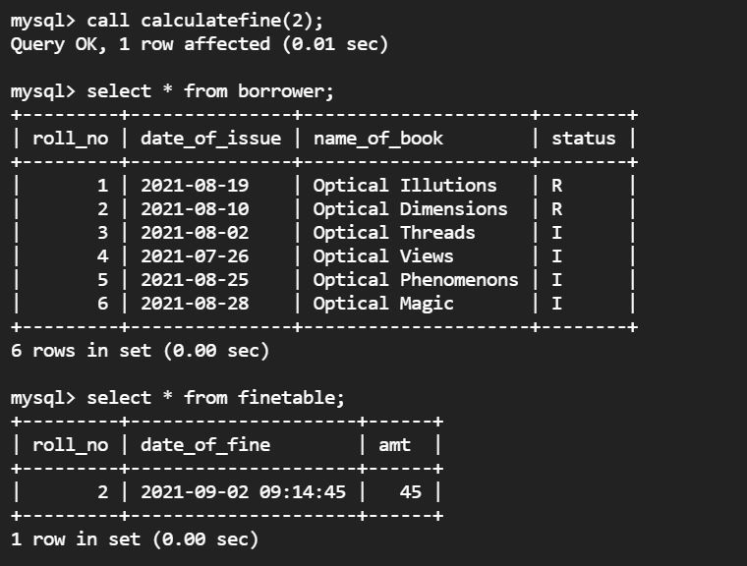

Calling procedure for roll number-3:

It has been 37 days from date of borrow for roll number 3.

Since days_passeed are greater than equal to 15 fine should be calculated for 15 days at 5 rs per day are for 7 days at 50 rs per day.

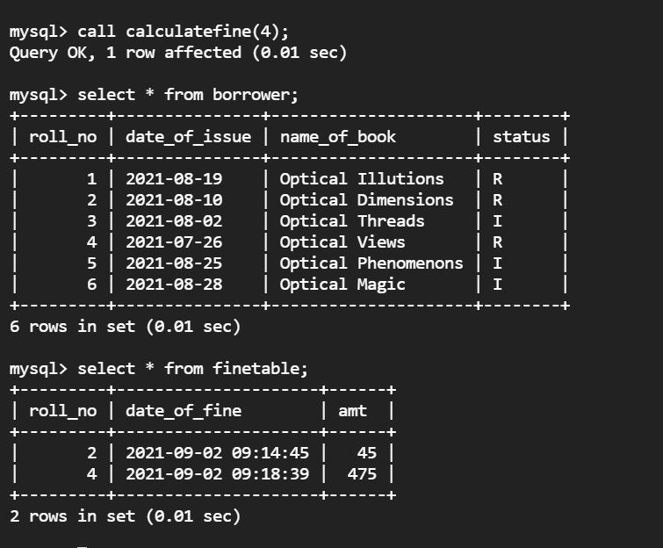

Exception Handing: Calling procedure for roll number which is not present in database

