Name: Shubham Chemate

Roll Number: 31118

Subject: DBSL – Assignment 06

**Code**:

CREATE TABLE new_emps(

    emp_id INT PRIMARY KEY NOT NULL,

    emp_name VARCHAR(200)

);

CREATE TABLE old_emps(

    emp_id INT PRIMARY KEY NOT NULL,

    emp_name VARCHAR(200)

);

INSERT INTO old_emps(emp_id, emp_name)

VALUES (1, 'Natasha'), (2, 'Tony'), (3, 'Steve');

INSERT INTO new_emps(emp_id, emp_name)

VALUES (4, 'Peter'), (5, 'Vision'), (3, 'Steve');

DELIMITER //

CREATE PROCEDURE update_old()

BEGIN

    DECLARE done INT DEFAULT FALSE;

    DECLARE cur_emp_id INT;

    DECLARE cur_emp_name VARCHAR(200);

    DECLARE cur CURSOR FOR

    SELECT emp_id, emp_name FROM new_emps WHERE emp_id NOT IN (SELECT emp_id FROM old_emps);

    DECLARE CONTINUE HANDLER FOR NOT FOUND SET done = TRUE;

    OPEN cur;

    emp_loop: LOOP

        FETCH cur INTO cur_emp_id, cur_emp_name;

        IF done THEN

            LEAVE emp_loop;

        END IF;

        INSERT INTO old_emps(emp_id, emp_name)

        VALUES(cur_emp_id, cur_emp_name);

    END LOOP;

    CLOSE cur;

END //

DELIMITER ;

**Output**:

**Tables**:

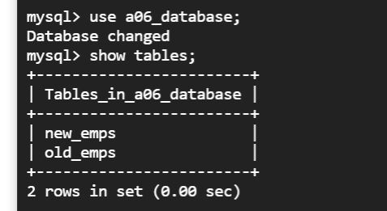

**Schema of the tables:**

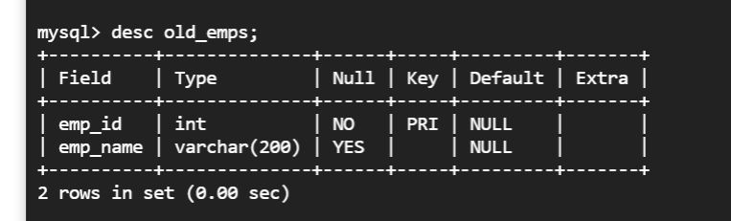

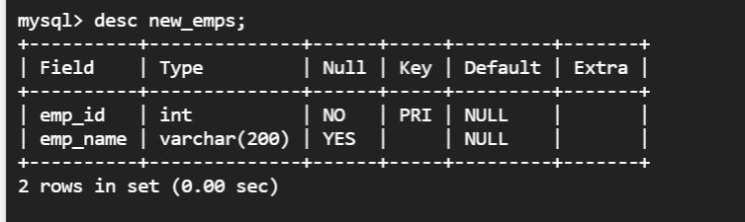

**Initial data in old_emps tables:**

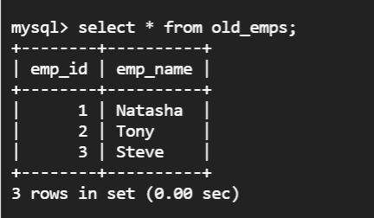

**Initial data in new_emps table:**

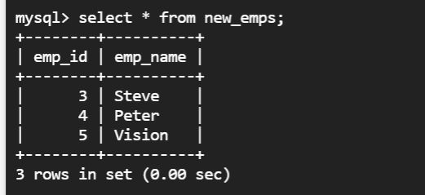

**Using Cursor to Update the old_emps table:**

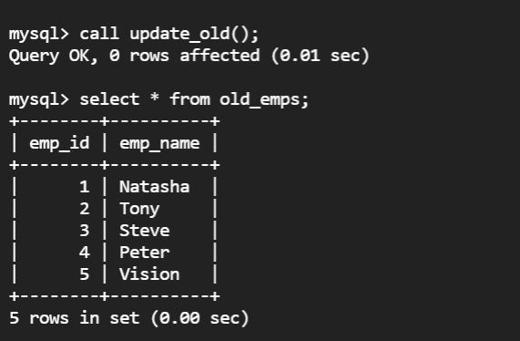

*Explanation:* There were three employees in old_emps table and three in new_emps table. We are updating old_emps table with new_emps table. As employee with id 3 is already present in old_emps table it should not added again while employees with id 4 and 5 are new entries for old_emps table so that should be added. So as a result our old_emps table should contain 5 emps which is shown in above screenshot.

Thank You!