Name: Shubham Chemate

Roll Number: 31118 (K-1 Batch)

Subject: DBS Lab

**Code:**

**import** java.sql.*;

**public** **class** Main {

**static** **final** String ***url*** = "jdbc:mysql://localhost:3306/a08_database";

**static** **final** String ***user*** = "root";

**static** **final** String ***pass*** = "root123";

**public** **static** **void** readDB(String query) **throws** Exception {

Class.*forName*("com.mysql.cj.jdbc.Driver");

Connection con = DriverManager.*getConnection*(***url***, ***user***, ***pass***);

Statement st = con.createStatement();

ResultSet rs = st.executeQuery(query);

System.***out***.println("Successfully Executed(Read)\n");

System.***out***.println("ResultSet: ");

**while** (rs.next()) {

String retrivedData = rs.getInt(1)+" "+rs.getString(2)+" "+rs.getString(3);

System.***out***.println(retrivedData);

}

st.close();

con.close();

}

**public** **static** **void** modifyDB(String query) **throws** Exception {

Class.*forName*("com.mysql.cj.jdbc.Driver");

Connection con = DriverManager.*getConnection*(***url***, ***user***, ***pass***);

Statement st = con.createStatement();

st.executeUpdate(query);

System.***out***.println("Successfully Executed(Modify)");

st.close();

con.close();

}

**public** **static** **void** UpdateGrade(**int** roll_no, String newGrade) **throws** Exception {

Class.*forName*("com.mysql.cj.jdbc.Driver");

Connection con = DriverManager.*getConnection*(***url***, ***user***, ***pass***);

String query = "update student set grade=? where roll_no=?";

PreparedStatement st = con.prepareStatement(query);

st.setString(1, newGrade);

st.setInt(2, roll_no);

st.executeUpdate();

System.***out***.println("Successfully Executed(Modify)");

st.close();

con.close();

}

**public** **static** **void** main(String[] args) **throws** Exception {

String query1 = "create table student (" +

" roll_no int not null primary key auto_increment," +

" name varchar(100)," +

" grade varchar(10)" +

")";

String query2 = "insert into student (name, grade)" +

"values ('Tony', 'A+')," +

"('Natasha', 'B')," +

"('Steve', 'A+')," +

"('Peter', 'B')," +

"('Stephen Strange', 'A')";

String query3 = "select * from student";

String query4 = "update student set grade='A+' where roll_no=5";

String query5 = "delete from student where roll_no=2";

// modifyDB(query5);

// readDB(query3);

// prepared statement on update query

**int** roll_no = 5;

String grade = "A";

*UpdateGrade*(roll_no, grade);

}

}

**Output Screenshots:**

*Table Creation:*

*Before:*

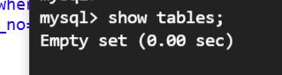

*After:*

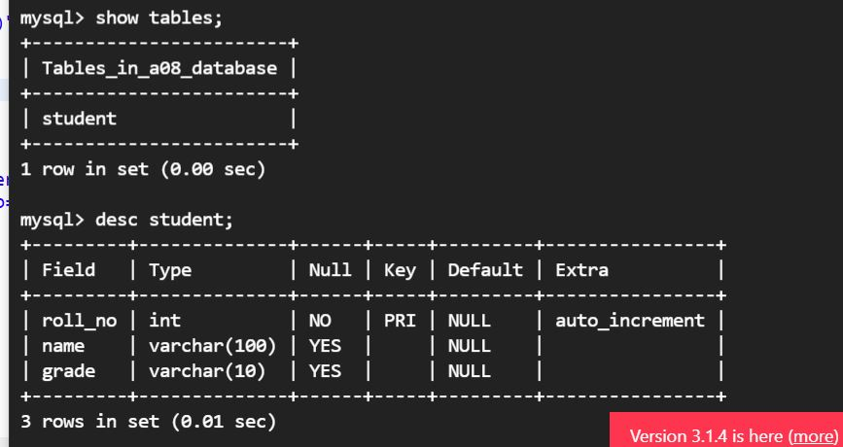

*Inserting Values:*

*Before:*

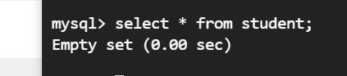

*After:*

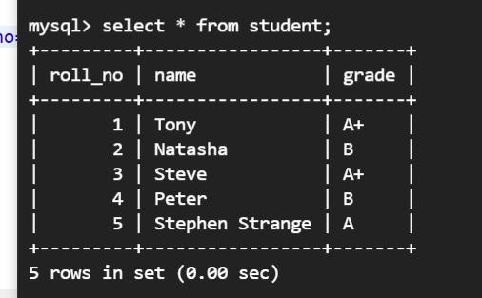

*Reading Data:*

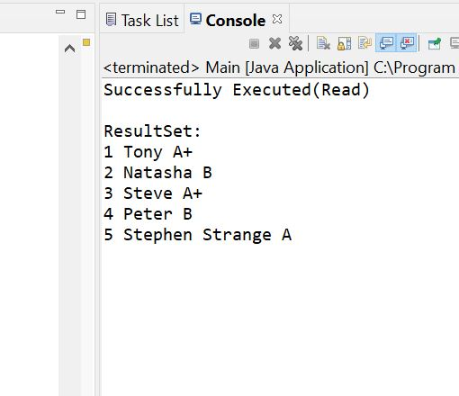

*Updating Record (roll number - 5):*

*Before:*

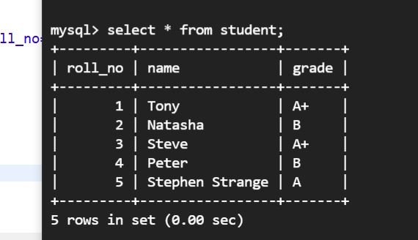

*After:*

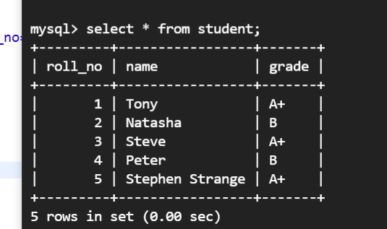

*Deleting Record (roll number - 2):*

*Before:*

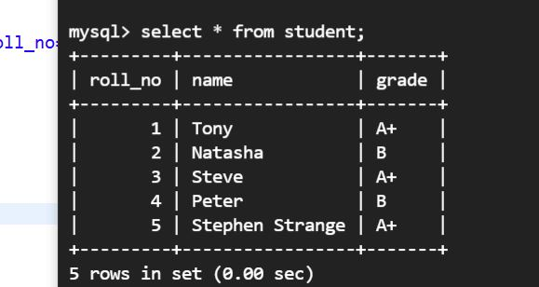

*After:*

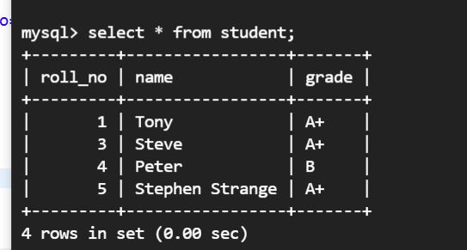

*Prepared Statement:*

*Code:*

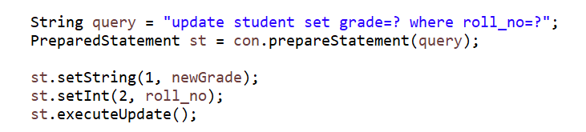

*Output (updating grade of roll number -5 using prepared statement):*

*Before:*

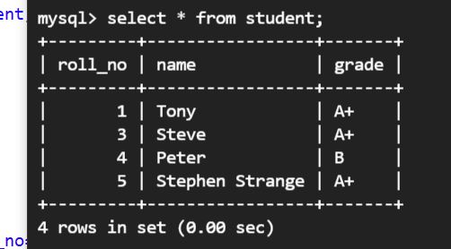

*After:*

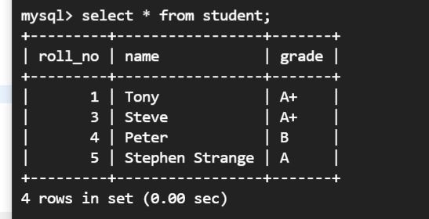

Thank You!