Name: Shubham Chemate

Roll Number: 31118

Subject: DBSL – Assignment B01 – MongoDB CRUD Operations

**Code:**

help

show dbs

// create db

use b01_db

// current db

db

// insert

db.students.insertOne(

    {

        name:"Alex",

        marks: 99,

        grade: "NA"

    }

)

db.students.insertMany([

    {

        name:"Bob",

        marks: 72,

        grade:"NA"

    },

    {

        name:"Tony",

        marks:90,

        grade:"NA"

    },

    {

        name:"Stephen",

        marks:83,

        grade:"NA"

    }

]

)

show collections

// read

// all records

db.students.find()

db.students.find(

    {},

    {

        _id:0

    }

)

// conditional find

db.students.find(

{

    marks:{$gte:80, $lte:100}

},

{

    _id:0,

    grade:0

}

)

// another way

db.students.find(

    {

        $and:[

            {marks:{$gte:80}},

            {marks:{$lte:100}}

        ]

    },

    {

        _id:0,

        grade:0

    }

)

// update

db.students.updateMany(

    {

        marks:{$gte:70, $lt:80}

    },

    {

        $set:{

            "grade":"B"

        }

    }

)

// delete

db.students.deleteOne(

    {marks:{$get:90, $lt:100}}

)

// save

db.students.save(

    {

        "_id":ObjectId("61a259548cf5b74a7ecdfe41"),

        "name":"Bob",

        "marks":95,

        "grade":"A+"

    }

)

db.dropDatabase()

**Output:**

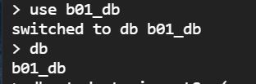

Screenshot-1: Using Database

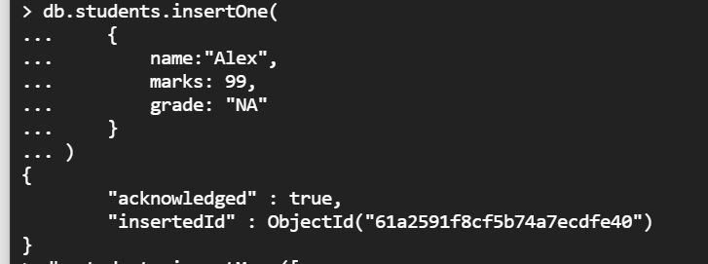

Screenshot-2: Inserting one document at a time

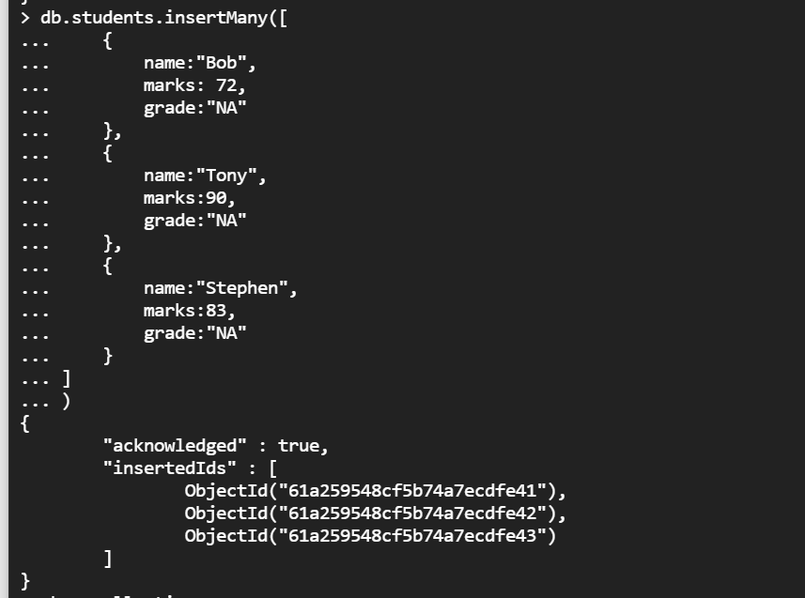

Screenshot-3: Inserting Many documents at a time

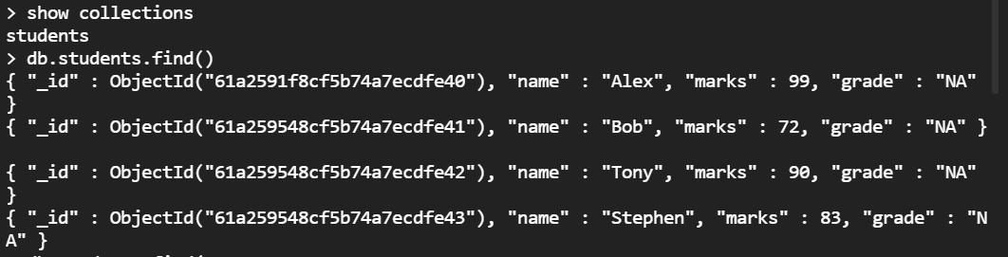

Screenshot-4: Reading database with find function

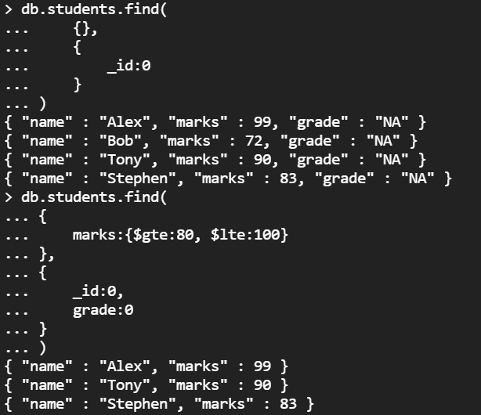

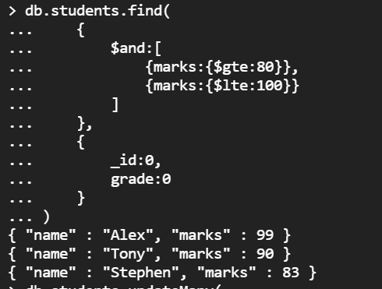

Screenshot-5: Reading records using conditionals in find

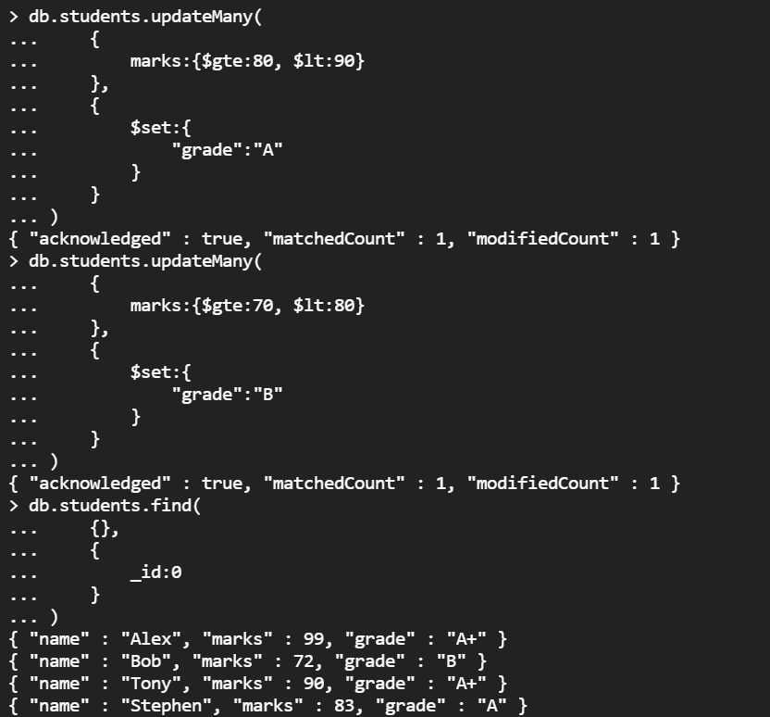

Screenshot-6: Updating records

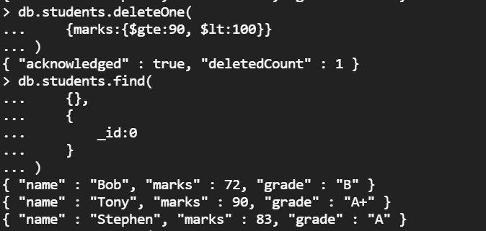

Screenshot-7: Deleting document

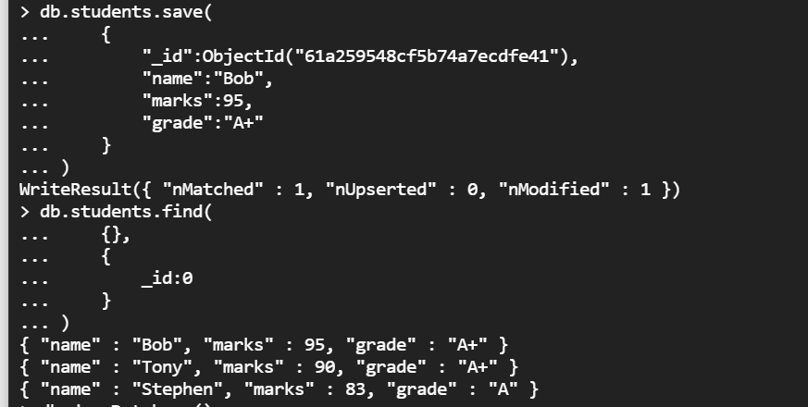

Screenshot-8: Save method to update record



Screenshot-9: Dropping Database