Name: Shubham Chemate

Roll Number: 31118

Subject: LP-1 – Second Pass of Two Pass Assembler

Code:

**import** java.io.*;

**import** java.util.HashMap;

**public** **class** PassTwo {

**public** **static** **void** main(String[] Args) **throws** IOException{

BufferedReader b1 = **new** BufferedReader(**new** FileReader("intermediate.txt"));

BufferedReader b2 = **new** BufferedReader(**new** FileReader("symtab.txt"));

BufferedReader b3 = **new** BufferedReader(**new** FileReader("littab.txt"));

HashMap<Integer, String> symSymbol = **new** HashMap<Integer, String>();

HashMap<Integer, String> litSymbol = **new** HashMap<Integer, String>();

HashMap<Integer, String> litAddr = **new** HashMap<Integer, String>();

String s;

**int** symtabPointer=1,littabPointer=1,offset;

**while**((s=b2.readLine())!=**null**){

String word[]=s.split("\t\t\t");

symSymbol.put(symtabPointer++,word[1]);

}

**while**((s=b3.readLine())!=**null**){

String word[]=s.split("\t\t");

litSymbol.put(littabPointer,word[0]);

litAddr.put(littabPointer++,word[1]);

}

**while**((s=b1.readLine())!=**null**){

**if**(s.substring(1,6).compareToIgnoreCase("IS,00")==0){

System.***out***.print("\n+ 00 0 000");

}

**else** **if**(s.substring(1,3).compareToIgnoreCase("IS")==0){

System.***out***.print("\n+ "+s.substring(4,6)+" ");

**if**(s.charAt(9)==')'){

System.***out***.print(s.charAt(8)+" ");

offset=3;

}

**else**{

System.***out***.print("0 ");

offset=0;

}

**if**(s.charAt(8+offset)=='S')

System.***out***.print(symSymbol.get(Integer.*parseInt*(s.substring(10+offset,s.length()-1))));

**else**

System.***out***.print(litAddr.get(Integer.*parseInt*(s.substring(10+offset,s.length()-1))));

}

**else** **if**(s.substring(1,6).compareToIgnoreCase("DL,01")==0){

String s1=s.substring(10,s.length()-1),s2="";

**for**(**int** i=0;i<3-s1.length();i++)

s2+="0";

s2+=s1;

System.***out***.print("\n+ 00 0 "+s2);

}

**else**{

System.***out***.print("\n");

}

}

b1.close();

b2.close();

b3.close();

}

}

Input IC:

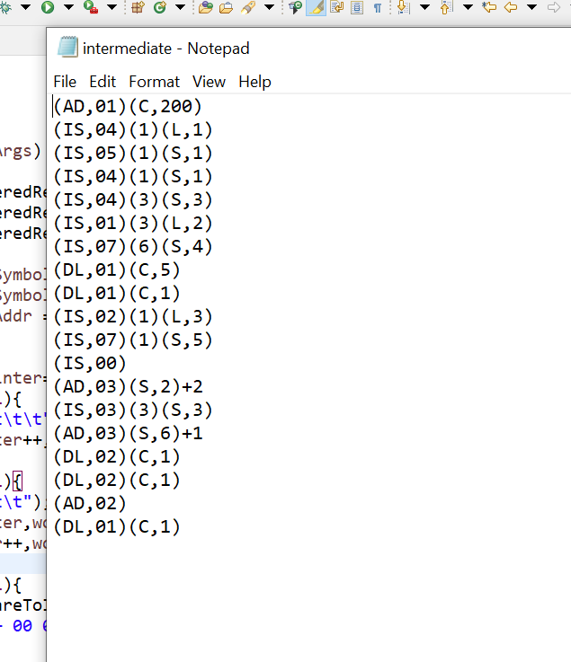

SYMTAB:

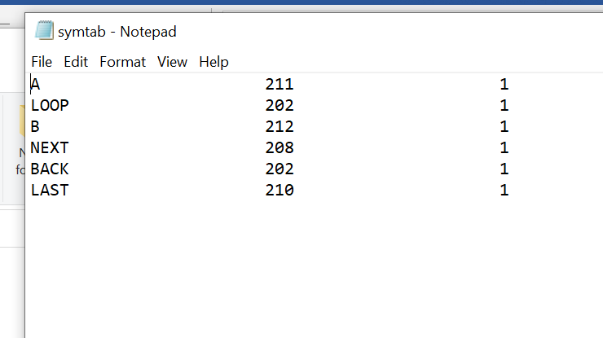

LITTAB:

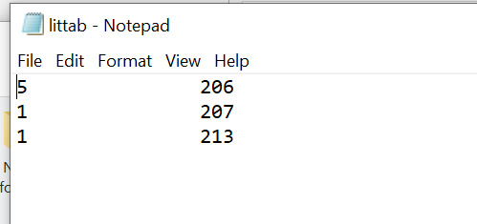

Output of Second Pass:

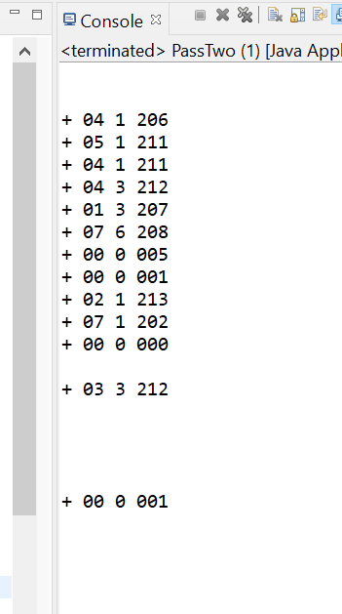

Thank You!