**Input:**

Source Code:

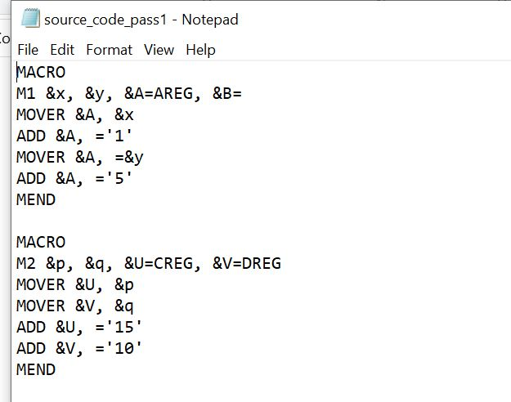

**Output:**

MNT (Macro Name Table):

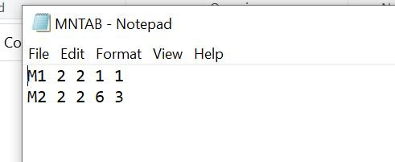

MDT (Macro Definition Table):

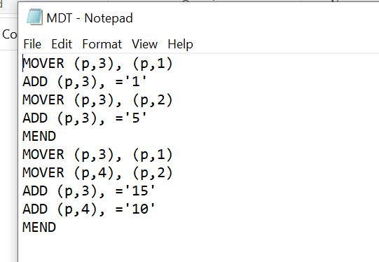

KPDT (Keyword Parameter Definition Table):

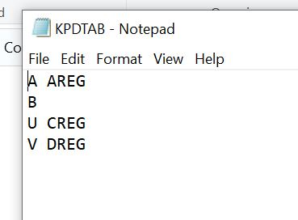

PNT (Parameter Name Table):

