1 ) What is the overall claims financial performance ?

SELECT
COUNT(*) AS total_claims,
SUM(billed_amount) AS total_billed,
SUM(allowed_amount) AS total_allowed,
SUM(paid_amount) AS total_paid,
AVG(paid_amount) AS avg_paid_per_claim,
SUM(OOP) AS total_member_oop
FROM claims;
Output :

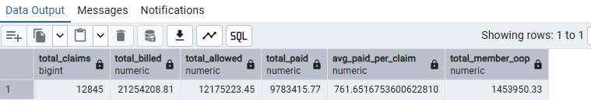

Business interpretation:

* Billed amount shows provider charges.
* Allowed amount represents the amount recognized under the claim's pricing or adjudication
* paid amount represents payer payment recorded in the dataset
* Out-of-pocket amount represents member responsibility recorded in the dataset.

2 ) What is the claim denial rate?
SELECT COUNT(*) AS total_claims,
SUM(CASE WHEN claim_status = 'Denied'
THEN 1
ELSE 0 END )AS denied_claims ,
100 * SUM( CASE WHEN claim_status = 'Denied'
THEN 1
ELSE 0
END) / COUNT(*) AS denied_claim_percentage
FROM claims;

Output :
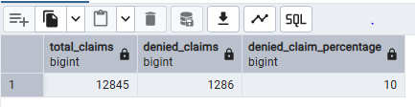

Business interpretation:

Business interpretation:
A high denial rate may indicate:
- Incorrect coding
- Missing authorization
- Eligibility problems
- Provider billing errors
- Contract or policy issues

As per my finding Percentage of denied claims is 10 %

3 ) What are the top denial reasons ?
SELECT denial_code,denial_reason,
COUNT(*) AS denied_claims
FROM claims
WHERE claim_status = 'Denied'
GROUP BY denial_code,denial_reason
ORDER BY denied_claims DESC;

OUTPUT :
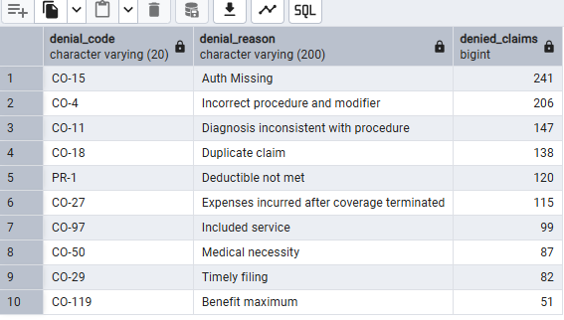

Business interpretation:
* I wrote a SQL query to identify which denial code has the greatest impact on the revenue cycle. Based on my analysis, I found that most claims were denied due to missing authorization
4) Which providers have the highest denial rates?

SELECT billing_npi,COUNT(*) AS total_claims,
SUM(
CASE WHEN claim_status = 'Denied' THEN 1
ELSE 0 END ) AS denied_claims,
(
100 * SUM(CASE WHEN claim_status = 'Denied' THEN 1
ELSE 0 END )/ COUNT(*)
) AS Denied_percentage
FROM claims
GROUP BY billing_npi
HAVING COUNT(*) >=20
ORDER BY Denied_percentage DESC;
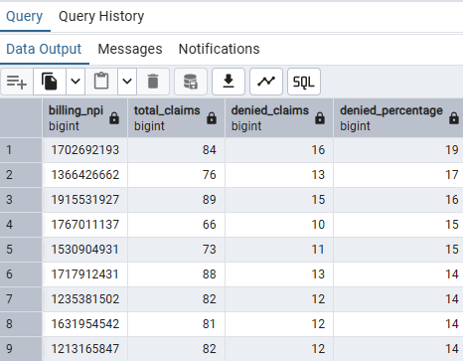
Business interpretation:
* I analyzed the denial percentage by provider to identify which providers have the highest claim denial rates.

