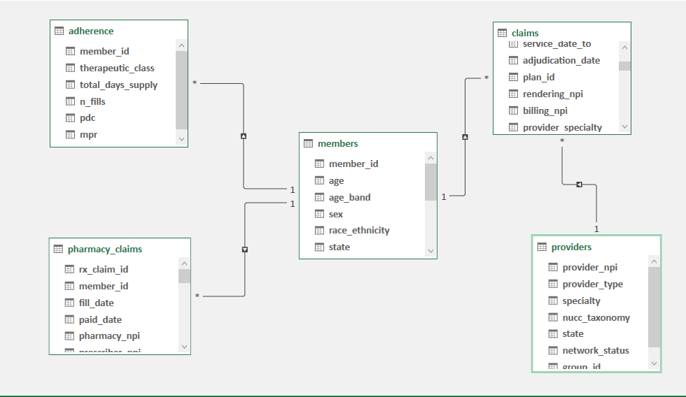

I creating following relationship

• Members.member_id → Medical Claims.member_id
One to Many
• Members.member_id → Pharmacy Claims.member_id
One to Many
• Members.member_id → Adherence.member_id
One to Many
• Providers.provider_npi → Medical Claims.rendering_npi
One to Many

