**High Level Design (HLD)**

**Mushroom Classification**

**Revision number:2.0**

**Last date of revision: 11/02/2023**

**Document Version Control**

|  |  |  |  |
| --- | --- | --- | --- |
| **Date Issued** | **Version** | **Description** | **Author** |
| 06/06/2024 | 1 | Initial HLD-V1.0 | Shubhamdeep |
| 06/06/2024 | 2 | Updated Conclusion-V1.2 | Shubhamdeep |

**Contents Page No.**

Document Version Control 2

Abstract 4

1. Introduction 5
   1. Why this High-Level Design Document 5 1.2) Scope 5

1.3) Definitions 5

1. General Description 6
   1. Problem Statement 6 2.2) Objective 6
   2. Approach 6
   3. Tools Used 7
2. Design Details 8
   1. Process Flow 8 3.2) Model Training and Evaluation 8
   2. Error Handling 9
3. Performance 9
   1. Reusability 9
   2. Application Compatibility 9
   3. Resource Utilization 9
4. Key Performance Indicators 10
5. Conclusion 11

# Abstract

One of the fungi-type foods with the most effective nutrients on the earth is the mushroom. Major medical benefits of mushrooms include their ability to kill cancer cells. The goal of this study is to determine the most effective method for classifying mushrooms, and two categories—poisonous and non-poisonous—will be used to do so. The suggested method will use many algorithms and techniques including Decision Tree, Random Forest, and Boosting

Techniques when the dataset comprises various mushroom attributes.

## 1. Introduction

**1.1 Why this High-Level Design Document?**

The goal of this High-Level Design (HLD) Document is to provide the current project description with the additional depth needed to describe an appropriate model for coding. This paper can serve as a reference guide for how the modules interact at a higher level and is also meant to assist identify conflicts before coding.

**Details on HLD:**

* Present all of the design elements and fully describe them
* explains the user interface that is being used
* explains the software and hardware interfaces
* describes the necessary performance standards
* Include the project's architecture and design elements
* List and explain the non-functional characteristics like those listed below o Security o Reliability o Maintainability o Portability o Reusability o Application compatibility o Resource utilization

o Serviceability

### 1.2 Scope

The HLD documentation outlines the system's architecture, including the technology architecture, application architecture (layers), database architecture, and application flow. The HLD employs words that should be clear to the system's management, ranging from non-technical to technical.

## 2. General Description

### 2.1 Problem Statement

From The Audubon Society Field Guide to North American Mushrooms, this dataset comprises descriptions of hypothetical samples belonging to 23 species of gilled mushrooms in the Agaricus and Lepiota Family Mushroom (1981). Each species is classified as either unquestionably edible, unquestionably poisonous, or maybe edible but not advised. The toxic class was joined with the latter. The Guide makes it very obvious that there is no easy rule—like "leaflets three, let it be" for Poisonous Oak and Ivy—for assessing if a mushroom is edible.

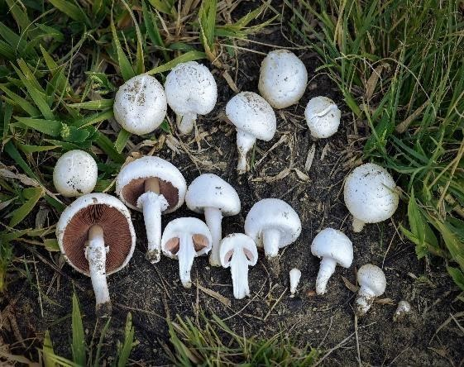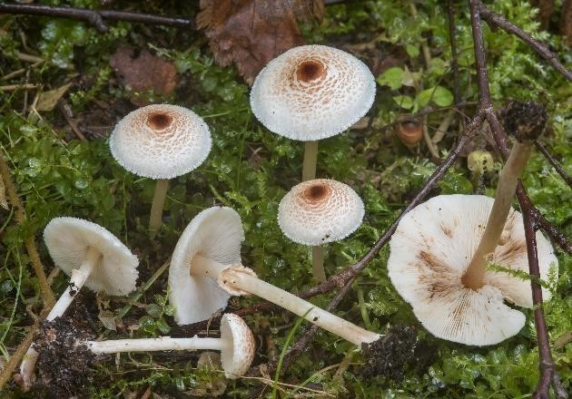

### Agaricus Mushroom Lepiota Mushroom

**2.2 Objective**

Predicting which mushroom is toxic and which is edible is the key goal.

#### 2.3 Approach

the traditional machine learning activities, including model building, model testing, feature engineering, data exploration, and data cleaning. applied various machine learning techniques that suited the aforementioned case the best.

#### 2.4 Tools Used

Models are built using the Python programming language and libraries like NumPy, Pandas, and Scikit-learn.

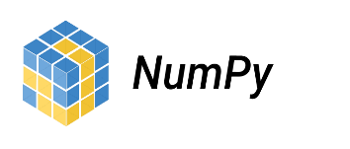

* Seaborn and Matplotlib are used for visualization.

* Deployment is done in local host.

* Front end development is done using HTML/CSS.
* Flask is used for backend development.
* GitHub is used as version control system.

### 3. Design Details

#### 3.1 Process Flow

The following is the procedure for constructing the machine learning model, which is used to categorise edible and poisonous mushrooms.

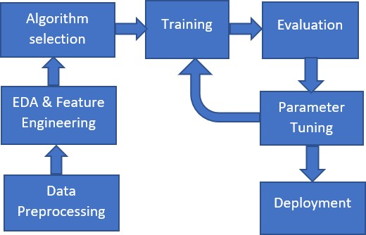

#### 3.2 Model Training and Evaluation

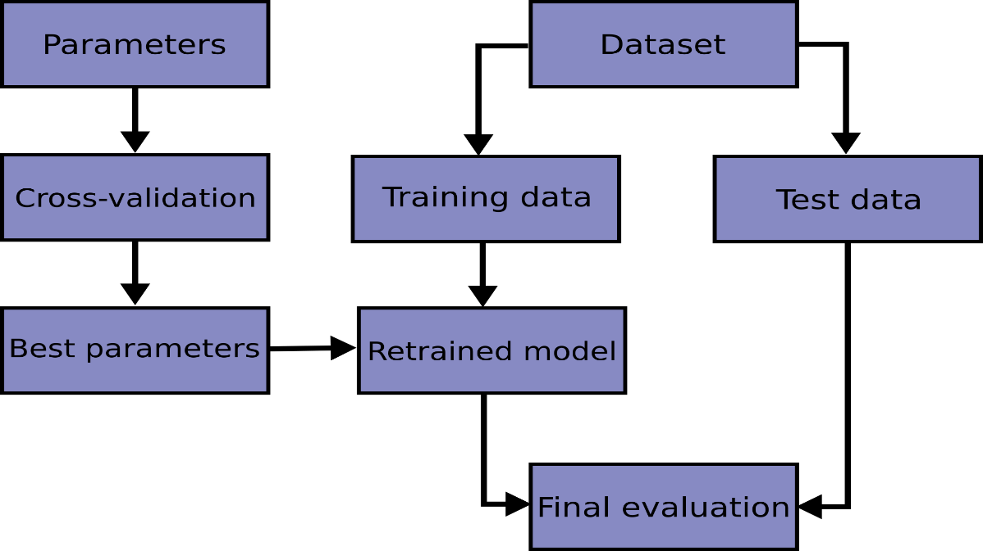

#### 3.3 Error Handling

Should errors can be encountered. An error will be defined as anything that falls outside the normal intended usage.

### 4. Performance

It is important that the Mushroom Classification be as exact as possible because it is used to determine which types of mushrooms are edible and poisonous based on their characteristics (**cap form and colour, odour, stem shape and colour, habitat, etc**.). Retraining the model is essential to enhancing performance.

#### 4.1 Reusability

It should be possible to reuse the written code and the component utilised without any issues.

#### 4.2 Application Compatibility

Python will serve as an interface between the project's many components. Each component will have a specific task to do, and it is Python's responsibility to make sure that the information is transformed correctly.

#### 4.3 Resource Utilization

Any task that needs to be completed will probably consume all of the available computing power.

### 5. Key Performance Indicators

1. To identify mushroom is edible or poisonous based on their features.

1. Time and work load can be reduced.

### 6. Conclusion

This mushroom classification project will help us to identify which mushroom is good for health or not, based on the different features of the mushroom. Anyone can know about the mushroom is edible or not without having deep knowledge about it.