CAREERTIQ
Cloud DevOps Engineering Series | Unit 4: Infrastructure Automation
HANDS-ON LAB REPORT
Chapter 3: Terraform Infrastructure as Code Suite
Provisioning VPC, Subnet, Security Group, EC2 and S3 Backup Bucket: Enterprise Smart Library Management Platform
Student Name | Shubham Deshmukh
PRN | 2125UDSM1027
Department | AI and DS
Environment | Windows 11 + WSL2, Ubuntu 22.04 LTS, Terraform v1.16.5, AWS region us-east-1
Date | 11 October 2026
GitHub Repository | https://github.com/shubhamdeshmukh1027/library-platform-devops

Table of Contents
1. Chapter 3 Overview & Objectives 3
Terraform workflow used in this lab 3
2. Project Structure and Terraform Code 3
2.1 providers.tf 4
2.2 variables.tf 4
2.3 main.tf 4
2.4 outputs.tf 7
2.5 Resources defined by the configuration 7
3. Initializing and Validating 7
3.1 terraform init 7
3.2 terraform fmt and validate 8
4. Plan and Apply 8
4.1 terraform plan 8
4.2 terraform apply 9
5. Verification of the Provisioned Infrastructure 9
5.1 Terraform outputs 9
5.2 EC2 instance 10
5.3 S3 backup bucket 10
5.4 SSH login to the EC2 instance 10
6. Cleanup with terraform destroy 11
7. GitHub Repository Notes 12
8. Troubleshooting Common Terraform Errors 13
9. Conclusion 13

1. Chapter 3 Overview & Objectives
Curriculum Module | Target Platform | Focus Tool | Release Status
Unit 4: Infrastructure Automation | AWS us-east-1 (N. Virginia) | HashiCorp Terraform v1.16.5 | Verified Lab Report

In Chapter 2 the workstation was prepared (AWS CLI, Terraform, Ansible, IAM user and SSH key pair). In this chapter Terraform is used as Infrastructure as Code (IaC) to provision the cloud foundation of the Enterprise Smart Library Management Platform. The whole infrastructure is described in code, created with one command and removed with one command, which makes it repeatable and version controlled.
Objectives
- Write Terraform configuration files (providers, variables, main, outputs)
- Initialize, format, validate, plan and apply the configuration
- Provision a VPC, public subnet, Internet Gateway, route table, security group, EC2 instance and S3 backup bucket
- Verify the resources with Terraform outputs, the AWS CLI and an SSH login
- Destroy all resources with terraform destroy to avoid unnecessary AWS charges

Terraform workflow used in this lab
Step | Command | Purpose
1 | terraform init | Download providers (aws, random) and prepare the working directory
2 | terraform fmt / validate | Format the code and check that the configuration is valid
3 | terraform plan | Preview the changes Terraform would make
4 | terraform apply | Create or update the real infrastructure
5 | terraform output | Show values such as VPC ID, public IP and bucket name
6 | terraform destroy | Remove every resource created by the configuration

2. Project Structure and Terraform Code
All code is kept in the chapter-3/terraform folder of the GitHub repository. The ls command shows the four configuration files. The terraform.tfstate file is created by Terraform after the first apply; it stores the real resource IDs and is therefore excluded from Git by .gitignore.
Terminal: Listing the Terraform project files
cd ~/library-platform-devops/chapter-3/terraform
ls

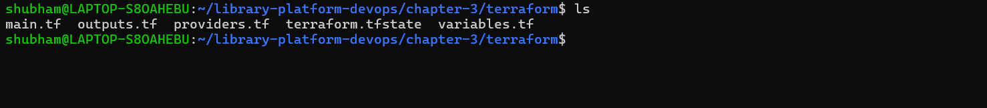
Figure 1: Terraform project files: main.tf, outputs.tf, providers.tf, variables.tf (terraform.tfstate created after apply)

2.1 providers.tf
Declares the required Terraform version, the aws and random providers, and the AWS region.
terraform {
required_version = ">= 1.7.0"
required_providers {
aws = {
source = "hashicorp/aws"
version = ">= 5.0"
}
random = {
source = "hashicorp/random"
version = ">= 3.0"
}
}
}

provider "aws" {
region = var.region
}

2.2 variables.tf
Input variables make the code reusable: region, instance type, SSH key name (the library-aws-key created in Chapter 2) and the CIDR allowed to SSH.
variable "region" {
type = string
default = "us-east-1"
}

variable "instance_type" {
type = string
default = "t3.micro"
}

variable "key_name" {
type = string
default = "library-aws-key"
}

variable "allowed_ssh_cidr" {
type = string
default = "0.0.0.0/0"
}

2.3 main.tf
Defines the network, security group, EC2 instance and S3 backup bucket. The Ubuntu 22.04 AMI is looked up automatically with a data source, so no AMI ID is hardcoded.
data "aws_ami" "ubuntu" {
most_recent = true
owners = ["099720109477"]
filter {
name = "name"
values = ["ubuntu/images/hvm-ssd/ubuntu-jammy-22.04-amd64-server-*"]
}
}

resource "aws_vpc" "main" {
cidr_block = "10.0.0.0/16"
enable_dns_hostnames = true
tags = { Name = "library-vpc" }
}

resource "aws_internet_gateway" "igw" {
vpc_id = aws_vpc.main.id
tags = { Name = "library-igw" }
}

resource "aws_subnet" "public" {
vpc_id = aws_vpc.main.id
cidr_block = "10.0.1.0/24"
availability_zone = "${var.region}a"
map_public_ip_on_launch = true
tags = { Name = "library-public-subnet" }
}

resource "aws_route_table" "public" {
vpc_id = aws_vpc.main.id
route {
cidr_block = "0.0.0.0/0"
gateway_id = aws_internet_gateway.igw.id
}
tags = { Name = "library-public-rt" }
}

resource "aws_route_table_association" "public" {
subnet_id = aws_subnet.public.id
route_table_id = aws_route_table.public.id
}

resource "aws_security_group" "web" {
name = "library-web-sg"
description = "Allow SSH and HTTP"
vpc_id = aws_vpc.main.id
ingress {
description = "SSH"
from_port = 22
to_port = 22
protocol = "tcp"
cidr_blocks = [var.allowed_ssh_cidr]
}
ingress {
description = "HTTP"
from_port = 80
to_port = 80
protocol = "tcp"
cidr_blocks = ["0.0.0.0/0"]
}
egress {
from_port = 0
to_port = 0
protocol = "-1"
cidr_blocks = ["0.0.0.0/0"]
}
tags = { Name = "library-web-sg" }
}

resource "aws_instance" "app" {
ami = data.aws_ami.ubuntu.id
instance_type = var.instance_type
subnet_id = aws_subnet.public.id
vpc_security_group_ids = [aws_security_group.web.id]
key_name = var.key_name
tags = { Name = "library-app-server" }
}

resource "random_id" "suffix" {
byte_length = 4
}

resource "aws_s3_bucket" "backup" {
bucket = "library-backup-${random_id.suffix.hex}"
tags = { Name = "library-backup" }
}

resource "aws_s3_bucket_versioning" "backup" {
bucket = aws_s3_bucket.backup.id
versioning_configuration {
status = "Enabled"
}
}

resource "aws_s3_bucket_public_access_block" "backup" {
bucket = aws_s3_bucket.backup.id
block_public_acls = true
block_public_policy = true
ignore_public_acls = true
restrict_public_buckets = true
}

2.4 outputs.tf
output "vpc_id" {
value = aws_vpc.main.id
}

output "instance_public_ip" {
value = aws_instance.app.public_ip
}

output "s3_bucket_name" {
value = aws_s3_bucket.backup.bucket
}

2.5 Resources defined by the configuration
Terraform resource | Name / purpose
aws_vpc.main | library-vpc, CIDR 10.0.0.0/16
aws_internet_gateway.igw | library-igw, internet access for the VPC
aws_subnet.public | library-public-subnet, 10.0.1.0/24 in us-east-1a
aws_route_table.public | library-public-rt, default route 0.0.0.0/0 to the gateway
aws_route_table_association.public | Attaches the route table to the public subnet
aws_security_group.web | library-web-sg, allows SSH (22) and HTTP (80)
aws_instance.app | library-app-server, t3.micro, Ubuntu 22.04, key library-aws-key
random_id.suffix | Random suffix so the S3 bucket name is globally unique
aws_s3_bucket.backup | library-backup-<suffix>, backup bucket
aws_s3_bucket_versioning.backup | Versioning enabled on the bucket
aws_s3_bucket_public_access_block.backup | All public access blocked

3. Initializing and Validating

3.1 terraform init
terraform init prepares the working directory and installs the providers. The output shows hashicorp/aws v6.68.0 and hashicorp/random v3.9.1 in use and the message "Terraform has been successfully initialized!". The versions are recorded in .terraform.lock.hcl.
Terminal: Initializing Terraform
terraform init

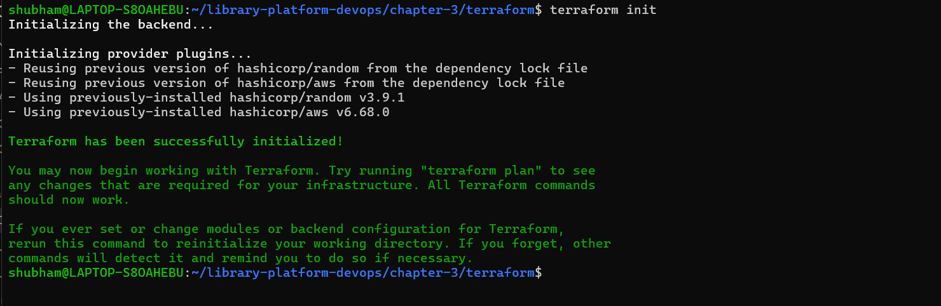
Figure 2: terraform init: providers aws v6.68.0 and random v3.9.1, successfully initialized

3.2 terraform fmt and validate
terraform fmt formats the files to the standard style (no output means nothing needed changing) and terraform validate checks the syntax and references.
Terminal: Formatting and validating the configuration
terraform fmt
terraform validate

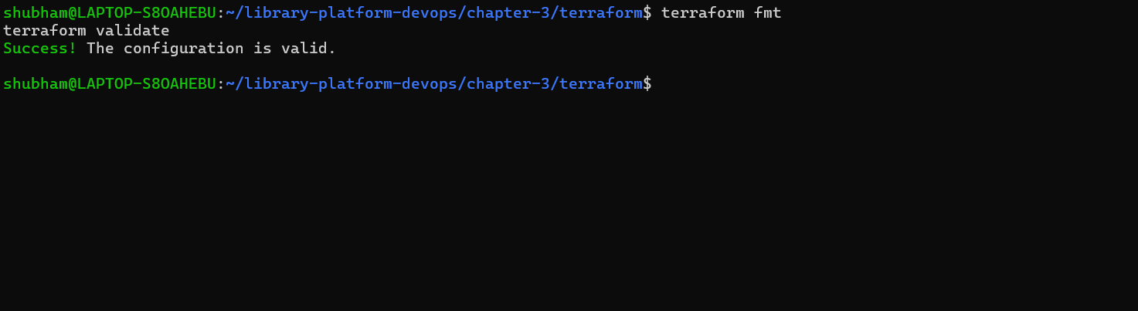
Figure 3: terraform validate: "Success! The configuration is valid."

4. Plan and Apply

4.1 terraform plan
terraform plan compares the configuration with the real infrastructure. All eleven resources already exist in the Terraform state from the first apply, so the plan reports "No changes. Your infrastructure matches the configuration." This shows that Terraform is idempotent: running it again does not create duplicate resources.
Terminal: Previewing changes
terraform plan

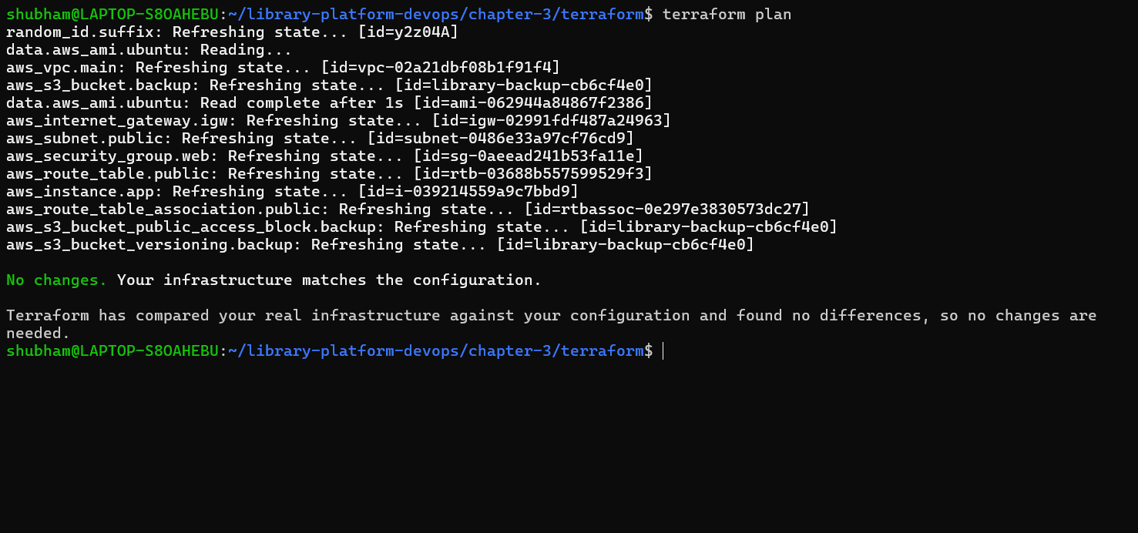
Figure 4: terraform plan: refreshes state of all resources and reports no changes

4.2 terraform apply
terraform apply creates or updates the infrastructure so that it matches the code. On the first run it asks for confirmation (only "yes" is accepted) and creates the 11 resources. Running it again, as shown below, finishes with 0 added, 0 changed, 0 destroyed and prints the outputs.
Terminal: Applying the configuration
terraform apply

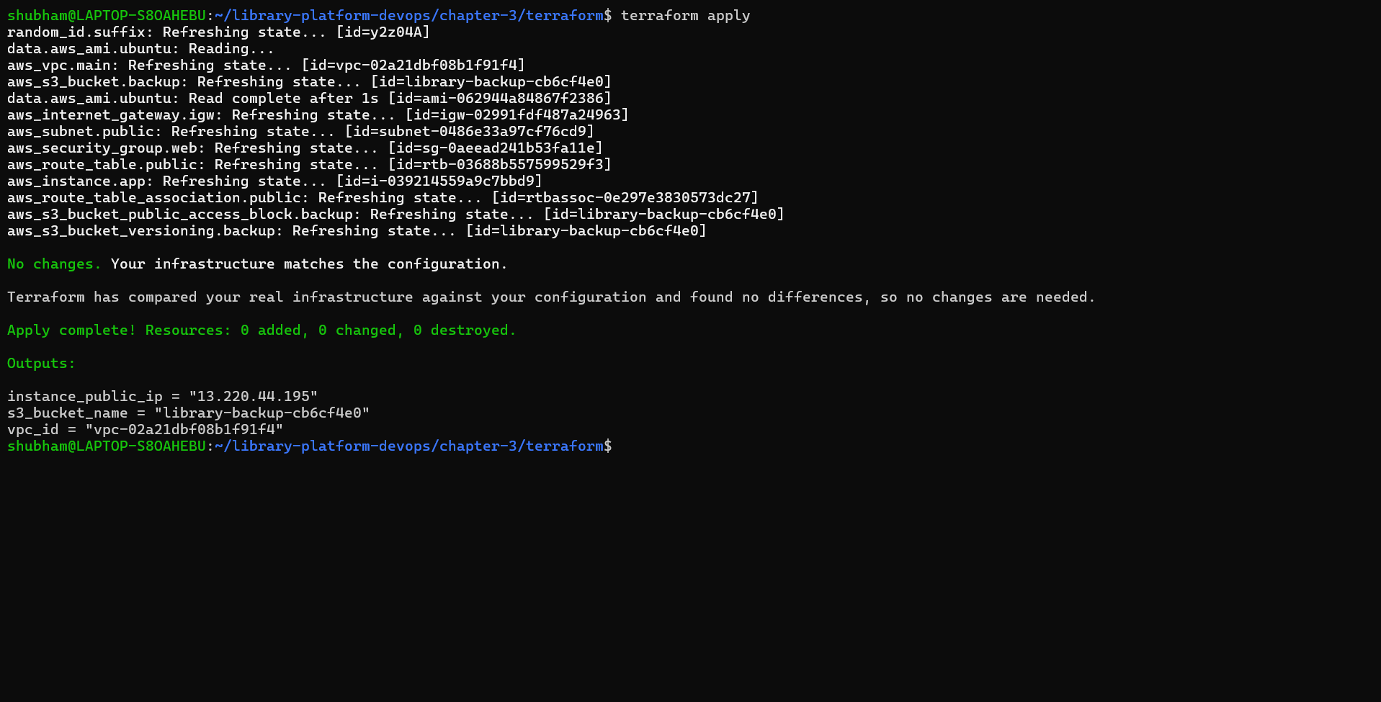
Figure 5: terraform apply: Apply complete with outputs instance_public_ip, s3_bucket_name and vpc_id

5. Verification of the Provisioned Infrastructure

5.1 Terraform outputs
terraform output prints the values defined in outputs.tf: the public IP of the EC2 instance (13.220.44.195), the S3 bucket name (library-backup-cb6cf4e0) and the VPC ID.
terraform output

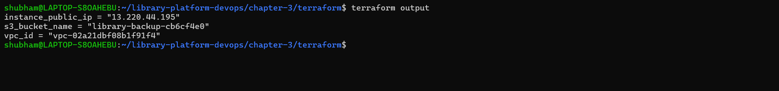
Figure 6: terraform output: public IP, S3 bucket name and VPC ID

5.2 EC2 instance
The AWS CLI confirms that the instance library-app-server (i-039214559a9c7bbd9) is in the running state with the same public IP.
aws ec2 describe-instances --filters "Name=tag:Name,Values=library-app-server" \
--query "Reservations[].Instances[].[InstanceId,State.Name,PublicIpAddress]" \
--output table --region us-east-1

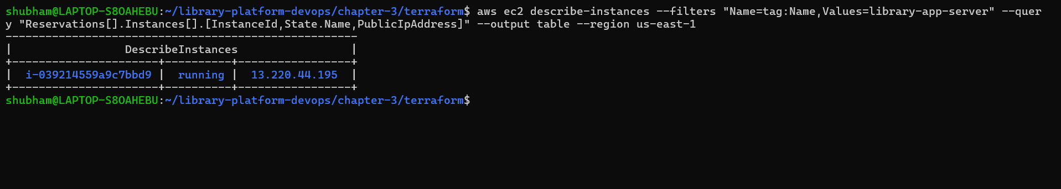
Figure 7: EC2 instance library-app-server is running with public IP 13.220.44.195

5.3 S3 backup bucket
aws s3 ls | grep library-backup

Figure 8: S3 bucket library-backup-cb6cf4e0 created by Terraform

5.4 SSH login to the EC2 instance
The key pair library-aws-key from Chapter 2 is used to log in to the new server. The first connection asks to trust the host fingerprint (answer yes). The Ubuntu 22.04.5 LTS welcome banner confirms a successful login and the private IP 10.0.1.246 matches the subnet 10.0.1.0/24.
ssh -i ~/.ssh/library-aws-key ubuntu@$(terraform output -raw instance_public_ip)

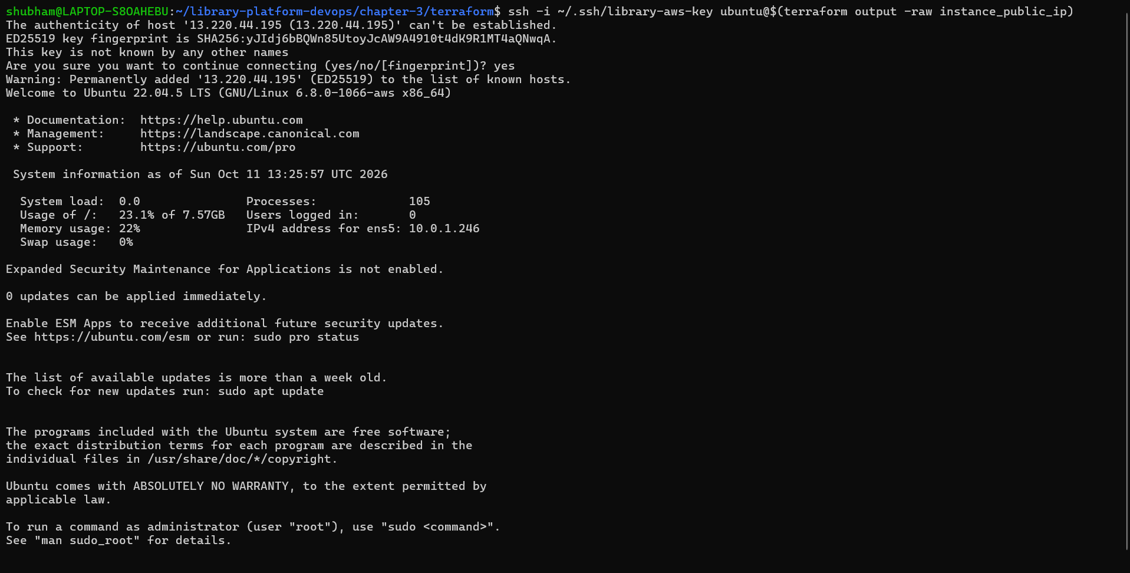
Figure 9: SSH login to the EC2 instance: Ubuntu 22.04.5 LTS, private IP 10.0.1.246

6. Cleanup with terraform destroy
After the verification, all resources are removed so that no EC2 or S3 charges continue. terraform destroy first shows the destroy plan and asks for confirmation.
terraform destroy

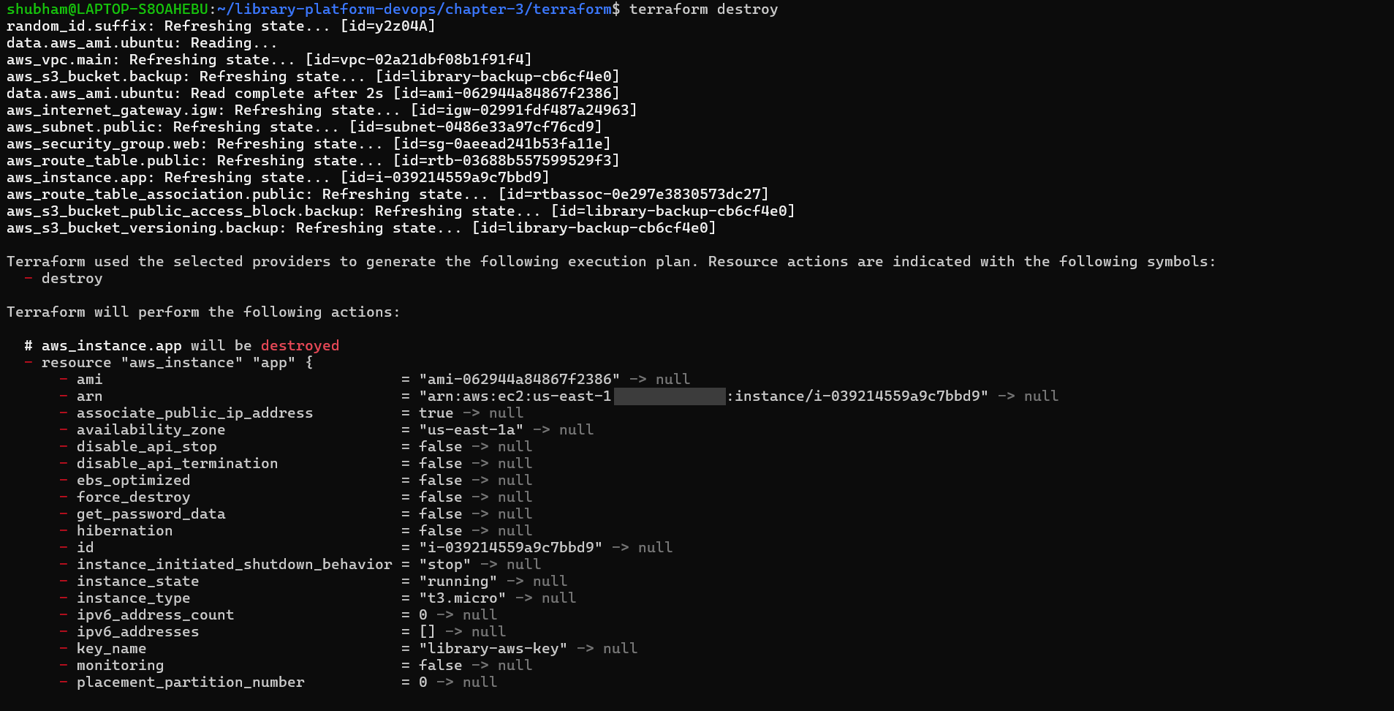
Figure 10: terraform destroy: state is refreshed and the destroy plan starts with aws_instance.app
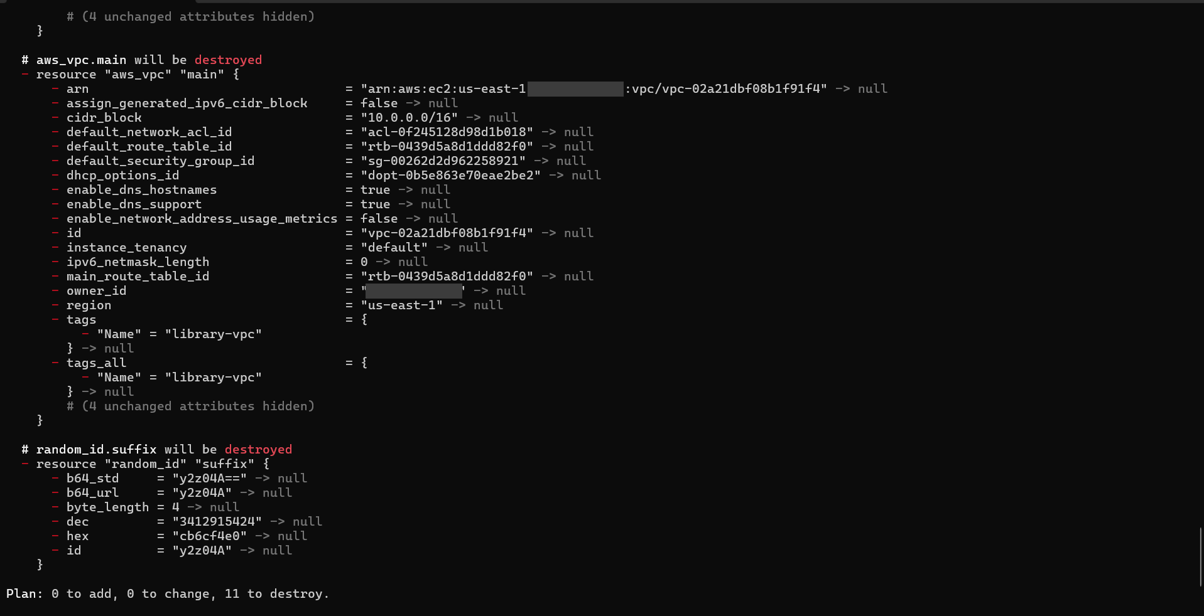
Figure 11: Destroy plan summary: Plan: 0 to add, 0 to change, 11 to destroy
After typing yes, Terraform deletes the resources in the correct dependency order: bucket settings and the instance first, then the gateway, subnet and security group, and the VPC last. It ends with "Destroy complete! Resources: 11 destroyed."
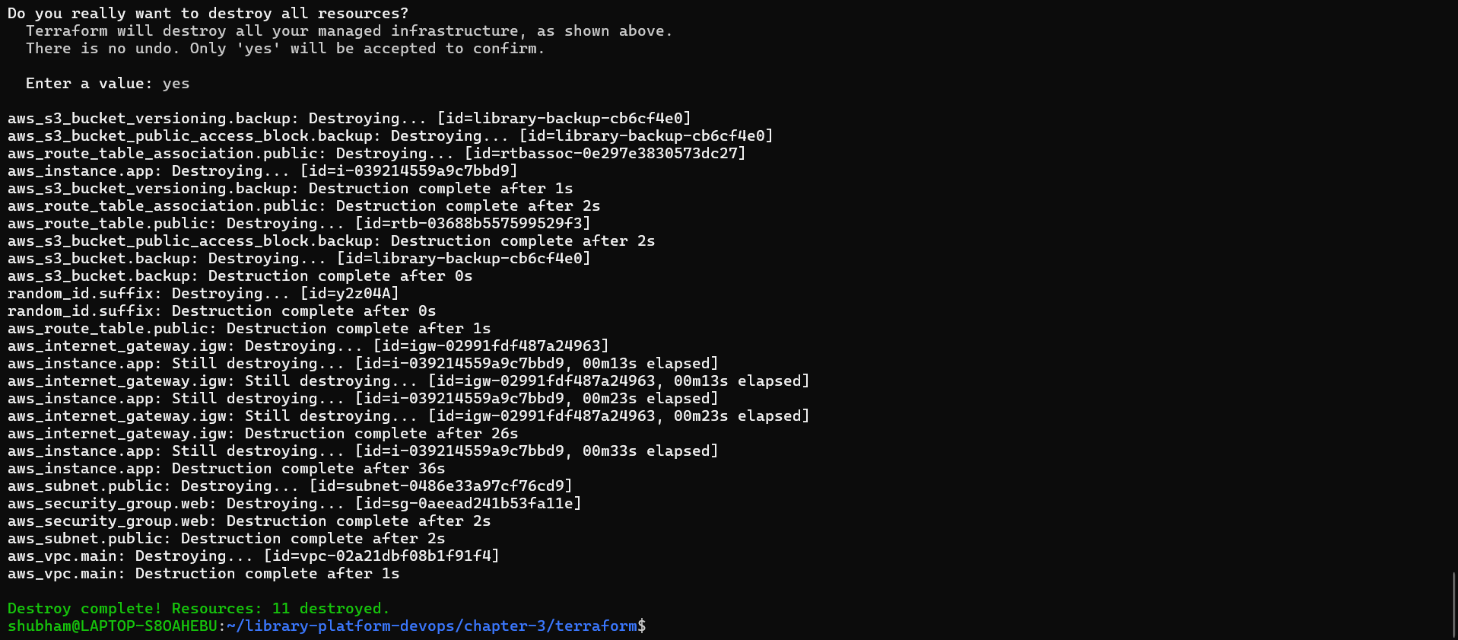
Figure 12: Destroy complete: 11 resources destroyed
COST NOTE
EC2 instances and S3 storage are billed while they exist. Always run terraform destroy after the lab, and check the AWS Console that no instance or bucket is left behind.

7. GitHub Repository Notes
The Terraform code is stored in chapter-3/terraform of the repository. The state file contains real resource IDs, so it must not be committed.
Commit to Git | Never commit (blocked by .gitignore)
main.tf, variables.tf, providers.tf, outputs.tf | terraform.tfstate and terraform.tfstate.*
.terraform.lock.hcl | .terraform/ directory
chapter-3/screenshots/ (masked screenshots) | *.tfvars, private keys (*.pem, library-aws-key*)

8. Troubleshooting Common Terraform Errors
Symptom / Error Message | Root Cause | Remediation Step
No valid credential sources found | AWS CLI credentials not configured or expired | Run aws configure list and aws sts get-caller-identity, then re-run aws configure if needed.
InvalidKeyPair.NotFound | key_name does not exist in the region | Check aws ec2 describe-key-pairs --region us-east-1 and set the correct key_name.
BucketAlreadyExists | S3 bucket names are global | Keep the random_id suffix so the name is unique.
Error acquiring the state lock | Another terraform command is still running | Wait for it to finish or stop the old process, then retry.
Plan shows 11 to add again | State file was lost or deleted | Keep terraform.tfstate in the working folder (but not in Git); do not delete it before destroy.

9. Conclusion
Using Terraform, the complete network and compute foundation of the Enterprise Smart Library Management Platform (VPC, subnet, Internet Gateway, route table, security group, EC2 instance and an S3 backup bucket) was defined as code, validated, applied and verified through Terraform outputs, the AWS CLI and an SSH login. The infrastructure was then removed cleanly with terraform destroy (11 resources). The EC2 instance created here is the target that Ansible will configure with Docker and Nginx in the next chapter.

