SHUBHAM DHENGALE - 3574
Experiment No. 10
Title: Deploy a MERN Stack Web Application on a Cloud Platform (Render/Netlify/Vercel) and Demonstrate End-to-End Functionality
Aim:
To deploy the spice-export MERN application with a React frontend, Express API and MongoDB database, then verify a sample request from the website through the backend.
Tools Used:
Git, MongoDB Atlas, Render, Vercel, environment variables, browser and Postman.
Methodology:
The deployment plan separates the static React frontend, Express API and MongoDB database so each service can be configured for production. The repository includes deployment guidance and cloud-platform configuration; private environment variables hold the database URI, allowed client origin and API settings. A complete release check would build the frontend, deploy the API, verify the health URL, open each direct route, submit a sample request and confirm the stored record. The current evidence is from a local website and local API only. No public URL or live cloud deployment is claimed because hosting accounts, client-approved details and production secrets have not yet been configured.
Theory:
Cloud deployment hosts an application for public access. A MERN site may host React separately from the Node/Express API and use managed MongoDB.
Environment variables hold service configuration and secrets outside source code. Production CORS should allow the deployed frontend origin. Verification includes health, direct routes, API requests and database persistence.
Procedure:
1. Confirm the client-approved company name, contact channels, office location and GSTIN before public launch.
2. Create a MongoDB Atlas database and restrict network access and credentials appropriately.
3. Push the reviewed project to the chosen Git repository and deploy the Express API to Render or another supported host.
4. Set MONGODB_URI, CLIENT_ORIGIN and any admin secret privately in the API host dashboard.
5. Deploy the React build to Vercel, Netlify or the selected static host.
6. Set the public API base URL and enable API mode in the frontend deployment settings.
7. Open the production health URL and verify the expected HTTP 200 JSON response.
8. Open each website route directly, then submit a test sample enquiry and inspect the API response.
9. Verify the test document in MongoDB, remove it if appropriate, and capture production screenshots with the real deployed URL.
10. Check the production build and environment-variable settings before selecting a cloud target.
11. Verify the public URL, API connectivity and a complete test request after deployment has actually succeeded.
Code:
Render API environment: MONGODB_URI, CLIENT_ORIGIN, ADMIN_API_KEY
Vercel frontend: VITE_API_ENABLED=true
VITE_API_BASE_URL=<deployed API base URL>/api
Health check: GET <deployed API base URL>/api/health
Output:
Expected checks after deployment:
GET /api/health -> HTTP 200 with status ok
Routes /, /products, /about, /register, /samples and /contact load directly.
Submitting the sample form -> HTTP 201; the request is visible in MongoDB.
The project is not deployed yet. Add actual live URLs and screenshots after configuring accounts, client details and secrets.
Figure 10.1: Local website preview; not a cloud deployment.
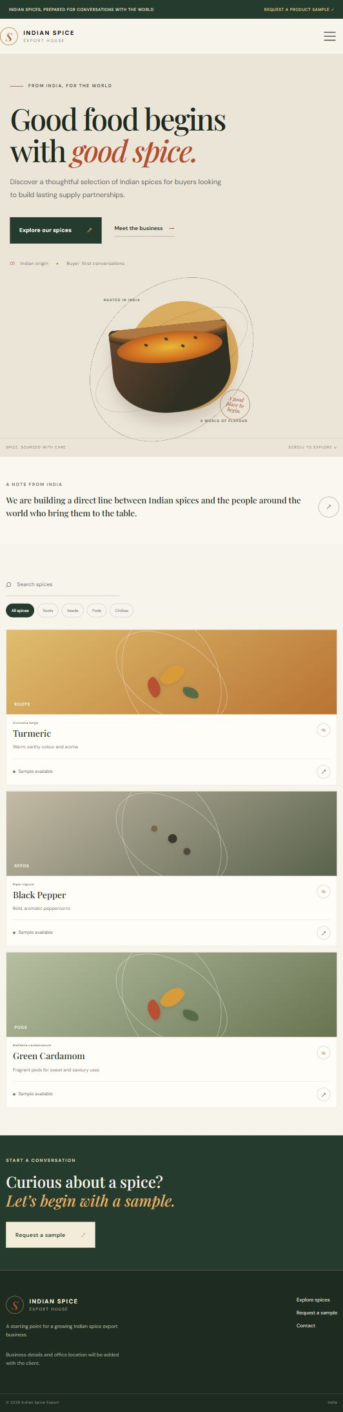
Figure 10.2: Local backend health output; not a public deployment.
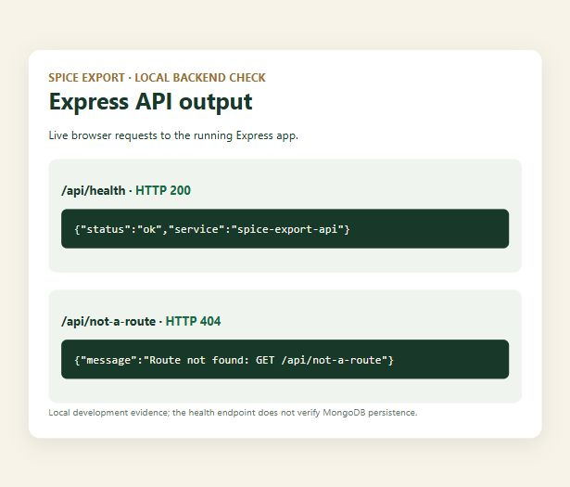
Figure 10.3: Site home page running locally.
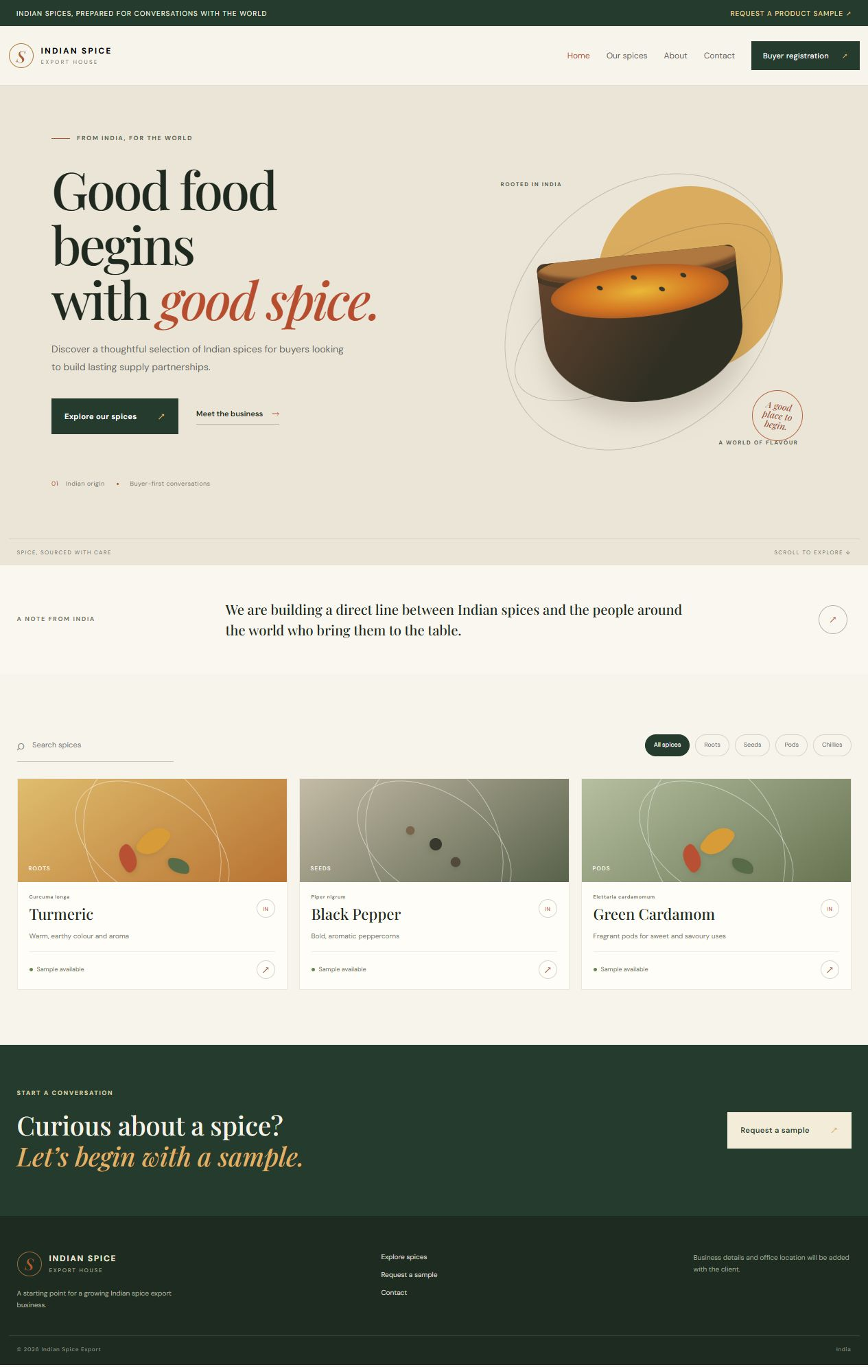
Figure 10.4: Product catalogue on the local build.
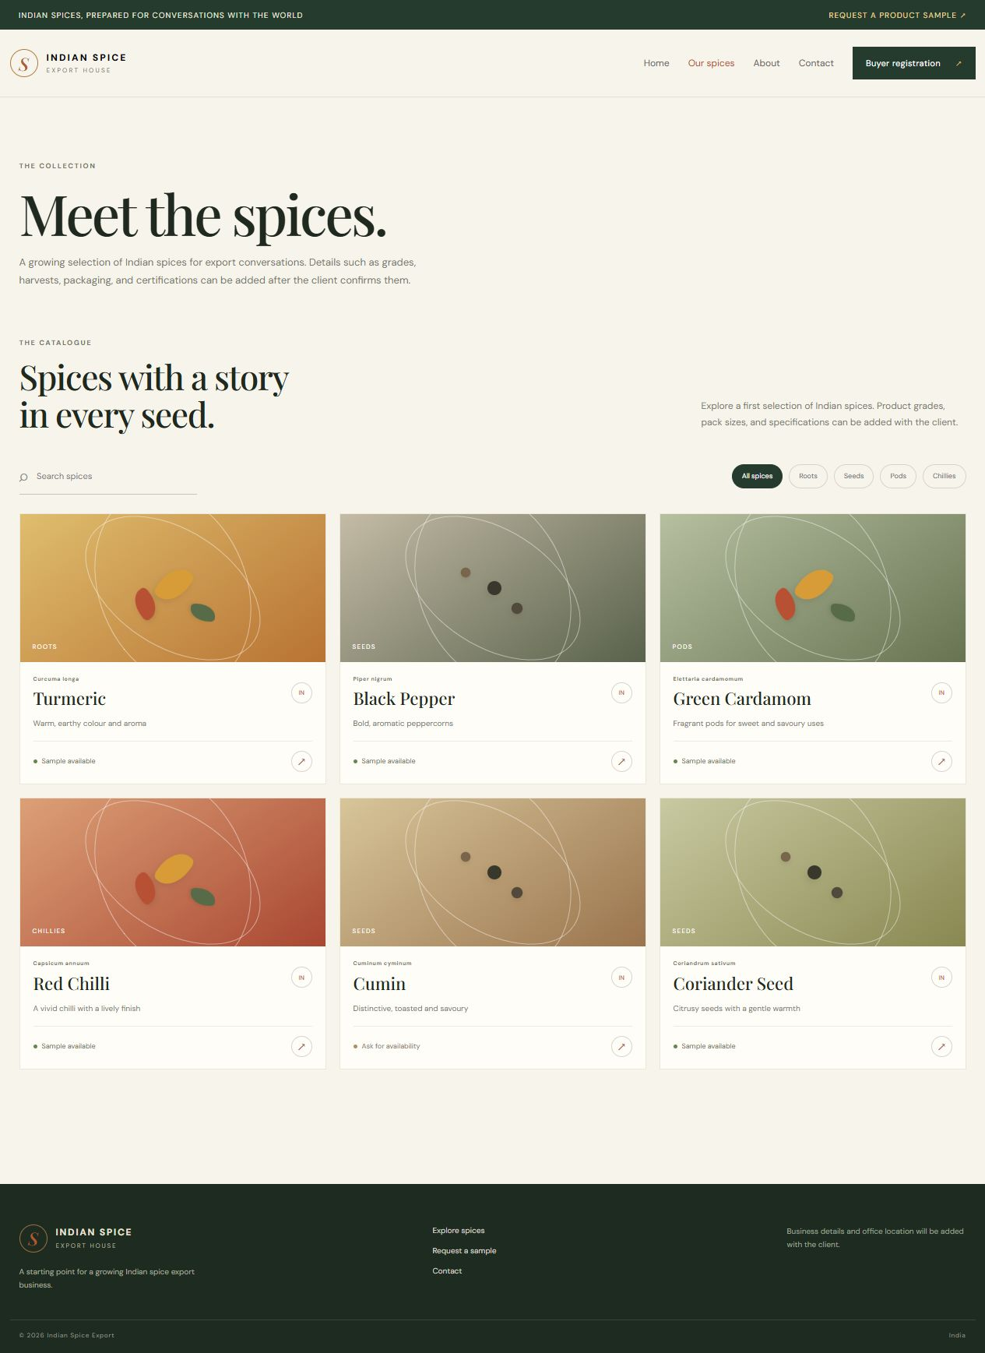
Figure 10.5: About route in the local build.
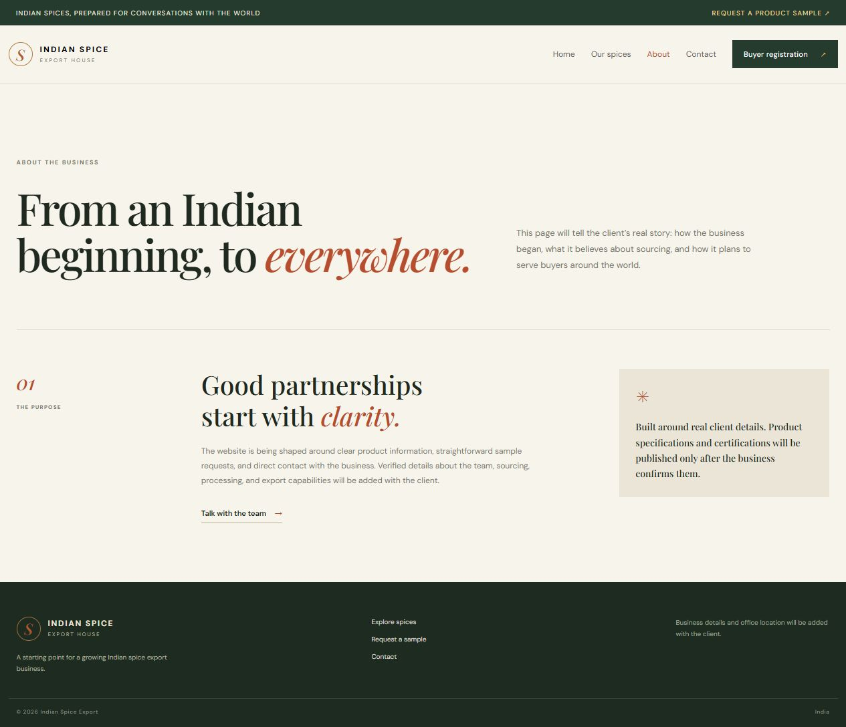
Figure 10.6: Contact route in the local build.
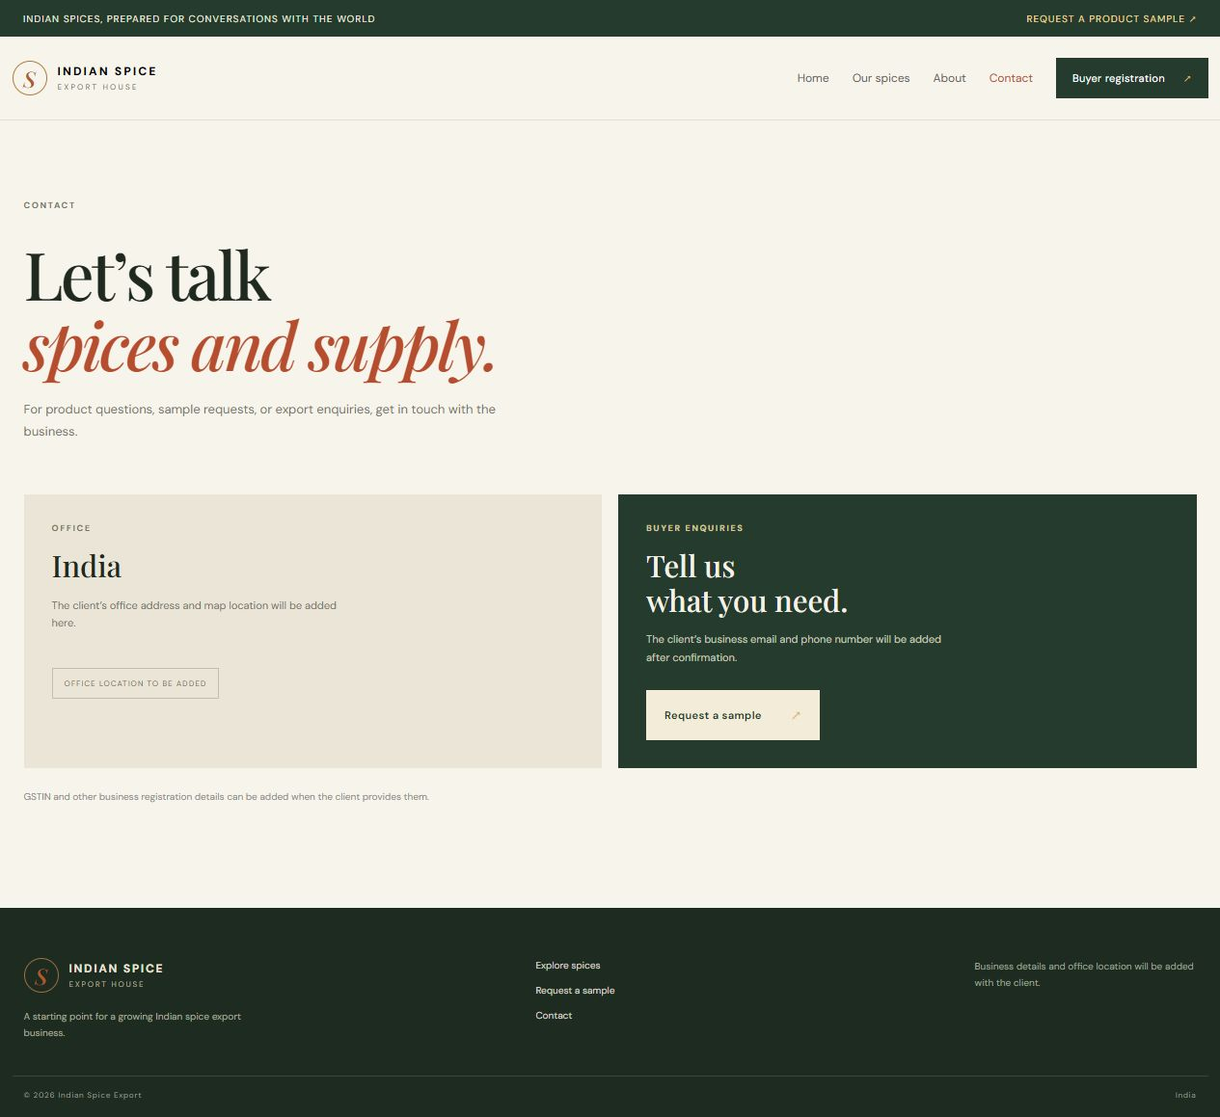
Figure 10.7: Sample route in the local build.
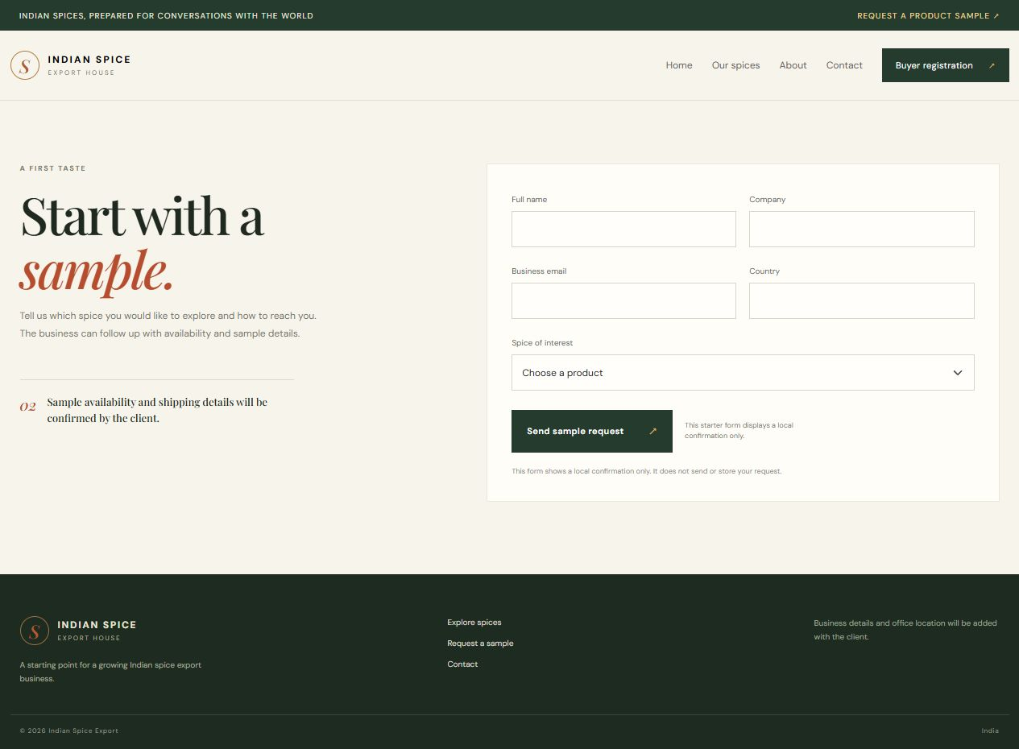
Figure 10.8: Registration route in the local build.
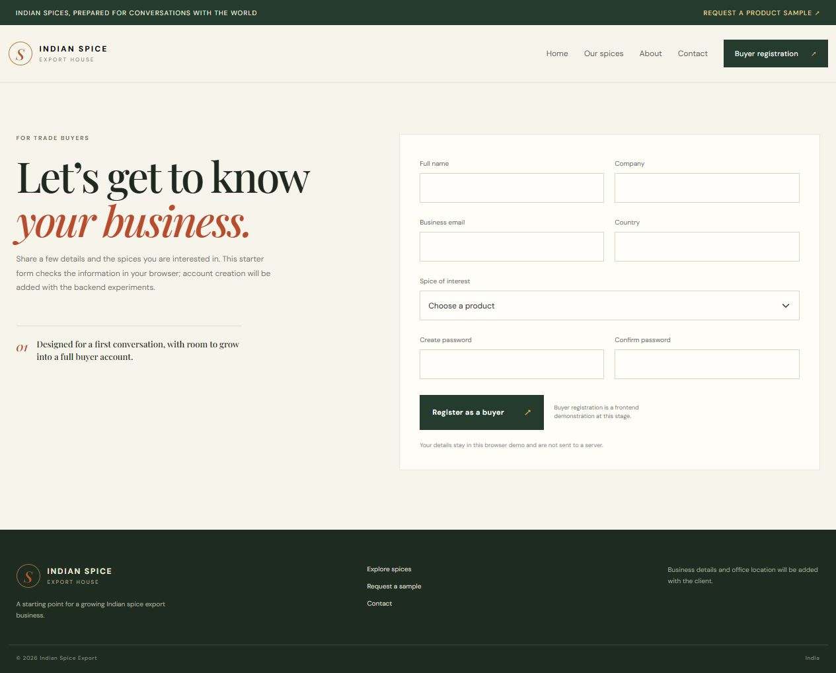
Conclusion:
This experiment prepared the steps needed to publish the spice-export application as a MERN website. The local project has a React frontend, Express service, Mongoose models and deployment notes, and the local site and API can be inspected before release. A successful deployment still depends on client-approved public details, a production database, hosting accounts, private environment variables and a domain or public service URL. The included local screenshots document the current build and backend health response; they are not cloud-hosting evidence. After deployment, the health route, direct website routes, sample-request API response and saved MongoDB record should all be checked from the public environment and recorded as actual production output.
The final report should replace each local-development capture with a production capture only after the public URL has been deployed and verified. A cloud screenshot should show the real host, the API response should come from the deployed endpoint, and the submitted test enquiry should be located in the production test database before it is removed. This preserves a clear distinction between preparation and a completed release.

