SHUBHAM DHENGALE - 3574
Experiment No. 1
Title: Design a Responsive Registration Form using Bootstrap and Perform Client-Side Validation using JavaScript
Aim:
To design a responsive buyer registration form for an Indian spice-export business using Bootstrap and to validate the entered details in the browser with JavaScript.
Tools Used:
HTML5
Bootstrap CSS
JavaScript (ES6)
Visual Studio Code
Google Chrome
Methodology:
The registration workflow was planned around the information an international spice buyer needs to share: name, company, business email, country, spice of interest and password confirmation. A mobile-first Bootstrap layout groups these fields into a clear form and keeps labels and controls readable at narrow widths. HTML5 required and email constraints handle common input errors, while JavaScript checks password matching and intercepts submission to show immediate feedback. The process was verified with an empty form and completed fields in the browser. At this stage the form is a client-side demonstration: validated information remains in the browser and is not written to the business database.
Theory:
A responsive form adjusts its layout to the available screen width. Bootstrap provides a grid system and reusable form classes such as container, row, col, form-label, and form-control. These classes help keep labels, fields, and buttons consistent across screen sizes.
HTML form controls support built-in constraints such as required, type=email, and minlength. The browser exposes the result through the Constraint Validation API. JavaScript can add project-specific checks, such as confirming that the password and confirmation fields match.
Client-side validation gives a user immediate feedback before submission. It improves usability but does not replace server-side validation. A production application must validate submitted data again on the server before storing it.
Procedure:
1. Open the spice-export project and identify the Buyer Registration route and BuyerForm component.
2. Group the buyer fields into a semantic form with labels, input types and a clear submit button.
3. Use Bootstrap spacing, grid and form-control classes so fields remain readable on phones and desktop screens.
4. Mark name, company, email, country, spice and password fields as required; use type=email and a suitable password minimum length.
5. On form submission, prevent a full-page reload and compare the password with its confirmation.
6. Call the browser validity checks and show field-level or summary feedback for invalid values.
7. Enter valid sample buyer details and confirm that the local success state appears.
8. Repeat with the form empty and with an invalid email or mismatched password; correct each error.
9. Resize the browser and capture the initial, validation and successful form states.
10. Check keyboard navigation, field focus and readable spacing at a narrow mobile viewport.
11. Record which feedback is browser validation and which message is produced by the form script.
Code:
<!doctype html>
<html lang="en">
<head>
<meta charset="utf-8">
<meta name="viewport" content="width=device-width, initial-scale=1">
<title>Buyer Registration | Spice Export</title>
<link rel="stylesheet" href="bootstrap.min.css">
</head>
<body>
<main class="container py-5">
<div class="row justify-content-center">
<section class="col-12 col-md-9 col-lg-7">
<h1 class="mb-2">Buyer Registration</h1>
<p>Register your interest in sourcing Indian spices.</p>
<form id="buyerForm" class="needs-validation" novalidate>
<label class="form-label" for="buyerName">Full name</label>
<input class="form-control mb-3" id="buyerName" required>
<label class="form-label" for="company">Company</label>
<input class="form-control mb-3" id="company" required>
<label class="form-label" for="email">Business email</label>
<input class="form-control mb-3" id="email" type="email" required>
<label class="form-label" for="country">Country</label>
<input class="form-control mb-3" id="country" required>
<label class="form-label" for="product">Product interest</label>
<select class="form-select mb-3" id="product" required>
<option value="">Choose a spice</option>
<option>Turmeric</option><option>Black pepper</option>
<option>Cardamom</option><option>Chilli</option>
</select>
<label class="form-label" for="password">Create password</label>
<input class="form-control mb-3" id="password" type="password"
minlength="8" required>
<label class="form-label" for="confirmPassword">Confirm password</label>
<input class="form-control mb-3" id="confirmPassword"
type="password" required>
<button class="btn btn-success" type="submit">Register interest</button>
<p id="formMessage" class="mt-3" role="status"></p>
</form>
</section>
</div>
</main>
<script>
const form = document.getElementById("buyerForm");
const password = document.getElementById("password");
const confirmPassword = document.getElementById("confirmPassword");
const message = document.getElementById("formMessage");
form.addEventListener("submit", (event) => {
event.preventDefault();
confirmPassword.setCustomValidity(
password.value === confirmPassword.value ? "" : "Passwords must match."
);
form.classList.add("was-validated");
if (!form.checkValidity()) {
message.textContent = "Please correct the highlighted fields.";
return;
}
message.textContent = "Details are valid and ready to be submitted.";
});
</script>
</body>
</html>
Output:
Buyer Registration displays name, company, business email, country, product interest, password and confirmation fields.
Invalid or missing values trigger browser validation feedback. Matching valid values display a local confirmation; this frontend experiment does not store or transmit the form.
Figure 1.1: Blank registration form before entry.
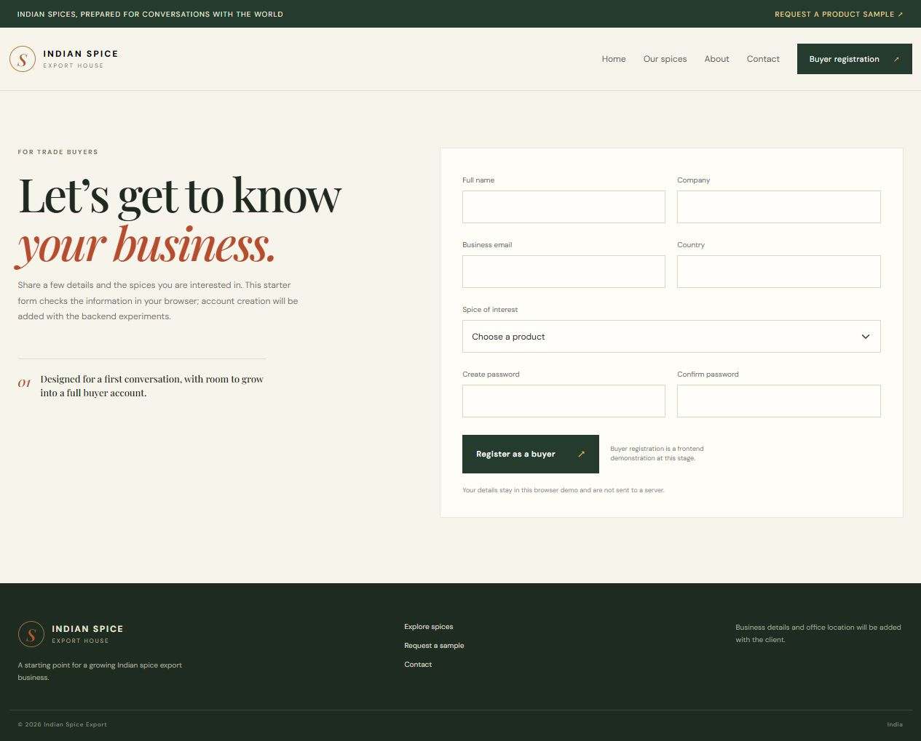
Figure 1.2: Required-field validation after an empty submission.
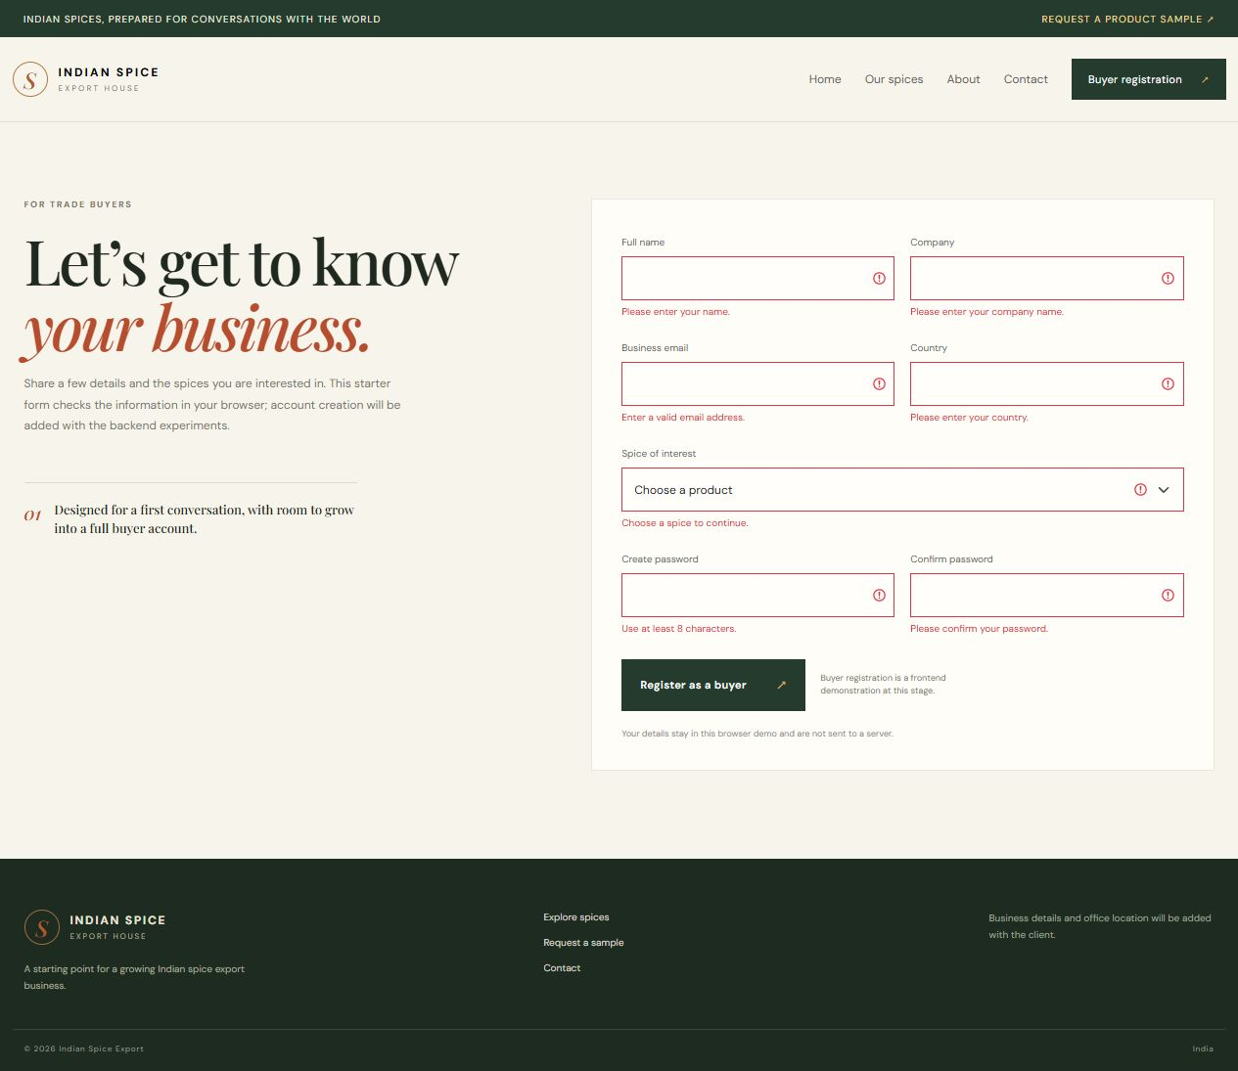
Figure 1.3: Email-format validation after an invalid address.
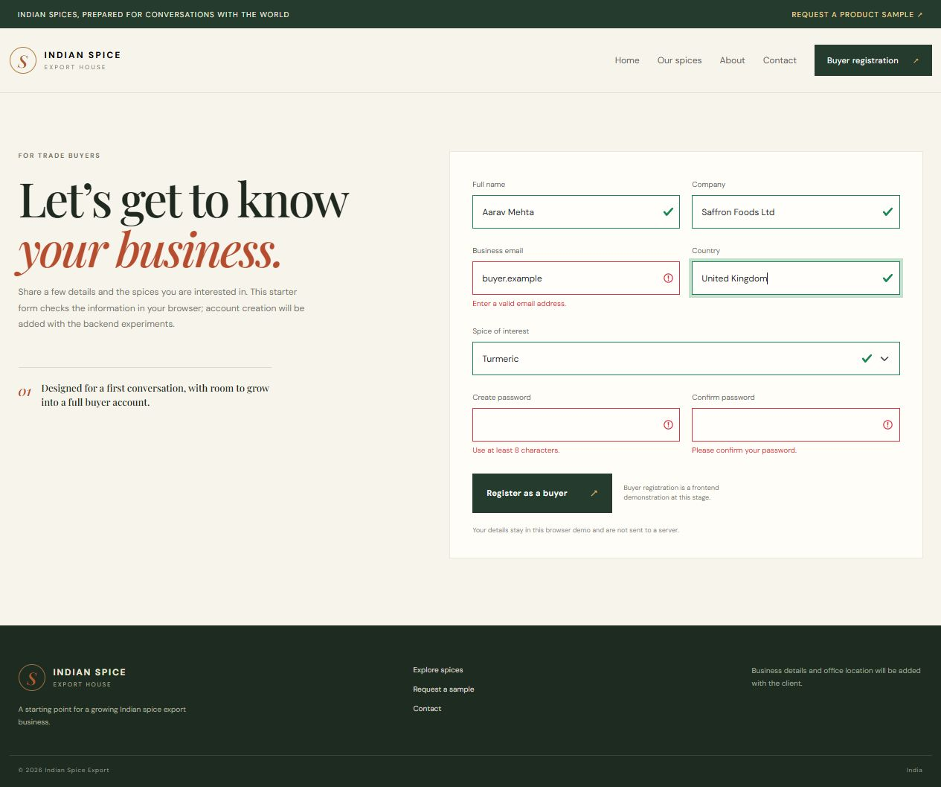
Figure 1.4: Buyer details entered in the registration form.
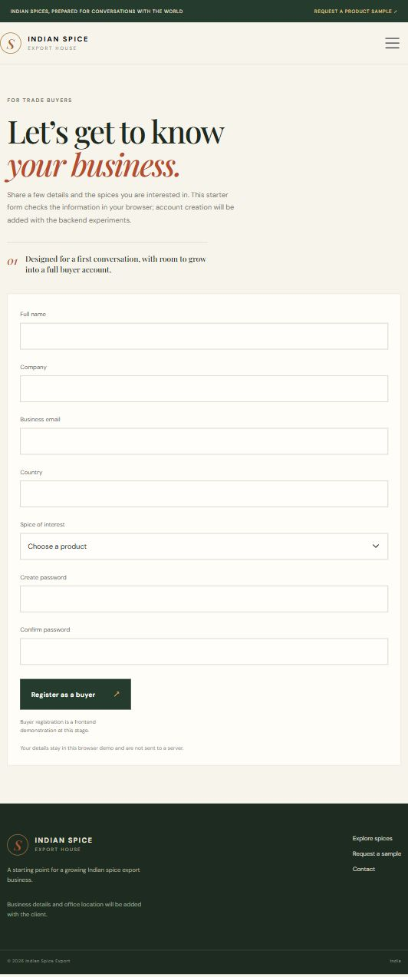
Figure 1.5: Local success state for valid buyer details.
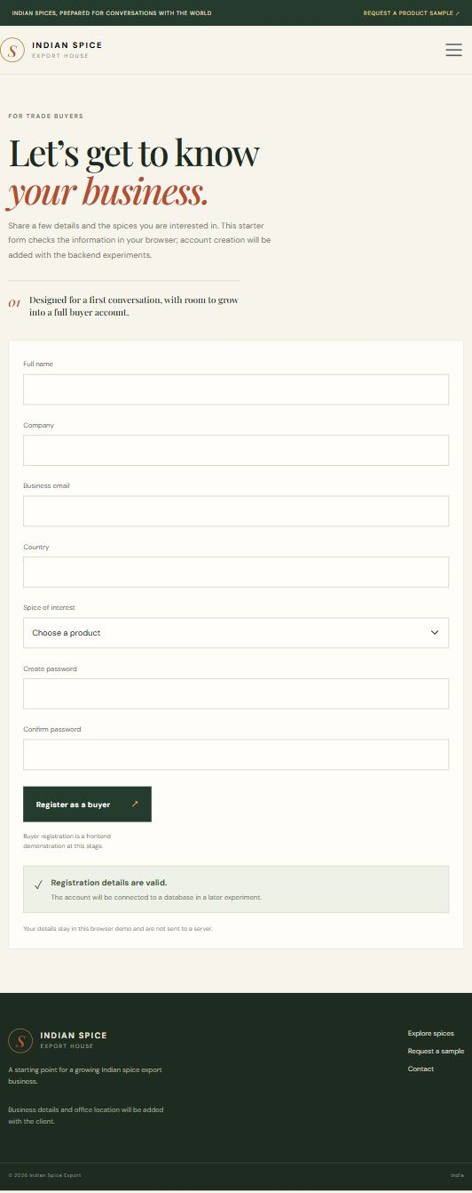
Figure 1.6: Desktop validation feedback.
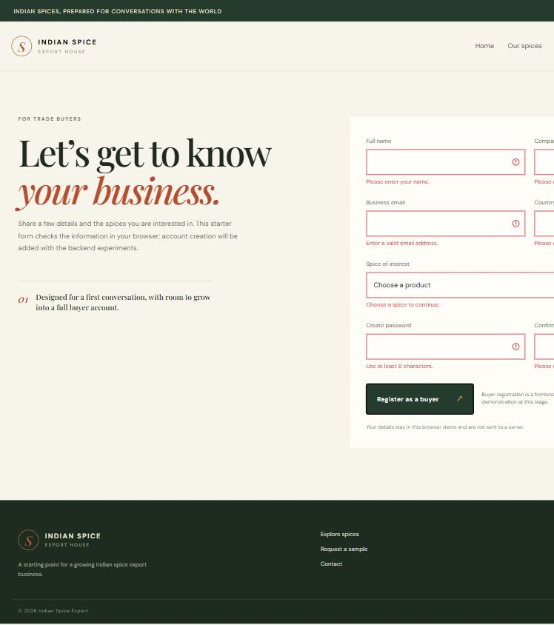
Figure 1.7: Responsive desktop registration layout.
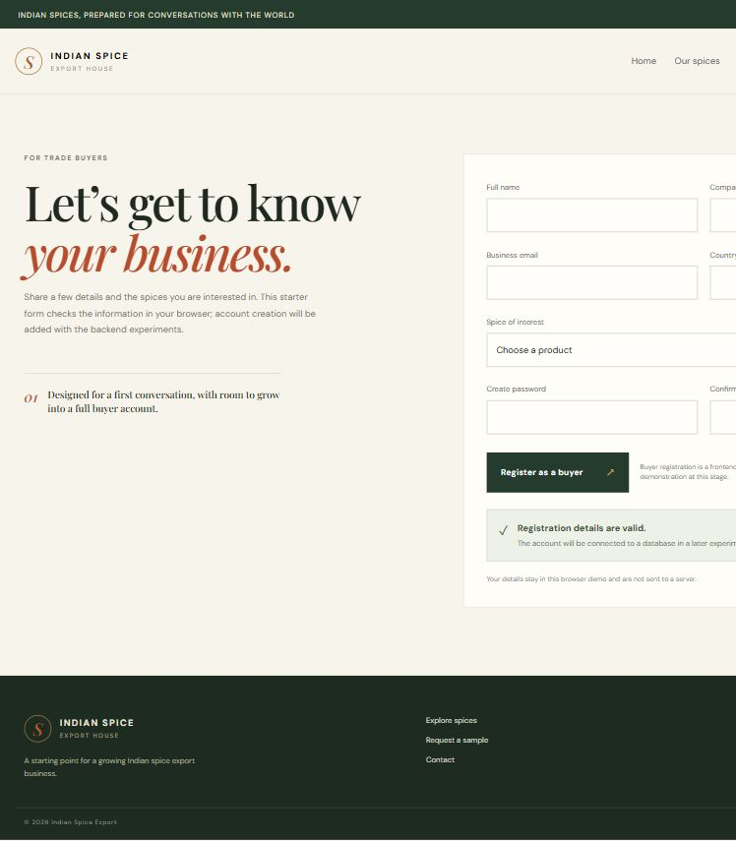
Figure 1.8: Final registration route in the local website.
Conclusion:
This experiment produced a responsive buyer-registration interface for the spice-export website and demonstrated how Bootstrap and JavaScript work together during form entry. Required fields and the browser email constraint prevent common input mistakes, while custom password matching demonstrates application-specific validation. The invalid and valid browser states give the buyer immediate feedback and keep the page from reloading during the demonstration. The layout was checked as a website screen at different widths. Because no persistence endpoint is connected in this experiment, the success message confirms only client-side validation; it does not create an account or send the buyer’s details to the client. A later backend step can add secure server validation and storage.
The registration form is intentionally designed as the entry point for the buyer journey: a trade buyer records a company and product interest before requesting export information. Before production use, the server must repeat all checks, protect credentials with secure password hashing, and save the buyer record only after successful validation. The current screenshots establish the interface and browser rules so later backend work can be compared against a clear baseline.

