SHUBHAM DHENGALE - 3574
Experiment No. 2
Title: Develop JavaScript Programs using ES6 Features (Arrow Functions, Anonymous Functions, Arrays, Events, and Popup Boxes)
Aim:
To demonstrate ES6 functions, arrays, array methods, event handling, and popup boxes using spice products and sample requests from the export website.
Tools Used:
JavaScript (ES6)
HTML5
Visual Studio Code
Google Chrome Developer Console
Methodology:
The spice website catalogue provides realistic data for practicing modern JavaScript. Product records are stored as an array of objects, then processed with arrow functions and array callbacks. A search input and category buttons raise DOM events; filter() selects matching products, map() formats the visible cards, and reduce() can summarize catalogue information such as available sample counts. Anonymous functions are used as event callbacks where an inline action is useful. Browser alert, confirm and prompt examples are attached to clear sample-request interactions. Each operation is checked in the rendered website so the data operation and its visible result can be related.
Theory:
Arrow functions provide concise function syntax and are commonly used as callbacks. Anonymous functions have no declared name and can be passed directly to methods such as forEach() or addEventListener().
Arrays store ordered collections. map() creates a transformed array, filter() selects elements that match a condition, and reduce() combines array values into one result. These methods are useful for creating catalogue views and calculating simple summaries.
Events let a page respond to actions such as clicking a button or submitting a form. The browser's alert() and confirm() functions display simple popup dialogs. Popup functions are suitable for demonstrations; a finished website can replace them with accessible in-page messages.
Procedure:
1. Open the products route and inspect the local spice array, including names, categories, origins and sample availability.
2. Create small arrow functions for formatting product names or availability labels.
3. Use map() to transform each matching product into a catalogue card.
4. Use filter() to match a search phrase and the selected category.
5. Use reduce() to calculate a simple total, such as the number of products with samples available.
6. Attach input and click listeners to the search field, category chips and sample buttons.
7. Use anonymous callbacks for concise event actions and keep the selected product in the message.
8. Demonstrate alert(), confirm() and prompt() with a non-destructive sample enquiry flow.
9. Test a matching search, a no-match search, each category and the reset-to-All action; capture the output states.
10. Combine a text search with a category filter and check that the catalogue remains understandable.
11. Follow a product sample link and verify that it opens the sample-request route with the selected item.
Code:
// Add these controls to the product page:
// <input id="search" placeholder="Search spices">
// <ul id="spiceList"></ul>
// <button id="sampleBtn">Request a sample</button>
const spices = [
{ name: "Turmeric", origin: "India", sampleAvailable: true },
{ name: "Black pepper", origin: "India", sampleAvailable: true },
{ name: "Cardamom", origin: "India", sampleAvailable: false },
{ name: "Red chilli", origin: "India", sampleAvailable: true }
];

const list = document.getElementById("spiceList");
const search = document.getElementById("search");
const renderSpices = (items) => {
list.innerHTML = items.map((spice) =>
`<li>${spice.name} — ${spice.origin}</li>`
).join("");
};

// Anonymous function callback for each catalogue entry.
spices.forEach(function (spice) {
console.log(`${spice.name}: sample available = ${spice.sampleAvailable}`);
});

const availableCount = spices.reduce(
(count, spice) => count + Number(spice.sampleAvailable), 0
);
console.log("Samples available:", availableCount);

search.addEventListener("input", (event) => {
const query = event.target.value.toLowerCase();
const matches = spices.filter((spice) =>
spice.name.toLowerCase().includes(query)
);
renderSpices(matches);
});

document.getElementById("sampleBtn").addEventListener("click", () => {
const selected = spices.find((spice) => spice.sampleAvailable);
if (selected && confirm(`Request a ${selected.name} sample?`)) {
alert(`Your ${selected.name} sample request is ready to submit.`);
}
});

renderSpices(spices);
Output:
The products view displays spice cards from the local catalogue. Typing in search filters the visible items; clearing the query restores the catalogue.
Request Sample opens the confirmation interaction for the selected spice. The data and action are local to the frontend.
Figure 2.1: Full product catalogue route.
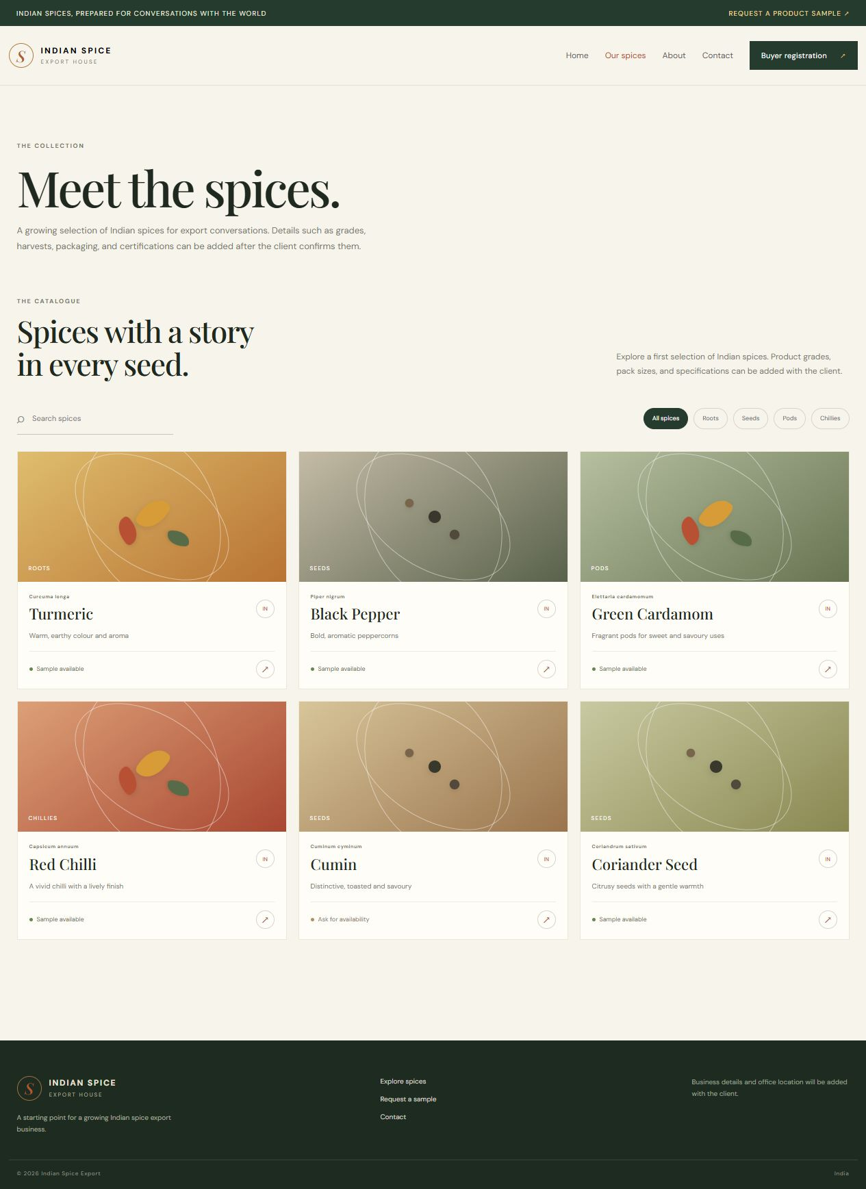
Figure 2.2: Catalogue with spice product cards.
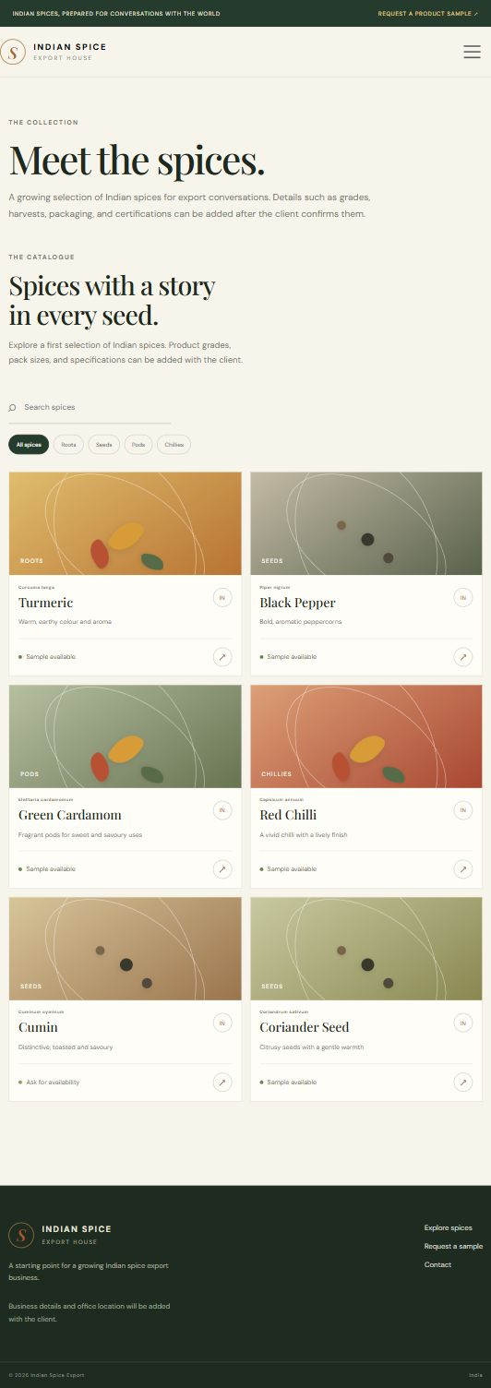
Figure 2.3: Desktop catalogue layout.
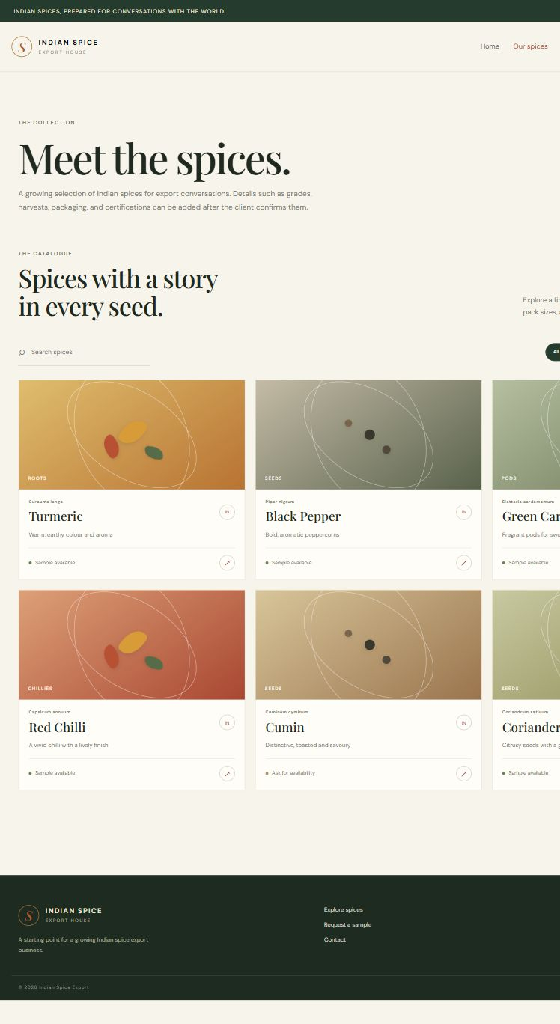
Figure 2.4: Catalogue filtered to the Roots category.
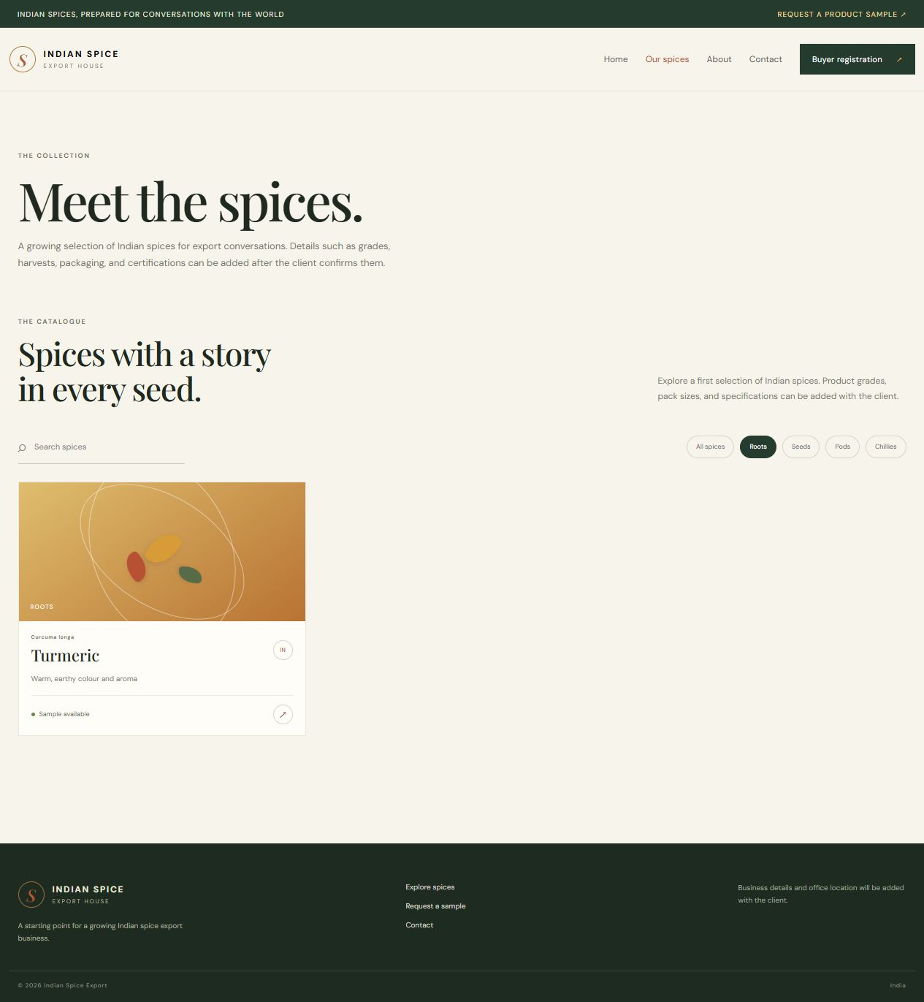
Figure 2.5: Catalogue search narrowed to Cumin.
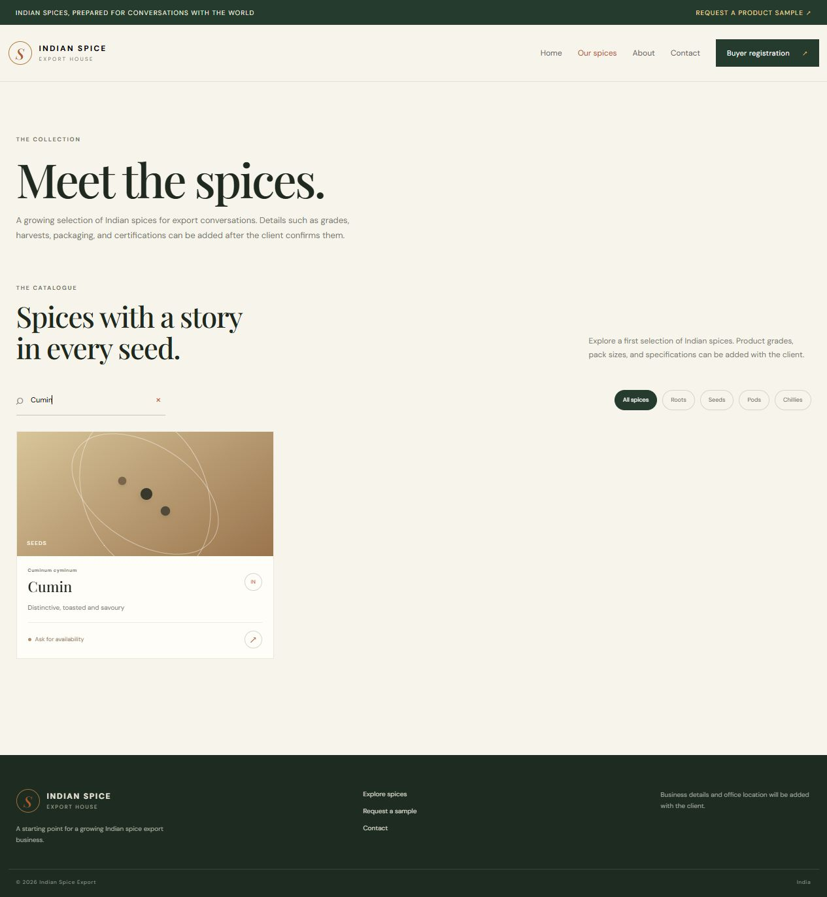
Figure 2.6: Website home page linked to the catalogue.
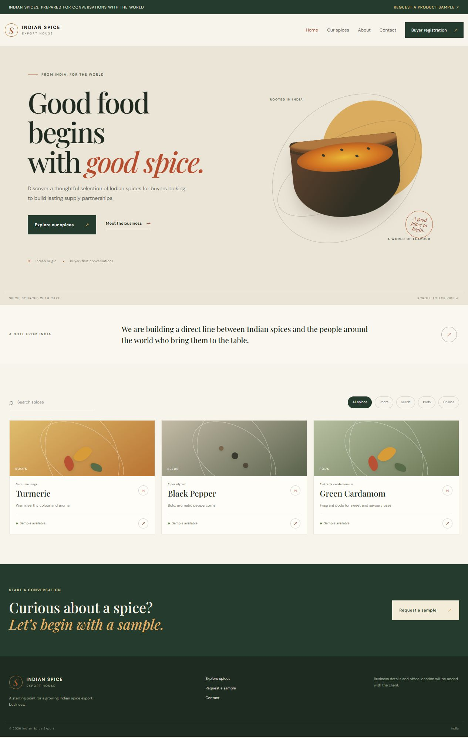
Figure 2.7: About route in the local website.

Figure 2.8: Contact route in the local website.
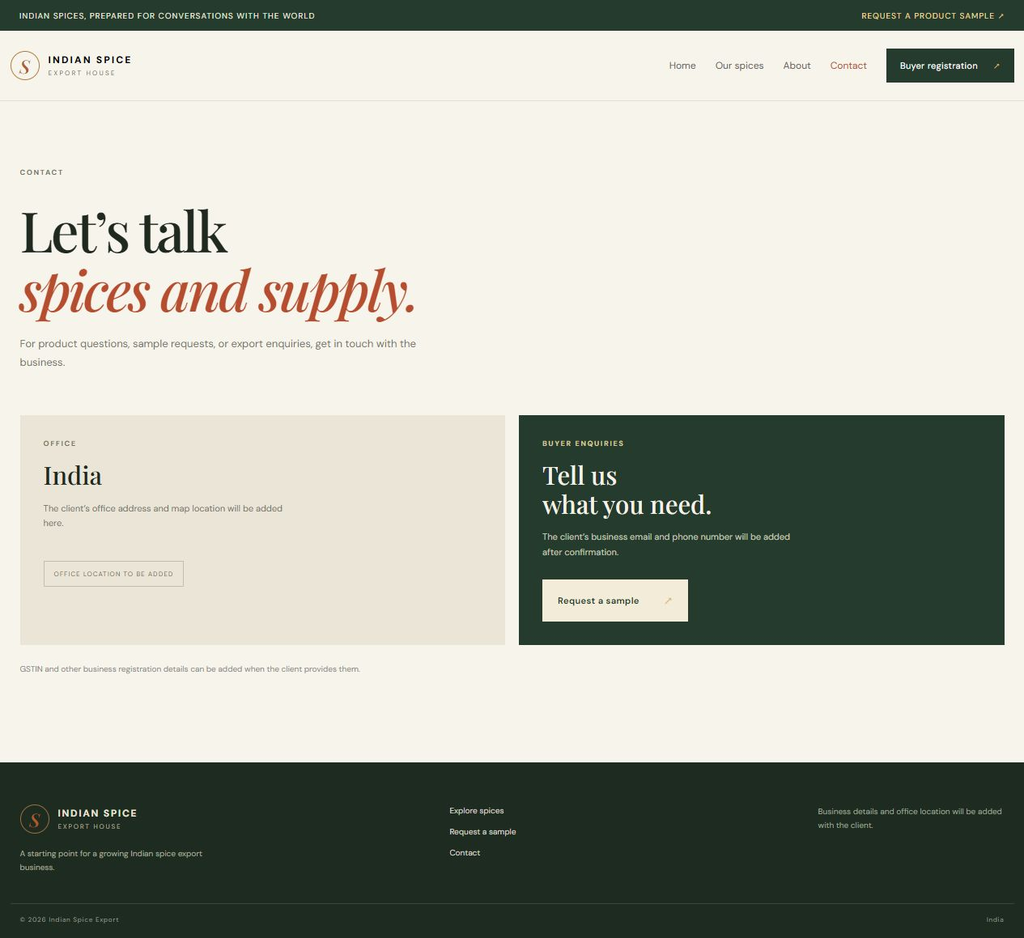
Conclusion:
The catalogue exercise applied ES6 arrow functions, callback functions, arrays and browser events to real spice-export data. Array methods separated data selection from card rendering: filter() narrowed the catalogue, map() produced the visible product entries, and reduce() supported a simple summary. Input and button events connected those transformations to the buyer’s actions, while popup examples demonstrated ways to request confirmation or a short value. The visible catalogue and filtered state provide practical output for the report. Product data still comes from a local array, so the interactions do not depend on a backend or save an enquiry. This experiment prepared the data-rendering and event-handling ideas used by later React components.
The examples keep calculations close to their purpose and use clear event handlers so the catalogue can be extended without mixing every action into one callback. Search terms should be normalized before comparison, category filters should combine with rather than overwrite search, and the empty state should explain how to broaden the query. These decisions make the JavaScript demonstrations relevant to an actual buyer-facing product list.

