SHUBHAM DHENGALE - 3574
Experiment No. 3
Title: Create a React Application using Functional Components, JSX, Props, and State
Aim:
To create a React spice catalogue using functional components, JSX, props, and state, with an interactive product search and sample-request action.
Tools Used:
React
JavaScript (ES6)
JSX
Vite
Visual Studio Code
Google Chrome
Methodology:
This experiment converts the catalogue into a React application using functional components and JSX. A shared site layout holds navigation and page structure, while product cards are rendered from local spice data. Props pass each product’s name, botanical label, origin, description and sample availability to a reusable card. State stores the search term and selected category; event handlers update those values and React re-renders the matching result without manually editing the DOM. The website was started in a browser and checked by viewing the catalogue, changing its controls and observing the resulting cards. This establishes the component and state foundation before adding multiple routed views.
Theory:
A functional component is a JavaScript function that returns React elements. Components divide an interface into smaller parts that can be reused and maintained separately.
JSX is a syntax extension that lets developers write HTML-like element descriptions in JavaScript. A build tool such as Vite transforms JSX into code React can render.
Props are read-only values passed from a parent component to a child component. They let a reusable component display different data or call a parent-provided function.
State stores values that can change while a component is in use. The useState Hook provides the current value and an update function; updating state causes React to render the affected interface again.
Procedure:
1. Create or inspect the Vite React entry point and mount the root App component.
2. Build the shared site layout as a functional component and return page structure with JSX.
3. Keep spice catalogue records in a data module as an array of objects.
4. Create a reusable SpiceCard component that receives the product record and action callback through props.
5. Render the card collection with map() and a stable key for each product.
6. Add useState for the search text and selected product category.
7. Connect the search field and category buttons to state-setting event handlers.
8. Derive the visible list from state and display an empty message when no product matches.
9. Run the website and verify the card props, filtered output and responsive layout in the browser.
10. Change component state through the search box and category controls, then observe the rendered cards.
11. Check the no-results state and confirm that the original product list returns when the filters are cleared.
Code:
import { useState } from 'react';

const products = [
{ id: 1, name: "Turmeric", origin: "India", sample: true },
{ id: 2, name: "Black Pepper", origin: "India", sample: true },
{ id: 3, name: "Cardamom", origin: "India", sample: false }
];

function SpiceCard({ product, onRequestSample }) {
return (
<article className="spice-card">
<h2>{product.name}</h2>
<p>Origin: {product.origin}</p>
<p>{product.sample ? "Sample available" : "Ask for availability"}</p>
<button onClick={() => onRequestSample(product.name)}>
Request sample
</button>
</article>
);
}

function ProductGrid({ items, onRequestSample }) {
return (
<div className="product-grid">
{items.map((product) => (
<SpiceCard key={product.id} product={product}
onRequestSample={onRequestSample} />
))}
</div>
);
}

export default function App() {
const [query, setQuery] = useState("");
const visibleProducts = products.filter((product) =>
product.name.toLowerCase().includes(query.toLowerCase())
);
const requestSample = (name) => {
alert(`Sample request selected: ${name}`);
};
return (
<main>
<h1>Indian Spices for Export</h1>
<label htmlFor="productSearch">Search products</label>
<input id="productSearch" value={query}
onChange={(event) => setQuery(event.target.value)} />
<ProductGrid items={visibleProducts}
onRequestSample={requestSample} />
</main>
);
}
Output:
React renders reusable spice cards with product name, origin and availability. Updating the search state filters the cards without a full-page reload.
A card button calls its callback prop and reports the selected spice. The catalogue is read from local project data.
Figure 3.1: React spice catalogue rendered.
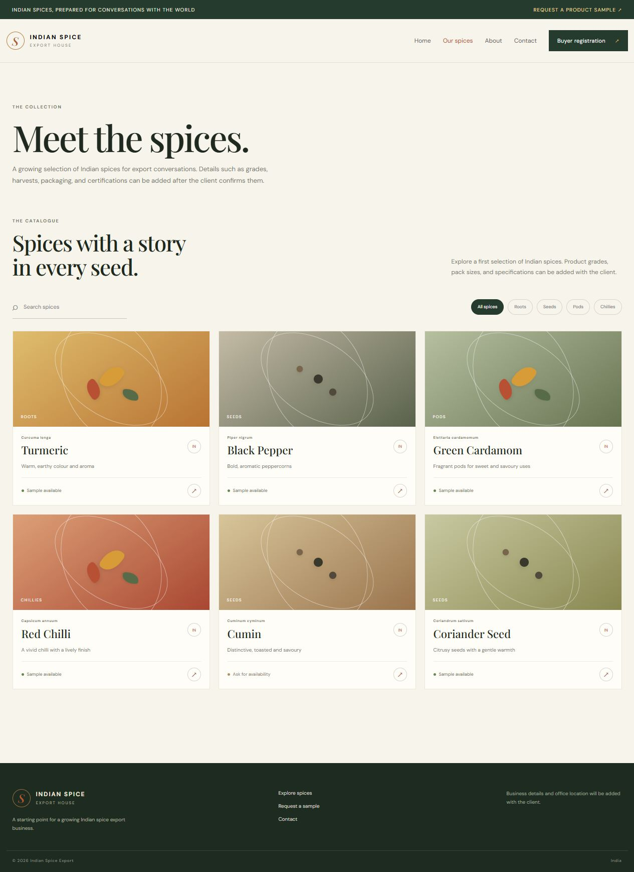
Figure 3.2: React catalogue card output.
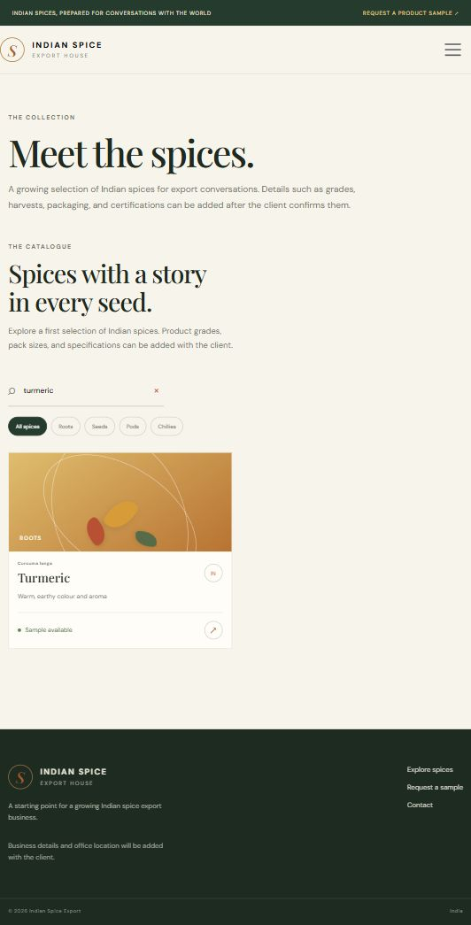
Figure 3.3: Category-filtered Roots output.
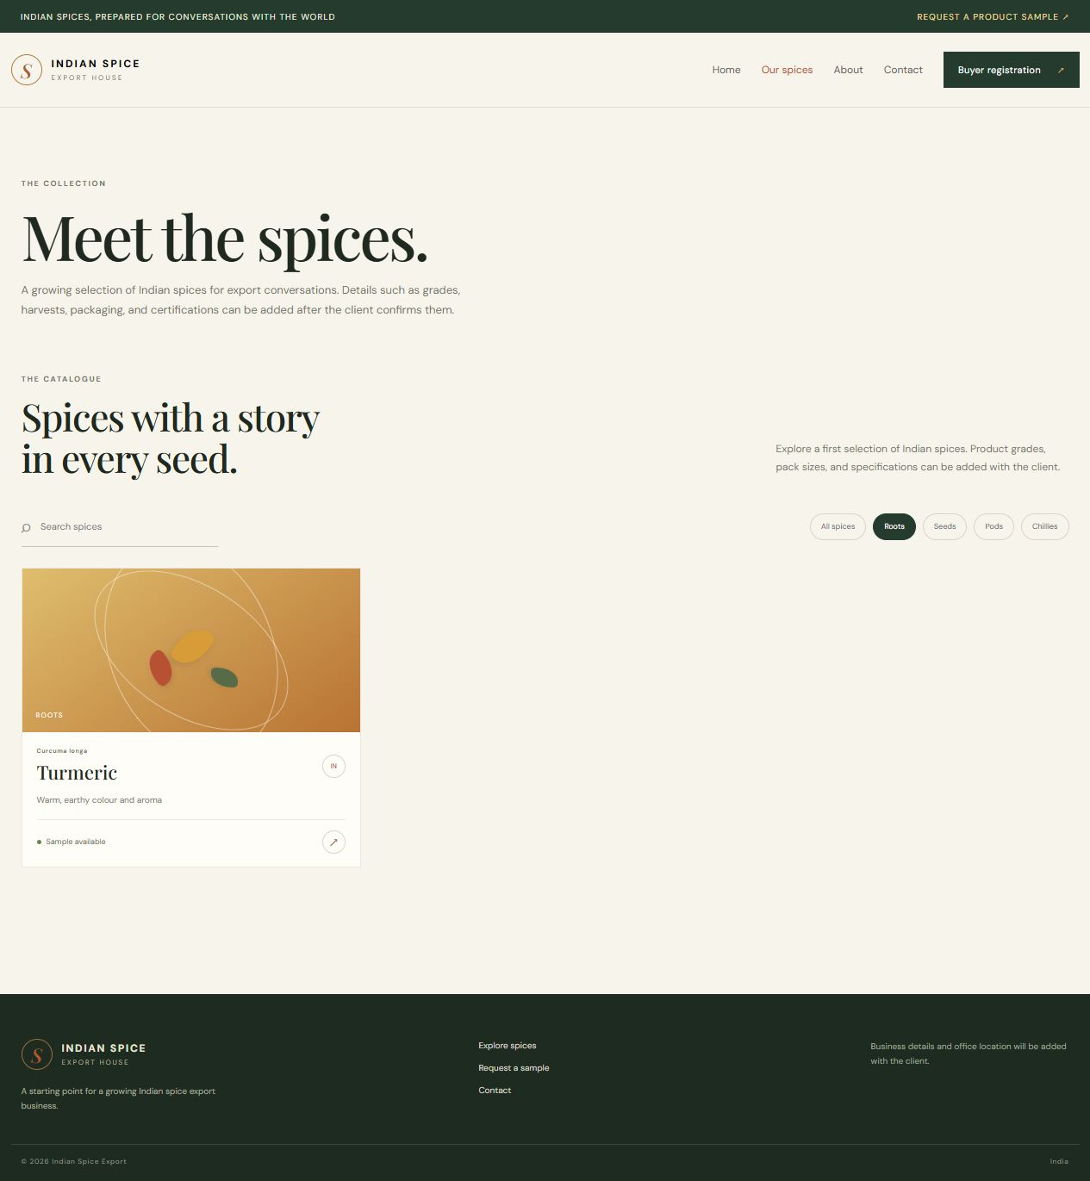
Figure 3.4: Search-filtered Cumin output.
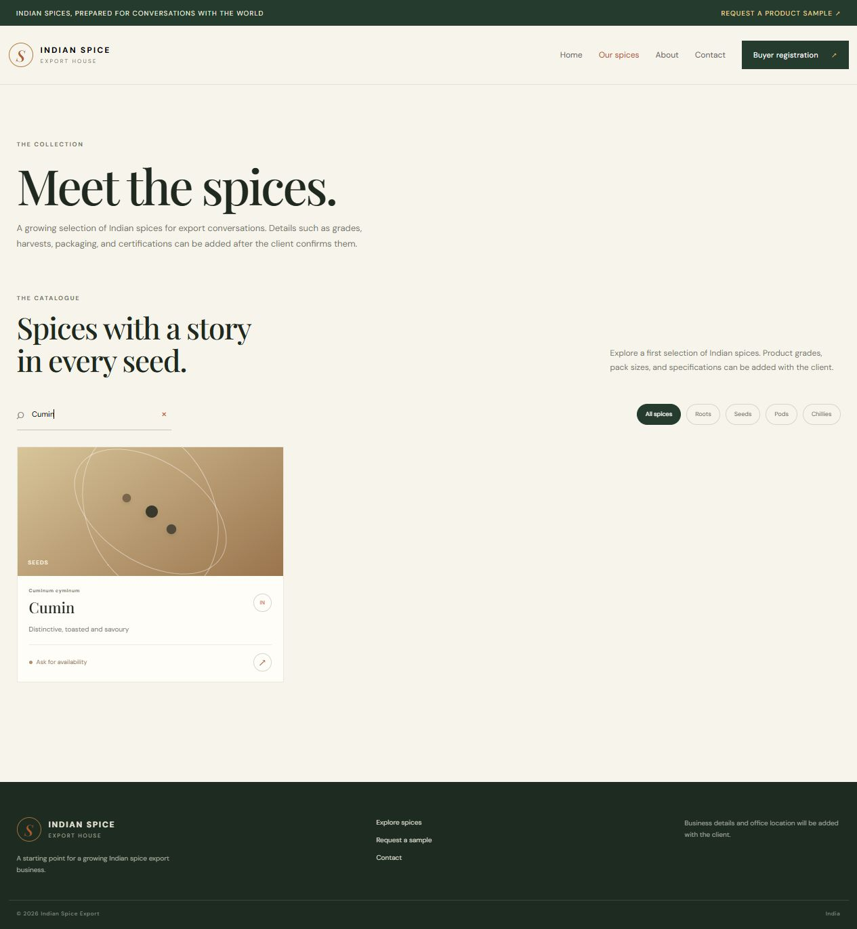
Figure 3.5: Product cards and origin details.
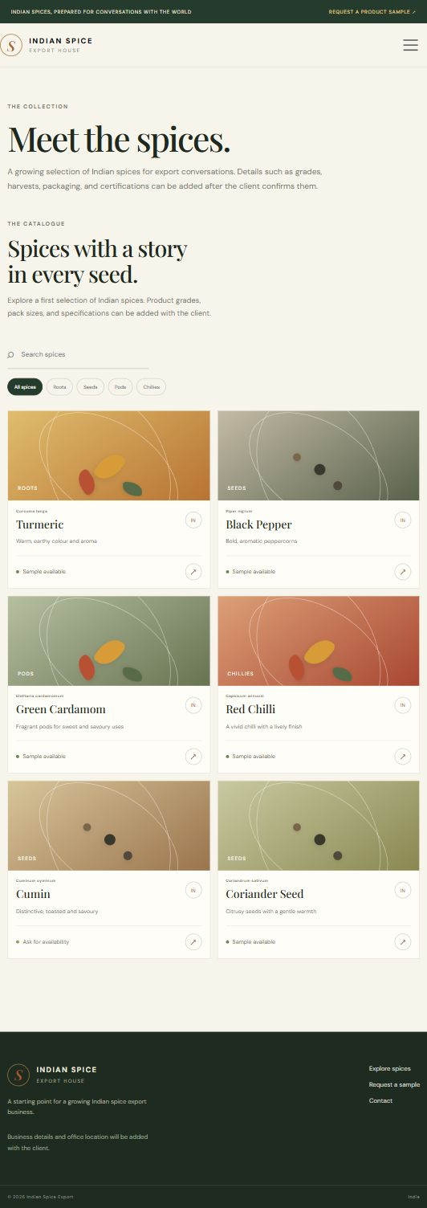
Figure 3.6: Desktop product grid.
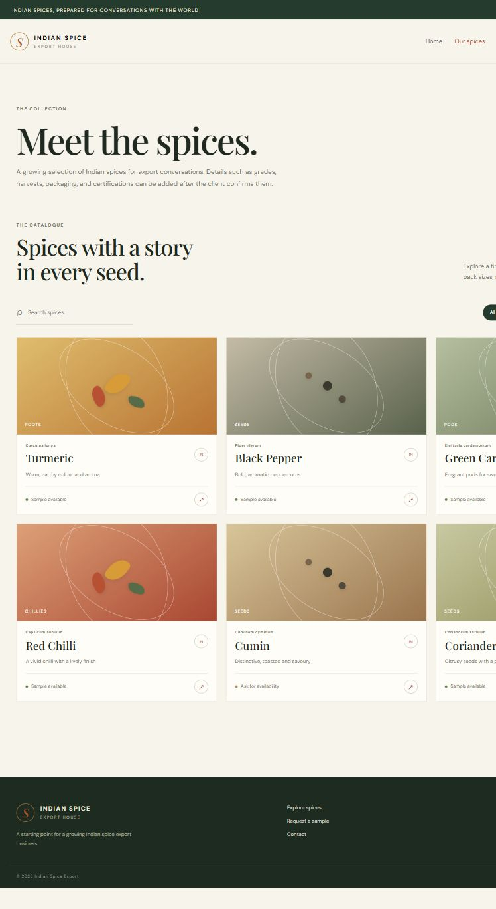
Figure 3.7: Sample route connected from a product.
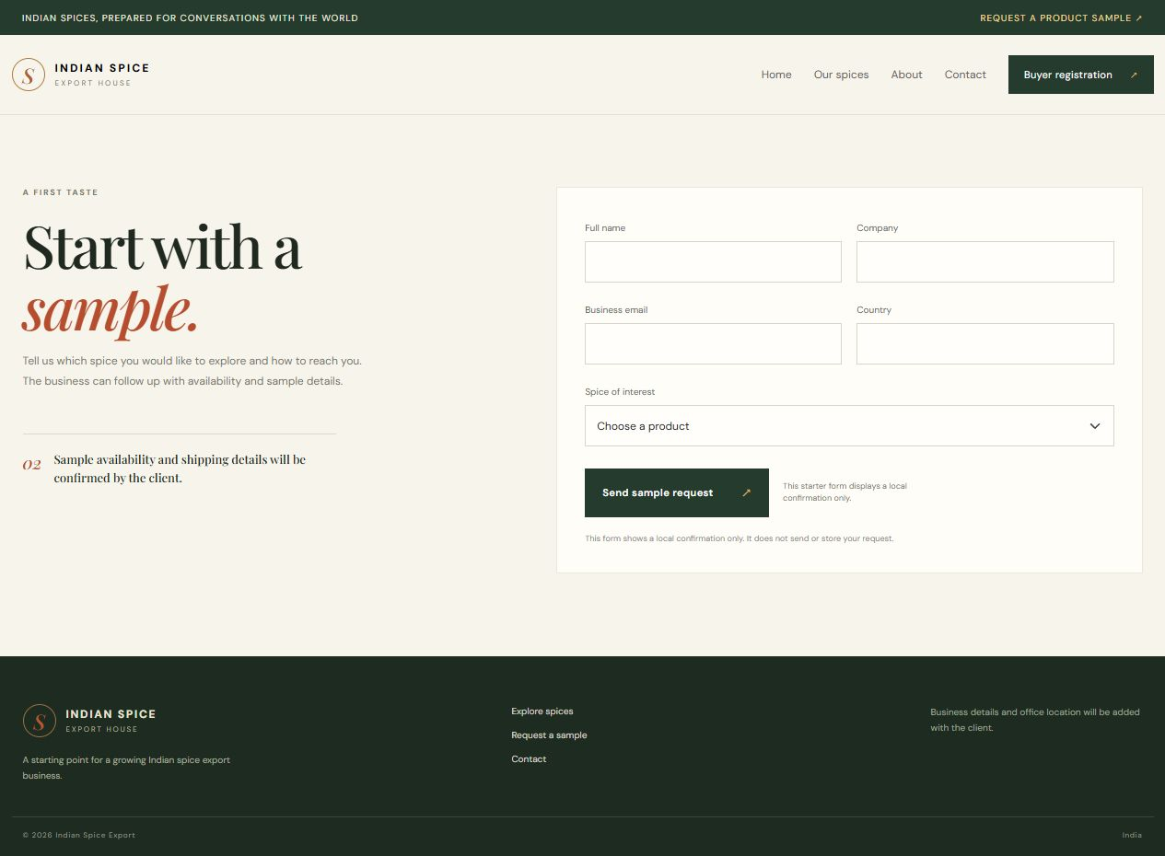
Figure 3.8: Registration route available from navigation.
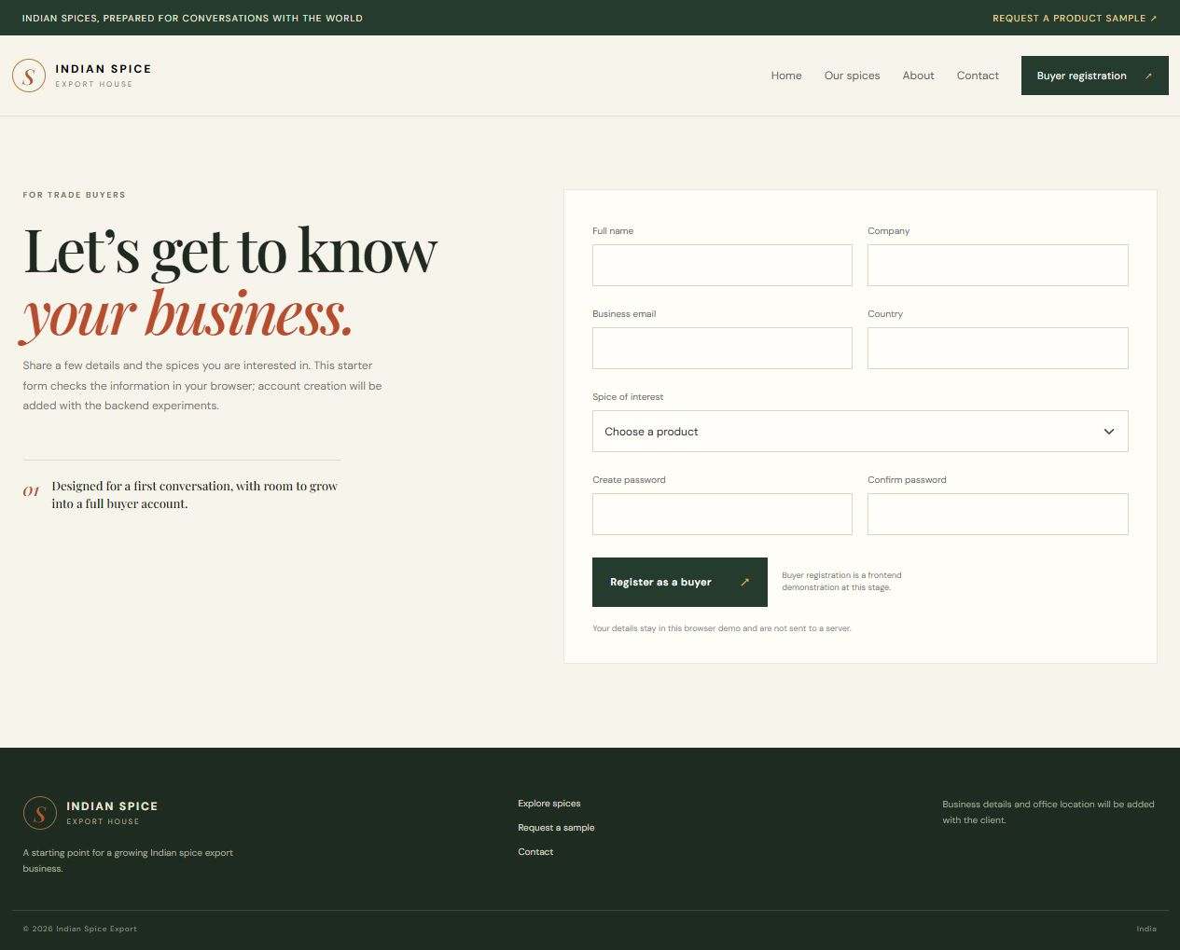
Conclusion:
The React catalogue demonstrates the main ideas of functional components, JSX, props and state in a spice-export context. JSX defines the card and page markup, while the reusable card receives product details and a callback from its parent. The parent component owns search and category state, which makes the visible catalogue respond to user input without a full-page reload. Browser inspection of the cards and filtered state confirms that data flows from the local array through component props into the interface. The data source is still local, so this result is not evidence of database retrieval. The component design is ready to be reused across the routed website and later connected to API responses.
The component boundary makes future updates easier: a change to one spice card need not require rewriting the page, and the same card can be reused wherever product data appears. State belongs to the component that coordinates the search and category controls, while the card receives display data through props. This arrangement also gives the API integration in Experiment 9 a predictable place to replace the local data source.

