SHUBHAM DHENGALE - 3574
Experiment No. 4
Title: Develop a Single Page Application (SPA) using React Router, Hooks, and Component Lifecycle Methods
Aim:
To develop a spice-export Single Page Application with React Router routes and React Hooks for navigation, page state, and lifecycle-equivalent side effects.
Tools Used:
React
React Router
JavaScript (ES6)
Vite
React Hooks (useState and useEffect)
Google Chrome
Methodology:
The website is organized as a single-page application so Home, Products, About, Buyer Registration, Sample Request and Contact can share one React runtime. React Router maps each URL path to a page component and keeps the shared navigation and footer in a layout. Route changes are checked in the browser, including direct entry to a page URL. React hooks manage local form state and side effects such as the document title; cleanup is included for any registered event listener. The sample route demonstrates a local confirmation state. These checks verify navigation and component behavior without claiming that form submissions or buyer accounts are persisted.
Theory:
A Single Page Application loads its main application shell once and updates the displayed view as the user navigates. Client-side navigation can avoid requesting a complete new page for each route.
React Router maps paths to components. BrowserRouter enables URL-based navigation, Link creates client-side navigation links, and Routes and Route select the component matching the current path.
React Hooks let functional components use state and side effects. useState() stores changing values, while useEffect() runs side-effect code after rendering. Its optional cleanup function runs before the effect is repeated and when its component is removed.
Class components used lifecycle methods such as componentDidMount and componentWillUnmount. In function components, useEffect() and its cleanup function provide the corresponding setup and cleanup pattern.
Procedure:
1. Wrap the shared website layout in BrowserRouter at the application root.
2. Declare route paths for Home, Products, About, Register, Samples and Contact.
3. Render each page as a separate functional component within the shared layout.
4. Add navigation links that point to the route paths and retain the shared site header and footer.
5. Use useState for sample-form values and the local submitted/confirmation state.
6. Use useEffect only for route-related side effects such as the document title, and return cleanup for listeners.
7. Navigate among routes using the visible links and confirm the URL and page content update without a full reload.
8. Paste a route URL directly into the browser to check that the page renders on direct entry.
9. Capture the About and Contact routes and note the client details still awaiting confirmation.
10. Navigate between each route from the shared navigation and check that the SPA remains responsive.
11. Open a nested route directly and refresh it to check the configured route fallback.
Code:
import { useEffect, useState } from 'react';
import { BrowserRouter, Link, Route, Routes, useLocation }
from 'react-router-dom';

function Home() { return <h1>Indian Spices for Export</h1>; }
function About() { return <h1>About Us</h1>; }
function Products() { return <h1>Our Spices</h1>; }
function Contact() { return <h1>Contact and Office Location</h1>; }

function RequestSample() {
const [email, setEmail] = useState("");
const [message, setMessage] = useState("");
function handleSubmit(event) {
event.preventDefault();
setMessage(`Sample request prepared for ${email}.`);
}
return (
<section>
<h1>Request a Sample</h1>
<form onSubmit={handleSubmit}>
<label htmlFor="buyerEmail">Business email</label>
<input id="buyerEmail" type="email" required value={email}
onChange={(event) => setEmail(event.target.value)} />
<button type="submit">Prepare request</button>
</form>
<p role="status">{message}</p>
</section>
);
}

function SiteLayout() {
const location = useLocation();
const [width, setWidth] = useState(window.innerWidth);
useEffect(() => {
document.title = `Spice Export | ${location.pathname}`;
const updateWidth = () => setWidth(window.innerWidth);
window.addEventListener("resize", updateWidth);
return () => window.removeEventListener("resize", updateWidth);
}, [location.pathname]);
return (
<>
<nav aria-label="Main navigation">
<Link to="/">Home</Link> | <Link to="/about">About Us</Link> |
<Link to="/products">Products</Link> |
<Link to="/sample">Request a Sample</Link> |
<Link to="/contact">Contact</Link>
</nav>
<small>Viewport width: {width}px</small>
<Routes>
<Route path="/" element={<Home />} />
<Route path="/about" element={<About />} />
<Route path="/products" element={<Products />} />
<Route path="/sample" element={<RequestSample />} />
<Route path="/contact" element={<Contact />} />
</Routes>
</>
);
}

export default function App() {
return <BrowserRouter><SiteLayout /></BrowserRouter>;
}
Output:
React Router navigates among Home, About, Products, Request a Sample and Contact routes while keeping the application loaded.
The sample form shows a state-based confirmation. useEffect handles route-related title and resize-listener setup and cleanup.
Figure 4.1: SPA home route.
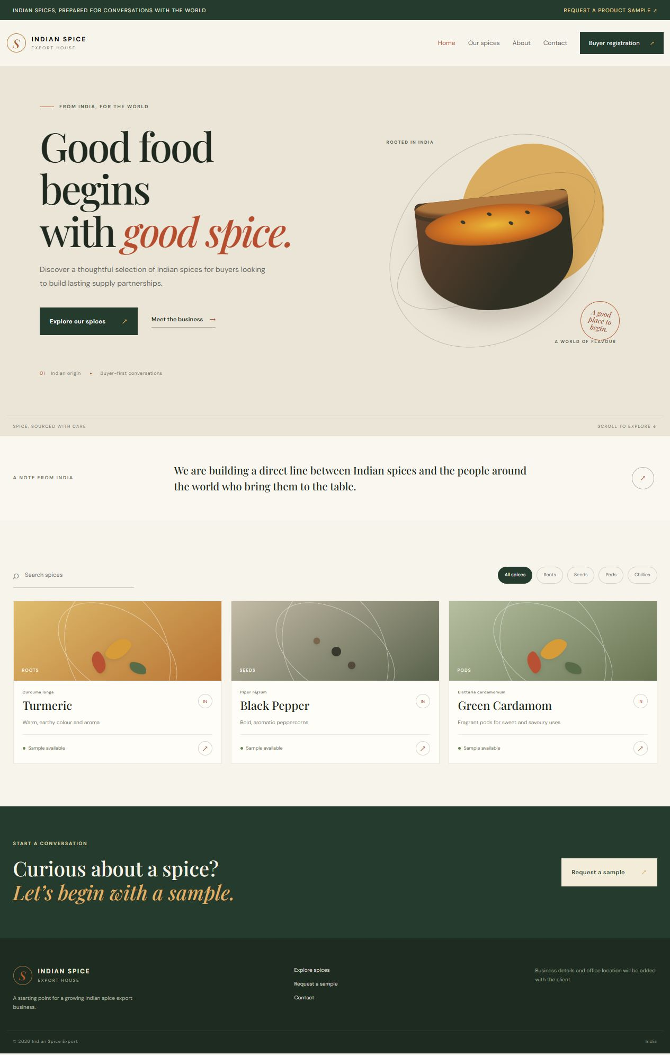
Figure 4.2: SPA products route.
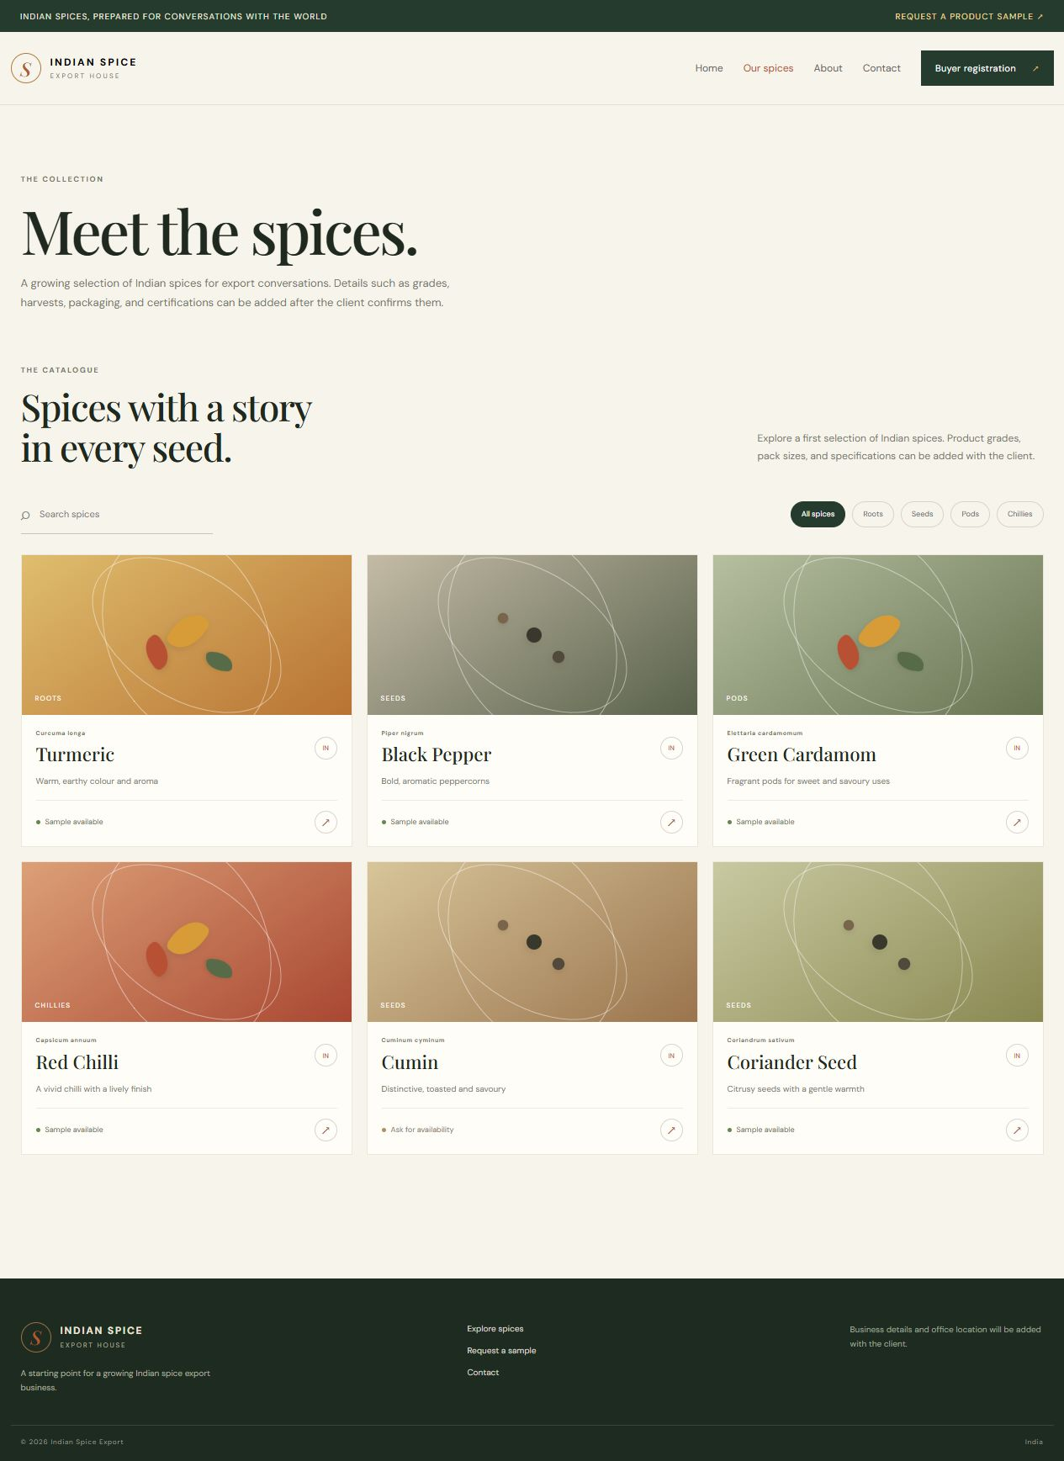
Figure 4.3: SPA about route.
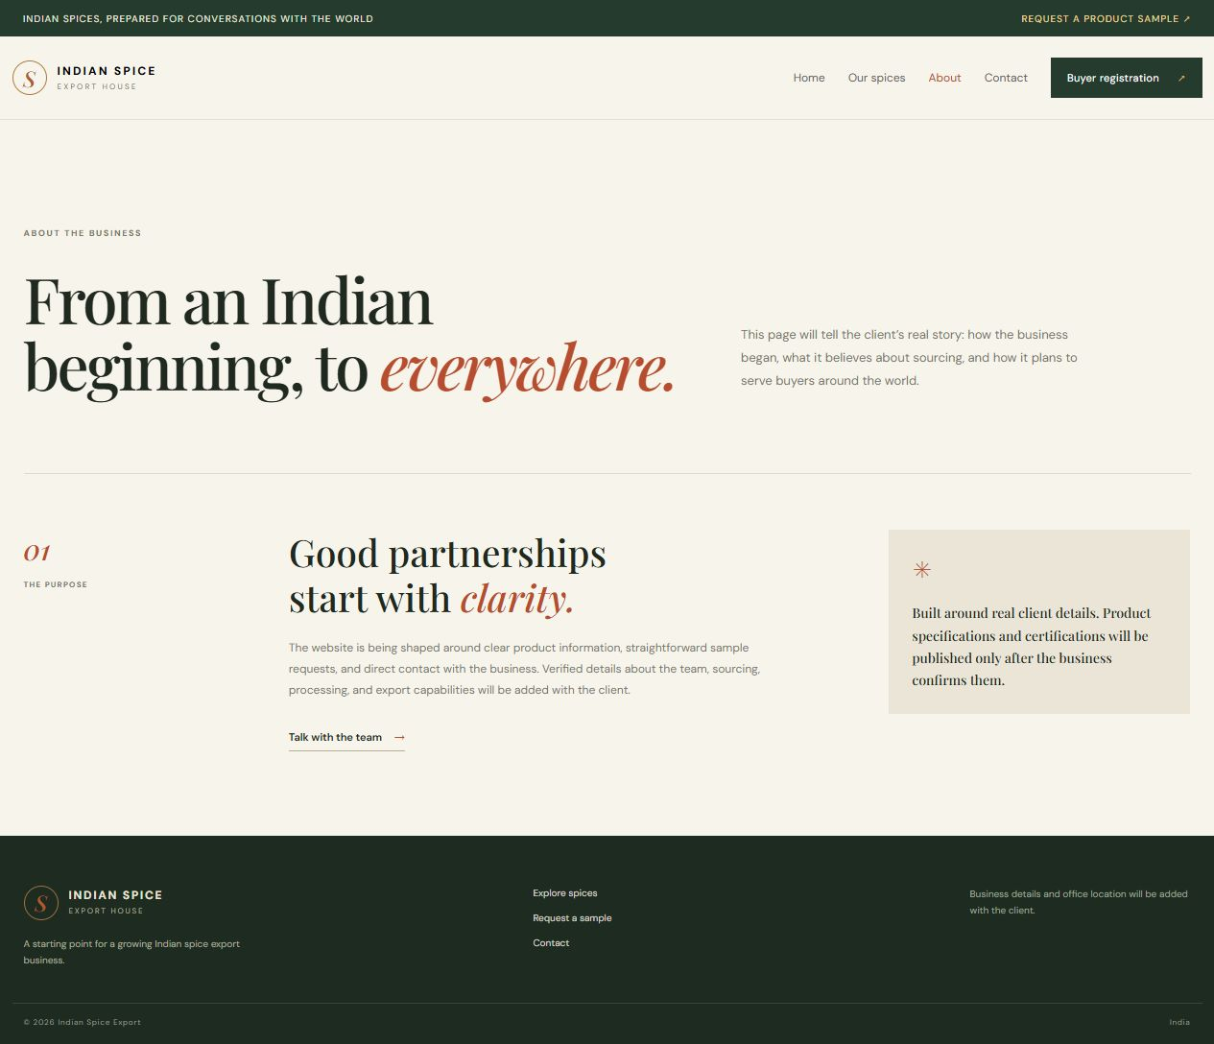
Figure 4.4: SPA contact route.
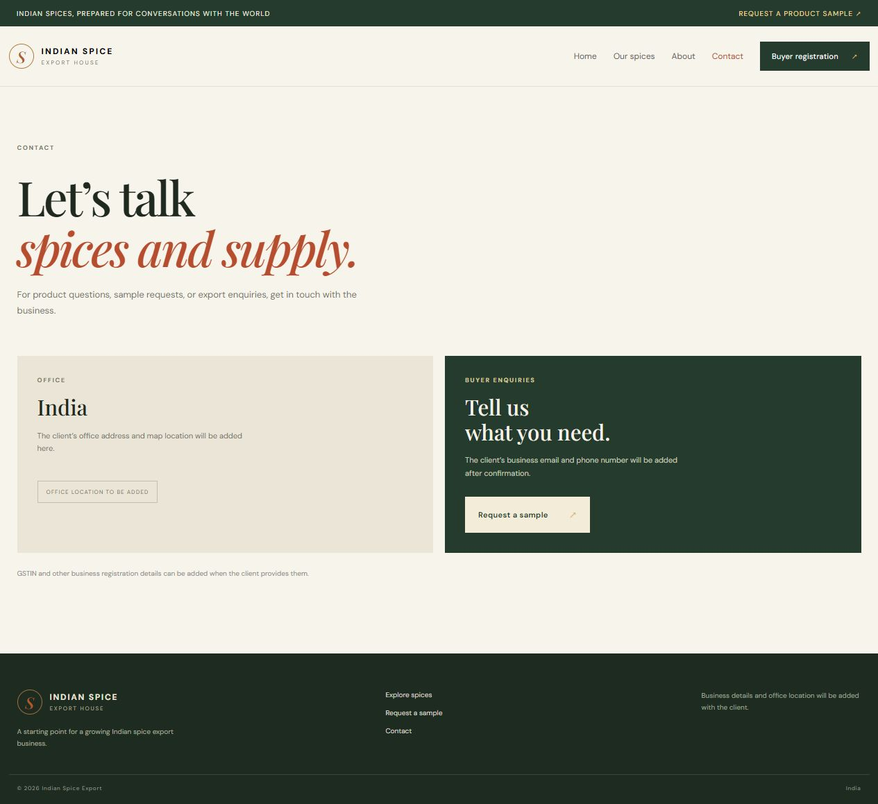
Figure 4.5: SPA sample-request route.
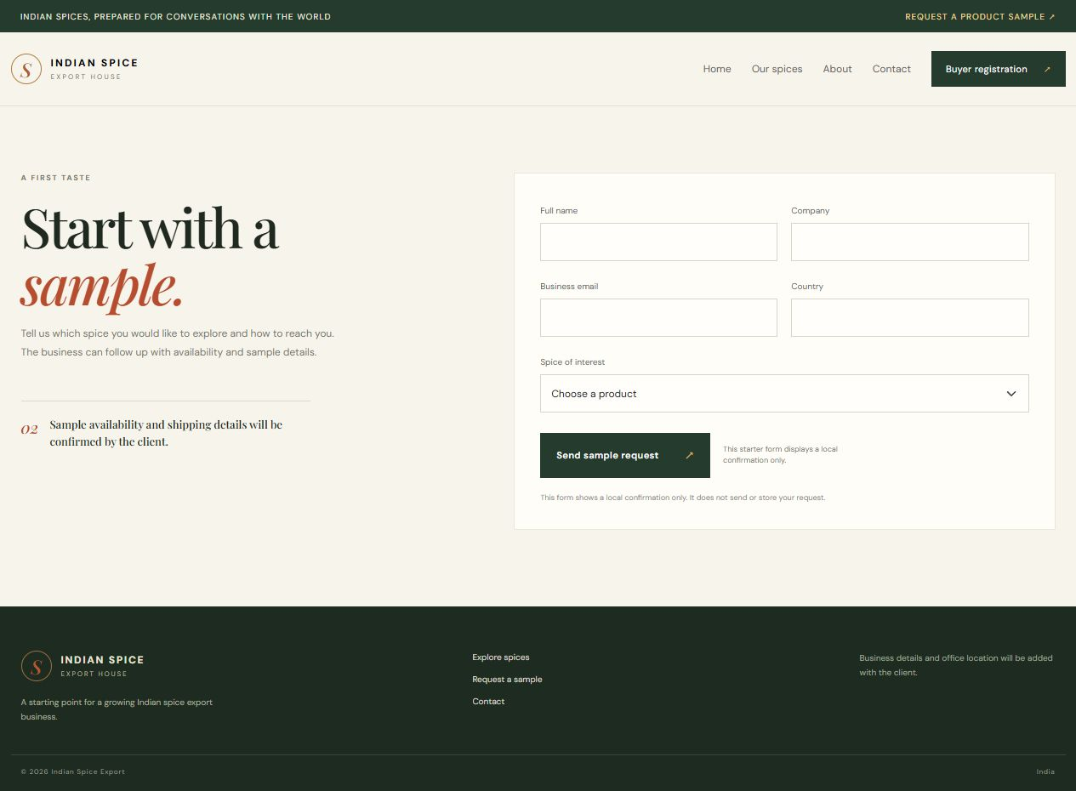
Figure 4.6: SPA buyer-registration route.
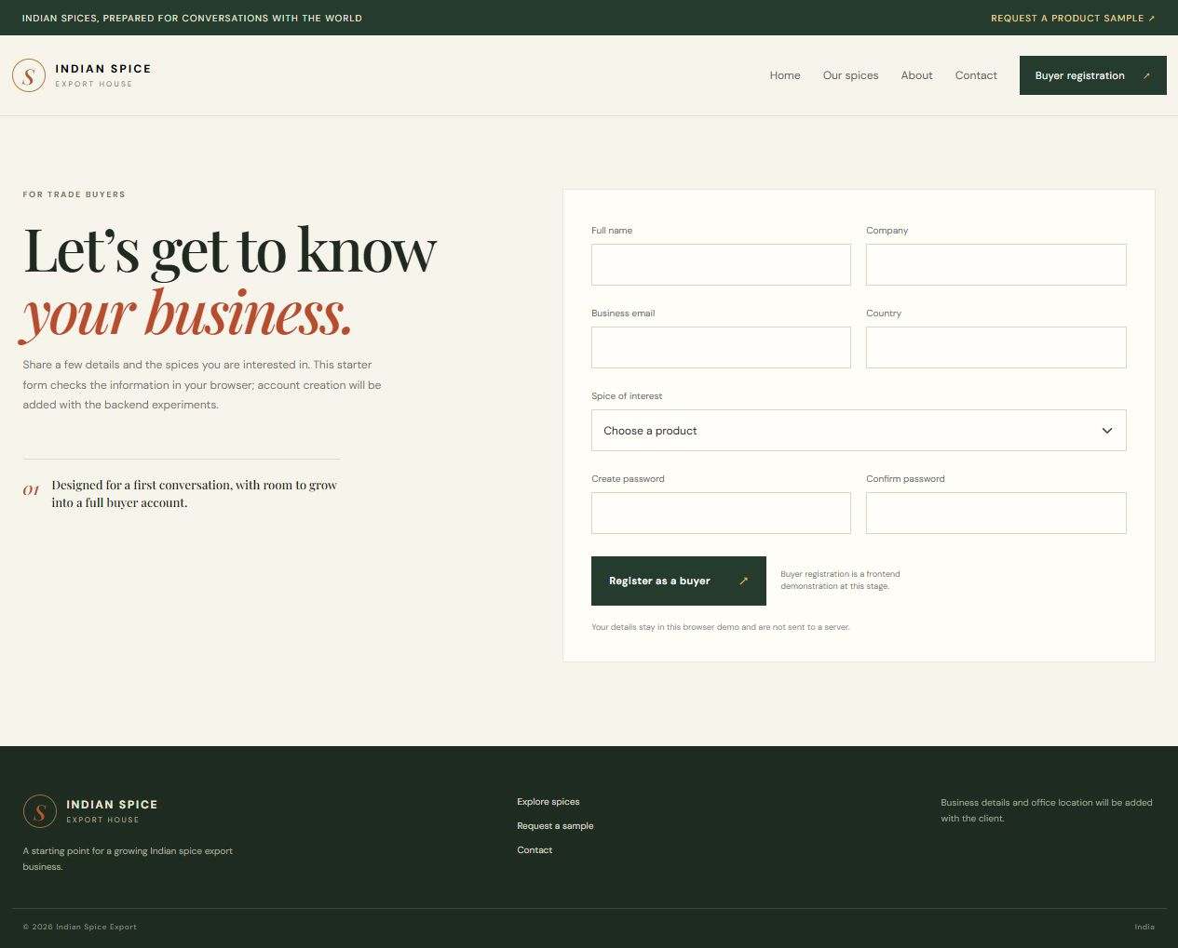
Figure 4.7: Category-filtered client-side catalogue.
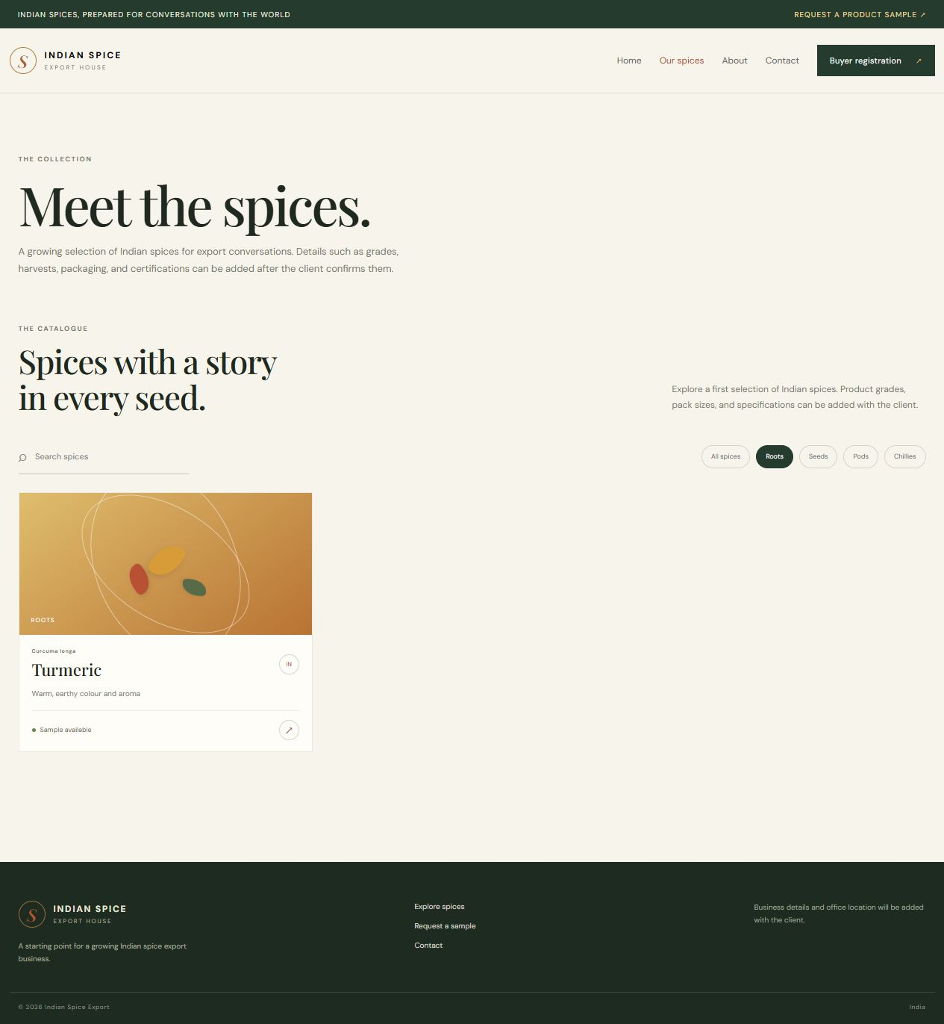
Figure 4.8: Search-filtered catalogue state.
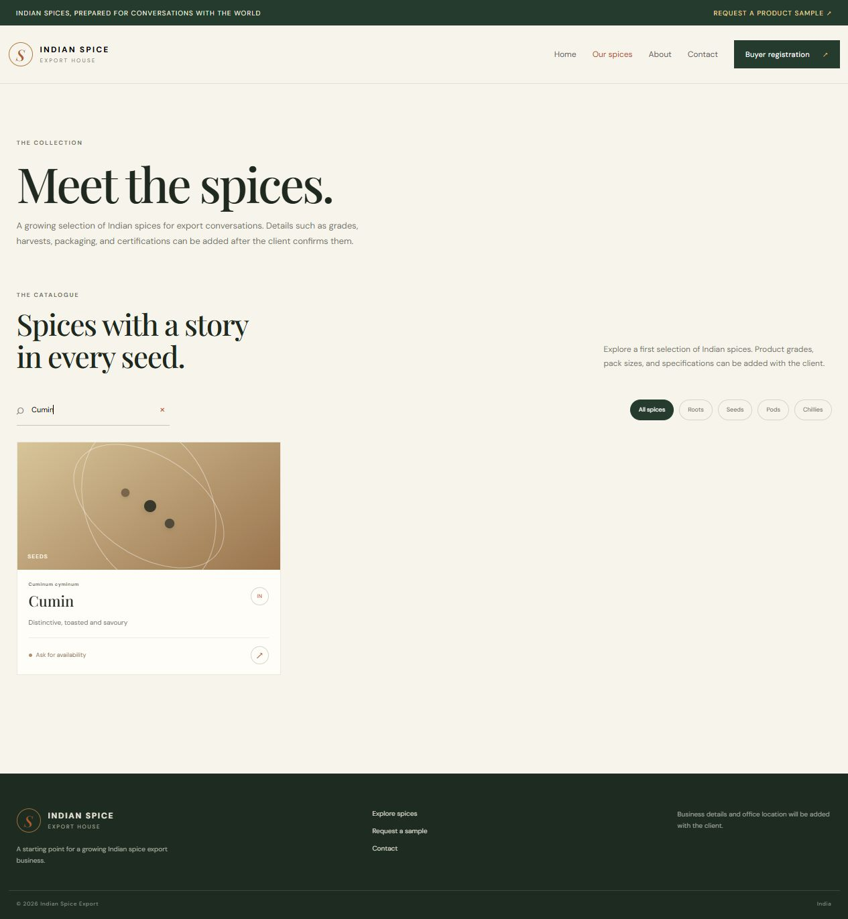
Conclusion:
This experiment assembled the spice-export pages into a React single-page application using React Router and hooks. Route components separate the Home, catalogue, About, registration, sample and contact content, while the shared layout keeps navigation and page identity consistent. The browser checks showed that the route content changes as the URL changes and that pages can be opened directly. React state supports the sample form’s local confirmation, and useEffect demonstrates how a component can set up and clean up side effects. These results establish website navigation and client-side interaction. Persistent registrations, sample requests, verified office details and production routing require later backend configuration and client-approved business information.
Direct route loading is an important SPA check because buyers may save or share a product or contact URL. A production host must also be configured to return the SPA entry document for known application routes. The local route checks establish the client-side behavior; deployment rewrite rules, persistent submissions, confirmed address details and the client’s official business identity remain later release tasks.

