SHUBHAM DHENGALE - 3574
Experiment No. 5
Title: Install and Configure MongoDB. Create Database, Collections, Documents, and Perform CRUD Operations
Aim:
To organize spice-export product and sample-request data in MongoDB and demonstrate Create, Read, Update and Delete (CRUD) using mongosh and Mongoose.
Tools Used:
MongoDB Community Server or Atlas, mongosh, MongoDB Compass, Node.js, Mongoose, Visual Studio Code.
Methodology:
The data model was designed from the website’s two main resources: export products and buyer sample requests. The Product schema defines required identifiers and descriptive fields, while SampleRequest stores buyer contact details, selected spice, message and request status. Mongoose validation was executed locally against a valid product and a product missing required fields; this test does not need a database connection. The report also describes the corresponding MongoDB database, collections and CRUD commands so they can be run when a local MongoDB instance or Atlas URI is available. CRUD persistence is kept distinct from schema validation in the recorded evidence.
Theory:
MongoDB is a document database. A database contains collections, and collections contain BSON documents with fields such as product name, origin and availability.
CRUD means Create, Read, Update and Delete. MongoDB methods insertOne(), find(), updateOne() and deleteOne() implement these operations. Mongoose supplies schemas and models for Node.js applications.
Procedure:
1. Review the Product and SampleRequest Mongoose schema files in the server project.
2. Identify required fields, field types, defaults, trimming rules, maximum lengths and the sample-request status values.
3. Choose the spice_export_db database and the products and samplerequests collections for the case study.
4. Create a valid Product model instance using a spice already listed in the local catalogue.
5. Run validateSync() and inspect the validated field names without saving the document.
6. Create a second instance with required values missing and inspect the reported validation errors.
7. When MongoDB is configured, select the database and insert a test product document with mongosh.
8. Read the inserted record, update one field, verify the update, then delete the test record.
9. Repeat database operations only against a test record and capture genuine mongosh output after a database connection is available.
10. Check each CRUD result by reading the document after insert and update, and confirm the test record after deletion.
11. Save screenshots only after running mongosh against a configured test database; do not treat the listed expected results as a live run.
Code:
use spice_export_db
db.createCollection('products')
db.createCollection('samplerequests')
db.products.insertOne({ slug:'turmeric', name:'Turmeric', origin:'India', sampleAvailable:true, active:true })
db.products.find({ active:true })
db.products.updateOne({ slug:'turmeric' }, { $set:{ sampleAvailable:false } })
db.products.findOne({ slug:'turmeric' })
db.products.deleteOne({ slug:'turmeric' })
Output:
Expected mongosh results after MongoDB is configured:
use spice_export_db -> switched to db spice_export_db
insertOne(...) -> acknowledged: true; insertedId: generated ObjectId
find({ active:true }) -> returns the Turmeric document
updateOne(...) -> matchedCount: 1; modifiedCount: 1
deleteOne(...) -> deletedCount: 1
ObjectId and shell formatting vary by database instance; no credentials are included.
Figure 5.1: Actual Mongoose schema validation output; no database write was made.
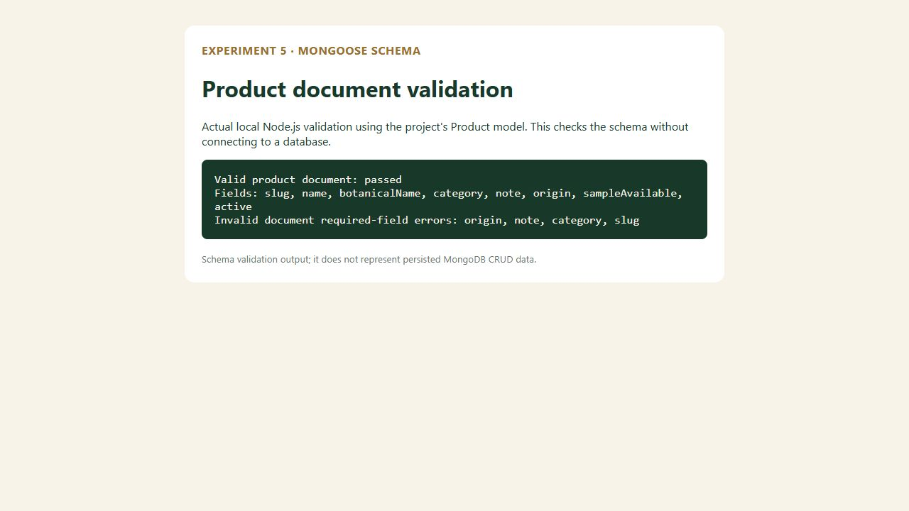
Figure 5.2: Product catalogue used as the CRUD case-study dataset.
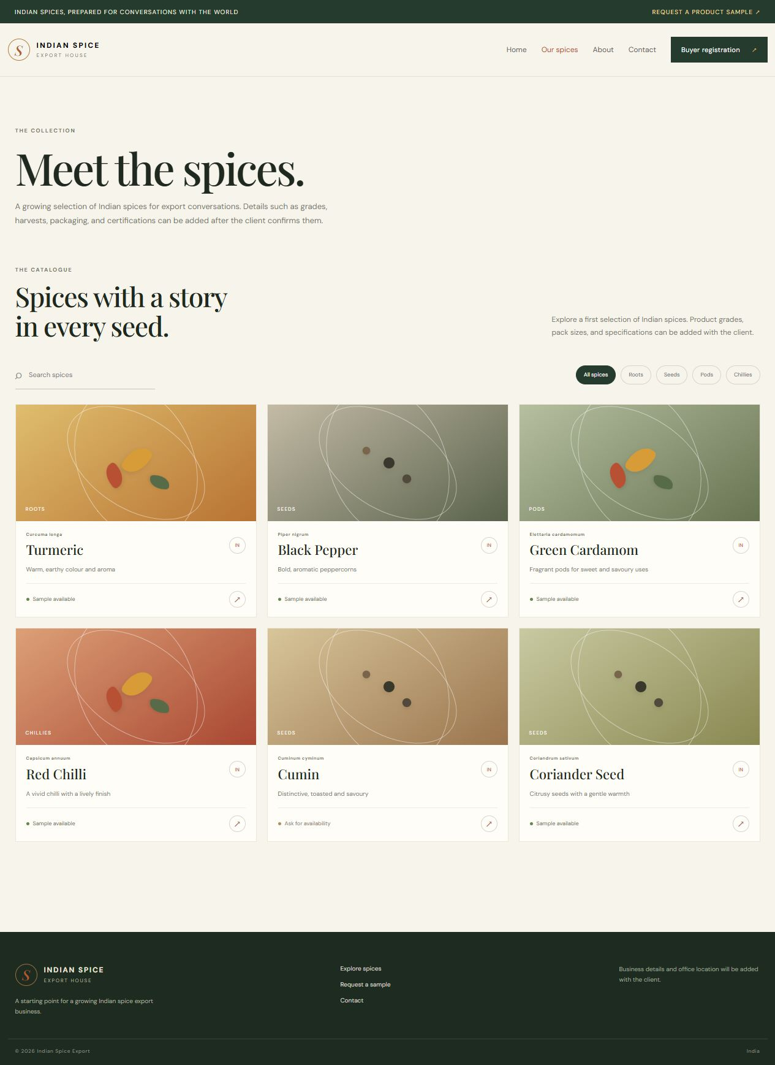
Figure 5.3: Product category state in the client catalogue.
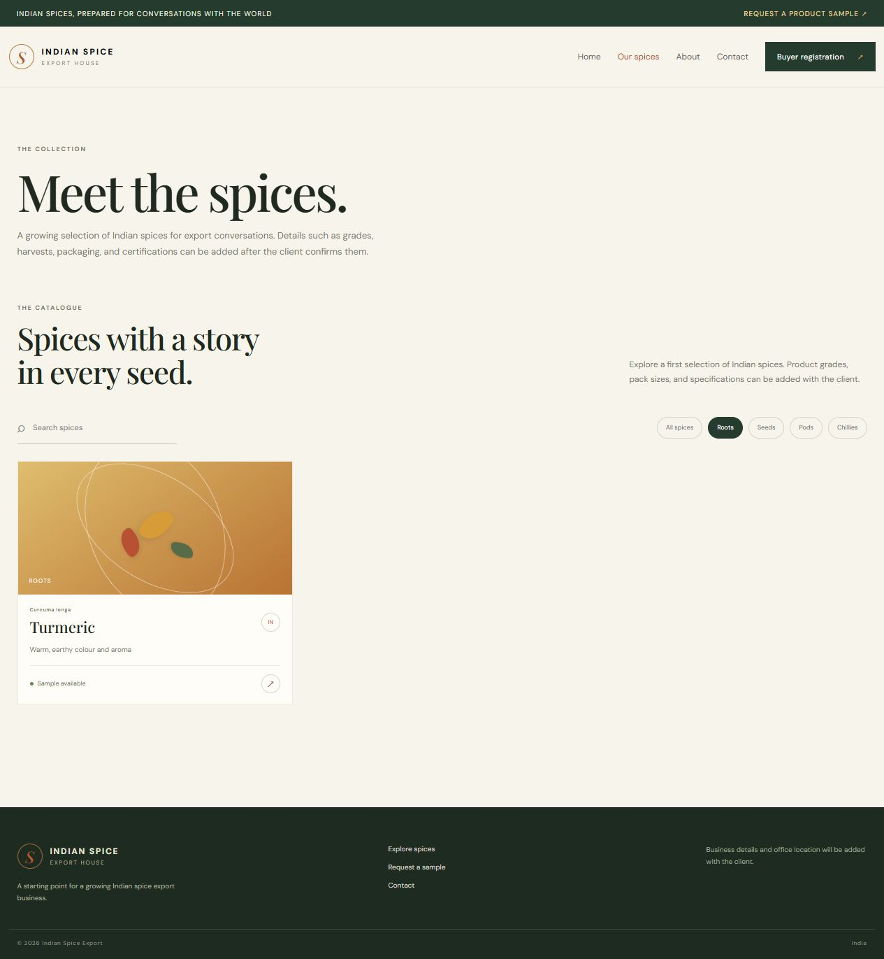
Figure 5.4: Search result for a spice product.
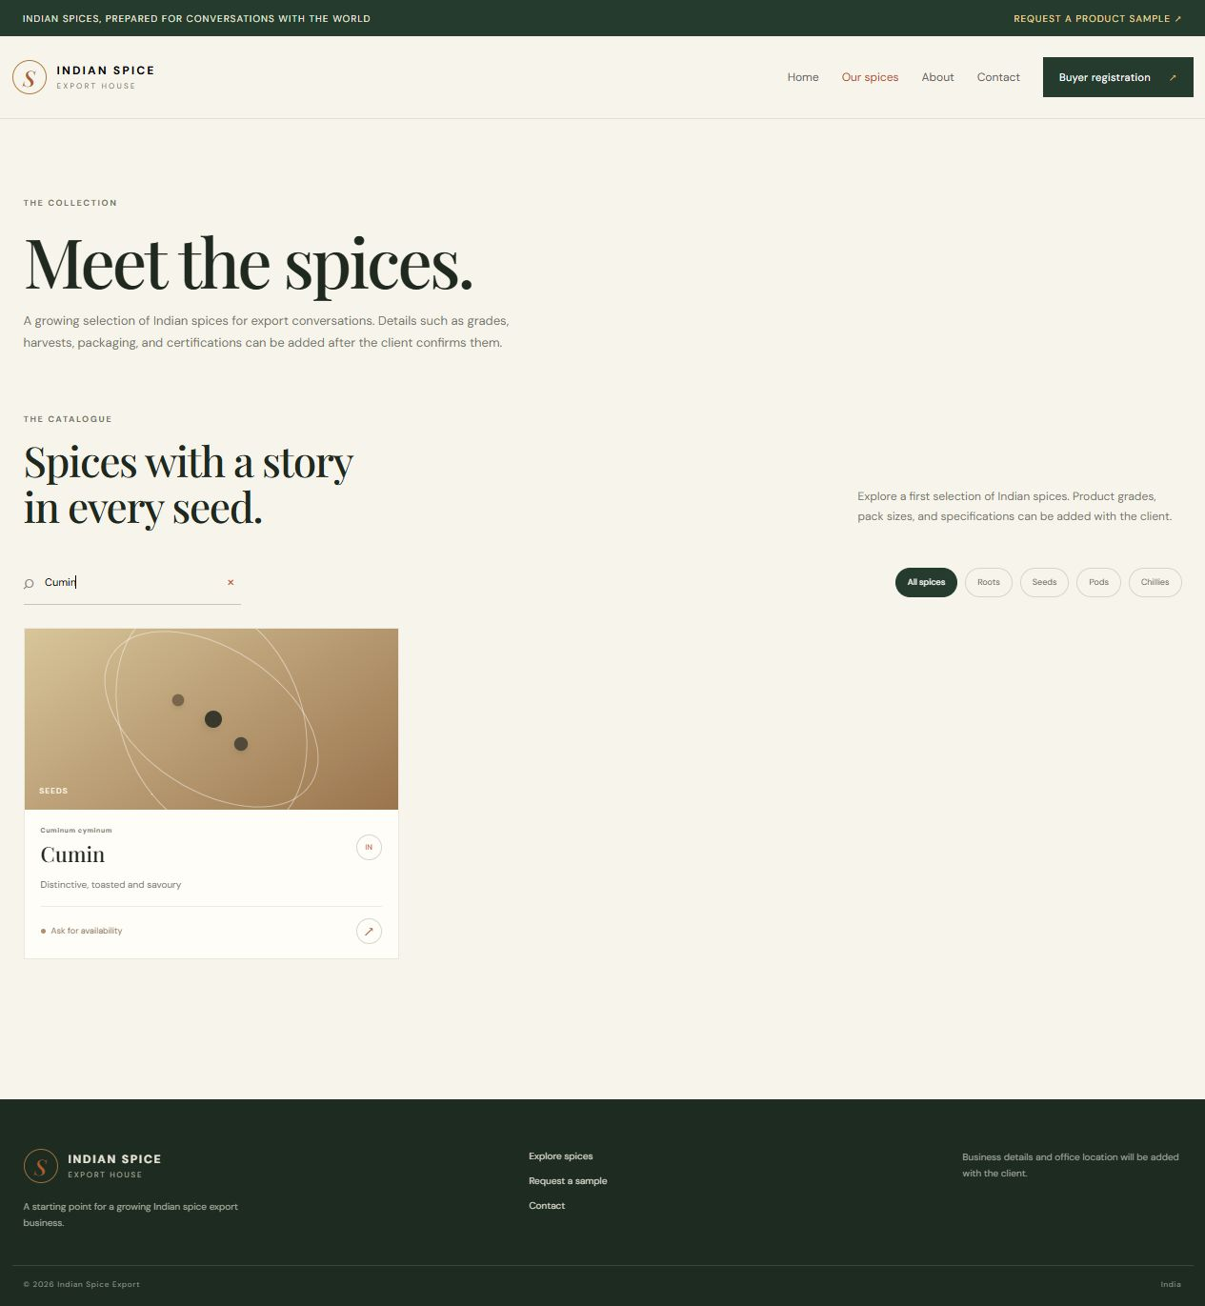
Figure 5.5: About route in the same project.
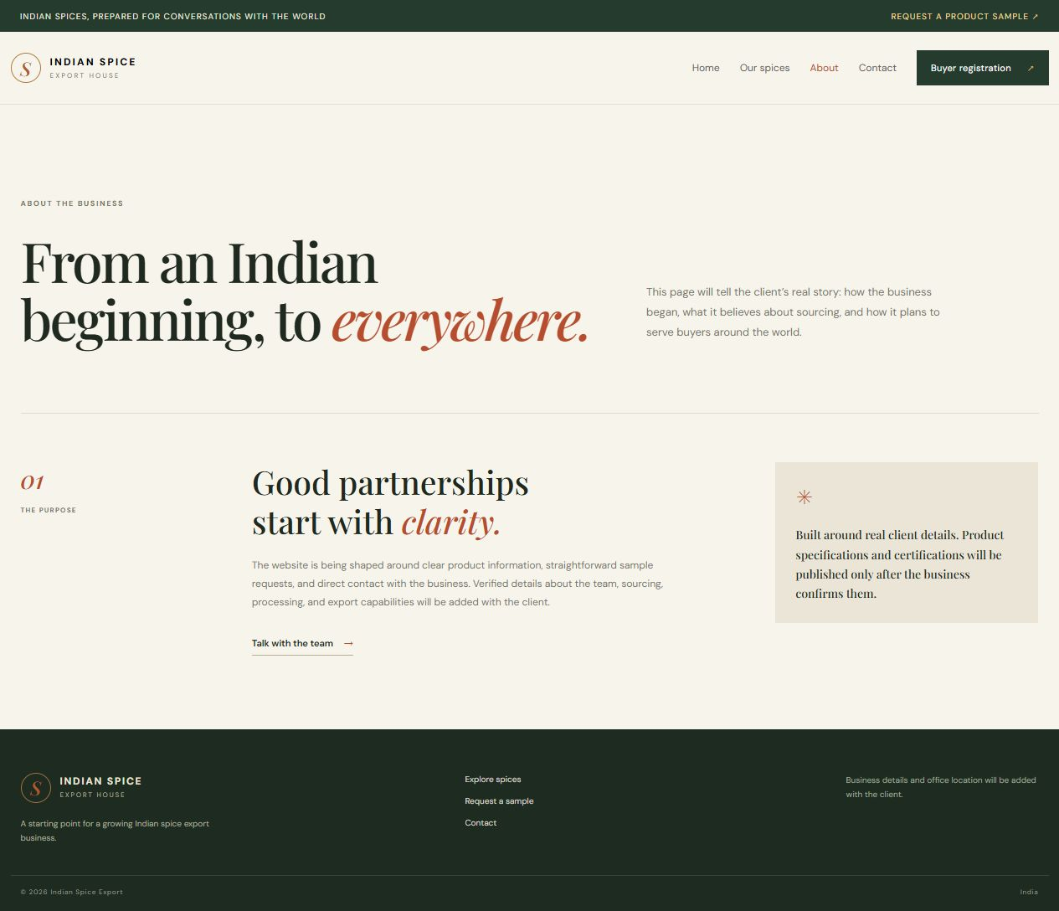
Figure 5.6: Contact route in the same project.
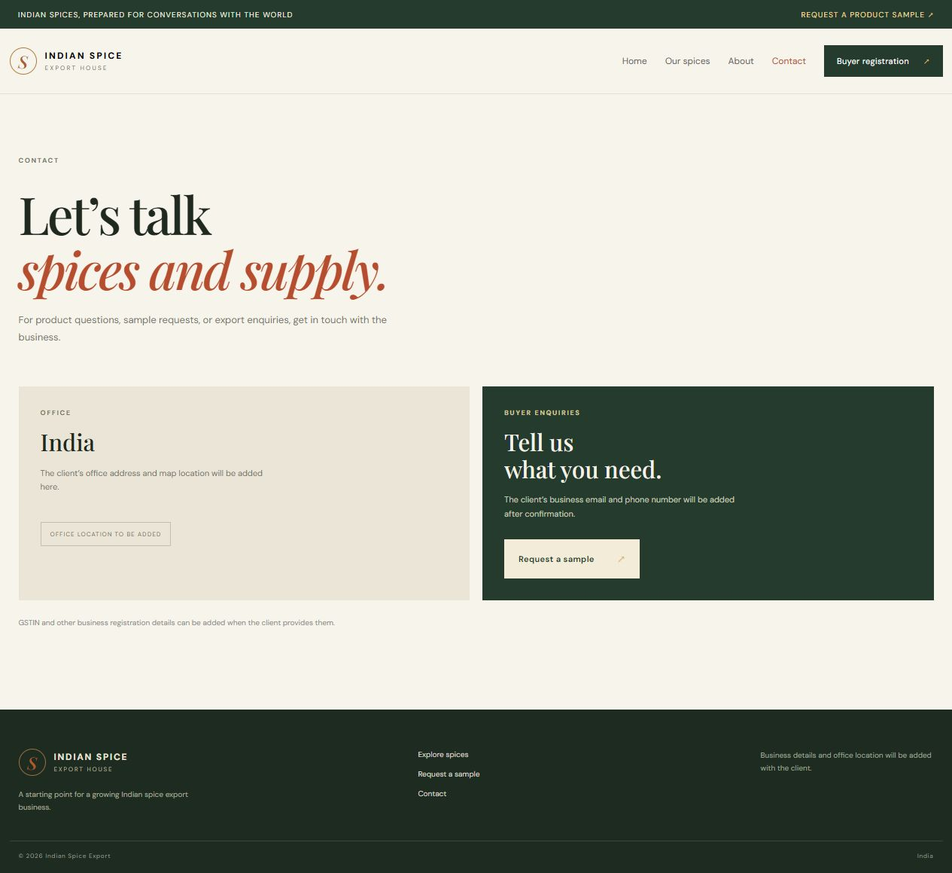
Figure 5.7: Buyer registration form (frontend demonstration).
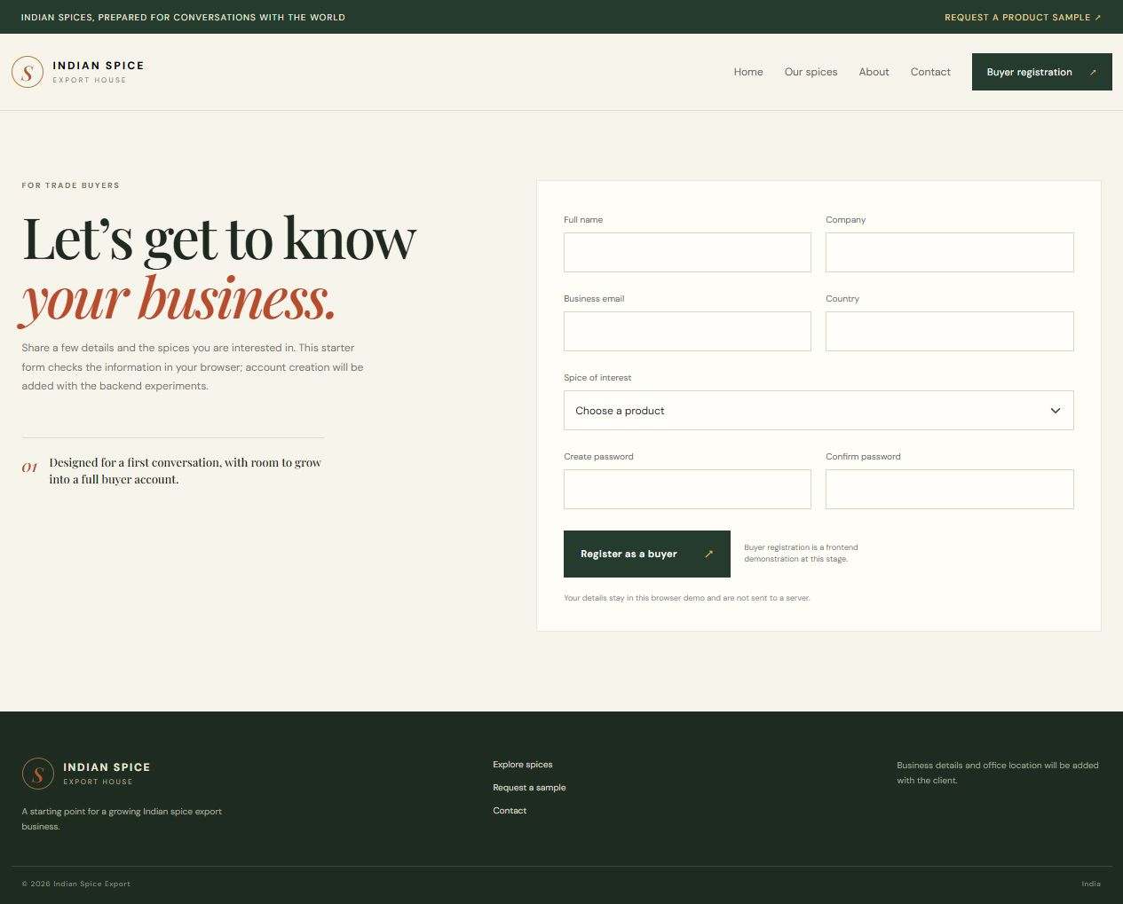
Figure 5.8: Sample request form (frontend demonstration).
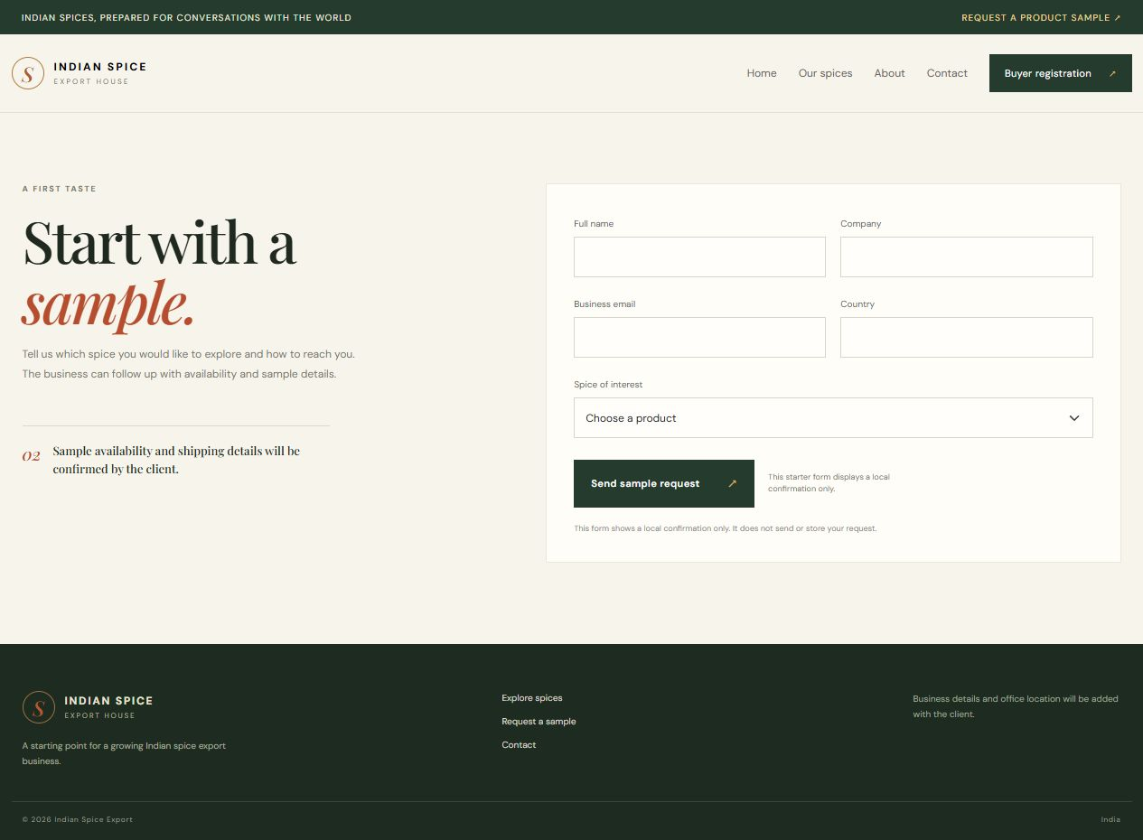
Conclusion:
The experiment translated spice catalogue and buyer-enquiry requirements into Mongoose schemas and MongoDB collections. The actual local Mongoose validation run confirmed that a complete product object passes and that missing required values are identified, providing backend evidence for the model rules. This is schema-level validation; no document was persisted and no live CRUD result is claimed. The procedure records the database operations to perform once MongoDB Community Server or Atlas is configured. The distinction matters because a model can validate an object before save, but only a reachable database can demonstrate insert, query, update and delete. The schemas now define the data contract used by the Express controllers in the next experiments.
The schema should match the client’s confirmed catalogue before seed data is treated as official. For a classroom CRUD run, use a clearly named test spice document, record the inserted identifier, verify the changed field after update, and delete only that test record. The screenshots in this revision must distinguish those database operations from the current Mongoose validation evidence so a reviewer can see exactly which stage has run.

