SHUBHAM DHENGALE - 3574
Experiment No. 6
Title: Develop a Node.js Application using Express.js and Mongoose to Connect with MongoDB
Aim:
To run an Express server for the spice-export website, connect it to MongoDB with Mongoose and provide API routes for products and sample requests.
Tools Used:
Node.js, Express.js, Mongoose, MongoDB, npm, Visual Studio Code, browser or Postman.
Methodology:
The backend separates HTTP concerns from data access. Express middleware parses JSON and configures CORS, then mounts product and sample-request routers. The health route returns a small JSON response that can be checked without reading MongoDB; product and sample routes call controllers that use Mongoose. The backend was started locally by mounting the project Express app without running the database-connecting entry point. Browser requests verified the real health response and the not-found handler. Database-backed routes require MONGODB_URI and are not described as successful until that service is configured.
Theory:
Node.js executes JavaScript outside the browser. Express adds HTTP routing, middleware and response helpers.
Mongoose connects the server to MongoDB and maps schemas to models. CORS controls which browser origin can call the API. The server opens a database connection at startup and reuses it for requests.
Procedure:
1. Inspect the Express app, database connector, route modules, controllers and Mongoose models.
2. Install the project dependencies and place MONGODB_URI in a private local environment file before database testing.
3. Configure CORS for the approved frontend origin and enable JSON request parsing.
4. Register the /api/health route and mount /api/products and /api/samples routers.
5. Start the API entry point when MongoDB is reachable; for health-only inspection, run the Express app without claiming a database connection.
6. Send GET /api/health and confirm the JSON service status and HTTP 200 response.
7. Send a request to an unknown path and confirm the JSON 404 response.
8. After MongoDB is configured, request the product route and submit a valid sample request.
9. Record the API response and database state separately so a health check is not mistaken for persistence.
10. Check the health route and unknown-route response separately from database-backed product routes.
11. Keep credentials in a local environment file and confirm that the server reports a clear connection error when the database URI is absent.
Code:
app.use(cors({ origin: process.env.CLIENT_ORIGIN || 'http://localhost:5173' }));
app.use(express.json({ limit:'32kb' }));
app.get('/api/health', (_req,res) => res.json({status:'ok',service:'spice-export-api'}));
app.use('/api/products', productRoutes);
app.use('/api/samples', sampleRoutes);
await connectDatabase(); // uses MONGODB_URI before app.listen()
Output:
Expected health check when the API is running:
GET /api/health -> HTTP 200
{ "status": "ok", "service": "spice-export-api" }
Database-backed endpoints require a reachable MongoDB connection; no live database result is claimed in this report.
Figure 6.1: Express health endpoint output captured in the local project.
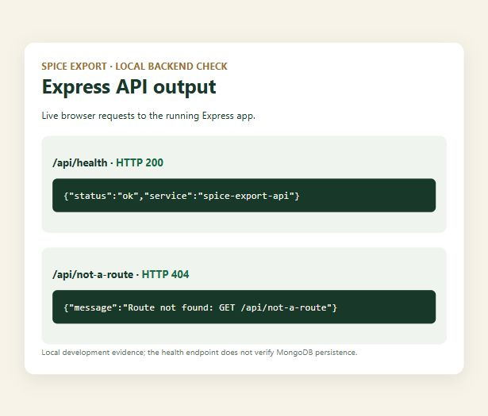
Figure 6.2: Mongoose model validation output without database persistence.
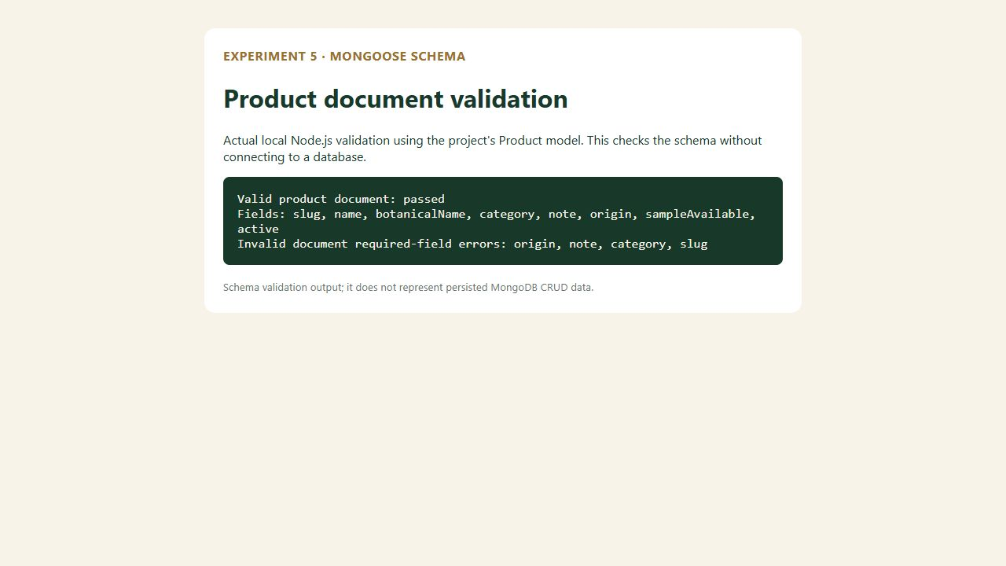
Figure 6.3: Node.js runtime output from the project script.
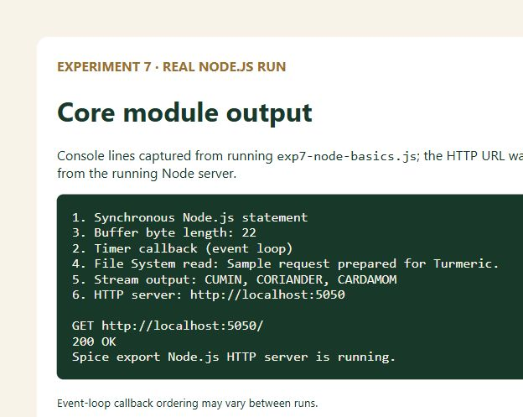
Figure 6.4: Client product route served by the local site.

Figure 6.5: Sample-request user interface.
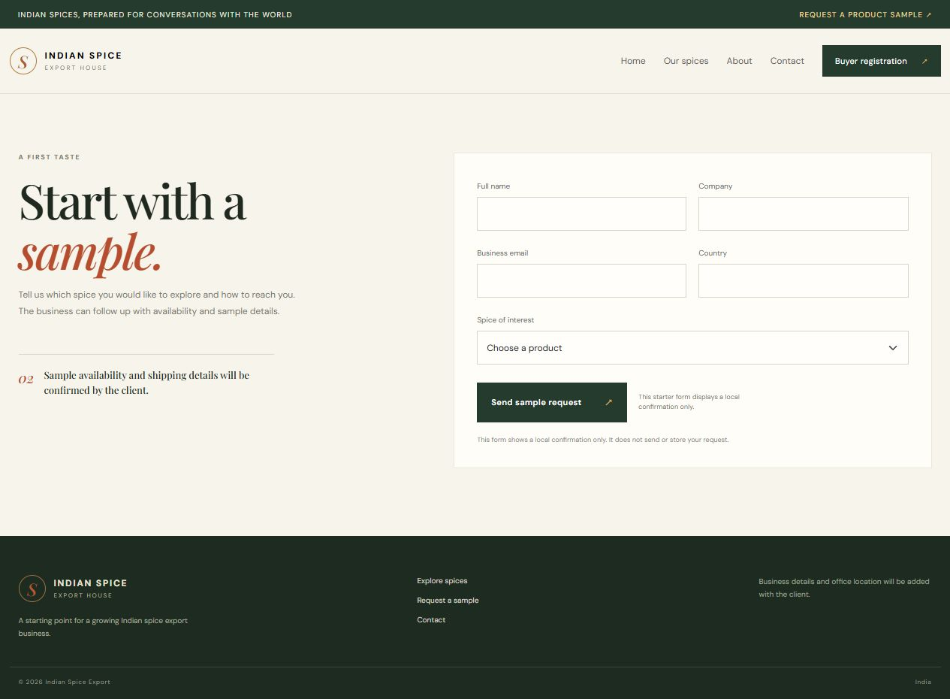
Figure 6.6: Buyer registration page.
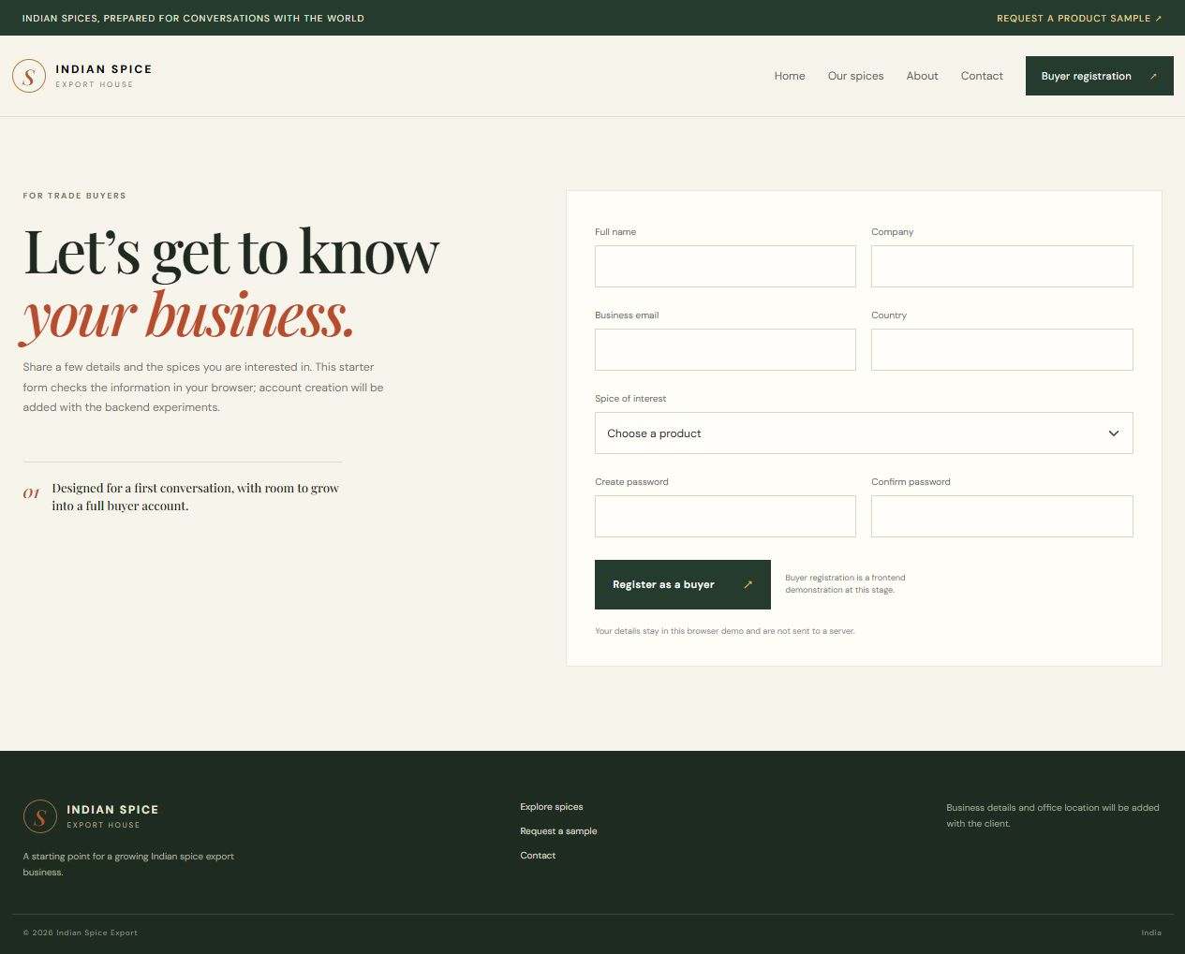
Figure 6.7: Contact route.

Figure 6.8: About route.
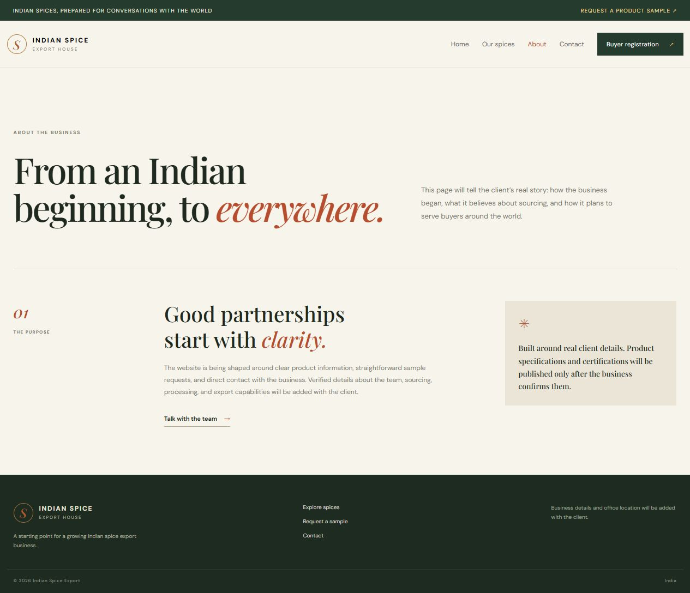
Conclusion:
This experiment connected the project’s HTTP layer to its data models through Express routes and Mongoose controllers. The local API health check returned the expected service JSON, and the unknown path returned an HTTP 404 JSON message, confirming that the running app and its fallback handler respond. These browser captures are genuine local backend outputs. They do not prove that MongoDB is connected: the app can answer its health route without querying the database. To complete the database-backed part, configure MONGODB_URI, start the normal server entry point, then verify product retrieval and sample-request creation. The separation of health and database checks makes the current implementation status clear.
The health route is deliberately lightweight and useful for checking that the process is listening, but it should not be used as a database readiness signal. A later production health check can expose a safe dependency state without returning credentials or connection details. The route and controller separation keeps those checks independent from business operations and makes backend failures easier to locate.

