SHUBHAM DHENGALE - 3574
Experiment No. 7
Title: Develop Basic Node.js Applications Demonstrating REPL, HTTP Server, File System, Buffers, Streams, and Event Loop
Aim:
To demonstrate Node.js REPL, HTTP, file-system, Buffer, stream and event-loop behavior with spice-export sample data.
Tools Used:
Node.js, built-in http, fs/promises, buffer and stream modules, terminal, Visual Studio Code.
Methodology:
This practical uses Node.js core modules with spice-export example data. The REPL accepts interactive JavaScript expressions; node:http creates a small HTTP server; node:fs/promises writes and reads a local enquiry note; Buffer reports the UTF-8 byte length; and Readable and Transform demonstrate a stream that uppercases a list of spices. A synchronous message and timer callback make event-loop scheduling visible. The supplied program was run locally, its console output inspected, and the HTTP response requested from the running server. Each result is tied to the corresponding Node API instead of being presented as a database or Express result.
Theory:
The REPL reads, evaluates and prints JavaScript expressions. Node core modules provide HTTP, file and stream operations without additional packages.
Buffers represent bytes, streams process data in chunks and the event loop schedules asynchronous callbacks after synchronous statements.
Procedure:
1. Open a terminal at the website project and start the Node.js REPL with node.
2. Evaluate a small spice array expression, inspect a value, and exit the REPL.
3. Run the exp7-node-basics.js demonstration from the project root.
4. Observe the synchronous statement and timer callback to compare event-loop scheduling.
5. Create a Buffer from the sample label and inspect its byte length.
6. Write the demonstration note with fs/promises, read it back and compare the returned text.
7. Pass the comma-separated spice list through the Readable and Transform streams and inspect uppercase output.
8. Request the program’s local HTTP URL in a browser and confirm the response text and status.
9. Stop the demonstration server after capturing the output; remove or retain the generated note as required by the lab.
10. Compare synchronous output with Promise and timer callbacks to observe event-loop ordering.
11. Confirm the file-system result and HTTP response, then close the server so the port is released.
Code:
import { createServer } from 'node:http';
import { readFile, writeFile } from 'node:fs/promises';
import { Buffer } from 'node:buffer';
import { Readable, Transform } from 'node:stream';
console.log('1. Synchronous Node.js statement');
setTimeout(() => console.log('Timer callback (event loop)'), 0);
const label = Buffer.from('Turmeric export sample', 'utf8');
await writeFile('./exp7-note.txt','Sample request prepared for Turmeric.\n','utf8');
const server = createServer((_req,res) => res.end('Spice export Node.js HTTP server is running.'));
server.listen(5050, () => console.log('HTTP server listening on 5050'));
Output:
Representative output from the supplied demonstration (stream and timer lines can interleave):
1. Synchronous Node.js statement
Buffer byte length: 22
Sample request prepared for Turmeric.
Stream output: CUMIN, CORIANDER, CARDAMOM
HTTP server listening on 5050
Timer callback (event loop)
Browser GET localhost:5050 -> Spice export Node.js HTTP server is running.
Figure 7.1: Node.js script output from the local runtime.
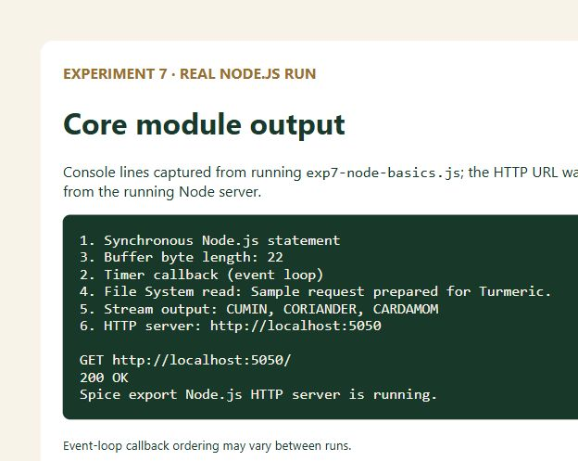
Figure 7.2: Express health endpoint output.
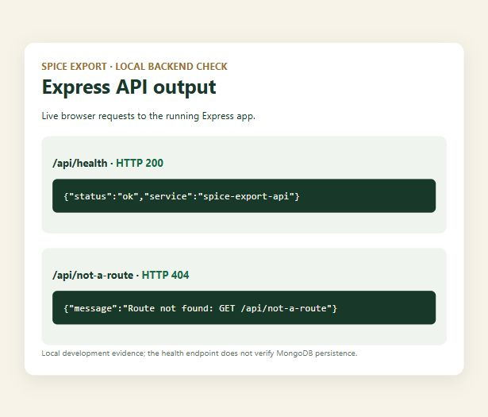
Figure 7.3: Mongoose schema validation output (no DB connection).
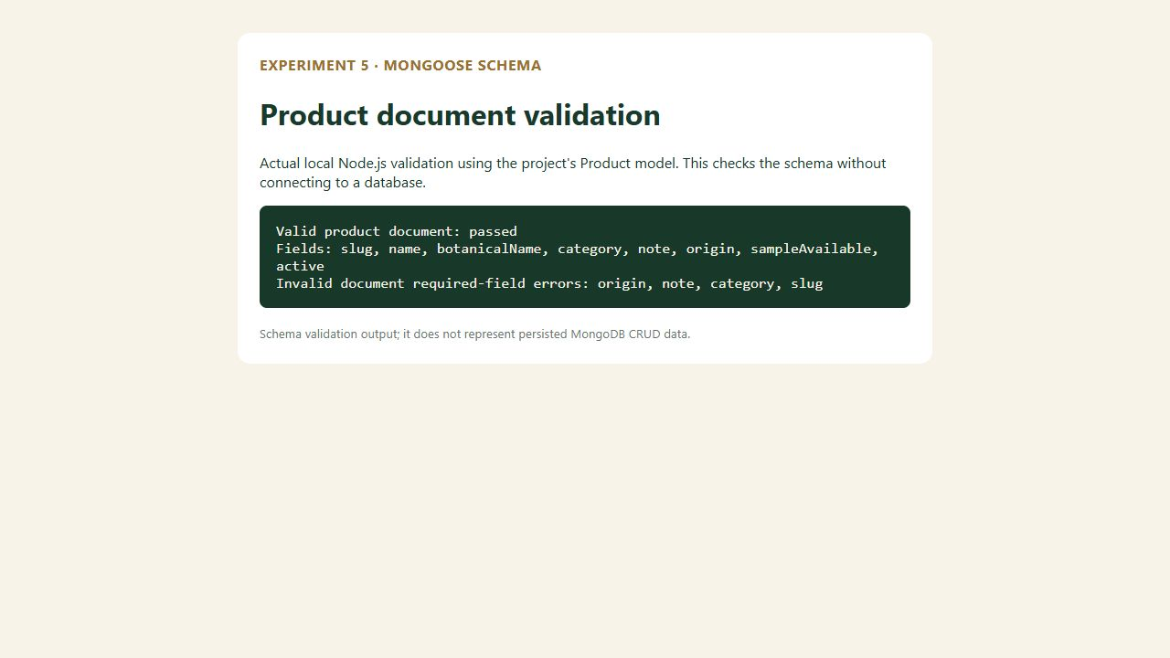
Figure 7.4: Project home page.

Figure 7.5: Product catalogue route.

Figure 7.6: About route.

Figure 7.7: Contact route.

Figure 7.8: Registration route.

Conclusion:
The Node.js demonstration exercised the REPL and several built-in modules with practical spice-export examples. The run produced a byte count for the Buffer, wrote and read a local note, transformed spice names through a stream, and started a raw HTTP server that returned a browser-readable response. The event-loop lines showed that asynchronous callbacks are scheduled separately from synchronous statements; exact ordering can vary with runtime scheduling. These results were obtained from the supplied local script and are represented in the report’s output capture. This is a Node core-module server, distinct from the Express API used in later experiments, and it does not connect to or save data in MongoDB.
The HTTP server in this exercise is deliberately small so the focus remains on the Node runtime rather than a framework. Its response, file output and stream transform are reproducible local observations, while the REPL gives a quick way to inspect a product array interactively. Running the script again rewrites its demonstration note, so the generated file should be treated as temporary practical output.

