SHUBHAM DHENGALE - 3574
Experiment No. 8
Title: Build a RESTful API using Express.js and Test API Endpoints using Postman
Aim:
To expose spice products and buyer sample requests through REST endpoints and inspect methods, JSON responses and status codes in Postman.
Tools Used:
Node.js, Express.js, Mongoose, MongoDB, Postman and the project Postman collection.
Methodology:
The API design treats products and sample requests as resources and assigns HTTP methods to their operations. Express routes expose public health and product-reading paths, sample creation, and protected management actions. Controllers validate input and use Mongoose models; middleware handles JSON parsing, CORS, authorization and consistent errors. The project Postman collection records requests for repeatable checks. The local backend’s health and unknown-route responses were tested in a browser, showing a real 200 response and a real 404 response. Product and sample database operations require the MongoDB service, and admin requests additionally require a private key.
Theory:
REST represents resources at URLs and uses GET, POST, PUT and DELETE to read, create, update and remove data.
HTTP status codes report outcomes: 200 for successful reads, 201 for creation, 400 for invalid input, 404 for missing routes or records, and 500 for unexpected errors.
Postman sends requests and displays status and JSON responses. Admin keys belong in private local variables and must not appear in screenshots.
Procedure:
1. Start the Express application and configure the local API base URL in Postman.
2. Import the Spice-Export-API collection from the project postman folder.
3. Set any admin key only in a private local variable; do not include it in a screenshot or report.
4. Send GET /api/health and verify status 200 and the JSON service name.
5. Send GET /api/products after MongoDB is available and inspect the returned product array.
6. Submit a valid POST /api/samples request and verify the creation status and response fields.
7. Try an invalid request body and inspect the validation status and message.
8. Test a protected management route without credentials and confirm it is rejected; repeat only with an authorized local key.
9. Check an unknown route for a 404 response and save the genuine Postman request/response evidence.
10. Send valid and invalid requests and inspect response codes, JSON bodies and validation messages.
11. Repeat database-dependent requests only after the API server has connected to the configured test database.
Code:
app.get('/api/health', (_req,res) => res.json({status:'ok',service:'spice-export-api'}));
app.use('/api/products', productRoutes);
app.use('/api/samples', sampleRoutes);
router.get('/', listProducts);
router.post('/', createSampleRequest);
router.put('/:id', requireAdmin, updateSampleRequest); // protected management route
Output:
Expected responses with the API and database configured:
GET /api/health -> 200 OK { "status":"ok", "service":"spice-export-api" }
GET /api/products -> 200 OK with product documents from MongoDB
POST /api/samples with valid JSON -> 201 Created with the saved request
Live database responses require configured MongoDB and, for management calls, the admin key.
Figure 8.1: Express health response from the local backend.
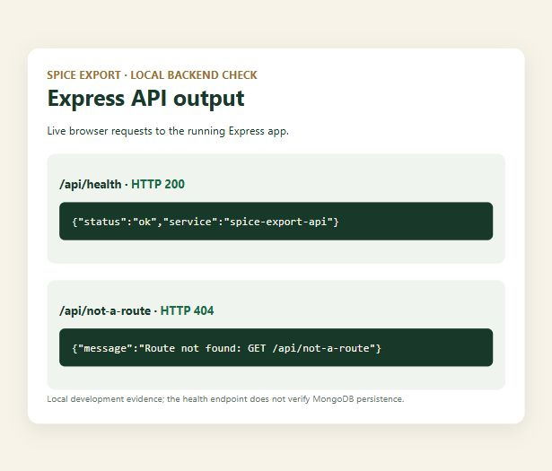
Figure 8.2: Mongoose validation output; CRUD persistence not configured.
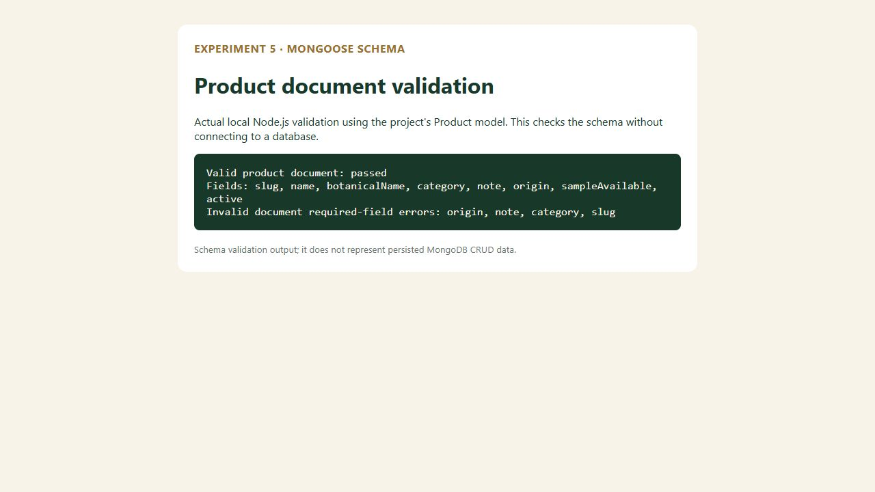
Figure 8.3: Product collection UI route.

Figure 8.4: Category filter state.

Figure 8.5: Search filter state.

Figure 8.6: Sample request page.
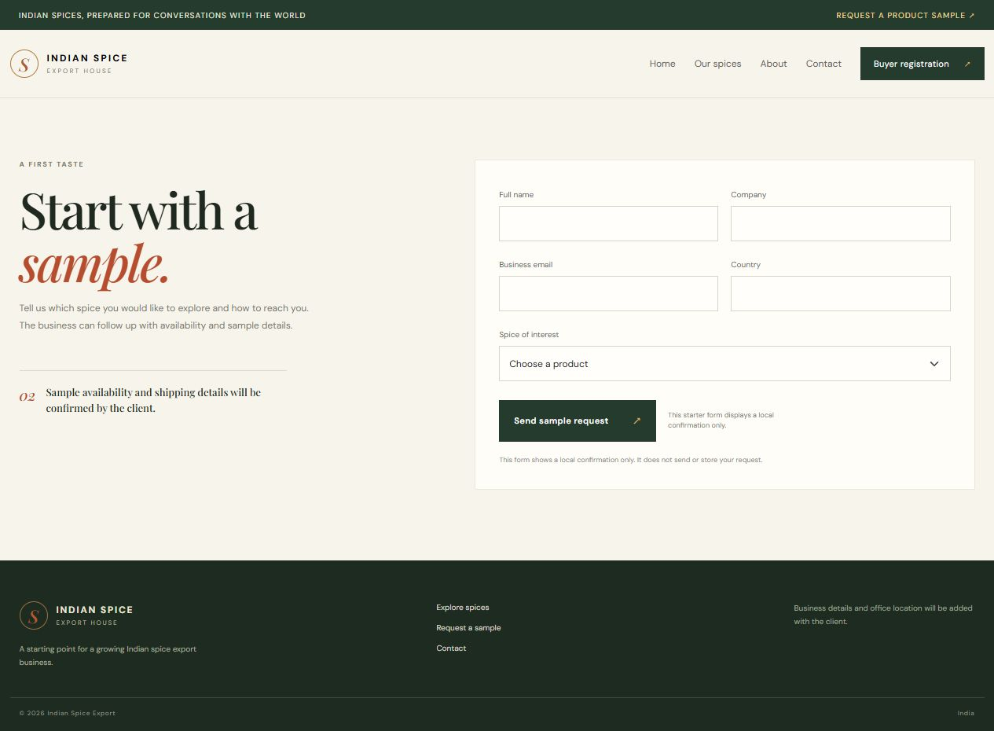
Figure 8.7: Registration page.
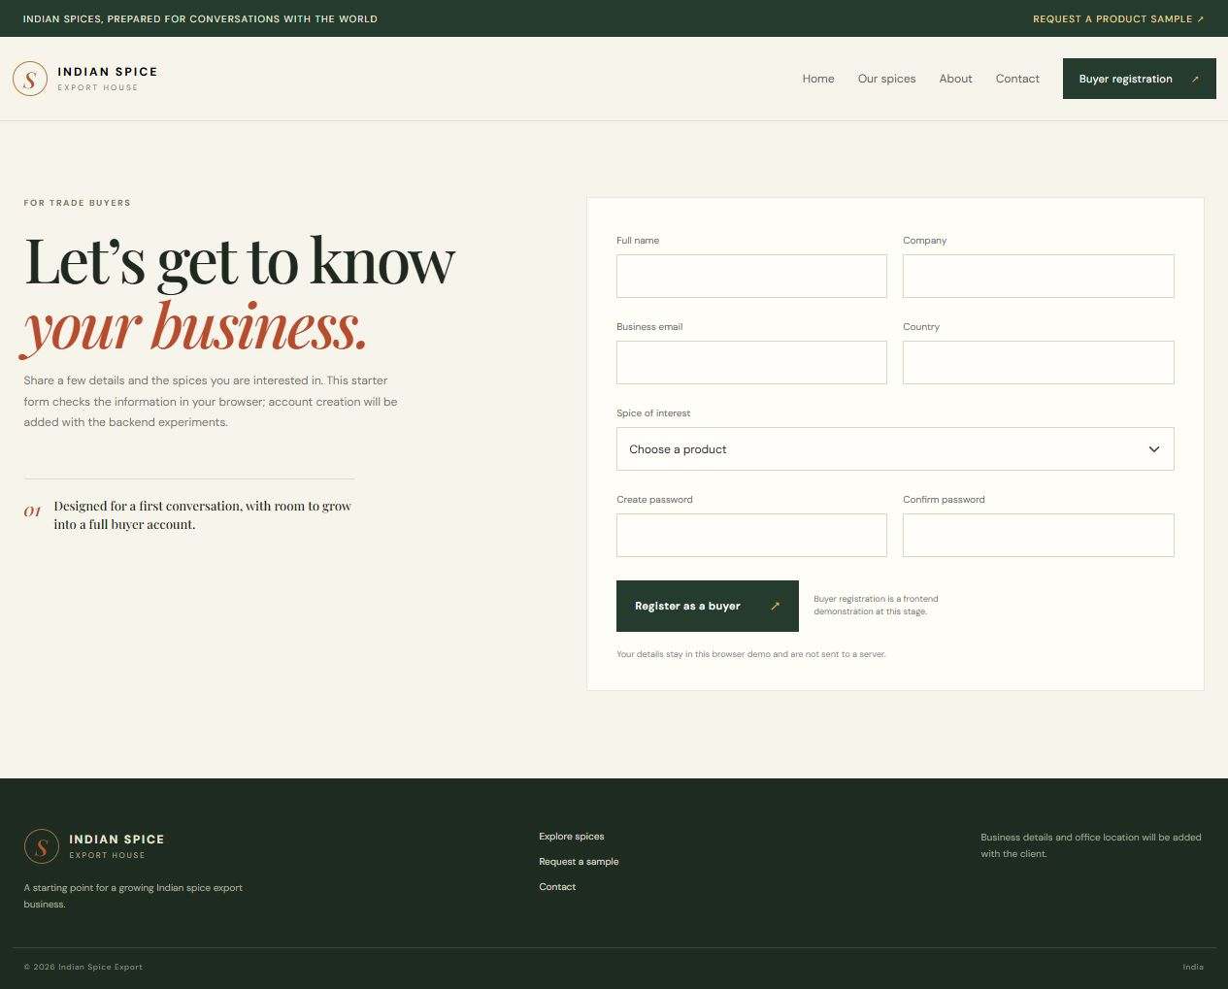
Figure 8.8: Contact page.
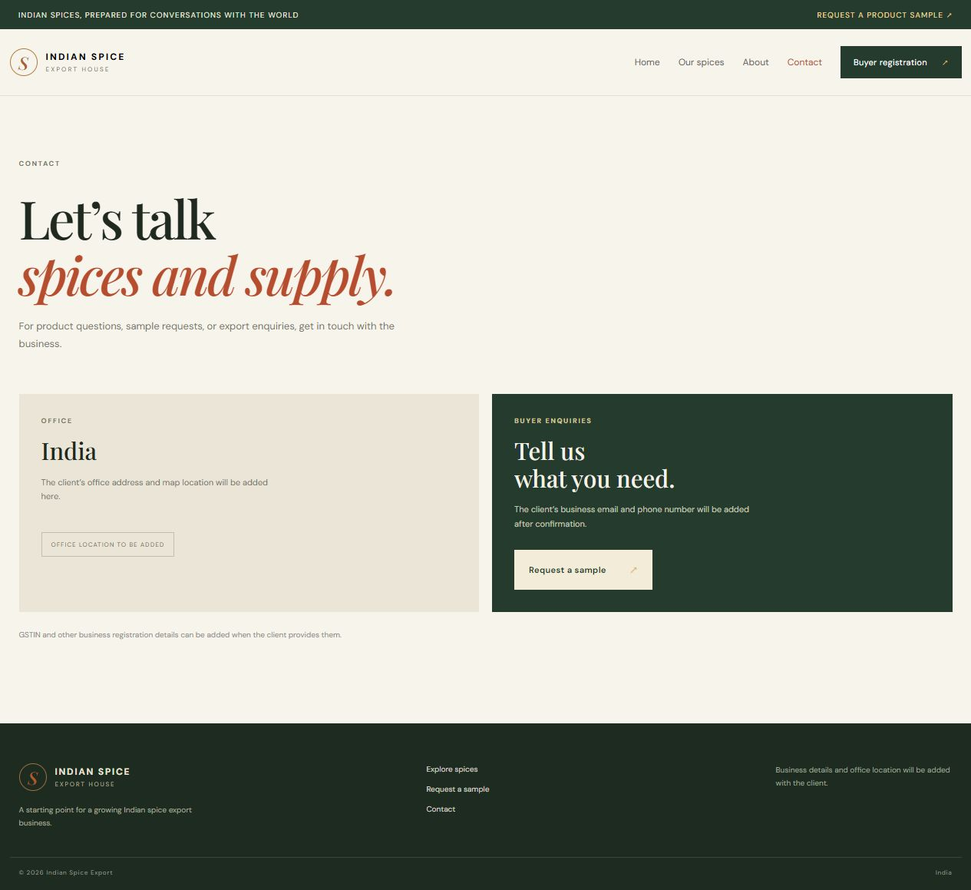
Conclusion:
The REST API experiment organized the spice-export backend around HTTP resources, JSON request bodies and status codes. The local Express output confirmed the health route with HTTP 200 and the not-found handler with HTTP 404, demonstrating both a successful request and a controlled error response. The Postman collection provides repeatable definitions for product and sample workflows. Database-backed product reads and sample creation still need a configured MongoDB connection, while protected management calls require the client’s authorized admin key. The screenshots therefore document the working local API behavior without claiming that a record was stored. Once configuration is supplied, the remaining endpoint cases can be recorded with their actual status and response bodies.
A complete API record should include the method and URL, request body where relevant, response status, response JSON and a note about database state. Credentials must stay in private local variables and must not appear in practical screenshots. Once MongoDB is available, the existing collection covers successful reads and writes; validation failures, missing records and unauthorized management operations should be recorded as separate outcomes.

