SHUBHAM DHENGALE - 3574
Experiment No. 9
Title: Develop a Full-Stack MERN Application by Integrating React Frontend with Express Backend using Axios/Fetch API
Aim:
To connect the React spice-export website to Express and MongoDB using Axios so products can be fetched and buyer sample requests submitted through the API.
Tools Used:
MongoDB, Express.js, React, Node.js, Mongoose, Axios, Vite and browser developer tools.
Methodology:
The full-stack workflow assigns the React client to presentation and user interaction, the Express API to HTTP processing, and MongoDB to persistent storage. The frontend API module uses Axios with a configurable base URL and API-mode flag. In demo mode it reads the local catalogue and displays a local sample-confirmation message; in API mode it requests products and posts sample requests. CORS must allow the real frontend origin, and the server must connect to MongoDB before persistent operations can complete. Current browser evidence covers the sample form demo and local API health separately; an end-to-end database transaction is pending configuration.
Theory:
MERN combines MongoDB, Express, React and Node.js. React renders the client, Express exposes routes, Node runs the server and MongoDB stores records.
Axios sends Promise-based HTTP requests and parses JSON responses. CORS response headers allow a browser page at an approved origin to call an API on another origin.
Procedure:
1. Review src/lib/api.js and note the API-enabled flag, base URL and local demo fallback.
2. Configure the backend MongoDB URI and frontend origin in private environment files.
3. Start the Express API and confirm its health endpoint before switching the frontend to API mode.
4. Set the frontend API mode and base URL to the running API, then restart the Vite frontend.
5. Open the products page and inspect the GET /api/products request in the browser Network panel.
6. Complete the sample form with buyer details and submit it through the website.
7. Inspect the POST /api/samples status and returned JSON in the Network panel.
8. Verify the new sample document in the configured database using a safe test request.
9. If API configuration is absent, keep demo mode enabled and label its confirmation as local-only evidence.
10. Review the browser network response and user-facing error state when the API is unavailable.
11. After backend persistence is enabled, submit one test request and confirm it through a read operation before documenting end-to-end success.
Code:
const api = axios.create({ baseURL: import.meta.env.VITE_API_BASE_URL || '/api', timeout:8000 });
export async function getProducts() {
if (!isApiEnabled) return spices;
const { data } = await api.get('/products'); return data;
}
export async function createSampleRequest(values) {
if (!isApiEnabled) return { demo:true };
const { data } = await api.post('/samples', values); return data;
}
Output:
Expected browser-to-API flow with the backend configured:
Products page -> GET /api/products -> HTTP 200 with spice records
Sample form -> POST /api/samples -> HTTP 201 with the saved request
With API mode disabled, the frontend uses local catalogue data and does not persist the request.
Figure 9.1: Local sample form confirmation; no API or database submission.
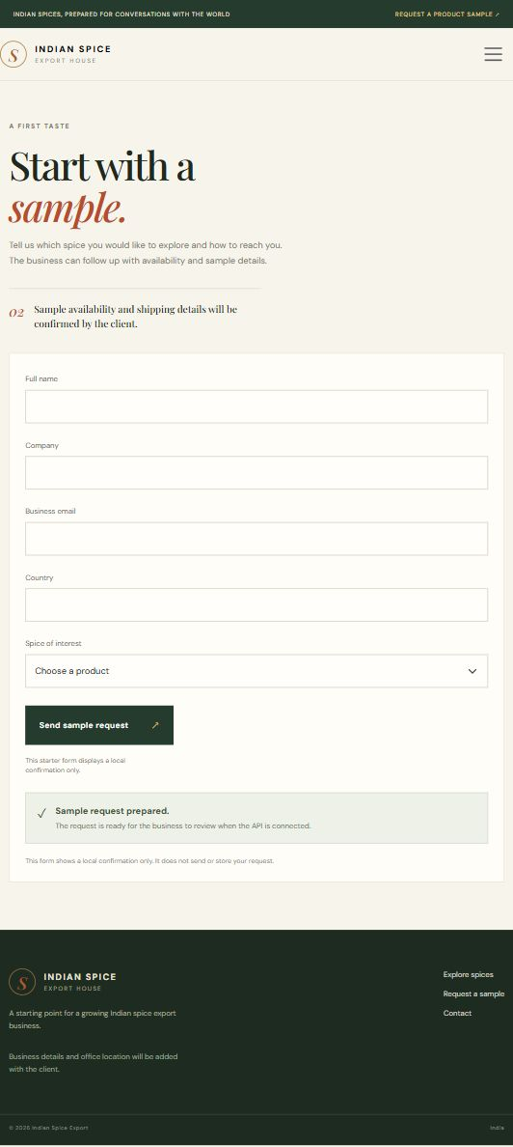
Figure 9.2: Backend health response in the local project.
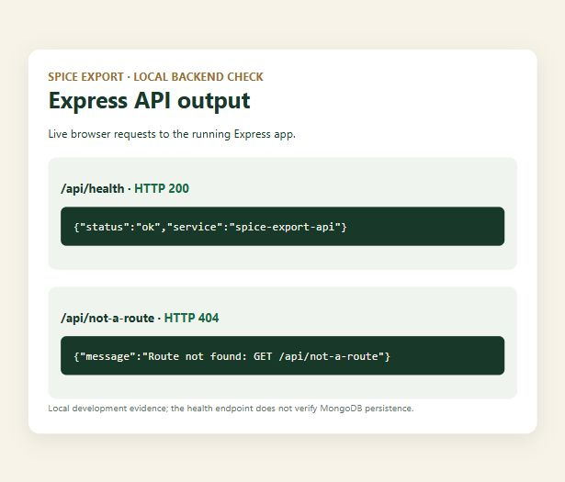
Figure 9.3: Sample form before or during local workflow.
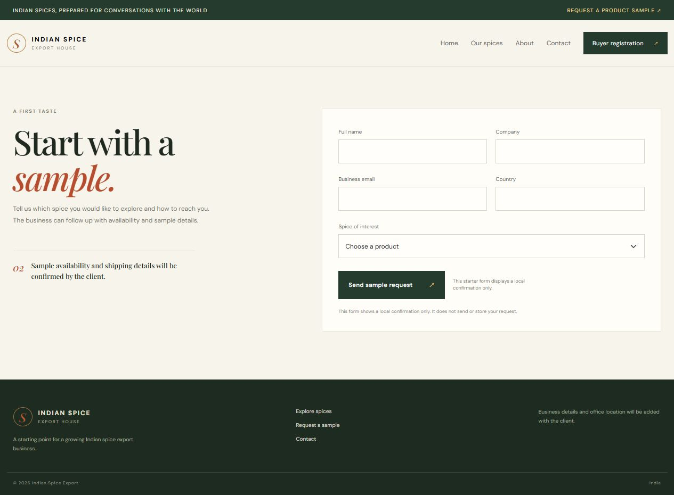
Figure 9.4: Product chosen for sample enquiry.
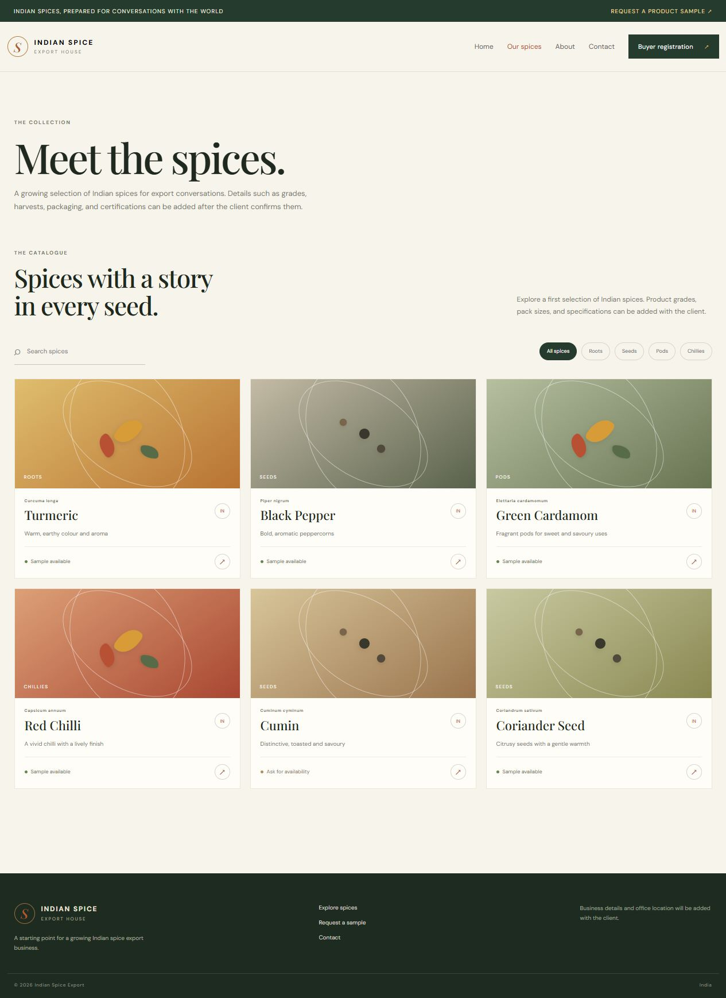
Figure 9.5: Filtered spice selection.
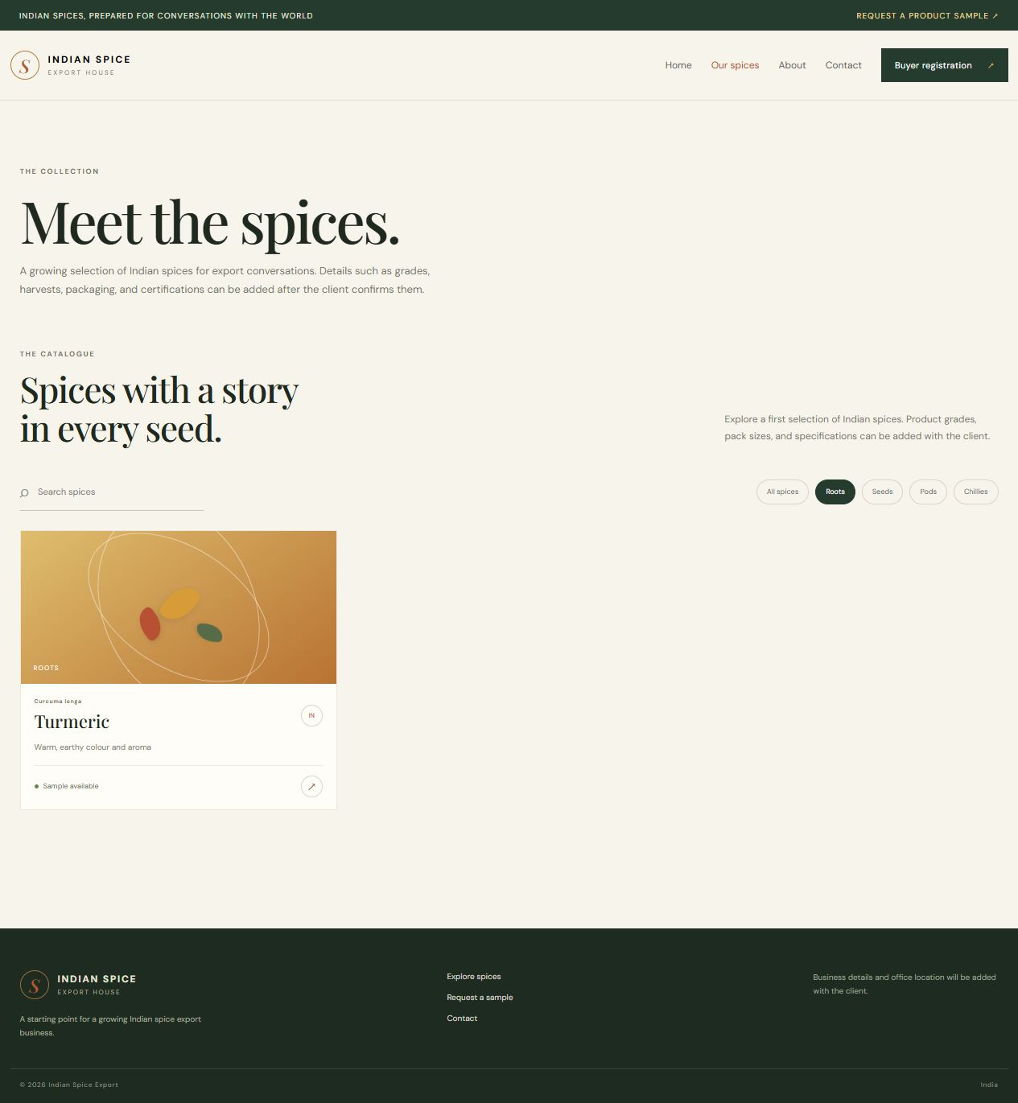
Figure 9.6: Contact route.
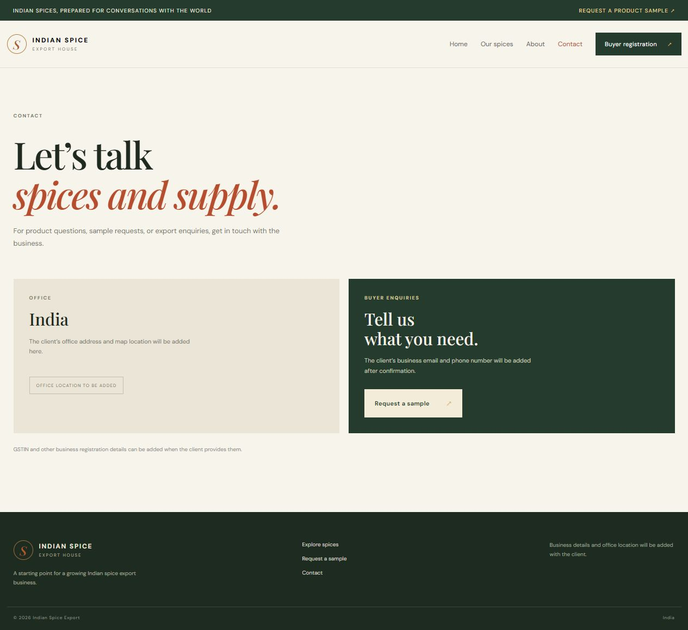
Figure 9.7: Registration route.
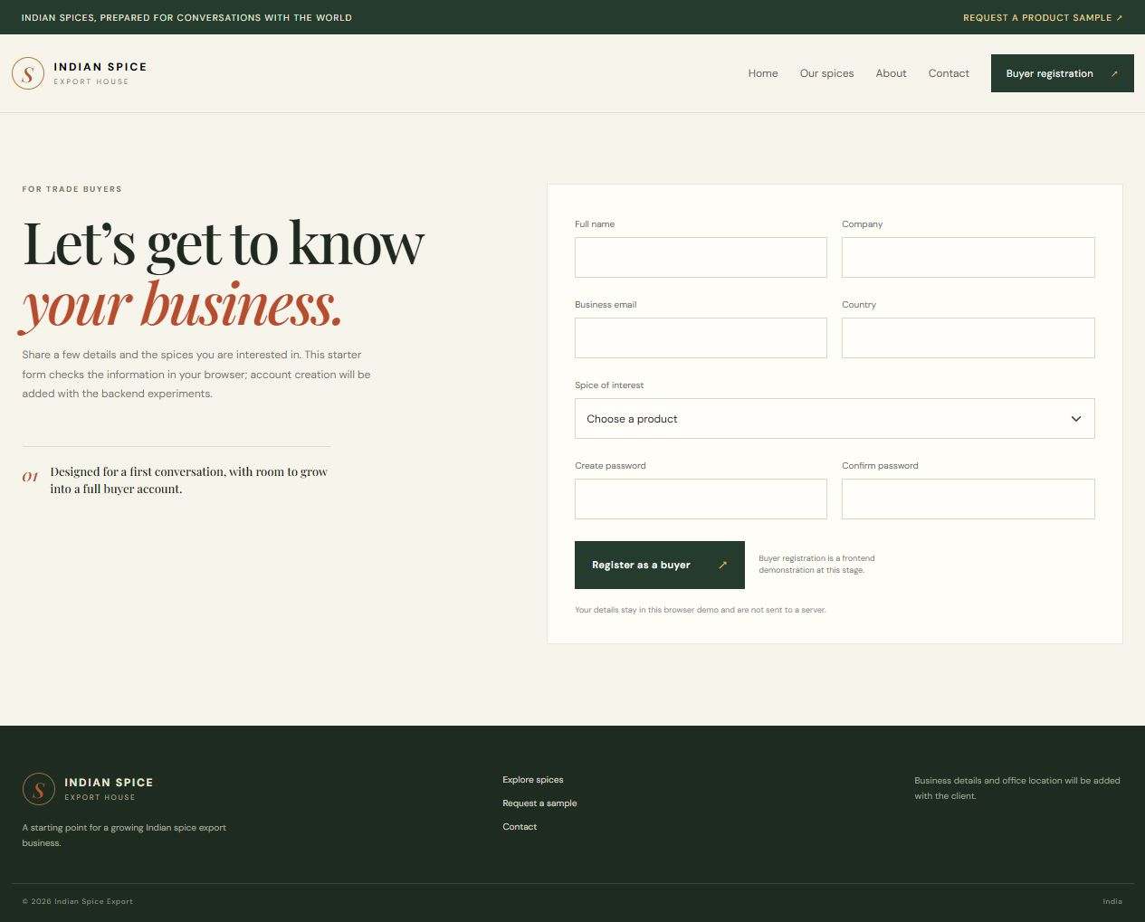
Figure 9.8: About route.
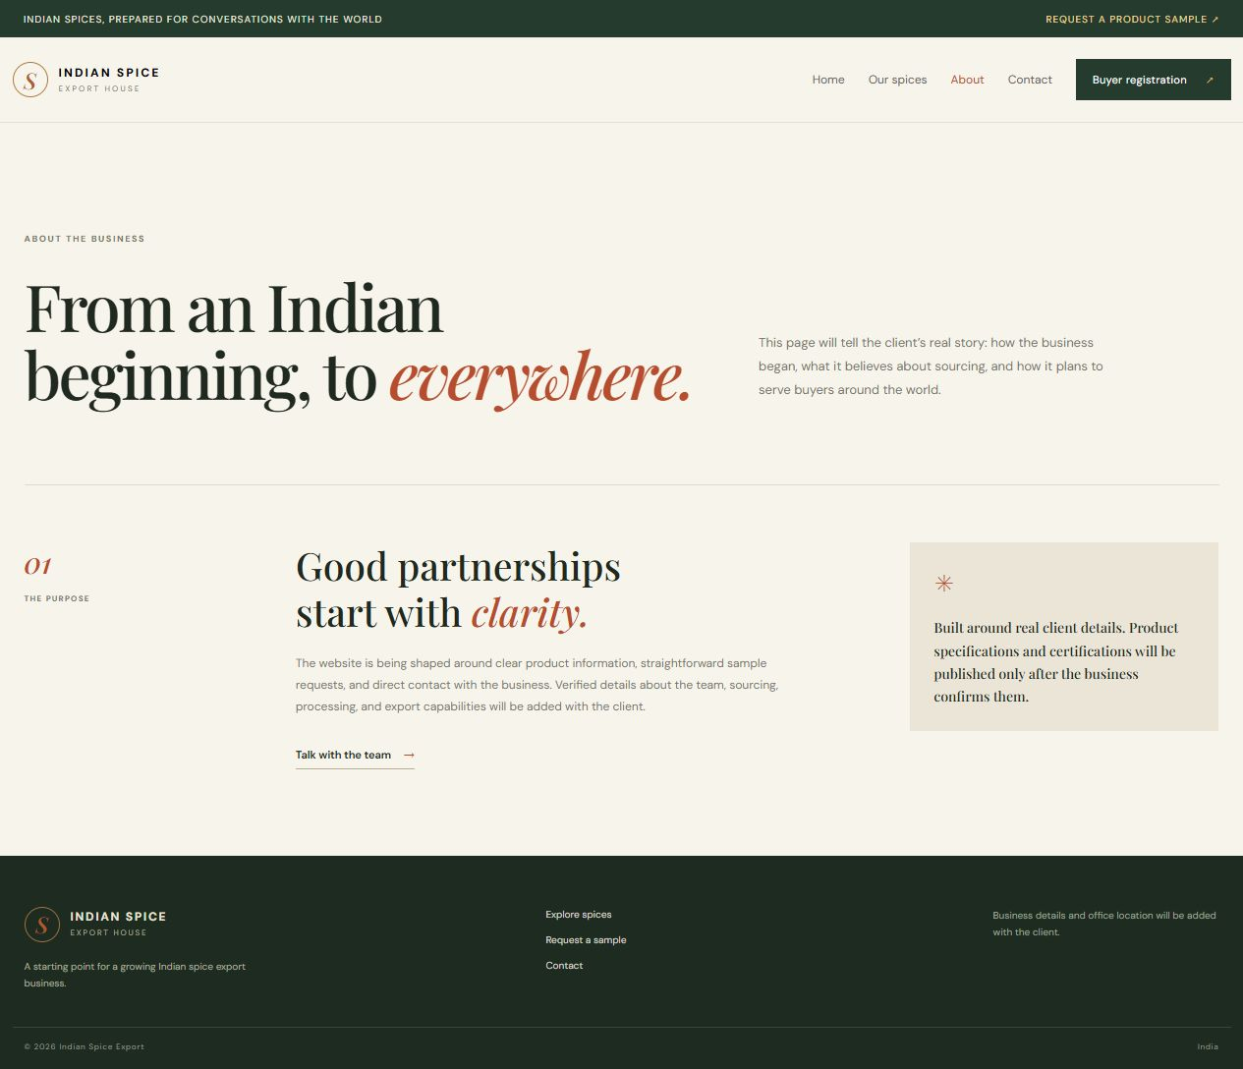
Conclusion:
This experiment defines the integration path between the spice-export React interface and its Express/MongoDB backend through Axios. The frontend module can either return the local catalogue in demo mode or issue requests to the configured API. The sample-request screen demonstrates the buyer journey, while the backend health capture confirms that the local API can respond. Together they show the interface and service as separate working pieces, but they are not an end-to-end persistence test. API mode, CORS and MongoDB credentials must be configured before claiming that product data came from MongoDB or a buyer request was saved. The next verification should capture both browser Network responses and the matching database record.
End-to-end verification requires tracing the same sample request through the form, browser Network panel, Express controller and database record. A confirmation shown only by the local demo branch is not proof of that complete path. Keeping the mode and result visible in the report helps show the work incrementally and makes the final persistent workflow straightforward to verify after the API configuration is supplied.

