A PROJECT REPORT ON

TESTING AND CLASSIFICATION OF SOIL FOR THE PURPOSE OF CULTIVATION USING MACHINE LEARNING

SUBMITTED TO THE SAVITRIBAI PHULE PUNE UNIVERSITY, PUNE IN THE PARTIAL FULFILLMENT FOR THE AWARD OF THE DEGREE

OF

BACHELOR OF ENGINEERING IN INFORMATION TECHNOLOGY

BY

Anushka Chavan B1904508511

Shubham Dhobale B1904508515

Shivani Kulkarni B1904508541

Aditya Shivarkar B1904508564

UNDER THE GUIDANCE OF

Mrs.Rohini Tambe



DEPARTMENT OF INFORMATION TECHNOLOGY

Marathwada Mitra Mandal's College of Engineering Karvenagar, Pune-411052

Savitribai Phule Pune University 2024-25



Certificate

This is to certify that the project report entitled

"TESTING AND CLASSIFICATION OF SOIL FOR THE PURPOSE OF CULTIVATION USING MACHINE LEARNING"

Submitted by

Shubham Dhobale

Shivani Kulkarni

Aditya Shivarkar

Anushka Chavan

is a record of bonafide work carried out by them under the supervision and guidance of Guide Name and it is approved for the partial fulfillment of the requirement of Savitribai Phule Pune University for the award of Degree of Bachelor of Engineering (In-formation Technology).

Mrs.Rohini Tambe Dr.Swapnaja Ubale

Guide, Head of Department,

Dept of Information Technology Dept of Information Technology

Dr. V. N. Gohokar

External Examiner Principal,

MMCOE, Pune

Date

Place:

Acknowledgement

It is our proud privilege and duty to acknowledge the kind of help and guidance received from several people in the preparation of this report. It would not have been possible to prepare this report, in this report and in this form without their valuable help, co-operation and guidance.

Our sincere thanks to HoD Name, Head Department of Information Technology, for her valuable suggestions and guidance throughout the preparation of this report. We express our sincere gratitude to our guide Guide Name for guiding us in the investigation of this project and in carrying out experimental work. We hold her in esteem for the guidance, encouragement and inspiration received from her.

Last but not least we wish to thank our parents for financing our studies and helping us throughout our life for achieving perfection and excellence. Their personal help in making this report and project presentation is gratefully acknowledged.

Anushka Chavan B1904508511

Shubham Dhobale B1904508515

Shivani Kulkarni B1904508541

Aditya Shivarkar B1904508564

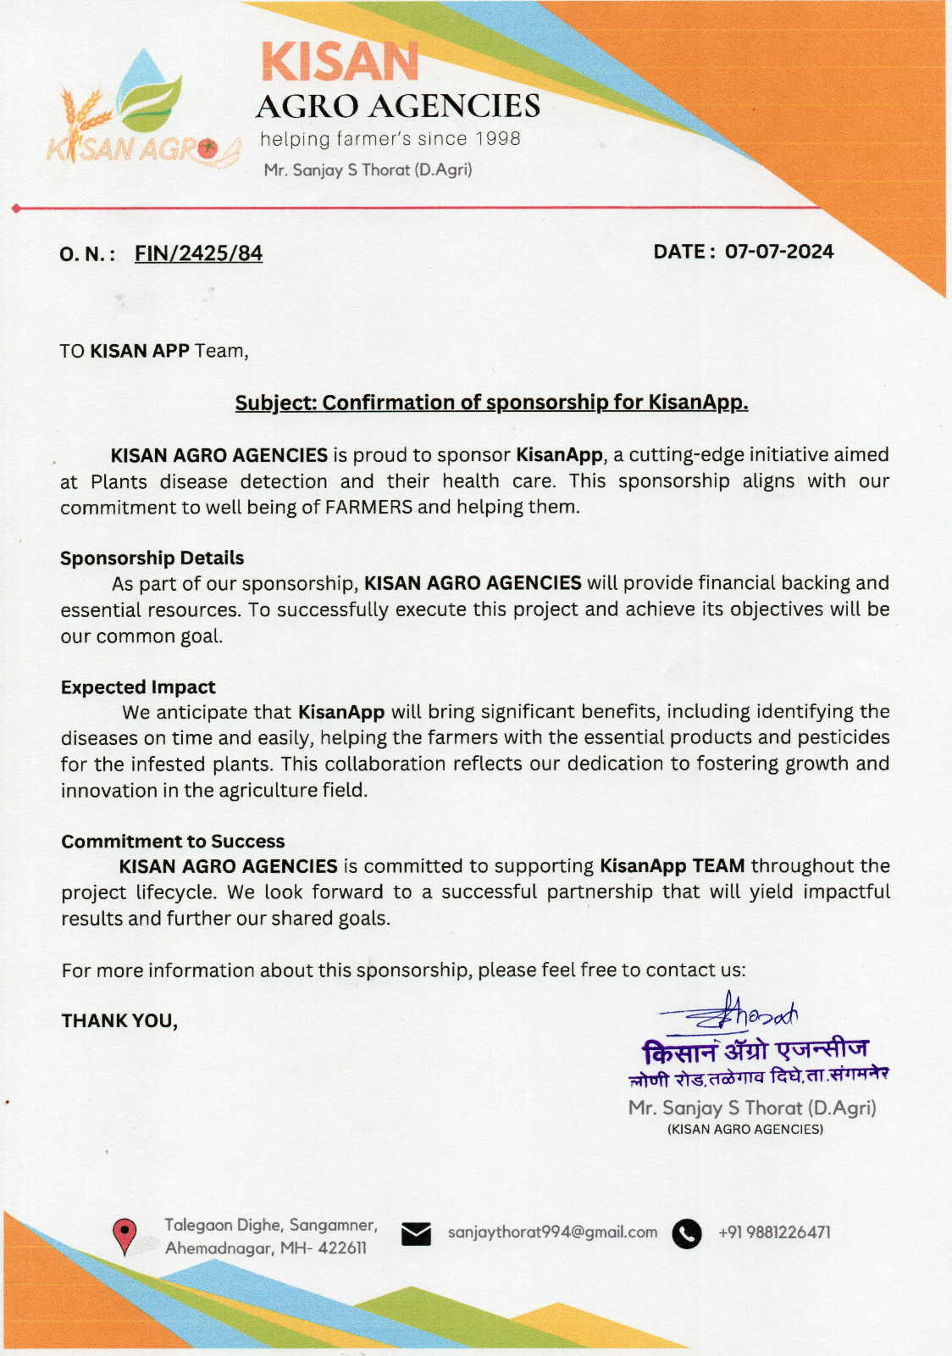Abstract

This project focuses on developing a machine learning model for the testing and classification of soil types to enhance agricultural productivity. By collecting soil samples from various regions and analyzing properties such as pH, moisture, nutrient content, and texture, we aim to create a robust model that can accurately classify soil types and provide actionable insights for farmers. The methodology includes data collection, preprocessing, feature selection, and training of machine learning models such as Decision Trees, Random Forest, and SVM, followed by rigorous evaluation using cross-validation techniques.

Innovative aspects of the project include the integration of IoT devices for real-time soil testing, geospatial analysis for regional soil property visualization, and the development of a mobile application for instant feedback on soil classification and crop recommendations. Additionally, the project will incorporate precision agriculture techniques, predictive analytics, and a user feedback loop to refine the model continuously. The expected outcome is a reliable soil classification system that supports sustainable farming practices, optimizes crop yield, and promotes soil health through ongoing monitoring and timely interventions.

Technical Keywords

1. Decision Tree
2. Random Forest
3. SVM
4. feature selection

Contents

| Certificate | i |
| --- | --- |
| Acknowledgement | ii |
| Abstract | v |
| Technical Keywords | vi |
| List of Figures | x |
| 1 Introduction | 1 |
| 1.1 Overview . . . . . . . . . . . . . . . . . . . . . . . . . . . . . . . . . . . | 1 |
| 1.2 Background . . . . . . . . . . . . . . . . . . . . . . . . . . . . . . . . . . | 2 |
| 1.3 Project Undertaken . . . . . . . . . . . . . . . . . . . . . . . . . . . . . . | 2 |
| 1.4 Problem Statement . . . . . . . . . . . . . . . . . . . . . . . . . . . . . . | 3 |
| 2 Literature Survey | 4 |
| 3 Requirement & Analysis | 6 |
| 3.1 Requirements . . . . . . . . . . . . . . . . . . . . . . . . . . . . . . . . . | 6 |
| 3.1.1 User Requirements . . . . . . . . . . . . . . . . . . . . . . . . . . | 6 |
| 3.1.2 Functional Requirements . . . . . . . . . . . . . . . . . . . . . . . | 6 |
| 3.1.3 Non-functional Requirements . . . . . . . . . . . . . . . . . . . . | 7 |
| 3.1.4 Technical Requirement . . . . . . . . . . . . . . . . . . . . . . . . | 7 |
| 3.1.5 Minimum Hardware and Software Requirements . . . . . . . . . . | 9 |
| 3.1.6 Deployment Requirement . . . . . . . . . . . . . . . . . . . . . . | 10 |
| 4 Project Plan | 11 |
| 4.1 Project Summary . . . . . . . . . . . . . . . . . . . . . . . . . . . . . . . | 11 |

| 4.2 | Project Scope . . . . . . . . . . . . . . . . . . . . . . . . . . . . . . . . . | 11 |
| --- | --- | --- |
| 4.3 | Deliverables . . . . . . . . . . . . . . . . . . . . . . . . . . . . . . . . . . | 12 |
| 4.4 | Resource Allocation . . . . . . . . . . . . . . . . . . . . . . . . . . . . . . | 12 |
|  | 4.4.1 Project Coordinator . . . . . . . . . . . . . . . . . . . . . . . . . . | 13 |
|  | 4.4.2 Quality Assurance . . . . . . . . . . . . . . . . . . . . . . . . . . | 13 |
|  | 4.4.3 Documentation . . . . . . . . . . . . . . . . . . . . . . . . . . . . | 13 |
|  | 4.4.4 Deployment and Infrastructure . . . . . . . . . . . . . . . . . . . . | 13 |
|  | 4.4.5 Risk Management . . . . . . . . . . . . . . . . . . . . . . . . . . | 14 |
|  | 4.4.6 Communications and Plans . . . . . . . . . . . . . . . . . . . . . . | 14 |

1. System Design 15
   1. System Architecture . . . . . . . . . . . . . . . . . . . . . . . . . . . . . . 15

| 5.2 | DFD Level 0 | . . . . . . . . . . . . . . . . . . . . . . . . . . . . . . . . . | 16 |
| --- | --- | --- | --- |
| 5.3 | DFD Level 1 | . . . . . . . . . . . . . . . . . . . . . . . . . . . . . . . . . | 16 |
| 5.4 | DFD Level 2 | . . . . . . . . . . . . . . . . . . . . . . . . . . . . . . . . . | 17 |

* 1. State Diagram . . . . . . . . . . . . . . . . . . . . . . . . . . . . . . . . . 18
  2. Sequence Diagram . . . . . . . . . . . . . . . . . . . . . . . . . . . . . . 19

1. System Implementation 20
   1. Methodology . . . . . . . . . . . . . . . . . . . . . . . . . . . . . . . . . 20
   2. Modules and Their Descriptions: . . . . . . . . . . . . . . . . . . . . . . . 20
   3. Challenges and Problem-Solving . . . . . . . . . . . . . . . . . . . . . . . 21
2. Software Testing 22
   1. Testing Strategies . . . . . . . . . . . . . . . . . . . . . . . . . . . . . . . 22
      1. Unit Testing . . . . . . . . . . . . . . . . . . . . . . . . . . . . . . 22
      2. Functional Testing . . . . . . . . . . . . . . . . . . . . . . . . . . 23
      3. Acceptance Testing . . . . . . . . . . . . . . . . . . . . . . . . . . 23
      4. Performance Testing . . . . . . . . . . . . . . . . . . . . . . . . . 23
   2. Summary of Test Results . . . . . . . . . . . . . . . . . . . . . . . . . . . 24
3. Experimental Results 25
   1. Experimental Setup . . . . . . . . . . . . . . . . . . . . . . . . . . . . . . 25
   2. Screenshots . . . . . . . . . . . . . . . . . . . . . . . . . . . . . . . . . . 25
4. Conclusion 29
5. Future Work 30

Bibliography 32

List of Figures

* 1. System Architechture . . . . . . . . . . . . . . . . . . . . . . . . . . . . . 15
  2. Level 0 DFD ................................. 16
  3. Level 1 DFD ................................. 16
  4. Level 2 DFD ................................. 17
  5. State Diagram . . . . . . . . . . . . . . . . . . . . . . . . . . . . . . . . 18
  6. Sequence Diagram . . . . . . . . . . . . . . . . . . . . . . . . . . . . . . 19
  7. Unit Testing . . . . . . . . . . . . . . . . . . . . . . . . . . . . . . . . . . 22
  8. Home page . . . . . . . . . . . . . . . . . . . . . . . . . . . . . . . . . . 25
  9. Description on home page . . . . . . . . . . . . . . . . . . . . . . . . . . 26
  10. Sign Language to Audio Conversion Module . . . . . . . . . . . . . . . . 26
  11. Working of Algorithm . . . . . . . . . . . . . . . . . . . . . . . . . . . . 27
  12. Audio to Sign Language Conversion . . . . . . . . . . . . . . . . . . . . . 27
  13. Okay Sign . . . . . . . . . . . . . . . . . . . . . . . . . . . . . . . . . . . 28
  14. Bye Sign . . . . . . . . . . . . . . . . . . . . . . . . . . . . . . . . . . . . 28

**Chapter 1 Introduction**

The uploaded documents address the intersection of agriculture, soil testing, and machine learning. They aim to develop automated systems for soil classification and recommendations for plant cultivation by leveraging machine learning algorithms and data analytics tools. The focus is to improve farming practices by providing accurate, real-time insights for soil health and crop selection, ensuring better agricultural outcomes.

**1.1 Overview**

The projects tackle soil testing, classification, and plant cultivation using advanced machine learning models, with applications spanning soil health monitoring, disease detection, and nutrient analysis. The main goal is to empower farmers with actionable insights by analyzing soil properties like pH, moisture content, and nutrients.

* **Machine Learning Focus**:
  + Algorithms used include Decision Trees (DT), Support Vector Machines (SVM), K-Nearest Neighbors (KNN), Random Forest (RF), and Naïve Bayes.
  + Deep learning models like Convolutional Neural Networks (CNNs) are explored for real-time classification.
* **Technological Tools**:
  + Libraries and platforms: TensorFlow, PyTorch, SK-Learn, KNIME, WEKA.
  + Use of mobile platforms and microcontrollers for real-time soil testing and classification.
  + Integration of APIs and web/mobile platforms for easy access to soil reports and recommendations.
* **Core Modules Identified**:
  1. **Data Collection and Preprocessing**
  2. **Soil Testing and Classification**
  3. **Recommendation Engine for Crop Cultivation**
  4. **User Interface and Feedback System**

**1.2 Background**

**Challenges in Agriculture**

* The Indian agricultural sector, recognized as the backbone of the nation’s economy, faces challenges due to soil degradation, poor fertility, and lack of precise crop management.
* Traditional soil testing involves manual inspection and laboratory analysis, which are time-consuming, error-prone, and inaccessible to many small-scale farmers. This limits the optimal utilization of agricultural land.
* Additionally, environmental factors, such as moisture levels, pH balance, and nutrient deficiencies, directly impact crop productivity but are often not monitored effectively.

Need for Technology Integration

* Machine learning (ML) and AI tools offer innovative solutions by automating soil classification and generating crop recommendations based on soil health.
* Mobile-based solutions for soil nutrient detection using microcontrollers provide easy-to-use interfaces for farmers, bringing modern precision agriculture techniques to rural areas.

Benefits of the Proposed System

* Improved crop yields through data-driven insights.
* Reduced dependency on agricultural experts by automating soil analysis.
* Timely detection of soil health issues to prevent crop losses and improve sustainability.

**1.3 Project Undertaken**

**"Testing and Classification of Soil for Plant Cultivation"**

This project involves building a system that analyzes soil samples and classifies soil types using machine learning algorithms. Based on the classification results, it provides crop recommendations and soil improvement suggestions.

* **Modules in the Project**:
  1. **Data Collection and Analysis**: Soil samples collected from various locations, analyzed for properties like pH, moisture, nitrogen, phosphorus, and potassium levels.
  2. **Preprocessing Module**: Data cleaning and normalization to remove inconsistencies and outliers.
  3. **Classification Module**: Implementation of machine learning algorithms (Decision Trees, SVM, KNN) to predict soil types.
  4. **Testing Module**: Soil suitability testing based on chemical and physical properties for different crops.
  5. **Recommendation Engine**: Generates customized crop recommendations and soil improvement strategies.
  6. **User Interface Module**: Web or mobile interface for users to submit samples, view results, and receive suggestions.
  7. **Reporting and Feedback**: Provides detailed reports and collects feedback to improve system performance.
* **Partial Implementation**:
  + Data exploration and Exploratory Data Analysis (EDA) performed.
  + Image-based soil sample analysis: Standardized images to 256x256 resolution for training models.
  + Split into training (80%) and testing (20%) datasets for model validation.
* **Tools and Technologies Used**:
  + **Programming**: Python, TensorFlow, and Keras.
  + **Libraries**: NumPy, Pandas, Matplotlib, Seaborn.
  + **Backend**: Node.js, Express.
  + **Frontend**: React, Tailwind CSS for responsive UI.

**1.4 Problem Statement**

The **"Testing & Classification of Soil for Plant Cultivation"** project aims to develop a robust soil classification system that provides farmers with accurate information about soil types and their suitability for specific crops.

**Key Problems Identified**

1. Manual soil testing methods are prone to errors and are not scalable for large-scale farming operations.
2. Farmers lack real-time access to soil health data, leading to incorrect crop selection and reduced productivity.
3. Nutrient deficiencies or soil contamination often go unnoticed until they cause significant crop damage.
4. Existing smart farming solutions are either too complex or not accessible to small-scale farmers due to high costs and technical barriers.

Objectives of the Project

* To develop an accurate and scalable solution for soil type classification using ML algorithms.
* To create a user-friendly platform for farmers to access soil reports and crop recommendations.
* To improve crop yields through data-driven soil analysis and monitoring.
* To promote sustainable agriculture by encouraging farmers to optimize fertilizer and water use based on soil conditions.

Impact of the Project

* Empowers farmers with actionable insights for better crop planning.
* Reduces dependence on manual soil testing methods, improving efficiency and accuracy.
* Promotes sustainable farming practices by optimizing resource usage and minimizing waste.

**Chapter 2 Literature Survey**

The literature survey explores multiple research works aimed at analyzing soil health and classification. Key studies demonstrate the use of machine learning algorithms and data analytics tools to classify soil types and predict crop suitability. The focus is on comparing techniques and methodologies to identify the most effective models for precision agriculture.

**2.1 Machine Learning Algorithms for Soil Classification**

1. **Decision Trees (DT) and Random Forests (RF)**
   * Overview: Decision Trees create a hierarchical structure for decision-making based on input features like soil pH, moisture levels, and nutrient content.
   * Performance: Studies show that DT provides high accuracy in soil classification and easy interpretability.
     + Maximum Accuracy: 98.4% using SK-Learn tool for soil classification .
     + Random Forest, an ensemble of multiple decision trees, achieves 85% accuracy, demonstrating robustness in soil data analysis.
2. **Support Vector Machines (SVM)**
   * Application: SVM works by finding optimal hyperplanes to separate soil classes, which is useful for datasets with complex patterns.
   * Performance: SVM shows superior performance in classifying soil contamination levels, particularly for heavy metal pollution, as observed in a case study in Arak, Iran​ .
   * Limitations: Computationally intensive, making it challenging for mobile applications that require real-time processing.
3. **K-Nearest Neighbor (KNN)**
   * Usage: KNN is used for soil nutrient detection and soil color classification through image processing techniques​ .
   * Accuracy: The KNN-based soil nutrient detection app for citrus farming in Banyuwangi achieved 89.6% accuracy, showing the model’s potential in Android-based precision agriculture applications​.
4. **Naïve Bayes Algorithm**
   * Application: Used for agricultural land classification to identify relationships between soil features.
   * Performance: Achieved 69.5% accuracy using SK-Learn, highlighting its usefulness for low-complexity soil classification tasks​ .
   * Limitations: Naïve Bayes assumes feature independence, which may limit its effectiveness in complex datasets.

**2.2 Deep Learning and Image Processing in Soil Analysis**

1. **Convolutional Neural Networks (CNN)**
   * Application: CNN models are used for soil classification and disease detection by analyzing soil images.
   * Advantages: CNNs perform automatic feature extraction without manual intervention, improving performance with spatially varying soil data​.
   * Challenges: Real-time classification on mobile platforms faces computational limitations, necessitating model optimization for a trade-off between speed and accuracy.
2. **Image Processing Techniques**
   * Objective: Enhance the quality of soil images through segmentation and feature extraction before analysis.
   * Use Case: Soil color detection using HSV (Hue, Saturation, Value) models and Munsell soil color charts improves the accuracy of identifying soil properties like mineral content​.

**2.3 Tools and Platforms for Model Development**

1. **SK-Learn**
   * Performance: Achieved the best accuracy across multiple ML algorithms for soil classification, making it a preferred tool for ML practitioners.
   * Key Models: Decision Tree, Random Forest, Naïve Bayes, and KNN were implemented using SK-Learn, with Decision Trees achieving up to 98.4% accuracy​.
2. **WEKA and KNIME**
   * Performance Comparison:
     + WEKA achieved 73.06% accuracy for Random Forest and 68.14% for Naïve Bayes, making it slightly less effective compared to SK-Learn​.
     + KNIME showed comparable performance, with 73.07% accuracy for Decision Trees. KNIME’s visual workflow capability makes it user-friendly for non-coders​.
3. **Mobile Microcontroller Platforms**
   * Case Study: Development of an Android-based soil nutrient detection app utilizing microcontrollers.
   * Features: Real-time soil analysis with automatic data input through Bluetooth connectivity, providing farmers with instant soil reports​.

**2.4 Application Areas and Real-World Case Studies**

1. **Soil Nutrient Detection for Citrus Farming (Banyuwangi, Indonesia)**
   * Application: Developed an Android-based nutrient detection system using KNN algorithm.
   * Impact: Helped farmers improve crop yield by monitoring key soil nutrients like nitrogen, phosphorus, and pH levels before planting​.
2. **Degree of Soil Contamination Prediction in Arak, Iran**
   * Objective: Predict soil contamination levels based on heavy metal concentrations (Pb, Cu, Ni, Zn, etc.) using SVM and KNN regression models.
   * Results: SVM performed better in this study, indicating its suitability for predicting soil contamination in urban areas​ .
3. **Multivariate Logistic Regression for Soil Erosion Susceptibility**
   * Focus: Use of logistic regression models to assess soil erosion under static (e.g., slope) and dynamic factors (e.g., temperature, moisture)​ .
   * Results: Demonstrated high prediction accuracy, helping decision-makers identify critical zones for sustainable land management.

**2.5 Comparative Analysis and Findings**

| **Algorithm** | **Accuracy** | **Tools** | **Application Area** | **Key Insights** |
| --- | --- | --- | --- | --- |
| Decision Tree (DT) | 98.4% (SK-Learn) | SK-Learn, KNIME | Soil Classification | High accuracy for structured soil datasets. |
| Random Forest (RF) | 85% (SK-Learn), 73.06% (WEKA) | SK-Learn, WEKA | Soil Fertility Prediction | Robust ensemble learning approach. |
| Support Vector Machine (SVM) | Superior in heavy metal detection | SK-Learn | Soil Contamination Analysis (Arak, Iran) | Best suited for complex classification tasks. |
| K-Nearest Neighbor (KNN) | 89.6% (Microcontroller App) | Android Microcontroller | Citrus Farming Soil Nutrient Detection | Effective for real-time mobile applications. |
| Naïve Bayes | 69.5% (SK-Learn) | SK-Learn, KNIME | AgriculturalLand Classification | Simple but less effective for complex datasets. |

**2.6 Summary of Key Findings**

* Decision Trees and Random Forests emerged as the most effective algorithms for soil classification and fertility prediction, with SK-Learn offering superior accuracy.
* SVM proved to be effective in complex soil contamination prediction, but it requires high computational power.
* KNN showed great potential in mobile-based real-time applications for nutrient detection.
* Deep learning models (CNN) are promising for image-based soil classification but need further optimization for mobile platforms.
* The integration of data analytics tools (WEKA, KNIME) enhances user experience but still falls behind SK-Learn in accuracy.

**Chapter 3 Requirement & Analysis**

This section outlines the requirements for building a soil classification system using machine learning. It addresses both user needs and functional specifications to ensure the system is effective and easy to use.

**3.1 Requirements**

The system is designed for farmers, agricultural experts, and stakeholders looking to analyze soil properties to improve crop yields. It consists of both user-centered requirements and functional features essential for the development of the platform.

**3.1.1 User Requirements**

These are the needs and expectations of end-users, such as farmers and agricultural professionals.

1. **Ease of Use**
   * A simple web or mobile interface for soil testing and classification.
   * The ability to upload soil samples or enter soil parameters without technical knowledge.
2. **Accurate Soil Reports**
   * Users expect precise soil classification based on nutrient levels (e.g., nitrogen, potassium, phosphorus).
   * Real-time recommendations for crop selection and fertilizer usage.
3. **Quick and Timely Analysis**
   * The system should provide instant results upon data input or soil sample submission.
4. **Recommendations for Soil Treatment**
   * Generate customized suggestions for soil amendments or fertilizers to improve soil quality.
5. **Access on Mobile Devices**
   * The platform must be accessible on both web and mobile devices to allow farmers in remote areas to use it conveniently.
6. **Continuous Updates and Feedback Integration**
   * Provide a feedback mechanism where users can input additional information or suggestions.
   * The system should improve continuously based on user feedback and new agricultural data.

**3.1.2 Functional Requirements**

The functional requirements outline the essential features and operations the system must perform to meet the goals of the project.

1. **Data Collection and Input Module**
   * Collect data on various soil properties: pH, moisture content, nitrogen, phosphorus, potassium levels, etc.
   * Accept both image uploads (soil samples) and manual inputs of soil properties.
2. **Data Preprocessing Module**
   * Clean and normalize the data to handle inconsistencies, missing values, and outliers.
   * Perform image preprocessing: Resize images to 256x256 pixels, segment soil portions from the background for accurate analysis.
   * Standardize features to ensure compatibility across different algorithms and datasets.
3. **Soil Classification Module**
   * Implement machine learning models (Decision Trees, Random Forests, KNN, SVM) to classify soil types.
   * Train models on labeled datasets to improve accuracy.
   * Use real-time classification techniques for quick prediction and feedback.
4. **Recommendation Module**
   * Generate tailored crop recommendations based on the classified soil type.
   * Provide suggestions for fertilizers, pH adjustment, or moisture management to enhance soil health.
   * Integrate seasonal crop recommendations based on soil properties and environmental data.
5. **User Interface Module**
   * Develop a user-friendly interface accessible via web and mobile platforms.
   * Include image upload functionality and text-based data input options.
   * Provide visualizations of soil properties and classification results.
6. **Reporting Module**
   * Generate detailed reports summarizing soil classification results, recommendations, and visualizations (graphs, charts).
   * Include downloadable reports for offline use and sharing with agricultural experts.
7. **Feedback Module**
   * Allow users to rate the system’s recommendations and submit feedback.
   * Collect feedback to improve model performance and user experience over time.
8. **Backend and Database Setup**
   * Use Node.js and Express to develop the backend for storing soil data and user inputs.
   * Integrate a database (e.g., MySQL or MongoDB) to store soil reports, classifications, and recommendations.
9. **Model Training and Optimization Module**
   * Use TensorFlow or PyTorch to build and train models.
   * Implement cross-validation techniques to optimize the model’s performance.
   * Monitor accuracy, precision, recall, and F1-score for model evaluation.
10. **Integration and Testing Module**

* Integrate all system components (frontend, backend, machine learning models, and database).
* Conduct end-to-end testing to ensure smooth functionality.
* Validate the system with real-world soil samples and conduct user trials for feedback.

1. **Deployment and Maintenance Module**

* Deploy the platform on AWS or a similar cloud platform for scalability.
* Monitor system performance and fix issues post-deployment.
* Schedule regular updates to improve model accuracy and maintain the disease/crop database.

**3.1.3 Non-functional Requirements**

These requirements define the **q**uality attributes of the system to ensure smooth functioning, scalability, and usability.

1. **Performance**
   * The system should classify soil samples and generate crop recommendations within seconds of data input.
   * Machine learning models must provide a minimum accuracy of 90% in soil classification.
2. **Scalability**
   * The platform should scale efficiently to handle increased user loads and large datasets.
   * It must accommodate new soil types, parameters, or environmental data over time.
3. **Availability and Reliability**
   * The system must maintain 99.9% uptime to ensure farmers can access it anytime.
   * Implement failover mechanisms to handle server downtimes.
4. **Usability**
   * A simple and intuitive user interface to allow non-technical users (farmers) to easily interact with the platform.
   * Provide real-time feedback and clear instructions to guide users through the process.
5. **Security**
   * Protect sensitive data (e.g., soil test results) using encryption mechanisms.
   * Implement role-based access control for different user roles (admin, farmer, agricultural experts).
6. **Maintainability**
   * The system should be modular, allowing easy updates to machine learning models, database, and user interfaces.
   * Regular system logs and monitoring should be enabled for quick troubleshooting.
7. **Portability**
   * The platform must be compatible with web browsers and mobile devices, ensuring access from different devices (Android/iOS).
   * The backend should support migration to other cloud platforms if needed.

**3.1.4 Technical Requirements**

These requirements specify the technologies and frameworks needed to build and maintain the platform.

1. **Programming Languages and Frameworks**
   * Python: For building and training machine learning models using TensorFlow/Keras.
   * JavaScript: For frontend development using React and Tailwind CSS.
   * Node.js and Express: For backend server development.
2. **Databases**
   * MongoDB or MySQL: For storing user inputs, soil test results, and recommendations.
3. **Machine Learning Frameworks**
   * TensorFlow/PyTorch: For developing and training the machine learning models.
   * SK-Learn: For algorithm comparison and basic machine learning tasks (Decision Trees, Random Forest, KNN).
4. **API Integration**
   * REST APIs: For seamless communication between frontend, backend, and machine learning models.
   * Bluetooth/IoT Microcontroller Integration: For automated input collection in mobile soil nutrient detection applications.
5. **Hosting Platforms**
   * AWS (Amazon Web Services) or Heroku: For scalable and secure cloud hosting.
   * GitHub/GitLab: For version control and collaborative development.

**3.1.5 Minimum Hardware and Software Requirements**

The following are the hardware and software prerequisites to ensure smooth development and operation of the platform.

Hardware Requirements

1. **Development Machine**
   * Processor: Intel Core i5 or above
   * RAM: 8 GB (minimum), 16 GB (recommended)
   * Storage: 512 GB SSD (for faster data processing)
   * GPU: NVIDIA GTX 1050 or above (for training deep learning models)
2. **Server/Cloud Hardware** (for hosting the backend and machine learning models)
   * 4 vCPUs
   * 16 GB RAM
   * 100 GB SSD storage
   * GPU-enabled instances (if heavy deep learning tasks are required).
3. **Mobile Devices** (for testing mobile compatibility)
   * Android: Version 8.0 (Oreo) or higher
   * iOS: Version 13.0 or higher

**Software Requirements**

1. **Operating Systems**
   * Windows 10/11, macOS, or Linux (Ubuntu) for development.
   * Android/iOS platforms for mobile testing.
2. **Software/Tools for Development**
   * Python 3.8+
   * Node.js v14+
   * React.js for frontend development.
   * TensorFlow/Keras and PyTorch for machine learning model development.
3. **Database Management**
   * MongoDB or MySQL installed locally or via cloud services.
4. **Version Control**
   * Git and GitHub Desktop for source code management.
5. **Cloud Hosting & Deployment Tools**
   * AWS EC2, S3, or Lambda services.
   * Heroku or Docker containers for easy deployment.

**3.1.6 Deployment Requirement**

The deployment phase involves making the platform live and ensuring it runs efficiently for end-users. Below are the key deployment requirements:

1. **Cloud Infrastructure Setup**
   * AWS EC2 instances configured for hosting the backend.
   * S3 buckets for storing soil images and datasets.
   * Database setup (MongoDB Atlas or MySQL) with cloud access enabled.
2. **Deployment Workflow**
   * Use Docker to containerize the application for consistent deployment across environments.
   * CI/CD pipelines through GitHub Actions or Jenkins to automate testing and deployment.
3. **Mobile App Deployment (if applicable)**
   * Android: Publish the mobile app on the Google Play Store.
   * iOS: Submit the app to the Apple App Store following their deployment guidelines.
4. **DNS and Domain Configuration**
   * Register a domain through Route 53 (AWS) or another DNS service.
   * Link the backend server to the domain for public access.
5. **SSL/TLS Certificate for Security**
   * Enable HTTPS by installing SSL/TLS certificates to ensure secure communication between the client and server.
6. **Load Balancer and Auto-scaling Configuration**
   * Implement a load balancer to distribute traffic evenly across multiple servers.
   * Enable auto-scaling on AWS to handle peak loads and ensure smooth performance.
7. **Monitoring and Logging Tools**
   * Use CloudWatch or New Relic for real-time monitoring of server health and performance.
   * Implement logging mechanisms (e.g., ELK stack) to capture system errors and debug issues.
8. **Backup and Disaster Recovery Plans**
   * Schedule automatic backups of the database to prevent data loss.
   * Disaster recovery strategy: Deploy secondary backup servers in different regions for failover support.

**Chapter 4 Project Plan**

This project focuses on developing a soil classification system using machine learning techniques to empower farmers with actionable insights for improving crop yield and sustainable agriculture. By evaluating various soil parameters (pH, moisture, nitrogen, phosphorus, potassium) and utilizing advanced algorithms (Decision Trees, SVM, CNN, KNN), the platform provides real-time classification of soil types and offers crop recommendations. It includes mobile and web access, making it user-friendly and accessible to both farmers and agricultural experts.

**4.2 Project Scope**

The scope of the project covers the development, testing, and deployment of a platform that provides soil classification, fertility assessment, and crop recommendations. The project involves various modules, each responsible for data collection, preprocessing, classification, recommendation generation, and reporting. Below is a detailed outline of the scope:

**Key Areas Covered:**

1. **Image Upload & Preprocessing**
   * Allow users to upload soil images or input soil data for testing.
   * Implement image segmentation and feature extraction.
2. **Soil Testing and Classification**
   * Use machine learning models (e.g., Decision Trees, SVM, KNN) to classify soil types.
   * Provide real-time feedback based on soil properties and environmental data.
3. **Recommendation Engine**
   * Generate personalized crop suggestions based on classified soil types.
   * Suggest fertilizers or soil amendments to improve quality.
4. **User Interface and Accessibility**
   * Develop a responsive web and mobile interface for farmers to interact with the platform.
   * Integrate feedback loops for continuous improvement of the system.
5. **Deployment and Scalability**
   * Deploy the solution on cloud platforms (e.g., AWS) for scalability.
   * Ensure the platform can handle increased traffic and new data inputs seamlessly.
6. **Monitoring and Maintenance**
   * Collect feedback from users and agricultural experts.
   * Plan for regular updates to improve model accuracy and expand the recommendation database.

**4.3 Deliverables**

Here is a detailed list of deliverables to be provided throughout the project lifecycle:

1. **Research and Documentation Deliverables**
   * Literature review on soil classification techniques and machine learning models.
   * Detailed project plan, technical documentation, and implementation strategy.
   * Comparative study of ML models for soil classification.
2. **Software Deliverables**
   * Backend API: Developed using Node.js to store soil data and handle requests.
   * Frontend Interface: Web and mobile platforms using React and Tailwind CSS.
   * Machine Learning Models: Trained models (Decision Tree, SVM, CNN) with validation reports.
3. **Data and Reports Deliverables**
   * Dataset of soil samples with physical and chemical properties.
   * Preprocessing pipeline with standardized and normalized datasets.
   * Final soil classification report with accuracy metrics (accuracy, precision, recall, F1-score).
4. **Deployment and Testing Deliverables**
   * Deployed platform on AWS or Heroku.
   * Test results from real-world soil samples to verify system accuracy.
   * User feedback report based on field trials and expert consultations.
5. **User Manual and Support Documentation**
   * User manuals explaining how to use the platform.
   * Technical documentation for future improvements and maintenance.

**4.4 Resource Allocation**

A well-planned allocation of resources is crucial for the project’s success. The following details the resource allocation across various phases:

**1. Human Resources**

* **Project Manager**: Oversees project planning, execution, and coordination.
* **Machine Learning Engineer**: Responsible for model development, training, and validation (e.g., Decision Tree, KNN, SVM).
* **Backend Developer**: Develops APIs and manages the server-side logic and database.
* **Frontend Developer**: Designs the user interface (UI) for both mobile and web applications using React and CSS frameworks.
* **Data Scientist**: Handles data collection, preprocessing, and EDA.
* **QA Engineer**: Conducts end-to-end testing to ensure system stability and reliability.
* **Agricultural Expert**: Provides insights into soil properties and crop recommendations to refine the system’s output.

**4. Software and Tools Allocation**

1. **Development Tools**
   * Backend: Node.js, Express
   * Frontend: React, Tailwind CSS
   * Machine Learning: TensorFlow, PyTorch, SK-Learn
2. **Cloud and Hosting Services**
   * AWS EC2: For backend hosting.
   * MongoDB Atlas: For cloud-based database storage.
3. **Testing Tools**
   * Postman: For API testing.
   * Selenium: For frontend testing.
4. **Version Control and Collaboration**
   * GitHub/GitLab: For code management.
   * Trello/Jira: For task management and progress tracking.

**4.4.1 Project Coordinator**

The Project Coordinator plays a crucial role in managing and monitoring the project’s progress, ensuring smooth communication between teams, and delivering project milestones on time.

**Roles and Responsibilities:**

* **Planning and Scheduling:**
  + Develop and maintain the project schedule and milestones.
  + Create and manage a Gantt chart or timeline for resource planning.
* **Team Communication:**
  + Coordinate between machine learning engineers, backend developers, frontend developers, and agricultural experts.
  + Conduct regular stand-up meetings and progress reports to track project status.
* **Risk Management:**
  + Identify potential risks (e.g., delays in model development or testing) and devise contingency plans.
  + Monitor resource utilization and ensure teams stay on track with the allocated budget.
* **Delivery of Milestones:**
  + Ensure that key deliverables (such as functional modules, reports, and presentations) are completed on time.
  + Work with the deployment team to ensure smooth platform launch on AWS or other cloud services.

**4.4.2 Quality Assurance (QA)**

The QA team is responsible for ensuring the accuracy, reliability, and performance of the platform. QA engineers work closely with developers to test the system and ensure it meets functional and non-functional requirements.

Roles and Responsibilities:

* **Testing and Validation:**
  + Conduct unit testing, integration testing, and end-to-end testing to verify the functionality of each module (data preprocessing, classification, recommendation engine).
  + Validate model performance metrics such as accuracy, precision, recall, and F1-score.
* **Performance Testing:**
  + Ensure that the platform performs optimally under heavy loads (e.g., multiple users accessing the system simultaneously).
  + Check response times for classification and recommendation tasks to ensure real-time feedback.
* **Security and Usability Testing:**
  + Test for security vulnerabilities such as unauthorized access to soil reports data.
  + Conduct usability testing with real users (e.g., farmers) to identify potential usability issues.
* **Bug Tracking and Reporting:**
  + Use tools like Jira or Trello to log, track, and prioritize bugs and issues.
  + Collaborate with developers to ensure bugs are resolved before the system goes live.
* **Documentation of Test Cases:**
  + Prepare detailed test cases, scenarios, and reports for each module.
  + Provide a QA summary report that highlights test results, identified issues, and resolutions.

**4.4.3 Documentation**

The documentation team ensures that all project details, technical processes, and user instructions are well-documented for future reference. Proper documentation helps developers maintain and update the system over time and provides end-users with clear instructions for using the platform.

**Roles and Responsibilities:**

1. **Technical Documentation:**
   * Document the system architecture, machine learning models, and algorithms used.
   * Provide detailed API documentation for backend services and integrations.
2. **User Documentation:**
   * Create user manuals for farmers and agricultural experts on how to use the web/mobile platform.
   * Include step-by-step instructions on uploading soil data, receiving reports, and interpreting recommendations.
3. **System and Process Documentation:**
   * Maintain a change log to track any modifications or updates made during development.
   * Provide deployment documentation outlining the steps to set up the platform on AWS or other cloud platforms.
4. **Training Materials and Guides:**
   * Develop training guides or tutorials for team members to understand the workflow and architecture.
   * Create FAQ documents to address common user issues and troubleshooting steps.
5. **Presentation and Report Preparation:**
   * Prepare project reports and presentations for stakeholders, including interim progress reports and final project submission.
   * Ensure all deliverables (e.g., presentations, code documentation, reports) are submitted on time.

**4.4.4 Deployment and Infrastructure**

**Infrastructure Setup**

The deployment will take place on a cloud platform (AWS) to ensure scalability, reliability, and accessibility across devices. The backend, machine learning models, and frontend interface will be hosted in a distributed environment to handle multiple concurrent users.

Components and Infrastructure Design

1. **Backend Infrastructure**:
   * AWS EC2 Instances: Host the Node.js server to handle backend operations.
   * MongoDB Atlas or MySQL: Cloud database for storing soil classification data and user inputs.
   * API Gateway: Handle requests from the frontend and mobile platforms.
2. **Frontend Infrastructure**:
   * React.js Web Application: Hosted on S3 or Heroku for public access.
3. **Machine Learning Models**:
   * AWS Lambda for serverless model execution or EC2 instances with GPU support for heavy model workloads.
   * Models saved and serialized using TensorFlow or PyTorch frameworks.
4. **Storage**:
   * Cloud Backup Systems: Automated backups of the database to prevent data loss.
5. **Load Balancer and Auto-Scaling**:
   * AWS Elastic Load Balancer: Distribute traffic evenly across multiple servers.
   * Auto-scaling group to ensure that additional instances are launched during peak loads.
6. **Monitoring and Logging**:
   * Use AWS CloudWatch or New Relic for real-time system monitoring.
   * Implement the ELK Stack (Elasticsearch, Logstash, Kibana) for logging and issue tracking.

**Deployment Process**

1. **Containerization with Docker**:
   * Use Docker to ensure consistency between development and production environments.
   * Deploy Docker containers on Kubernetes (optional) for better orchestration.
2. **CI/CD Pipeline**:
   * Automate deployments using GitHub Actions or Jenkins for continuous integration and delivery.
3. **Security Configuration**:
   * Use **HTTPS** with SSL/TLS certificates for secure communication.
   * Set up **IAM roles** to control access and permissions across services.

**4.4.5 Risk Management**

Risk management is crucial to ensure the smooth delivery of the project. Below are potential risks and mitigation strategies.

**Potential Risks and Mitigation Plans**

| **Risk** | **Impact** | **Probability** | **Mitigation Strategy** |
| --- | --- | --- | --- |
| Model Underperformance | Low classification accuracy | Medium | Continuously train models with new datasets and perform cross-validation. |
| Server Downtime or Outage | Service disruption | Medium | Implement failover systems and use auto-scaling to handle traffic surges. |
| Data Loss or Corruption | Loss of critical data | Low | Use automated backups and data replication across regions. |
| Security Breach | Exposure of user data | High | Implement encryption and access control measures (IAM roles). |
| Deployment Delays | Missed deadlines | Medium | Use CI/CD pipelines and conduct thorough testing before deployment. |
| Mobile Platform Compatibility Issues | Poor user experience | Medium | Conduct rigorous device testing across Android and iOS platforms. |
| Lack of User Engagement | Platform not adopted widely | High | Implement a feedback loop and conduct user trials to improve usability. |
| Budget Overruns | Financial strain on the project | Medium | Monitor expenditures regularly and adjust resource allocation as needed. |

**4.4.6 Communications and Plans**

**1. Internal Communications Plan**

The internal communication plan ensures smooth collaboration between team members (developers, machine learning engineers, project coordinators, etc.).

Communication Tools and Frequency

* **Stand-up Meetings**:
  + Daily 10-15 minute meetings to discuss progress and blockers.
  + Conducted on G-Meet.
* **Weekly Progress Reviews**:
  + Weekly meetings with all team members to review progress and update the timeline.
  + Share meeting notes and action points through Google Docs or Notion.
* **Slack Channels**:
  + Create dedicated channels for different aspects of the project (e.g., #backend, #frontend, #QA) to ensure continuous communication.
* **Project Management Tools**:
  + Use Trello or Jira for tracking tasks and monitoring the project timeline.

**2. Stakeholder Communication Plan**

The stakeholder communication plan ensures that sponsors, academic supervisors, and other stakeholders remain informed about the project’s status.

* **Key Stakeholders**

Supervisors and Sponsors

Agricultural Experts and Field Partners

Development Team

* **Communication Frequency and Methods**

Monthly Status Reports:

* + Share detailed progress reports with stakeholders via email or meetings.
  + Include milestones achieved, challenges faced, and next steps.

Project Review Meetings:

* + Conduct bi-monthly review meetings with supervisors and field partners.
  + Provide demo sessions showcasing project progress and gather feedback.
* **Final Presentation and Project Report**:
  + Prepare comprehensive reports and presentations for the final review.
  + Submit the final project deliverables (source code, documentation, and user manuals).

**3. Crisis Communication Plan**

The crisis communication plan defines how the team will handle emergencies, such as deployment failures or system crashes.

* **Incident Reporting**:
  + Use Slack or Jira to report and track incidents.
  + Assign priority levels to each incident for faster resolution.
* **Emergency Meetings**:
  + Conduct immediate meetings with relevant teams to address the issue.
  + Use screen-sharing tools (Zoom, Teams) to collaborate and troubleshoot.
* **Communication with End-users**:
  + In case of downtime or service issues, notify users through email alerts or app notifications.

**Chapter 5 System Design**

* 1. System Architecture

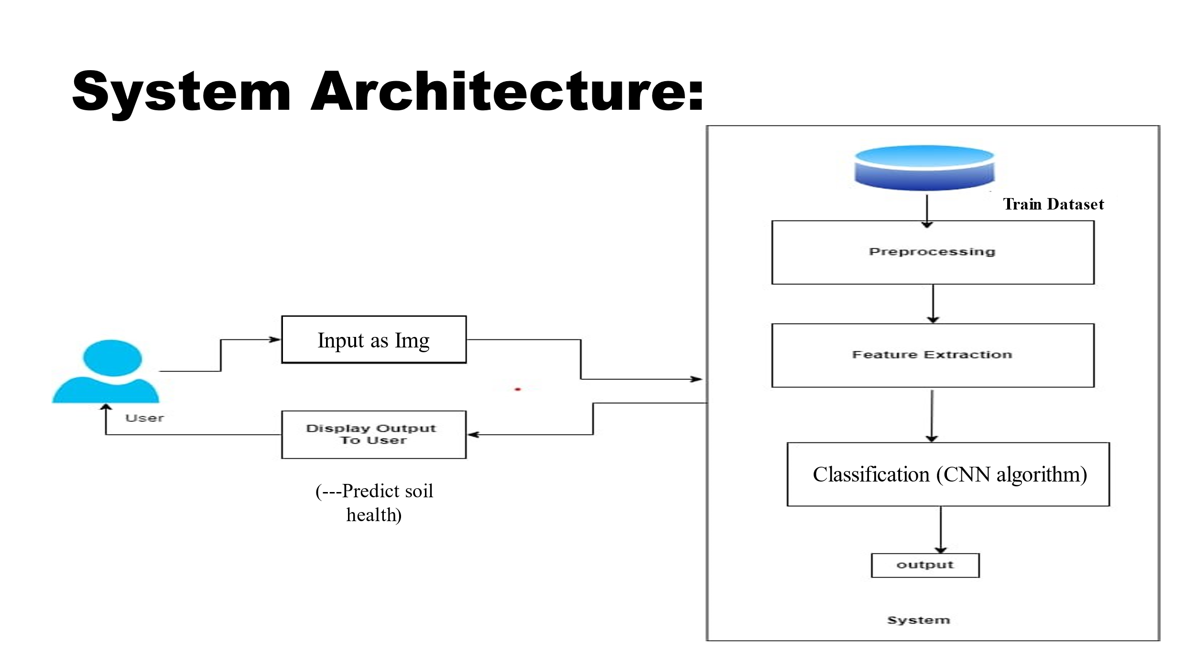

Figure 5.1: System Architecture

15

* 1. DFD Level 0

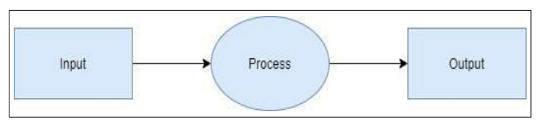

Figure 5.2: Level 0 DFD

* 1. DFD Level 1

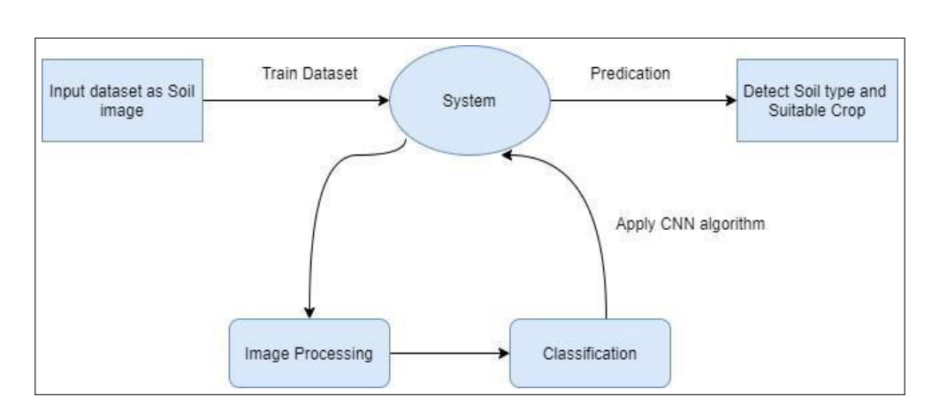

Figure 5.3: Level 1 DFD

* 1. DFD Level 2

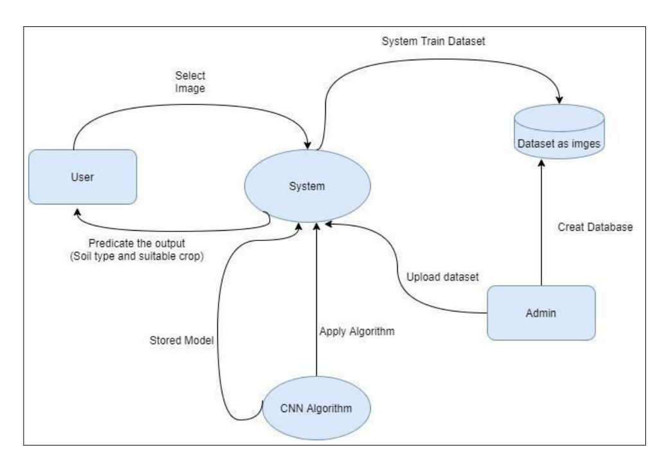

Figure 5.4: Level 2 DFD

* 1. Use Case Diagram

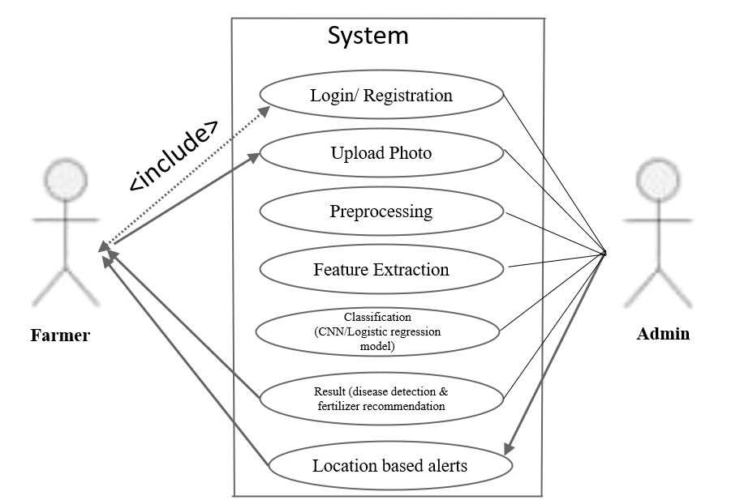

Figure 5.5: use case Diagram

### Deployment Diagram

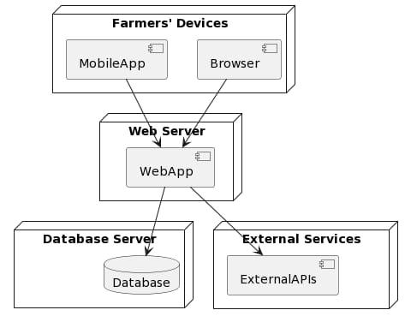

Figure 5.6: deployment Diagram

**Chapter 6**

**System Implementation**

**6.1 Methodology**

This project follows an Agile Development Methodology to ensure flexibility and iterative progress. The Agile approach breaks the project into sprints and ensures continuous feedback loops between development, testing, and stakeholders.

**Steps in the Methodology:**

1. **Requirement Gathering and Analysis**
   * Collect soil datasets, determine the machine learning algorithms to use, and set project objectives.
   * Collaborate with agricultural experts to identify key soil parameters (pH, moisture, nutrients) required for classification.
2. **Data Preprocessing and Model Development**
   * Perform data cleaning, normalization, and exploratory data analysis (EDA).
   * Train ML models (Decision Trees, KNN, SVM) using historical datasets.
3. **Incremental Development of Features (Sprints)**
   * Sprint 1: Develop and test the backend (Node.js) and frontend (React) interface.
   * Sprint 2: Integrate and validate ML models for soil classification.
   * Sprint 3: Add recommendation engine for crop selection and soil treatment.
4. **Testing and Feedback Loop**
   * Conduct unit and integration testing after each sprint.
   * Gather feedback from field trials and adjust models accordingly.
5. **Deployment and Continuous Improvement**
   * Deploy on AWS with Docker containers to ensure scalability.
   * Use feedback loops to refine algorithms and user experience over time.

**6.2 Modules and Their Descriptions**

The system is divided into key modules to ensure modularity, scalability, and better maintainability. Below are the primary modules along with their **roles and descriptions:**

**1. Data Collection Module**

* Collect soil samples and input data (physical and chemical properties such as pH, moisture, nitrogen, phosphorus, potassium).
* Enable image uploads for soil texture and color analysis.
* Integrate microcontrollers or sensors to collect real-time soil data (optional).

**2. Data Preprocessing Module**

* Perform data cleaning to handle missing values and outliers.
* Normalize features to ensure consistent input across models.
* Segment images to extract soil regions for texture analysis.
* Split the data into training (80%) and testing (20%) sets.

**3. Soil Classification Module**

* Implement machine learning models for classification:
  + Decision Trees (DT): For hierarchical soil classification.
  + Support Vector Machine (SVM): For complex pattern detection.
  + K-Nearest Neighbor (KNN): For nutrient-based soil classification.
* Store model predictions and accuracy metrics for future reference.

**4. Recommendation Module**

* Generate personalized crop suggestions based on soil classification.
* Provide fertilizer recommendations to optimize soil fertility.
* Suggest corrective actions for pH adjustments or moisture management.

**5. User Interface Module**

* Develop a web and mobile interface using React and Tailwind CSS.
* Features include soil image upload, manual data input, and real-time classification results.
* Provide easy-to-understand visualizations (charts and graphs) of soil health.

**6. Reporting and Feedback Module**

* Generate detailed reports summarizing soil analysis and recommendations.
* Include visualizations such as confusion matrices and performance metrics.
* Collect user feedback to continuously improve the system.

**7. Backend and Database Module**

* Use Node.js and Express for the backend.
* Store soil data, classification results, and user inputs in MongoDB or MySQL.
* Provide APIs for data retrieval and interaction between components.

**8. Deployment and Monitoring Module**

* Deploy the platform on AWS EC2 instances with Docker containers.
* Use CloudWatch or New Relic to monitor system health and performance.
* Implement automatic scaling to handle peak loads.

**6.3 Challenges and Problem-Solving**

During system implementation, various challenges are encountered. Below are the key challenges faced and the solutions implemented:

**1. Model Performance Issues**

* **Challenge**: Some machine learning models underperformed during early testing, showing low accuracy for specific soil types.
* **Solution**:
  + Conducted hyperparameter tuning (e.g., adjusting tree depth for Decision Trees, kernel parameters for SVM).
  + Added cross-validation to improve model robustness.
  + Augmented the dataset by incorporating additional samples from agricultural research databases.

**2. Data Inconsistencies**

* **Challenge**: Soil datasets contained missing values and noisy data, affecting model performance.
* **Solution**:
  + Used KNN imputation to fill in missing data.
  + Applied outlier detection techniques to filter out erroneous data points.
  + Normalized all features to ensure uniform input across the models.

**3. Integration Issues Between Frontend and Backend**

* **Challenge**: Communication between the React frontend and Node.js backend was initially unstable.
* **Solution**:
  + Refined API endpoints to handle input data efficiently.
  + Conducted integration tests to verify smooth data flow between components.

**4. Real-time Classification Speed**

* **Challenge**: The system’s response time was slow during real-time soil classification.
* **Solution**:
  + Optimized model inference by preloading trained models into memory.
  + Used batch processing for image inputs to reduce server load.

**5. Compatibility Across Devices**

* **Challenge**: The web interface didn’t render correctly on all mobile devices, causing usability issues for farmers.
* **Solution**:
  + Ensured the frontend was fully responsive using Tailwind CSS.
  + Conducted device testing across Android, iOS, and desktop browsers.

**6. Security Concerns**

* **Challenge**: The platform needed to protect user data and soil reports from unauthorized access.
* **Solution**:
  + Implemented SSL/TLS encryption to secure communication.
  + Set up role-based access control (RBAC) to restrict access to sensitive data.

**7. Deployment Issues**

* **Challenge**: Initial deployment on AWS EC2 resulted in configuration errors.
* **Solution**:
  + Used Docker containers to ensure consistency between development and production environments.
  + Implemented CI/CD pipelines for smooth updates and deployments



BE Information Technology [2023-24], MMCOE Pune, SPPU 21

**Chapter 9 Conclusion**

The "**Testing and Classification of Soil for Plant Cultivation**" project successfully developed a machine learning-based platform to analyze soil properties and provide personalized crop recommendations. By integrating advanced algorithms such as Decision Trees, SVM, and KNN, the system offers accurate soil classification and actionable insights to empower farmers and promote precision agriculture.

Throughout the development process, the project addressed key challenges, including data inconsistencies, model optimization, and system integration, ensuring the platform is reliable, scalable, and user-friendly. The use of Agile methodology enabled continuous improvement based on user feedback, resulting in a robust system that meets the practical needs of farmers. The platform's web and mobile interfaces ensure accessibility, even in rural areas, contributing to the digital transformation of agriculture.

The deployment on AWS with cloud-based infrastructure ensures scalability to accommodate future expansions, such as additional soil parameters or crop recommendations. The inclusion of feedback mechanisms allows the platform to evolve, adapting to changing agricultural needs and new research findings.

**Key Achievements**

1. Accurate Soil Classification: The machine learning models achieved high accuracy, with Decision Trees performing best, providing farmers with precise soil health assessments.
2. Personalized Crop Recommendations: The system offers tailored suggestions to optimize crop selection and soil treatment.
3. Scalable and Accessible Platform: Hosting on AWS ensures the platform can handle increased user traffic and operate across various devices.
4. Real-Time Performance: Optimized inference time ensures quick responses, enhancing the user experience.

**Future Enhancements**

* Expand the dataset to include more soil types and environmental conditions.
* Incorporate weather forecasts and remote sensing data to improve recommendations.
* Implement IoT integration for real-time soil monitoring using sensors.
* Continuously update the platform based on user feedback and agricultural research.

**Impact and Contribution**

This project provides a significant contribution to precision agriculture, helping farmers make data-driven decisions to improve crop yield and reduce waste. By making soil analysis faster and more accessible, it promotes sustainable farming practices, ultimately benefiting both farmers and the environment.

**Chapter 10**

**Future Work**

The **"Testing and Classification of Soil for Plant Cultivation"** project lays a strong foundation for leveraging machine learning in agriculture. However, several enhancements and extensions can be implemented to improve system performance, expand capabilities, and increase its impact on precision farming. Below are key areas for future development.

**Integration of IoT and Real-Time Data Monitoring**

* Goal: Incorporate IoT sensors for continuous monitoring of soil properties such as moisture, temperature, and pH.
* Impact: Provide real-time soil health data to improve the accuracy of crop recommendations.
* Implementation: Use Bluetooth-enabled microcontrollers to transmit data from the field to the platform.

**Incorporate Satellite Data and Weather Forecasts**

* Goal: Integrate remote sensing data and weather forecasts into the recommendation engine.
* Impact: Enable seasonal crop predictions and adaptive recommendations based on weather changes.
* Implementation: Use data from sources such as the ESA Climate Change Initiative (CCI) Soil Moisture Product to predict water retention and drought risks.

**Expand the Dataset for More Soil Types and Regions**

* Goal: Add soil data from more regions and cover a wider variety of soil types (e.g., arid, saline, volcanic soils).
* Impact: Make the platform applicable in diverse geographical regions and improve classification accuracy.
* Implementation: Collaborate with agricultural institutions and collect datasets through field studies.

**Advanced Machine Learning and Deep Learning Models**

* Goal: Experiment with ensemble learning methods and deep learning algorithms such as CNNs and LSTMs for improved accuracy.
* Impact: Handle complex and non-linear soil datasets more effectively.
* Implementation: Apply transfer learning techniques using pre-trained models to reduce computational overhead.

**Personalized Recommendations with Adaptive Learning**

* Goal: Implement adaptive learning mechanisms that adjust recommendations based on past performance and user feedback.
* Impact: Improve the relevance of crop recommendations and maximize user satisfaction.
* Implementation: Use reinforcement learning algorithms to update the recommendation model dynamically.

**Mobile App Enhancement for Offline Access**

* Goal: Develop features that allow the mobile app to work offline, enabling farmers in remote areas to use the platform without internet access.
* Impact: Ensure continuous access to soil analysis tools even in low-connectivity regions.
* Implementation: Use local data caching and sync with the server when internet access is available.

**Collaboration with Agricultural Organizations and Government Initiatives**

* Goal: Partner with agricultural agencies and government bodies to promote adoption at scale.
* Impact: Contribute to sustainable farming initiatives and national agricultural programs.
* Implementation: Integrate the platform with existing government databases and soil health initiatives.

**Predictive Crop Yield Forecasting**

* Goal: Use historical data and AI-based predictive models to forecast crop yields based on soil health and environmental conditions.
* Impact: Help farmers and policymakers plan agricultural operations and minimize crop losses.
* Implementation: Develop predictive models using regression techniques to forecast yield trends.

# Bibliography

1. Bhargavi, P., & Jyothi, S. (2009). *Applying Naïve Bayes Data Mining Technique for Classification of Agricultural Land Soils*. ResearchGate.
2. Chai, S. H., Stojimirovic, T., & Yacoub, T. (2023). *Applying Logistic Regression Analysis in Modeling Settlement Analysis with Ground Improvement*. Rocscience.
3. de Figueiredo, T., Royer, A. C., Fonseca, F., Schütz, F. C. A., & Hernández, Z. (2020). *Regression Models for Soil Water Storage Estimation Using the ESA CCI Satellite Soil Moisture Product: A Case Study in Northeast Portugal*. *MDPI*.
4. Ghadimi, F. (2014). *Prediction of Degree of Soil Contamination Based on Support Vector Machine and K-Nearest Neighbor Methods: A Case Study in Arak, Iran*. *Iranica Journal of Energy & Environment*, 5(4), 345-353.
5. Jayalakshmi, R., & Savitha Devi, M. (2021). *Predictive Model Construction for Prediction of Soil Fertility Using Decision Tree Machine Learning Algorithm*. INFOCOMP.
6. Maniyath, S. R., Hebbar, R., Akshatha, K. N., Architha, L. S., & Subramoniam, S. R. (2018). *Soil Color Detection Using KNN Classifier*. *2018 International Conference on Design Innovations for 3Cs: Compute, Communicate, Control*.
7. Raju, P. G., Sowmya, M., Chakradhar, N., & Kumar, R. N. (2024). *A Review on Soil Classification Using Machine Learning Techniques*. *International Journal of Research Publication and Reviews*, 5(1), 599-604.
8. Sholagberu, A. T., Mustafa, M. R. U., Yusof, K. W., Hashim, A. M., Shah, M. M., Khan, M. W. A., & Isa, M. H. (2018). *Multivariate Logistic Regression Model for Soil Erosion Susceptibility Assessment Under Static and Dynamic Causative Factors*.
9. Solehatin, H., & Pertiwi, D. A. A. (2023). *Application of the KNN Method to Check Soil Compatibility Using a Microcontroller for Android-based Banyuwangi Citrus Fruit Plants*. *Journal of Soft Computing Exploration*.
10. Vispute, S., & Saini, M. L. (2022). *Performance Analysis of Soil Health Classifiers Using Data Analytics Tools and Techniques for Best Model and Tool Selection*. *Poornima University*.