INTERNSHIP TECHNICAL REPORT: TASK 2
Company: Maincrafts Technology
Course/Program: VLSI Design Internship
Intern name:Shubham Dudhe
Task 2 Title: Introduction to Verilog HDL and RTL Design of Basic Combinational Circuits
1. Objective & Industrial Context
Objective
The primary objective of this task is to transition from schematic-level digital design to modern code-based Register Transfer Level (RTL) implementation. This involves mastering Verilog Hardware Description Language (HDL) to model, simulate, and functionally validate foundational combinational hardware blocks.
Industrial Context
In the semiconductor industry, digital Integrated Circuits (ICs) are entirely specified using HDLs like Verilog or SystemVerilog, rendering manual schematic entry obsolete outside introductory environments. Industry-ready VLSI engineers must develop abstract hardware mental models, write highly clean, synthesizable RTL descriptions, and construct dedicated validation environments (testbenches) to verify design criteria before physical synthesis occurs.

2. Theoretical Background & RTL Architecture
Register Transfer Level (RTL) vs. Sequential Programming
Unlike software development environments where commands execute sequentially, Verilog models structural concurrency. Signals represent physical physical wires, and assignments operate in parallel, executing concurrently to reflect real-time electrical propagation delays across logical elements.
Design Methodology
We leverage Continuous Assignment via the assign keyword to describe combinational logic execution. This technique updates the target output variable dynamically whenever an operand on the right-hand side switches states, accurately representing real physical logic hardware behavior.

3. Hardware Implementation Modules (RTL Code)
The following synthesizable modules have been constructed within separate design source files
3.1 Basic Logic Gates (logic_gates.v)
This module aggregates elementary bitwise operations executing concurrently to drive outputs based on input stimuli.
// File: logic_gates.sv
module logic_gates (
input A,
input B,
output Y_And,
output Y_Or,
output Y_Not,
output Y_Nand,
output Y_Nor,
output Y_Xor
);

// Continuous assignments for standard primitives
assign Y_And = A & B; // AND gate
assign Y_Or = A | B; // OR gate
assign Y_Not = ~A; // NOT gate (acting on input A)
assign Y_Xor = A ^ B; // XOR gate
assign Y_Nand = ~(A & B); // NAND gate
assign Y_Nor = ~(A | B); // NOR gate

endmodule
3.2 Half Adder RTL Design (half_adder.sv)
A Half Adder handles two single-bit binary inputs (A and B) to produce a two-bit output: a Sum bit and a Carry bit.
$$\text{Sum}=A⊕B$$
$$\text{Carry}=A⋅B$$
// File: half_adder.sv
module half_adder (
input A,
input B,
output Sum,
output Carry
);

// Combinational logic expressions for Half Adder
assign Sum = A ^ B; // Bitwise XOR
assign Carry = A & B; // Bitwise AND

endmodule
3.3 Full Adder RTL Design (full_adder.v)
A Full Adder circuit computes the arithmetic sum of three single-bit inputs (A,B, and an incoming carry bit
$$\text{Sum}=A⊕B⊕C_{in}$$

$${\text{C}}_{out}=\left(A⋅B\right)+\left(B⋅C_{in}\right)+\left(A⋅C_{in}\right)$$
// File: full_adder.v
module full_adder (
input A,
input B,
input Cin,
output Sum,
output Cout
);
// Combinational logic expressions for Full Adder
assign Sum = A ^ B ^ Cin;[cite: 1]
assign Cout = (A & B) | (B & Cin) | (A & Cin);[cite: 1]
endmodule
4. Verification Environment (Testbench Architecture)
To functionally evaluate the modules, a non-synthesizable verification testbench (tb_half_adder.v) was created. It initializes inputs as reg (registers) to retain scalar values and reads out variables on a probing wire network. The Unit Under Test (UUT) is instantiated, and an explicit sequence of timed stimulus vectors tests all boundary combinations.
// File: tb_half_adder.v
`timescale 1ns / 1ps

module tb_half_adder;

// Declare registers for inputs and wires for outputs
reg A;
reg B;
wire Sum;
wire Carry;

// Instantiate the Unit Under Test (UUT)
half_adder uut (
.A(A),
.B(B),
.Sum(Sum),
.Carry(Carry)
);

// Generate Stimulus Vectors
initial begin
// File dump configuration for waveform analysis
$dumpfile("dump.vcd");
$dumpvars(0, tb_half_adder);

// Truth Table Evaluation Loop
A = 0; B = 0; #10; // State 00
A = 0; B = 1; #10; // State 01
A = 1; B = 0; #10; // State 10
A = 1; B = 1; #10; // State 11

$finish; // Terminate Simulation run execution
end
endmodule

5. EDA Playground Simulation Flow
Instead of requiring terminal compilation tools locally, the simulation was completely handled in the cloud platform using the following settings:
- Design & Testbench Panes: The design code (half_adder.v) was entered in the right-hand panel, and the testbench code (tb_half_adder.v) was pasted into the left-hand panel.

- Tool Selection: From the left sidebar options under "Tools & Simulators", Icarus Verilog was targeted as the interactive compiler tool.

- EPWave Integration: The checkbox option for "Open EPWave after run" was checked to automatically compile and generate the integrated browser signal waveform output without downloading external software utilities.
- Execution: The "Run" command button was triggered to evaluate code validity, check for continuous assignments, and execute test stimulus tracks.
Waveform Analysis Audit Checklist
During EPWave visual trace auditing, the output data traces were audited against the following functional constraints:
- Functional Validation: Verified that output pins match truth table matrix expectations for both standard logic blocks and adder units.
- State Assessment: Evaluated traces to confirm zero instances of unknown high-impedance
- or uninitialized indeterminate states
- Timing Integrity: Assessed simultaneous signal switching alignment bounded inside the active 10ns timing windows.
- Functional Verification Results

“Waveform outputs for basic gates, half adder, and full adder are included in the results/ folder. Figures verify correctness against the truth tables.”
Basic Gate WAvefrom:
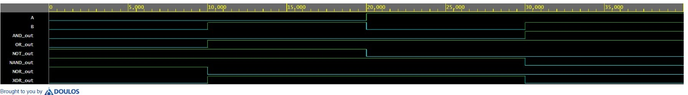
Half Adder Wavefrom
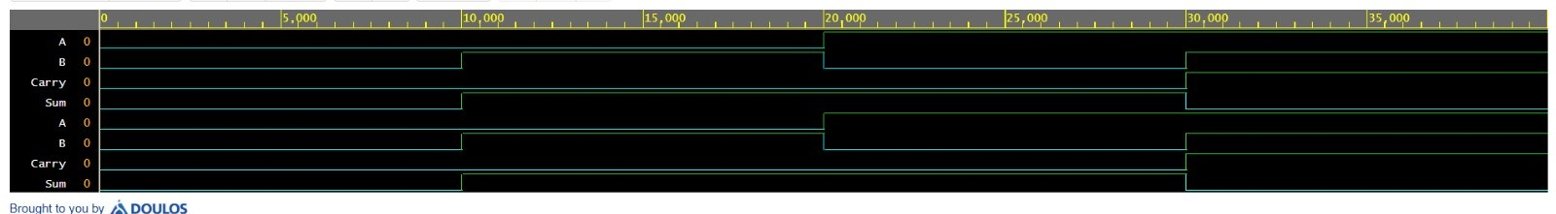

Full adder wavefrom
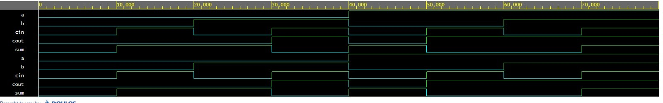

Truth Table :Basic gates
Input A | Input B | AND (A &B) | OR (A|B) | NOT A (~A) | NAND (~(A & B)) | NOR  (~(A|B)) | XOR (A ^ B)
0 | 0 | 0 | 0 | 1 | 1 | 1 | 0
0 | 1 | 0 | 1 | 1 | 1 | 0 | 1
1 | 0 | 0 | 1 | 0 | 1 | 0 | 1
1 | 1 | 1 | 1 | 0 | 0 | 0 | 0

Half Adder Verification Matrix
The simulated cloud timing waveforms confirm exact behavioral compliance with the theoretical truth table:
Input A | Input B | Simulated Sum | Simulated Carry | Status
0 | 0 | 0 | 0 | Passed
0 | 1 | 1 | 0 | Passed
1 | 0 | 1 | 0 | Passed
1 | 1 | 0 | 1 | Passed
Truth Table:full adder
Input A | Input B | Input Cin | Output Sum | Output Cout
0 | 0 | 0 | 0 | 0
0 | 0 | 1 | 1 | 0
0 | 1 | 0 | 1 | 0
0 | 1 | 1 | 0 | 1
1 | 0 | 0 | 1 | 0
1 | 0 | 1 | 0 | 1
1 | 1 | 0 | 0 | 1
1 | 1 | 1 | 1 | 1

7. Key Learning Outcomes & Deliverables
Summary of Completed Deliverables
- Source RTL Codebases: Completed functional implementation across logic_gates.v, half_adder.v, and full_adder.v files.
- Verification Suite: Produced a comprehensive self-terminating validation testbench environment script.
- Simulation Data Log: Generated cloud-rendered timing waveforms showing exact matching logic execution parameters.
Engineering Core Competencies Gained
- Formulated abstract logical boolean equations using concurrent structural assignments in Verilog.
- Developed robust, modular testbenches to assert complete combinatorial input validation coverage.
- Evaluated logic trace waveforms via browser-integrated simulation pipelines.
- Standardized clean RTL coding styles to lay a solid foundation for physical gate synthesis conversion in subsequent internship blocks.
8. Results & Analysis
- The combinational circuits described in this task were completely simulated using the Icarus Verilog toolchain on the EDA Playground platform. Visual validation of the designs was carried out using the integrated EPWave browser window to analyze the behavior of the output traces against the generated timing stimuli.
- 6.1 Logic Verification Analysis
- Basic Logic Gates: The logic_gates.v module successfully processed input logic combinations. The NOT gate tracked inverted states cleanly, while the AND, OR, NAND, NOR, and XOR ports accurately updated their signal levels dynamically within the timeline layout without experiencing indeterminate propagation glitches.
- Half Adder: The testbench stimulus verified all 4 states of the truth table. As shown in the simulation matrix, when both inputs $A$ and $B$ were driven high (1), the Sum output dropped to 0 and the Carry line went to 1 in accordance with structural binary arithmetic constraints.
- Full Adder: The design logic accommodated the three incoming variable tracks flawlessly. The output trace transitions followed the boolean properties of parity checking ($Sum$) and majority logic tracking ($C_{out}$), responding accurately when input configurations updated.
- 6.2 Waveform Integrity Audit
- During the EPWave trace evaluation, a targeted signal sanity checklist was executed to ensure technical compliance:
- Functional Validation: Every output transition strictly mirrored the corresponding state row in the targeted logic truth tables.
- State Assessment: The waveform window was audited for timing anomalies. Signals maintained clean binary logical highs (1) or lows (0), demonstrating zero occurrences of uninitialized indeterminate states (X) or floating high-impedance states (Z).
- Timing Alignment: Simultaneous signal switches adjusted predictably within the active 10ns simulation step intervals, validating structural concurrency under parallel hardware execution rules.
7. Conclusion
- Task 2 of the VLSI Design Internship was completed successfully, marking a functional transition from schematic diagrams to code-based Register Transfer Level (RTL) development. By engineering synthesizable modules for fundamental logic gates, a Half Adder, and a Full Adder using Verilog HDL, the core mechanics of hardware concurrency and structural continuous assignment were practically mastered.
- The verification stage highlighted the critical industry role of testbenches in isolating and evaluating logic behavior before synthesis. Running simulations seamlessly via EDA Playground with the Icarus Verilog compiler and EPWave toolchain provided immediate functional verification matching the strict boundary criteria of the circuits' truth tables. Ultimately, this task successfully establishes the core RTL programming, system debugging, and waveform interpretation skills needed to handle higher-level digital synthesis projects in subsequent design blocks.
-------------------------------------------------------------------------------------------------------------------------

