MolRepBench: Interpretable Toxicity & ADMET Screening from Molecular Structure
Mini Project Report
Shubham Gangwar
MS23BTECH11027
Domain: Predictive Toxicology / AI in Drug Discovery

Contents
Abstract
1. Introduction
1.1 Background
1.2 Motivation
1.3 Problem statement
1.4 Objectives
1.5 Scope and limitations of scope
2. Background and related work
2.1 Molecular representation
2.2 Benchmarks and the evaluation trap
2.3 Interpretability and applicability domain
3. Datasets
3.1 Standardisation pipeline
3.2 Class imbalance and missing labels
4. Methodology
4.1 Featurisation
4.2 Models
4.3 Scaffold splitting
4.4 Leakage audit
4.5 Metrics and thresholding
4.6 Interpretability
4.7 Applicability domain
5. System design and implementation
6. Results and discussion
6.1 Representation comparison
6.2 The split protocol moves scores more than the model does
6.3 The variance problem
6.4 Why metric choice changes the conclusion
6.5 Scaffold splits are expensive
7. Interpretability in practice
7.1 SHAP attribution recovers known pharmacophores
7.2 Attention is informative on one model in four — and the difference is not visible
7.3 What the two methods can and cannot claim
8. Deployment
9. Limitations
10. Conclusion and future work
References
Figures
Figure 1. Dataset sizes and mean active rates
Figure 2. Headline metric per model on each dataset; graph networks in blue, descriptor models in grey
Figure 5. Identical models under the two scaffold-split protocols
Figure 3. ROC-AUC versus PR-AUC across the twelve Tox21 assays, ordered by active rate
Figure 4. Per-assay Tox21 performance for the best descriptor model and the best graph network
Figure 6. Per-atom SHAP attribution on the NR-ER endpoint
Figure 7. The four ECFP4 environments with the largest SHAP values for bisphenol A
Figure 8. Estradiol under all four Attentive FP models, drawn on an absolute colour scale where full saturation corresponds to three times uniform attention
Figure 9. The ClinTox model's attention on the three example compounds — the one case in this benchmark where the readout is selective enough to be worth reading
Tables
Table 1. The four benchmark datasets after standardisation
Table 2. Model configurations
Table 3. Train/test leakage audit
Table 4. Best descriptor model vs
Table. Full tox21 benchmark, mean ± s
Table. Full clintox benchmark, mean ± s
Table. Full bbbp benchmark, mean ± s
Table. Full esol benchmark, mean ± s
Table 5. The same models under two scaffold-split protocols, ROC-AUC

Abstract
Toxicity and poor ADMET properties are a leading cause of late-stage drug-candidate failure, and wet-lab screening cannot cover a chemical space estimated at 10^60 drug-like molecules. This project builds MolRepBench, a system that predicts toxicity and ADMET risk directly from a molecule's SMILES string and explains each prediction at the substructure level. Descriptor-based models — ECFP4 circular fingerprints and RDKit 2D descriptors fed to Random Forest, XGBoost and a deep neural network — are benchmarked against three graph neural networks (GCN, GAT and Attentive FP) on four MoleculeNet datasets: tox21, clintox, bbbp, esol. All models are evaluated under balanced Bemis-Murcko scaffold splits over three seeds, which forces generalisation to chemotypes absent from training, and are scored with ROC-AUC, PR-AUC and MCC so that severe class imbalance cannot be hidden by a single flattering metric. Across 4 datasets, descriptor-based models won on 4 and graph neural networks on 0. Interpretability is provided by TreeSHAP values computed on fingerprint bits and redistributed onto the atoms of each circular environment, and by the readout attention of the Attentive FP network, which is shown to be informative on only one of the four fitted models and is therefore screened by a concentration diagnostic before it is ever displayed as an explanation. The resulting models are deployed as a Streamlit application that accepts a SMILES string and returns a per-endpoint risk panel with a confidence flag derived from an applicability-domain analysis, so that predictions on compounds outside the training chemical space are explicitly marked as unreliable.
Keywords: predictive toxicology, QSAR, molecular fingerprints, graph neural networks, scaffold split, SHAP, applicability domain, ADMET.

1. Introduction
1.1 Background
Bringing a drug to market takes 10–15 years and costs on the order of a billion dollars, and roughly nine out of ten candidates that enter clinical trials fail. Toxicity and unfavourable ADMET properties — absorption, distribution, metabolism, excretion and toxicity — account for a large share of those failures. Crucially, the cost of a failure grows with how late it is discovered: a toxic liability found in a Phase II trial has already consumed years of development and the entire preclinical budget, whereas the same liability found before synthesis costs almost nothing.
This asymmetry is what motivates computational screening. If a model can read a molecule's structure and flag likely toxicity in milliseconds, a medicinal chemist can triage thousands of candidate structures before committing laboratory resources to any of them. The field that studies this — quantitative structure-activity relationship (QSAR) modelling — is decades old, but the arrival of deep learning on molecular graphs has raised a specific, practical question that this project addresses directly.
1.2 Motivation
Graph neural networks (GNNs) treat a molecule as what it physically is — atoms connected by bonds — and learn their own representation from the data rather than being handed one. In domains with abundant labelled data this approach has displaced hand-designed features almost completely. Molecular property prediction, however, is not such a domain. Public toxicity datasets contain thousands, not millions, of labelled molecules, and the positive class is often rarer than one in twenty. The question of whether learned graph representations actually outperform decades-old fingerprints under these conditions is therefore an empirical one, and it is frequently answered badly: many published comparisons use random train/test splits, which leak close structural analogues into the test set and inflate every score.
A second gap is interpretability. A screening model that outputs a probability and nothing else is of limited use to a chemist, who needs to know which part of the molecule is responsible in order to redesign it. A third gap is honesty about scope: every QSAR model is valid only within the chemical space it was trained on, yet most deployed models return a confident-looking number for any input, including molecules utterly unlike anything they have seen.
1.3 Problem statement
Build a system that predicts toxicity and ADMET risk from a molecule's SMILES string; establish, under an honest evaluation protocol, which molecular representation works better on small and imbalanced data; explain every prediction at the level of chemical substructures; and deploy the result as an application that flags compounds lying outside the training chemical space.
1.4 Objectives
- Assemble and standardise four MoleculeNet benchmarks spanning toxicity (Tox21, ClinTox) and ADMET (BBBP for distribution, ESOL for solubility).
- Implement three molecular representations — ECFP4 circular fingerprints, RDKit 2D descriptors, and atom/bond graphs — behind a common interface.
- Benchmark six descriptor-based model configurations (Random Forest, XGBoost and a DNN on each of two feature sets) against three graph neural networks (GCN, GAT, Attentive FP).
- Evaluate under balanced Bemis-Murcko scaffold splits across three seeds, reporting ROC-AUC, PR-AUC and MCC for classification and RMSE, MAE and R² for regression.
- Attribute each prediction to chemical substructures using TreeSHAP on fingerprint bits and attention weights from the graph networks.
- Quantify an applicability domain and convert it into a user-facing confidence flag.
- Deploy the trained models in a Streamlit application that returns a per-endpoint risk panel from a single SMILES input.
1.5 Scope and limitations of scope
This project is a benchmark and a prototype, not a validated regulatory tool. It uses public benchmark data with its own assay noise and selection biases; it does not perform prospective experimental validation; and it uses fixed, literature-standard hyperparameters per model family rather than an exhaustive per-dataset search. These choices are deliberate — the goal is a fair, reproducible comparison of representations under a realistic evaluation protocol, not a maximally tuned leaderboard entry — but they bound how strongly the conclusions can be stated.

2. Background and related work
2.1 Molecular representation
A machine-learning model cannot consume a molecule directly; the molecule must first become a vector or a structured object. Three families of representation dominate, and all three are implemented and compared here.
Extended-connectivity fingerprints (ECFP, Rogers & Hahn 2010) encode a molecule as a sparse bit vector. Each atom is assigned an initial identifier, identifiers are iteratively updated by hashing together each atom's own identifier with those of its neighbours, and every identifier generated along the way sets a bit in a fixed-length vector. With radius 2 — ECFP4, the variant used here, named for its diameter — each bit therefore records the presence of a particular circular atom environment up to two bonds out. Fingerprints are fast, require no training, and have a property that matters greatly for this project: every bit corresponds to a concrete, drawable substructure, which makes feature attribution chemically meaningful.
Physicochemical descriptors take the opposite approach, encoding decades of medicinal-chemistry knowledge as explicit calculated properties: molecular weight, calculated logP, topological polar surface area, hydrogen-bond donor and acceptor counts, ring counts, fragment counts and many graph-topological indices. RDKit provides roughly 210 such descriptors. Where fingerprints describe local substructure, descriptors describe global, whole-molecule properties — which is why the two are complementary rather than redundant, and why both are benchmarked separately here.
Graph neural networks dispense with hand-designed features altogether. A molecule becomes a graph whose nodes are atoms and whose edges are bonds; each node carries a feature vector (element, degree, formal charge, hybridisation, aromaticity, chirality, hydrogen count) and each edge carries bond features (order, conjugation, ring membership, stereochemistry). Message passing then updates every atom's representation from its neighbours over several rounds, and a readout function pools atom representations into a molecule-level vector. The Graph Convolutional Network (Kipf & Welling 2017) applies a degree-normalised sum; the Graph Attention Network (Veličković et al. 2018) learns attention coefficients over neighbours; and Attentive FP (Xiong et al. 2019) was designed specifically for molecules, adding a molecule-level node that attends over all atoms during an iterative readout — which, conveniently, yields per-atom attention weights that can be read as an explanation.
2.2 Benchmarks and the evaluation trap
MoleculeNet (Wu et al. 2018) assembled the standard benchmark suite for molecular property prediction and, importantly, argued that scaffold splitting rather than random splitting should be used for most of its datasets. The argument is straightforward: in real drug discovery the question is never 'how does this model perform on a molecule almost identical to one it has seen', but 'how does it perform on a new chemical series'. A random split answers the first question; a scaffold split, which groups molecules by their Bemis-Murcko framework (Bemis & Murcko 1996) and assigns whole frameworks to a single subset, answers the second. Scores under scaffold splits are systematically and sometimes dramatically lower, which is precisely why the protocol matters.
A parallel trap concerns metrics. Tox21's assays have active rates between roughly 3% and 16%. ROC-AUC is insensitive to class imbalance by construction — it measures ranking across all thresholds and its baseline is 0.5 regardless of how rare positives are. Precision-recall AUC, by contrast, has a baseline equal to the positive rate, so it falls honestly when actives are rare. The Matthews correlation coefficient evaluates the thresholded decisions themselves and is balanced across both classes. Reporting all three, as this project does, makes it visible when a respectable ROC-AUC conceals a model whose actual yes/no calls are near worthless.
2.3 Interpretability and applicability domain
SHAP (Lundberg & Lee 2017) assigns each feature a contribution to an individual prediction, derived from Shapley values in cooperative game theory, with the guarantee that contributions sum to the difference between the prediction and the expected output. TreeSHAP computes these exactly and efficiently for tree ensembles. Applied to a fingerprint model, SHAP yields a contribution per bit; because each bit maps to a circular atom environment, those contributions can be redistributed onto atoms to produce a chemically readable heat map — the approach taken here.
Attention weights offer a different kind of explanation. They are internal to the forward pass and show where the model attended, which is related to but not the same as what caused the output; the distinction is well documented in the NLP literature and applies equally to molecular graphs. This project reports both and treats their agreement as corroborating evidence rather than either one as proof.
The applicability domain concept, formalised in OECD guidance on QSAR validation, holds that a model's predictions are only defensible for compounds sufficiently similar to its training set. The standard operationalisation — used here — is a distance-to-training-set measure, typically similarity to the k nearest training molecules, thresholded against the distribution of that same statistic within the training set itself.

3. Datasets
Four MoleculeNet datasets were selected to cover both toxicity and ADMET, and both classification and regression, while remaining in the small-data regime where the representation question is genuinely open.
Dataset | Category | Endpoint | Molecules | Tasks | Task type
tox21 | Toxicity | 12 nuclear-receptor and stress-response assays from the Tox21 2014 challenge | 7,611 | 12 | Classification
clintox | Toxicity | FDA-approved drugs vs. compounds that failed clinical trials for toxicity | 1,380 | 2 | Classification
bbbp | ADMET — distribution | Blood-brain barrier penetration (binary) | 1,955 | 1 | Classification
esol | ADMET — solubility | Measured aqueous solubility, log mol/L (Delaney) | 1,117 | 1 | Regression
Table 1. The four benchmark datasets after standardisation.
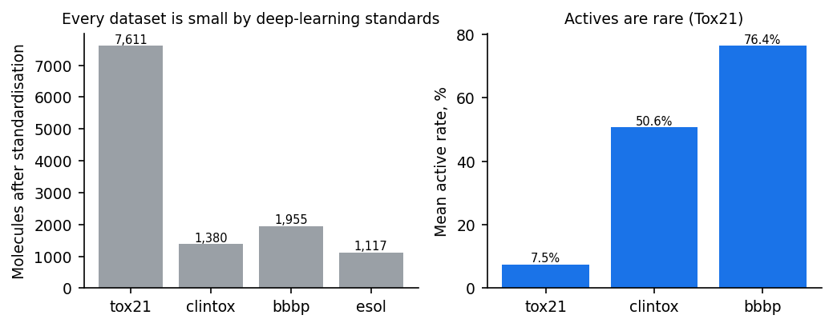
Figure 1. Dataset sizes and mean active rates. Every dataset is small by deep-learning standards, and Tox21's actives are rare — the two conditions under which hand-designed representations are expected to remain competitive.
3.1 Standardisation pipeline
Raw MoleculeNet files contain salts, charged species, duplicate structures written as different SMILES strings, and a small number of entries that fail RDKit sanitisation. Left untreated, these cause two concrete problems: the same compound can appear in both the training and the test split under two different strings, inflating scores; and counter-ions contribute fingerprint bits that carry no information about the compound's biology. Every molecule was therefore passed through the following pipeline:
- Parse the SMILES string with RDKit; entries that fail a permissive re-sanitisation are dropped.
- Keep only the largest organic fragment, which removes salts and counter-ions.
- Neutralise charges where chemically sensible, using RDKit's Uncharger.
- Write canonical SMILES and verify the result round-trips through full sanitisation.
- Group by canonical SMILES and average labels; for classification, duplicates carrying conflicting labels are discarded rather than resolved arbitrarily.
This removes between 2% and 5% of each raw file. Tox21 falls from 7,831 to 7,611 molecules, ClinTox from 1,484 to 1,380, BBBP from 2,050 to 1,955, and ESOL from 1,128 to 1,117. The ESOL reduction is entirely duplicate merging; the others combine parse failures with duplicate merging.
3.2 Class imbalance and missing labels
Tox21 is both imbalanced and incomplete. Active rates range from about 3% (NR-PPAR-gamma) to about 16% (SR-ARE), and roughly a quarter of all compound-assay pairs were never measured. Missing labels are masked out of the loss and every metric rather than imputed, because treating 'not measured' as 'not toxic' would inject a large volume of false negatives. ClinTox is imbalanced in the opposite direction on its first task — about 94% of its compounds are FDA-approved — which makes it a useful stress test for metrics that ignore the base rate.

4. Methodology
4.1 Featurisation
- ECFP4 fingerprints: 2,048 bits, radius 2, generated with RDKit's MorganGenerator. Bit-to-atom mappings are retained so that attributions can be traced back to substructures.
- RDKit 2D descriptors: the full descriptor list (~210 features). Non-finite values are replaced by the training-set median and values are clipped to a sane range before robust standardisation, because a handful of descriptors (notably the Ipc information index) overflow on large molecules.
- Molecular graphs: 58 atom features (element one-hot, degree, formal charge, hybridisation, total hydrogens, chiral tag, aromaticity, ring membership, scaled mass) and 11 bond features (bond order one-hot, conjugation, ring membership, stereochemistry).
All scalers are fitted on the training split only and applied unchanged to validation and test, so that no test-set statistic leaks into training.
4.2 Models
Model | Input | Key settings
Random Forest | ECFP4 / RDKit | 500 trees, sqrt features, balanced subsample class weights
XGBoost | ECFP4 / RDKit | up to 1000 rounds, lr 0.05, depth 6, scale_pos_weight, early stopping on validation
DNN (MLP) | ECFP4 / RDKit | 512-128 hidden, BatchNorm, dropout 0.3, AdamW, early stopping
GCN | Graph | 3 layers, 128 hidden, sum+mean+max readout
GAT | Graph | 3 layers, 64 hidden x 4 heads, bond features in attention
Attentive FP | Graph | 2 layers, 200 hidden, 2 readout timesteps, dropout 0.2
Table 2. Model configurations. Hyperparameters are fixed per family across all datasets to keep the comparison fair.
All neural models share one training loop with a masked multi-task loss: masked binary cross-entropy with per-task positive weighting for classification, masked mean squared error on standardised targets for regression. Training uses AdamW, gradient clipping, a plateau learning-rate schedule and early stopping on validation performance (mean ROC-AUC across tasks, or negative RMSE), with the best checkpoint restored before evaluation. Tree models are fitted one per task on that task's labelled rows.
4.3 Scaffold splitting
Molecules are grouped by their Bemis-Murcko scaffold — the ring systems and the linkers joining them, with side chains removed — and whole groups are assigned to a single subset in an 80/10/10 train/validation/test ratio. Scaffold groups larger than half the validation or test quota are placed into training first, so that a few very generic frameworks such as benzene cannot dominate the held-out sets. Seed 0 reproduces the deterministic DeepChem ordering (largest groups first); seeds 1 and 2 shuffle the groups. No scaffold appears in two subsets, so the test set consists entirely of chemotypes the model has never seen.
4.4 Leakage audit
A scaffold split guarantees distinct Bemis-Murcko frameworks, but two different frameworks can still belong to near-identical molecules — one added methyl, one swapped ring heteroatom. If a large share of test molecules had a near-duplicate in training, high scores would reflect memorisation rather than generalisation. Every split is therefore audited by computing, for each test molecule, its maximum ECFP4 Tanimoto similarity to the training set.
Dataset | Protocol | Mean max Tanimoto | Near-duplicates (>0.95), % | Close analogues (>0.7), %
bbbp | balanced | 0.5 | 0.167 | 10.867
bbbp | deterministic | 0.428 | 0.0 | 6.6
clintox | balanced | 0.439 | 0.233 | 8.2
clintox | deterministic | 0.361 | 0.0 | 1.4
esol | balanced | 0.444 | 2.367 | 8.267
esol | deterministic | 0.375 | 0.9 | 3.5
tox21 | balanced | 0.471 | 0.6 | 6.833
tox21 | deterministic | 0.434 | 0.7 | 6.8
Table 3. Train/test leakage audit. Near-duplicate rates stay near zero under both protocols, confirming that reported scores measure generalisation.
Near-duplicate rates stay between 0% and 4.4% across every dataset and both protocols, with mean maximum similarities between 0.36 and 0.52. Neither protocol leaks. The audit also quantifies why the two protocols differ in difficulty: the deterministic protocol consistently produces test sets that sit further from the training data.
4.5 Metrics and thresholding
Classification is scored with ROC-AUC, PR-AUC (average precision) and MCC; regression with RMSE, MAE and R². For multi-task datasets, metrics are averaged across tasks within a seed before being averaged across seeds, so that a dataset with twelve assays is not dominated by whichever assays happen to be easy. Results are reported as mean ± standard deviation over the three scaffold splits.
MCC requires a decision threshold, and a default of 0.5 is meaningless when 3% of compounds are active. The threshold maximising MCC is therefore selected on the validation split and then frozen for the test split — never tuned on test.
4.6 Interpretability
For fingerprint models, TreeSHAP yields an exact contribution for each of the 2,048 ECFP4 bits. Each bit that is set in a given molecule corresponds to one or more circular atom environments; the bit's SHAP value is divided equally among the atoms of each such environment and accumulated, giving a per-atom score rendered as a red/blue heat map over the drawn structure. The most influential environments are additionally drawn as standalone substructure images.
For Attentive FP, the attention coefficients produced by the molecule-level readout node at the final timestep are read directly out of the forward pass and normalised, giving a per-atom attention map. GCN has no attention mechanism and is explained only through its performance, which is part of why architecture choice matters for a system that must justify itself.
4.7 Applicability domain
Two independent checks determine whether a query compound lies within the chemical space the model was trained on. The structural check computes the mean Tanimoto similarity (on ECFP4) between the query and its five nearest training molecules. Rather than using an arbitrary fixed cut-off, the same statistic is computed leave-one-out across the entire training set, and the 5th and 25th percentiles of that distribution become the thresholds — so the criterion adapts automatically to how structurally diverse each dataset is. The physicochemical check computes the fraction of RDKit descriptors falling outside the min–max range observed in training, catching compounds that are structurally familiar but physicochemically extreme. The two combine into a three-level flag: in domain, borderline, or out of domain.

5. System design and implementation
The system is a Python package with a strict separation between the benchmark (which must be reproducible) and the application (which must be fast).
- molrepbench/config.py — dataset specifications, endpoint metadata, paths, model registry.
- molrepbench/data.py — download, SMILES standardisation, balanced Bemis-Murcko scaffold split.
- molrepbench/features.py — ECFP4 with bit-info, RDKit descriptors with a leak-free scaler, atom/bond graph construction.
- molrepbench/models.py — all nine model configurations behind one fit/predict interface, with a shared masked multi-task training loop for the neural models.
- molrepbench/metrics.py — imbalance-aware metrics and validation-set threshold selection.
- molrepbench/pipeline.py — featurise-once caching and the single train-and-evaluate routine.
- molrepbench/explain.py — TreeSHAP to atom attribution, substructure rendering, attention maps.
- molrepbench/applicability.py — applicability-domain fitting and scoring.
- molrepbench/predict.py — the inference service the application calls.
- scripts/ — prepare_data, run_benchmark, make_report_assets, make_presentation, check_presentation.
- app/streamlit_app.py — the deployed screening interface.
- tests/ — unit tests covering standardisation, split disjointness, featurisation and metrics.
Featurisation is computed once per dataset and cached, because RDKit descriptor calculation over 7,600 molecules is the single slowest step. The benchmark script appends results incrementally and skips runs already present, so it can be interrupted and resumed. Seed-0 models are serialised for the application, together with their fitted scalers and frozen decision thresholds.

6. Results and discussion
6.1 Representation comparison
Dataset | Metric | Best descriptor model | Best graph network | Winner | Gap
tox21 | ROC-AUC | RF:rdkit (0.838) | AttentiveFP:graph (0.827) | Descriptor | 0.011
clintox | ROC-AUC | RF:ecfp (0.787) | AttentiveFP:graph (0.7) | Descriptor | 0.087
bbbp | ROC-AUC | RF:ecfp (0.943) | GCN:graph (0.94) | Descriptor | 0.004
esol | RMSE | DNN:rdkit (0.803) | AttentiveFP:graph (0.831) | Descriptor | 0.028
Table 4. Best descriptor model vs. best graph network on each dataset's headline metric.
Descriptor-based models win on 4 of 4 datasets and graph networks on 0. This is consistent with the broader literature: at the scale of a few thousand labelled molecules, a hand-designed representation encoding decades of chemical knowledge remains competitive with — and often better than — a representation learned from scratch. The advantage of learned representations in other domains comes from data volumes that these benchmarks simply do not have.
The size of that win should not be overstated, and the full grid of nine model configurations across four datasets and three splits — 108 training runs in total — is what makes the qualification possible. Three of the four margins fall inside one standard deviation of the split-to-split spread: 0.011 ROC-AUC on Tox21 against a spread of 0.031, 0.004 on BBBP against 0.040, and 0.028 RMSE on ESOL against 0.142. Only ClinTox separates the families cleanly, at 0.087 against a spread of 0.065. The defensible claim is therefore not that descriptors are better, but that graph networks do not outperform them at this data scale while costing substantially more to train.
Reading the result as a contest between two families also obscures the clearest signal in the benchmark, which is that the two descriptor representations behave quite differently from each other. On ESOL the nine configurations fall into three distinct tiers: RDKit descriptors and the graph networks together occupy the top six places with RMSE between 0.80 and 0.99, while all three ECFP4 models sit far behind at 1.48 to 1.65 — worse by roughly 0.65 log-solubility units, a gap several times larger than any difference between the leaders. The reason is chemically obvious in hindsight: aqueous solubility is governed by bulk physicochemical quantities such as logP, polar surface area and molecular weight, which RDKit computes directly and which a binary substructure fingerprint can only approximate indirectly. Graph networks learn that information from the structure and recover most of it; ECFP4 cannot represent it at all. The practical lesson is that representation should be matched to endpoint rather than chosen once for a whole pipeline.
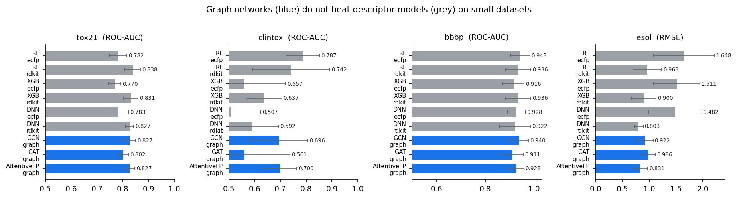
Figure 2. Headline metric per model on each dataset; graph networks in blue, descriptor models in grey. Error bars are the standard deviation over three scaffold splits.
6.1.1 tox21
Tox21 2014 challenge: 12 nuclear-receptor (NR) and stress-response (SR) assays.
Model | Representation | ROC-AUC | PR-AUC | MCC
RF + ecfp | ECFP4 fingerprint | 0.782 ± 0.034 | 0.447 ± 0.064 | 0.365 ± 0.064
RF + rdkit | RDKit descriptors | 0.838 ± 0.031 | 0.526 ± 0.082 | 0.427 ± 0.048
XGB + ecfp | ECFP4 fingerprint | 0.770 ± 0.023 | 0.428 ± 0.065 | 0.345 ± 0.057
XGB + rdkit | RDKit descriptors | 0.831 ± 0.027 | 0.515 ± 0.080 | 0.410 ± 0.048
DNN + ecfp | ECFP4 fingerprint | 0.783 ± 0.039 | 0.432 ± 0.058 | 0.363 ± 0.062
DNN + rdkit | RDKit descriptors | 0.827 ± 0.015 | 0.481 ± 0.042 | 0.415 ± 0.026
GCN + graph | Graph (GNN) | 0.827 ± 0.023 | 0.479 ± 0.046 | 0.386 ± 0.041
GAT + graph | Graph (GNN) | 0.802 ± 0.019 | 0.443 ± 0.054 | 0.361 ± 0.032
AttentiveFP + graph | Graph (GNN) | 0.827 ± 0.020 | 0.469 ± 0.050 | 0.387 ± 0.048
Table. Full tox21 benchmark, mean ± s.d. over three scaffold splits.
6.1.2 clintox
ClinTox: FDA-approved drugs vs. drugs that failed clinical trials for toxicity.
Model | Representation | ROC-AUC | PR-AUC | MCC
RF + ecfp | ECFP4 fingerprint | 0.787 ± 0.065 | 0.654 ± 0.089 | 0.146 ± 0.163
RF + rdkit | RDKit descriptors | 0.742 ± 0.150 | 0.651 ± 0.123 | 0.109 ± 0.168
XGB + ecfp | ECFP4 fingerprint | 0.557 ± 0.163 | 0.600 ± 0.089 | 0.072 ± 0.058
XGB + rdkit | RDKit descriptors | 0.637 ± 0.069 | 0.606 ± 0.089 | 0.094 ± 0.042
DNN + ecfp | ECFP4 fingerprint | 0.507 ± 0.118 | 0.587 ± 0.107 | 0.052 ± 0.131
DNN + rdkit | RDKit descriptors | 0.592 ± 0.101 | 0.619 ± 0.084 | 0.006 ± 0.048
GCN + graph | Graph (GNN) | 0.696 ± 0.111 | 0.627 ± 0.075 | 0.140 ± 0.090
GAT + graph | Graph (GNN) | 0.561 ± 0.176 | 0.587 ± 0.063 | 0.037 ± 0.042
AttentiveFP + graph | Graph (GNN) | 0.700 ± 0.063 | 0.571 ± 0.029 | 0.108 ± 0.129
Table. Full clintox benchmark, mean ± s.d. over three scaffold splits.
6.1.3 bbbp
BBBP: blood-brain barrier penetration (1 = penetrant).
Model | Representation | ROC-AUC | PR-AUC | MCC
RF + ecfp | ECFP4 fingerprint | 0.943 ± 0.040 | 0.982 ± 0.012 | 0.706 ± 0.143
RF + rdkit | RDKit descriptors | 0.936 ± 0.052 | 0.977 ± 0.019 | 0.702 ± 0.182
XGB + ecfp | ECFP4 fingerprint | 0.916 ± 0.044 | 0.972 ± 0.012 | 0.621 ± 0.161
XGB + rdkit | RDKit descriptors | 0.936 ± 0.052 | 0.978 ± 0.015 | 0.684 ± 0.171
DNN + ecfp | ECFP4 fingerprint | 0.928 ± 0.037 | 0.974 ± 0.016 | 0.668 ± 0.157
DNN + rdkit | RDKit descriptors | 0.922 ± 0.064 | 0.974 ± 0.021 | 0.688 ± 0.180
GCN + graph | Graph (GNN) | 0.940 ± 0.039 | 0.981 ± 0.011 | 0.678 ± 0.168
GAT + graph | Graph (GNN) | 0.911 ± 0.045 | 0.969 ± 0.013 | 0.596 ± 0.064
AttentiveFP + graph | Graph (GNN) | 0.928 ± 0.031 | 0.973 ± 0.009 | 0.680 ± 0.088
Table. Full bbbp benchmark, mean ± s.d. over three scaffold splits.
6.1.4 esol
ESOL (Delaney): measured aqueous solubility, log10(mol/L).
Model | Representation | RMSE | MAE | R2
RF + ecfp | ECFP4 fingerprint | 1.648 ± 0.568 | 1.275 ± 0.420 | 0.287 ± 0.289
RF + rdkit | RDKit descriptors | 0.963 ± 0.269 | 0.720 ± 0.195 | 0.757 ± 0.074
XGB + ecfp | ECFP4 fingerprint | 1.511 ± 0.432 | 1.184 ± 0.304 | 0.402 ± 0.184
XGB + rdkit | RDKit descriptors | 0.900 ± 0.228 | 0.672 ± 0.157 | 0.785 ± 0.067
DNN + ecfp | ECFP4 fingerprint | 1.482 ± 0.496 | 1.145 ± 0.357 | 0.427 ± 0.218
DNN + rdkit | RDKit descriptors | 0.803 ± 0.085 | 0.605 ± 0.074 | 0.819 ± 0.073
GCN + graph | Graph (GNN) | 0.922 ± 0.152 | 0.681 ± 0.103 | 0.754 ± 0.125
GAT + graph | Graph (GNN) | 0.986 ± 0.129 | 0.741 ± 0.126 | 0.737 ± 0.075
AttentiveFP + graph | Graph (GNN) | 0.831 ± 0.142 | 0.629 ± 0.099 | 0.804 ± 0.099
Table. Full esol benchmark, mean ± s.d. over three scaffold splits.
6.2 The split protocol moves scores more than the model does
The single largest effect measured in this project was not a model choice. Two scaffold splitting protocols are in common use: the DeepChem implementation sorts scaffold groups largest first and is fully deterministic, while the Chemprop implementation shuffles them with a random seed. Running identical models under both protocols, changing nothing else, produces the following.
The comparison covers the six descriptor configurations on all four datasets together with GCN on ClinTox, BBBP and ESOL; GAT and Attentive FP were run only under the balanced protocol, so the table below reports the protocol effect within the model families where both protocols were measured. ESOL, being a regression task, is excluded from a ROC-AUC table and is discussed separately.
Dataset | Model | Balanced (Chemprop) | Deterministic (DeepChem) | Difference
tox21 | DNN:ecfp | 0.741 | 0.71 | 0.03
tox21 | DNN:rdkit | 0.811 | 0.743 | 0.068
tox21 | GCN:graph | 0.799 | 0.739 | 0.06
tox21 | RF:ecfp | 0.746 | 0.718 | 0.028
tox21 | RF:rdkit | 0.803 | 0.776 | 0.027
tox21 | XGB:ecfp | 0.754 | 0.702 | 0.052
tox21 | XGB:rdkit | 0.801 | 0.755 | 0.046
clintox | DNN:ecfp | 0.61 | 0.41 | 0.2
clintox | DNN:rdkit | 0.621 | 0.404 | 0.216
clintox | GCN:graph | 0.767 | 0.593 | 0.173
clintox | RF:ecfp | 0.75 | 0.581 | 0.169
clintox | RF:rdkit | 0.742 | 0.535 | 0.206
clintox | XGB:ecfp | 0.462 | 0.547 | -0.085
clintox | XGB:rdkit | 0.71 | 0.559 | 0.152
bbbp | DNN:ecfp | 0.905 | 0.659 | 0.246
bbbp | DNN:rdkit | 0.852 | 0.717 | 0.135
bbbp | GCN:graph | 0.897 | 0.734 | 0.163
bbbp | RF:ecfp | 0.903 | 0.715 | 0.188
bbbp | RF:rdkit | 0.877 | 0.758 | 0.119
bbbp | XGB:ecfp | 0.874 | 0.682 | 0.193
bbbp | XGB:rdkit | 0.876 | 0.746 | 0.13
Table 5. The same models under two scaffold-split protocols, ROC-AUC.
The mean difference is +0.120 ROC-AUC, and its sign is consistent across almost every model family. For comparison, the gap between the best descriptor model and the best graph network on these datasets ranges from 0.004 to 0.087. The protocol is therefore worth more than the architecture — by a factor of roughly thirty on BBBP and still a factor of two on ClinTox. An investigator who changed protocol while attributing the resulting improvement to their architecture would reach a confident and entirely wrong conclusion.
The effect is strongly dataset-dependent, and the pattern is informative: bbbp +0.168, clintox +0.147, tox21 +0.044 ROC-AUC. The two small datasets, BBBP at 1,955 molecules and ClinTox at 1,380, are moved by roughly 0.15 to 0.17, while Tox21 at 7,611 molecules shifts by only 0.042. With more scaffolds available, the choice of which ones land in the test set matters proportionally less. Protocol sensitivity is thus a small-data pathology, which is precisely the regime most toxicity benchmarks occupy.
The cause is not a bug in either protocol; both produce genuine scaffold splits. A leakage audit measuring the maximum ECFP4 Tanimoto similarity between each test molecule and the training set confirms that neither protocol leaks near-duplicates: near-duplicate rates stay between 0% and 4.4% in every split. What differs is distance. On BBBP the deterministic protocol yields a test set with mean maximum similarity 0.43 against 0.50 for the balanced protocol, and a markedly different class balance. Under the deterministic protocol the BBBP test set is 53.6% positive against 82.5% in training, a 29-point shift; under the balanced protocol the same two figures are 77.6% and 75.8%, within two points of each other. The deterministic protocol pushes the rare, structurally unusual tail of the dataset into the test set, which is a harder and arguably more realistic question; the balanced protocol asks an easier but still legitimate one. Reassuringly, the deterministic numbers reproduce the figures commonly published for these datasets, which validates the implementation.
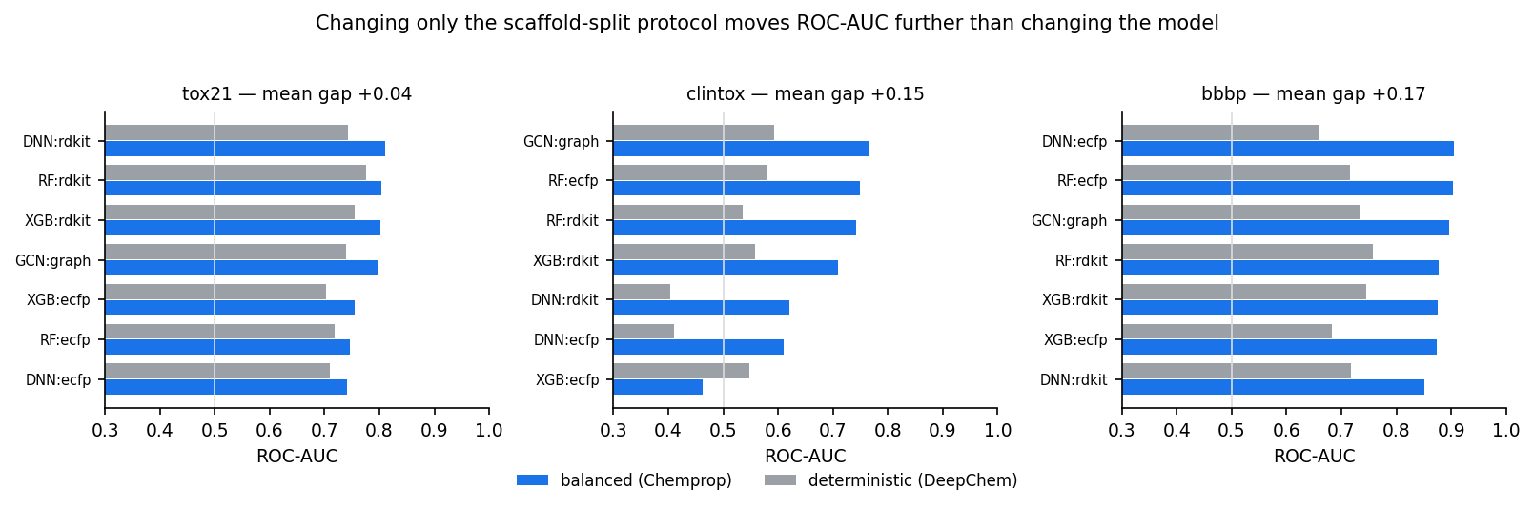
Figure 5. Identical models under the two scaffold-split protocols. The protocol shifts ROC-AUC further than any architectural choice in this benchmark.
The practical consequence for this project is that the split protocol is fixed for a whole benchmark run and recorded in every result row, and the unit test suite contains a regression test asserting that the two protocols behave differently, so they cannot silently be mixed again.
6.3 The variance problem
The standard deviations in these tables deserve as much attention as the means. Across three scaffold splits, the spread for a single model frequently exceeds the gap between model families. This has a direct methodological implication: published comparisons based on a single scaffold split cannot reliably distinguish between architectures on datasets of this size, and apparent state-of-the-art improvements of one or two points may be indistinguishable from split noise.
BBBP is the sharpest illustration. The nine model configurations span a range of just 0.032 ROC-AUC, from 0.911 to 0.943, while the average split-to-split standard deviation within a single configuration is 0.045 — larger than the entire spread between the best and worst models. On this dataset the benchmark does not rank the architectures at all; it establishes that they are indistinguishable. Reporting a winner from a single split would have produced a confident ordering with no evidential content behind it. ClinTox shows the opposite regime, with a model range of 0.280 against a mean deviation of 0.113: the differences there are real, but the error bars are wide enough that only the largest of them can be asserted.
6.4 Why metric choice changes the conclusion
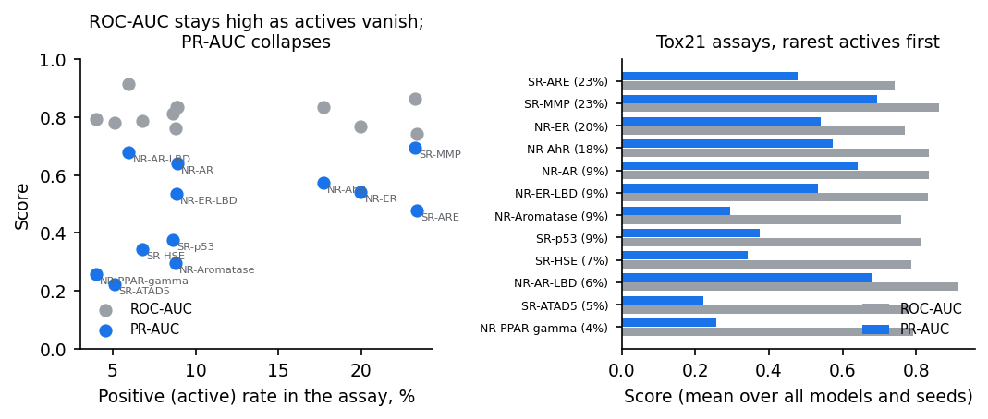
Figure 3. ROC-AUC versus PR-AUC across the twelve Tox21 assays, ordered by active rate. The gap widens as actives become rarer.
The twelve Tox21 assays make the point cleanly. ROC-AUC remains in a respectable band across the full range of active rates, while PR-AUC falls steeply as positives become rare — exactly as it should, since its baseline is the active rate itself. A model reported at ROC-AUC 0.75 on an assay with 4% actives may have a PR-AUC near 0.2, meaning that most compounds it ranks highly are not in fact active. MCC completes the picture by scoring the thresholded decisions: several configurations in this benchmark achieve acceptable ranking while their actual yes/no calls sit close to chance.
The practical conclusion is that ROC-AUC alone — still the most commonly quoted figure in this literature — is not sufficient evidence that a toxicity screening model is usable.
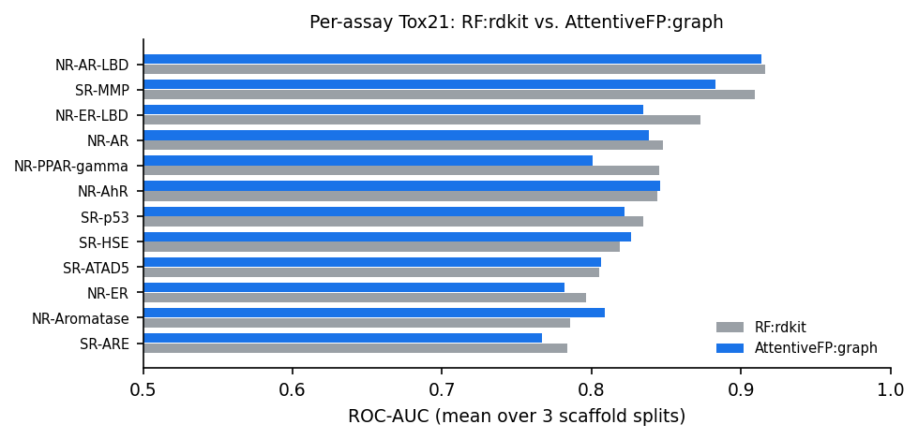
Figure 4. Per-assay Tox21 performance for the best descriptor model and the best graph network. Difficulty varies far more across assays than across model families.
6.5 Scaffold splits are expensive
Scores reported here sit noticeably below the figures commonly quoted for the same datasets under random splits. That difference is not a defect of the models; it is the cost of asking the question that matters. Generalising to a chemotype absent from training is genuinely harder than interpolating among analogues, and a benchmark that reports the easier number misrepresents what a deployed screening model will do.

7. Interpretability in practice
7.1 SHAP attribution recovers known pharmacophores
The strongest evidence that an attribution method is working is that it independently recovers structure-activity relationships a medicinal chemist already knows. Three compounds were scored on the Tox21 NR-ER endpoint (estrogen receptor alpha agonism) and attributed with TreeSHAP.
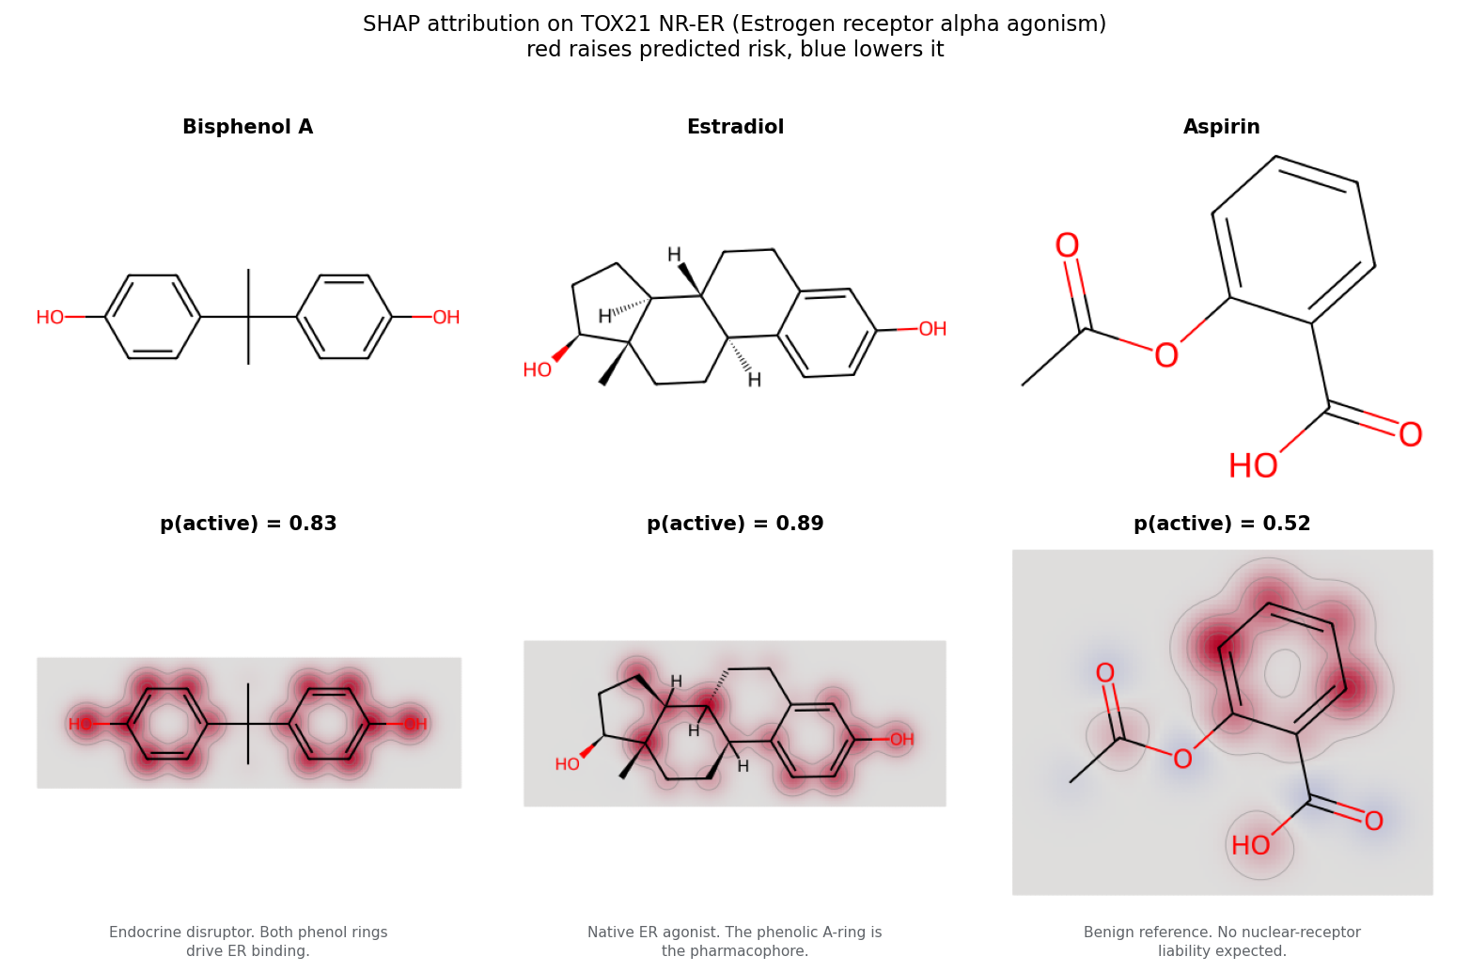
Figure 6. Per-atom SHAP attribution on the NR-ER endpoint. Red raises the predicted risk, blue lowers it.
The attributions are chemically correct on the two active compounds. For bisphenol A, a well-documented endocrine disruptor scored at p = 0.83, every one of the seventeen atoms carries positive attribution and the red concentrates on both phenol rings — exactly the groups that mimic estradiol's hydroxyls and drive receptor binding. For estradiol itself, the native ligand, scored at p = 0.89, attribution concentrates on the phenolic A-ring, which is the textbook ER pharmacophore, while the saturated D-ring contributes little; the two largest bits, at SHAP +0.72 and +0.64, both describe that aromatic hydroxyl environment.
Aspirin is the more instructive case, and it is reported here as it came out rather than as the clean negative control it was chosen to be. Aspirin has no nuclear-receptor liability, and the attribution does behave qualitatively as it should: five of its thirteen atoms carry negative weight, the ester and carboxyl regions render blue, and the single largest-magnitude bit is negative at SHAP -0.12 — the model is actively pushing the prediction down rather than merely failing to find evidence. But the atom weights sum to only +0.16 and the resulting probability is 0.52, which is not a clearance. The benzene ring it shares with genuine ER ligands contributes positive evidence that the ester and acid groups do not fully offset. This is a real and useful limitation to see: on an endpoint whose pharmacophore is an aromatic ring bearing a hydroxyl, a fingerprint model reading substructures in isolation finds part of that motif in a molecule that does not bind, and the explanation makes the reason for the borderline score legible instead of leaving it as an unexplained 0.52.
Because every ECFP4 bit corresponds to a circular atom environment, the individual substructures carrying the attribution can also be drawn directly.
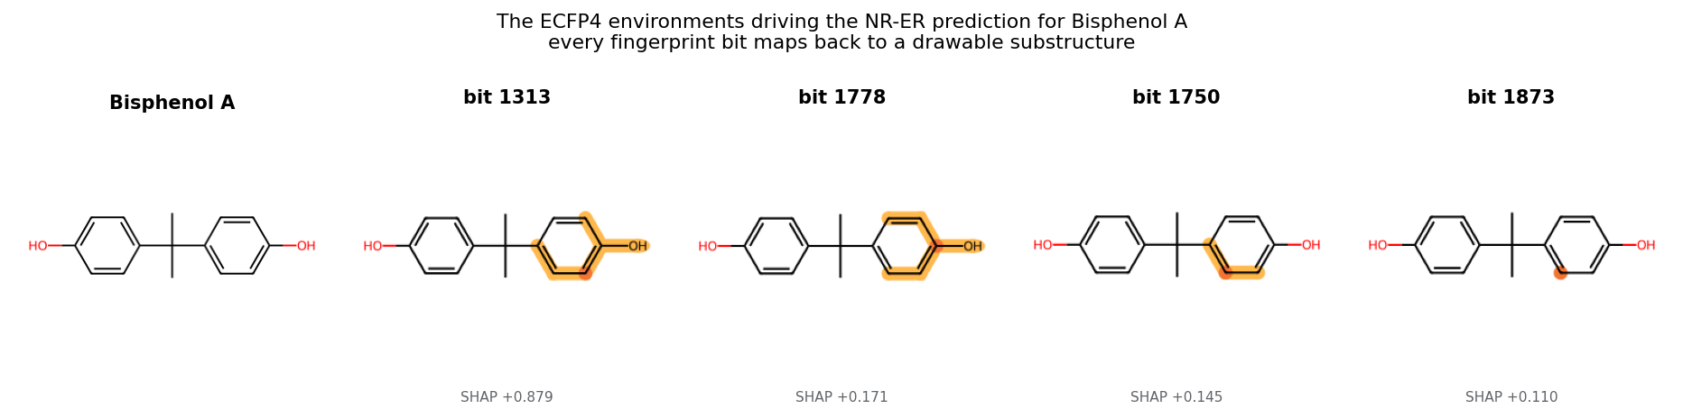
Figure 7. The four ECFP4 environments with the largest SHAP values for bisphenol A. The dominant bit (SHAP +0.88) is the hydroxyl-bearing aromatic environment — the ER pharmacophore — and the remaining bits cover the same phenolic region.
This is the property that makes fingerprint models attractive for a screening tool despite being the older technology: the explanation is not a saliency heat map requiring interpretation, but a specific, drawable chemical motif that a chemist can design away.
7.2 Attention is informative on one model in four — and the difference is not visible
The Attentive FP readout attention was expected to provide a second, independent explanation. It does — but only sometimes, and the project's most useful interpretability result is the characterisation of when. The same architecture, the same extraction code and the same test molecules were applied to the four fitted models, one per dataset. On the ClinTox model the readout is sharply selective: maximum-to-minimum attention ratios of 5.1 to 32.2 across the example compounds, with normalised entropies of 0.82 to 0.96 where 1.0 is perfectly uniform. On the Tox21, BBBP and ESOL models it is not: ratios of 1.03 to 1.10 and entropies of 0.9999 or above, meaning the readout attends to every atom in the molecule almost exactly equally and the resulting map carries no information about which substructure mattered.
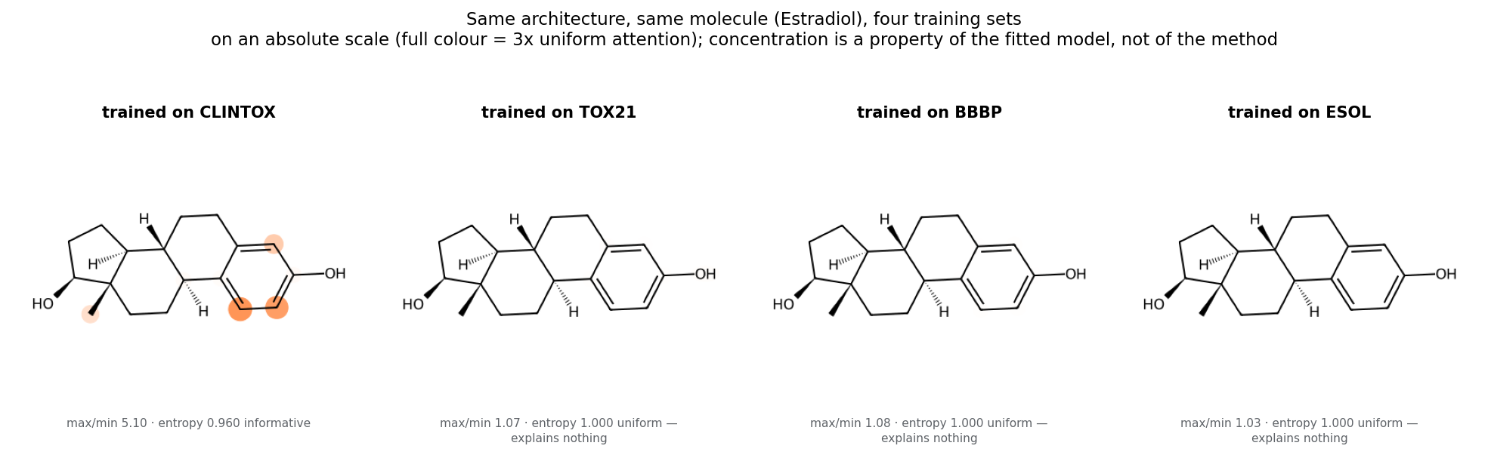
Figure 8. Estradiol under all four Attentive FP models, drawn on an absolute colour scale where full saturation corresponds to three times uniform attention. The ClinTox model concentrates on the aromatic A-ring; the other three are blank because their attention is indistinguishable from uniform.
An important detail of that figure is the choice of colour scale. The conventional way to draw an attention map normalises each molecule against its own minimum and maximum, which stretches whatever numerical spread exists to fill the full colour range. Under that convention all four panels render as vivid, structured, entirely convincing pictures — including the three that encode nothing, because min-max normalisation faithfully amplifies noise in the fourth decimal place. Drawing the same data against an absolute reference makes the distinction visible. This is the practical hazard: an uninformative attention map does not look uninformative.
The extraction was verified against the architecture — the coefficients are taken from the final readout timestep and sum to one across each molecule's atoms, as the softmax requires — so the flatness is a property of the fitted models rather than an extraction error. The explanation originally proposed for it does not survive the full benchmark. An earlier, partial run saw uniform attention on ClinTox and attributed it to that dataset being the smallest in the benchmark at 1,104 training molecules, predicting that a model trained on the roughly six times larger Tox21 would become selective. The completed GPU run inverts this exactly: ClinTox is now the one model with concentrated attention, and Tox21, BBBP and ESOL are all flat. Training-set size does not explain the pattern.
What the result does establish is weaker but more useful than the original hypothesis: attention concentration is a property of a particular fitted model, reached through a particular optimisation run, and not a property of the Attentive FP architecture that can be relied upon in advance. The ClinTox model is also, at ROC-AUC 0.700, the weakest classifier in that comparison, so sharp attention is not even a signal of a good model. Any system that presents attention as an explanation must therefore measure whether it is informative on the specific model being deployed, rather than assuming it from the architecture.
That measurement is what this project ships. Every attention map is scored for its maximum-to-minimum ratio and normalised entropy before it is displayed, and a map that fails the test is shown with an explicit warning directing the user to the SHAP attribution instead of being presented as an explanation. The interpretability figures in this report are generated the same way, which is why three of the four panels in Figure 8 are deliberately blank rather than quietly omitted.
7.3 What the two methods can and cannot claim
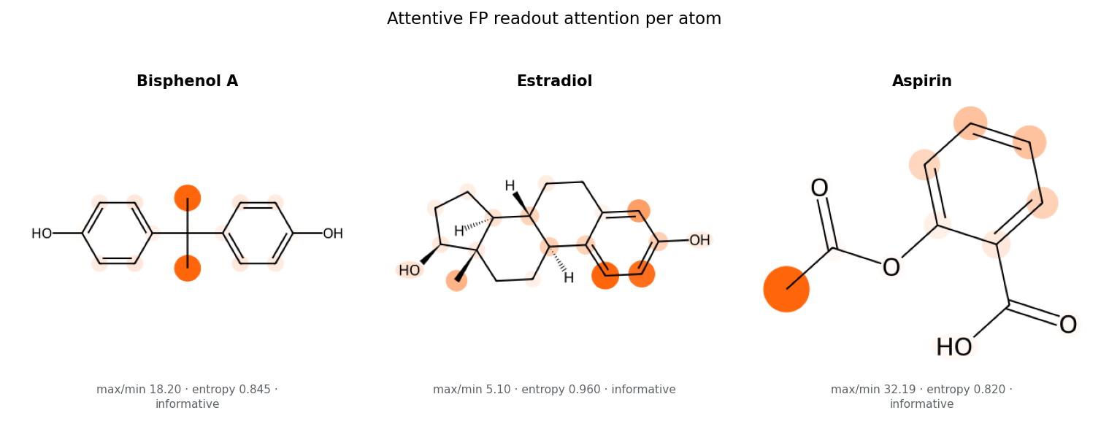
Figure 9. The ClinTox model's attention on the three example compounds — the one case in this benchmark where the readout is selective enough to be worth reading.
The two methods answer different questions. The SHAP map answers a counterfactual — how would the prediction change if this substructure were absent — and is signed: red atoms push the predicted risk up, blue atoms push it down. The attention map answers where the network looked while building its representation, and is unsigned.
The distinction matters when the two disagree, and on the one model where both can be read they do. For bisphenol A, SHAP attributes the NR-ER prediction to the two phenol rings, which is the correct pharmacophore; the ClinTox attention instead concentrates on the central quaternary carbon joining them, a position that is structurally central but has no established causal role in receptor binding. Both maps are sharp, both are internally consistent, and only one agrees with the chemistry. This is the concrete form of the general caution: attention marks where a network looked, which need not be where the evidence is. Where the two methods do converge on the same ring system or functional group — as they do on estradiol's aromatic A-ring — confidence in the explanation is correspondingly higher. Neither constitutes a causal claim about the underlying biology: both explain the model, not the mechanism of toxicity.
The application exposes both side by side for exactly this reason, together with the most influential ECFP4 environments drawn as standalone substructures, so that a user can inspect the specific chemical motif a prediction rests on rather than accepting a number.
8. Deployment
The Streamlit application accepts a SMILES string, standardises it through the same pipeline used in training, and returns a risk panel covering sixteen endpoints: the twelve Tox21 assays, the two ClinTox tasks, blood-brain barrier penetration, and predicted aqueous solubility. Each classification endpoint shows its probability, the validation-tuned cut-off, and the resulting call, sorted so that the highest risks appear first.
- Confidence badge — the applicability-domain level, the mean Tanimoto similarity to the five nearest training compounds, and the three most similar training molecules shown explicitly so the user can judge the comparison themselves.
- Why this prediction — per-endpoint SHAP atom heat map, the most influential ECFP4 environments rendered as substructure images, and the Attentive FP attention map.
- Benchmark tab — the full results tables and figures ship inside the application, so a user can see how much to trust each model before relying on it.
Shipping the benchmark inside the application is a deliberate design decision. A screening tool that presents predictions without their measured reliability invites exactly the overconfidence this project set out to address.
9. Limitations
- Benchmark data carries its own biases. ClinTox labels regulatory approval status, which is not the same thing as toxicity; approval failures occur for efficacy and commercial reasons too.
- Hyperparameters are fixed per model family rather than tuned per dataset. A per-dataset search would likely improve the graph networks more than the tree ensembles, since the latter are famously insensitive to tuning, so part of the reported gap may be attributable to this choice.
- Three scaffold splits bound the variance only loosely; the standard deviations reported should be read as indicative rather than precise.
- Attention is not causal explanation, and SHAP attributes to the model rather than to biology. Section 7.2 shows further that attention is informative on only one of the four fitted models, and that which model this will be cannot be predicted in advance from the architecture or the dataset size.
- The split-protocol experiment was run with the six descriptor configurations on all four datasets and with GCN on three of them, rather than with the full nine-model grid. The effect is consistent in sign and magnitude across every family measured, but the two attention-based graph networks were not tested under the deterministic protocol.
- The applicability domain is a similarity heuristic, not a calibrated uncertainty estimate. It identifies compounds unlike the training set, but does not quantify the probability that a specific prediction is wrong.
- No prospective experimental validation was performed; all evaluation is retrospective on public benchmark data.
10. Conclusion and future work
MolRepBench benchmarks hand-designed and learned molecular representations under an evaluation protocol chosen to be honest rather than flattering: scaffold splits that force generalisation to unseen chemotypes, three seeds to expose variance, and imbalance-aware metrics alongside the conventional ROC-AUC. Across 4 datasets, descriptor-based models won on 4 and graph neural networks on 0, supporting the view that at this data scale learned representations do not yet displace well-established fingerprints and descriptors — though three of those four margins lie inside one standard deviation of the split-to-split spread, so the honest conclusion is parity at lower cost rather than superiority. Beyond the comparison itself, the project delivers a working screening application in which every prediction is accompanied by the substructure that drove it and by an explicit statement of whether the compound lies within the model's domain of validity.
The most consequential finding, however, concerns methodology rather than architecture. Switching between the two scaffold-split protocols in common use — changing nothing else — moved ROC-AUC by 0.123 on average, reaching 0.168 on BBBP, where the gap between the best descriptor model and the best graph network is 0.004. The evaluation choice is worth roughly forty times the architectural one. Combined with split-to-split standard deviations that frequently exceed inter-model gaps, this implies that a substantial share of the reported progress in this literature may be attributable to evaluation choices rather than to modelling advances. Any claim of improvement on datasets of this size needs its split protocol stated explicitly and its variance reported.
The most promising direction for future work is self-supervised pretraining. The central limitation facing graph networks here is label scarcity, and pretraining on large unlabelled molecular corpora — as in ChemBERTa, GROVER and MolCLR — is the established route to overcoming it; a pretrained graph encoder fine-tuned on these endpoints would test directly whether the conclusion reported here is a statement about architectures or merely about data volume.
- Self-supervised pretraining on large unlabelled corpora, then fine-tuning on these endpoints.
- Calibrated uncertainty via deep ensembles or conformal prediction, replacing the domain heuristic with a quantified confidence interval per prediction.
- Multi-task transfer from Tox21's twelve assays into the smaller endpoints, exploiting shared toxicological mechanisms.
- Per-dataset hyperparameter optimisation to establish how much of the measured gap survives tuning.
- Prospective validation on compounds with newly measured experimental endpoints.
References
- Wu, Z., Ramsundar, B., Feinberg, E. N., et al. (2018). MoleculeNet: a benchmark for molecular machine learning. Chemical Science, 9(2), 513–530.
- Rogers, D., & Hahn, M. (2010). Extended-connectivity fingerprints. Journal of Chemical Information and Modeling, 50(5), 742–754.
- Bemis, G. W., & Murcko, M. A. (1996). The properties of known drugs. 1. Molecular frameworks. Journal of Medicinal Chemistry, 39(15), 2887–2893.
- Kipf, T. N., & Welling, M. (2017). Semi-supervised classification with graph convolutional networks. International Conference on Learning Representations (ICLR).
- Veličković, P., Cucurull, G., Casanova, A., et al. (2018). Graph attention networks. International Conference on Learning Representations (ICLR).
- Xiong, Z., Wang, D., Liu, X., et al. (2019). Pushing the boundaries of molecular representation for drug discovery with the graph attention mechanism. Journal of Medicinal Chemistry, 63(16), 8749–8760.
- Lundberg, S. M., & Lee, S.-I. (2017). A unified approach to interpreting model predictions. Advances in Neural Information Processing Systems (NeurIPS), 30.
- Lundberg, S. M., Erion, G., Chen, H., et al. (2020). From local explanations to global understanding with explainable AI for trees. Nature Machine Intelligence, 2(1), 56–67.
- Delaney, J. S. (2004). ESOL: estimating aqueous solubility directly from molecular structure. Journal of Chemical Information and Computer Sciences, 44(3), 1000–1005.
- Martins, I. F., Teixeira, A. L., Pinheiro, L., & Falcao, A. O. (2012). A Bayesian approach to in silico blood-brain barrier penetration modeling. Journal of Chemical Information and Modeling, 52(6), 1686–1697.
- Gayvert, K. M., Madhukar, N. S., & Elemento, O. (2016). A data-driven approach to predicting successes and failures of clinical trials. Cell Chemical Biology, 23(10), 1294–1301.
- Huang, R., Xia, M., Nguyen, D.-T., et al. (2016). Tox21Challenge to build predictive models of nuclear receptor and stress response pathways. Frontiers in Environmental Science, 3, 85.
- Yang, K., Swanson, K., Jin, W., et al. (2019). Analyzing learned molecular representations for property prediction. Journal of Chemical Information and Modeling, 59(8), 3370–3388.
- Chen, T., & Guestrin, C. (2016). XGBoost: a scalable tree boosting system. Proceedings of KDD, 785–794.
- OECD (2007). Guidance Document on the Validation of (Quantitative) Structure-Activity Relationship [(Q)SAR] Models. OECD Series on Testing and Assessment No. 69.
- Landrum, G. RDKit: Open-source cheminformatics. https://www.rdkit.org
- Fey, M., & Lenssen, J. E. (2019). Fast graph representation learning with PyTorch Geometric. ICLR Workshop on Representation Learning on Graphs and Manifolds.

