STORE SALES PREDICTION

Wireframe Documentation

Home Page

It is divided into two sections –

* The first section on the left side of the window allows a user to upload the input data and get an output prediction.
* The second section on the right side of the window allows a user to upload a file and an output file gets generated which the user can download.

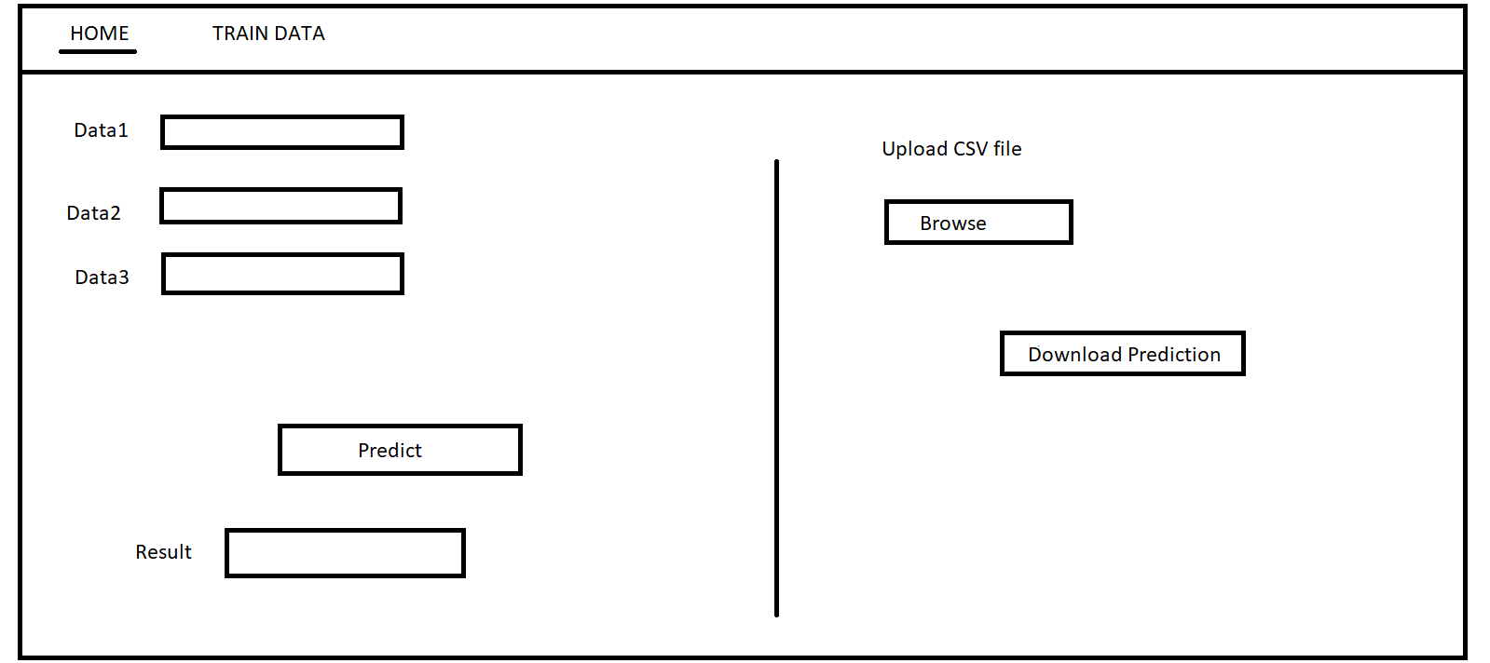

Train Data

This page allows the user to train the model using new training data. This page requires administrator access along with the training file with valid data.

