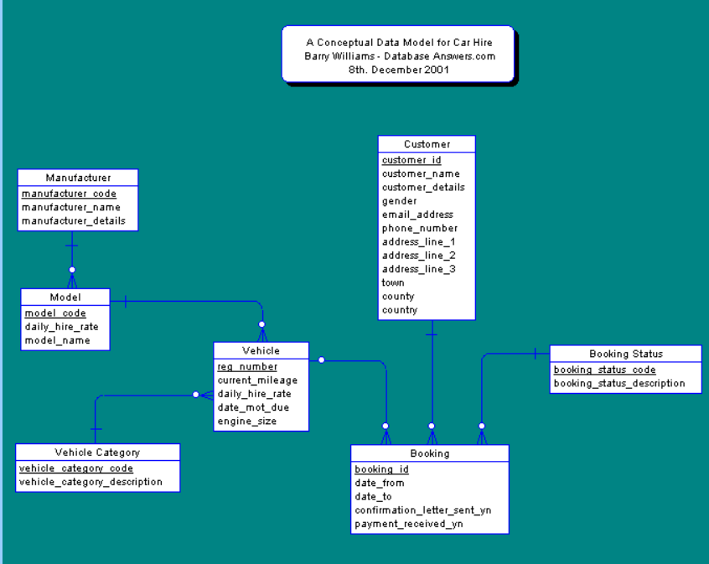

Prepare CREATE TABLE STATEMENT based on your understanding of data types and width of mentioned entities.
Assignment :-
Try Your Constraints :-
- Primary Key
- Unique
- Not Null
- Foreign Key
Question 1 : Observe after applying all the constraint on the single table.
Question 2 : Apply Unique constraint on the multiple column of the table.
Question 3 : Consider a scenario where I need to have a another column to have the similar functionality as Primary Key. Try to achieve this with the help of your all other constraints.
Question 4 : Check all the constraints in the Information_Schema Table.

