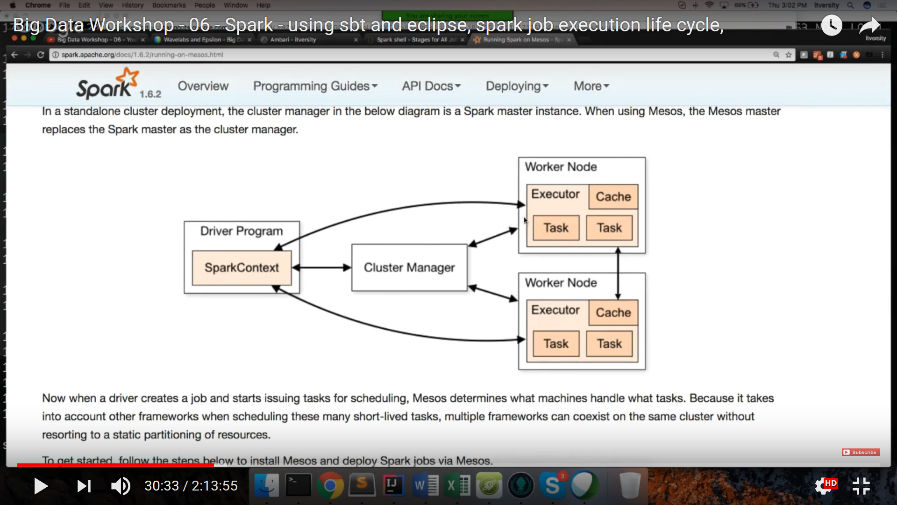

HDFS Commands

hadoop fsck hdfs.directory(or file location) -files -blocks

-It will list all the files in the directory with their properties like blocks information.block id etc

it does not provide location here

To get the location also

hadoop fsck hdfs.directory(or file location) -files -blocks -locations

To override hdfs parameter at run time use -D

For eg. To copy a file from local to hdfs with some custom properties like 64Mb block size etc

hadoop fs -Ddfs.blocksize=67108864 -Ddfs.replication=1 -copyFromLocal /usr/ubuntu/.... /user/flume/data

Q- Can we change the block size and replication factor of previous saved file ?

Ans – No we cannot change the block size but we can change the replication factor using setrep command

hadoop fs -setrep 2 /user/flume/data

It will change all the files in hdfs directory with replication factor 2