Class Hierearchy

In scala the super class of all the classes is "Any"

scala> val a:Int=5
a: Int = 5

scala> val b: Any=a
b: Any = 5

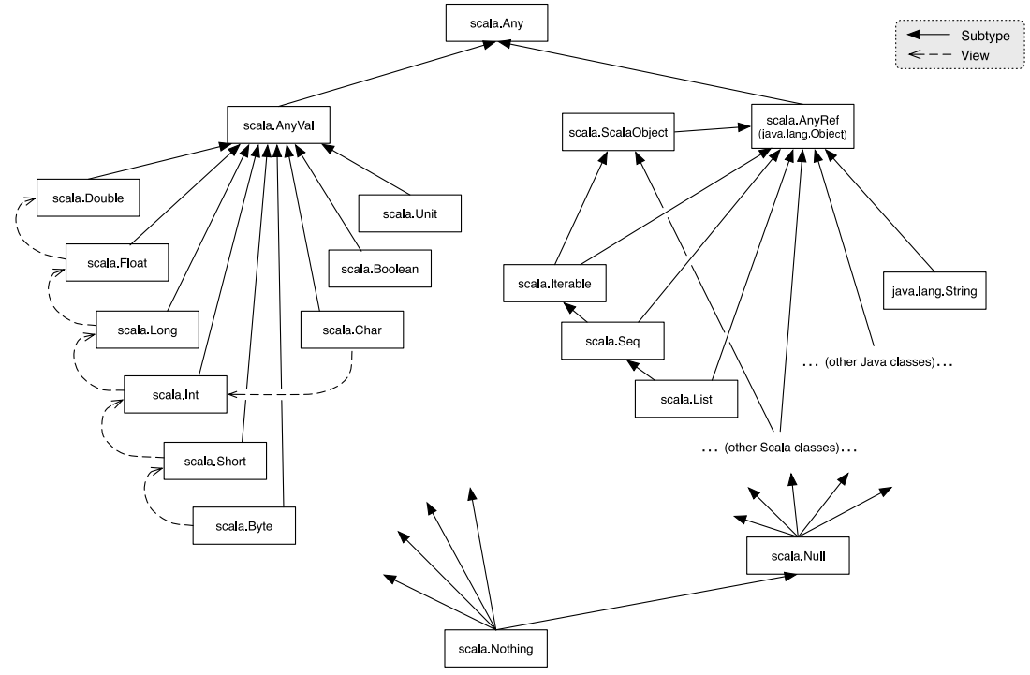

Any is super class of everything in scala
Nothing is sub class of everything in java

You can understand that we dont specify a datatype ...it automatically selects the type depending upon type of value you are providing

so basically it invokes nothing which in turn invokes the required datatype

Collections

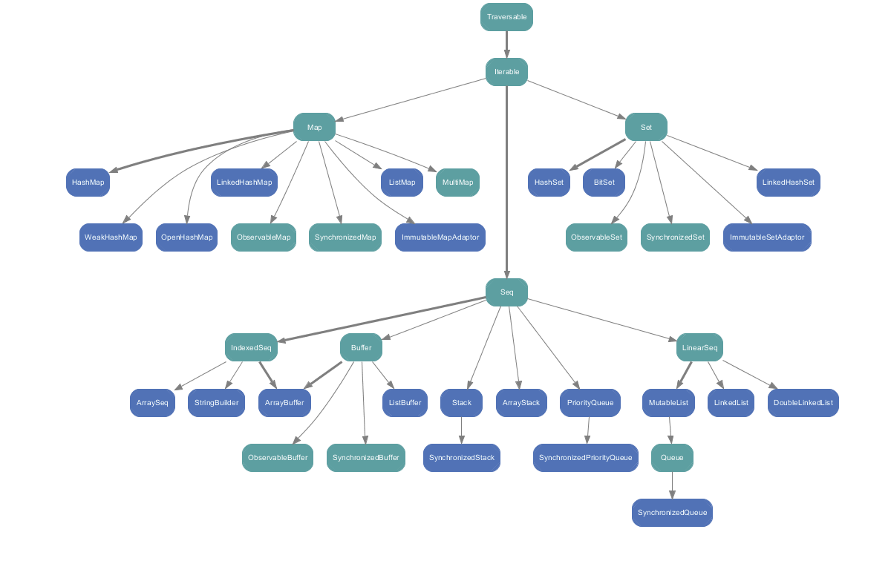
Traversable is the main class or interface in collections
All Collections are iterable

Sequence

It is represented by Seq
It is a kind of iterable that has a length and whose elements have fixed position starting from index 0

scala> val a =Seq(1,2)
a: Seq[Int] = List(1, 2)

scala> a.length
res4: Int = 2

scala> a.sum
res5: Int = 3

1.Linear Sequence –index is not fixed
eg. scala.collection.immutable.List
2.Indexed Sequence – Index is fixed like array
eg. scala.Array or scala.collections.mutable.ArrayBuffer

*Each collection has a companion object with apply() method in it
That is the reason we can directly create list using

scala> val a=List(1,2,3,4)
a: List[Int] = List(1, 2, 3, 4)

*All Elements in a list are homogenous...i.e. must have common base class

For eg
scala> class Animal
defined class Animal

scala> class tiger extends Animal
defined class tiger

scala> class lion extends Animal
defined class lion

scala> val a=List(new tiger,new lion)
a: List[Animal] = List(tiger@3e2ffa0a, lion@780a0cee)

Here List of type Animal is created

If we also add an element in same List like Int type 1 .....then what will happen ...
see eg below

scala> val a=List(new tiger,new lion,1)
a: List[Any] = List(tiger@11cf60c0, lion@288f2217, 1)

The type of List will convert to type Any as Any is the parent of everything in scala

TYPE PARAMETERS

we define data type of list in scala is

scala> val a: List[Int]=List(1,2,3,4)
a: List[Int] = List(1, 2, 3, 4)n scala by

toList

you can create element also like in range ie.. (0 to 10), (5-50) etc and using toList you can convert it to List
eg
scala> (0 to 10)
res0: scala.collection.immutable.Range.Inclusive = Range 0 to 10

scala> (0 to 10).toList
res1: List[Int] = List(0, 1, 2, 3, 4, 5, 6, 7, 8, 9, 10)

Lists are by default immutable
To add an element in val type of list in end

val l=List(1,2)

scala> l=l:+5 or l :: 5
l: List[Int] = List(1, 2, 5)

scala> l=5 +:l or 5 :: l
l: List[Int] = List(5, 1, 2, 5)

to append one list to another “ ++ ” is used

scala> val a=(1 to 10).toList
a: List[Int] = List(1, 2, 3, 4, 5, 6, 7, 8, 9, 10)

scala> a ++ l
res20: List[Int] = List(1, 2, 3, 4, 5, 6, 7, 8, 9, 10, 1, 2)

-------------
Set

Set contains no duplicate elements
scala> val a=Set(1,2,3,4,5,1,2,3,4,5)
a: scala.collection.immutable.Set[Int] = Set(5, 1, 2, 3, 4)

*TUPLE

Tuple is an collection of heterogenous elements.
In Spark...tuple is used a lot

scala> val t=(1,2,"hello",5.67)
t: (Int, Int, String, Double) = (1,2,hello,5.67)

To read tuple values we use _position with dot .

For eg t._1=1
t._2=2
t._3=”hello”

Map

It is a collection in which elements are stored in key value pairs
Keys have to be UNIQUE

scala> val m =Map(1->"shubham",2->"Gosain",3->"shubham")
m: scala.collection.immutable.Map[Int,String] = Map(1 -> shubham, 2 -> Gosain, 3 -> shubham)

scala> m(1)
res1: String = shubham

scala> m.get(5)
res2: Option[String] = None

scala> m.getOrElse(2,"not found")
res3: String = Gosain

scala> m.getOrElse(4,"not found")
res4: String = not found

Array

scala> val a=Array(1,2,3)
a: Array[Int] = Array(1, 2, 3)

scala> a.length
res5: Int = 3

scala> a(5)
java.lang.ArrayIndexOutOfBoundsException: 5
... 37 elided

Arrays are mutable

Lazy val

val is executed when it is defined
lazy val is executed when it is accessed for the first time

val
scala> val x={println("here");1}
here
x: Int = 1

lazy val
scala> lazy val y={println("here");1}
x: Int = <lazy>

scala> y
here
res7: Int = 1

*In Spark is by defualt is lazy evaluation

Loop

For loop

var total =0
total: Int = 0

scala> val l=(0 to 100).toList
l: List[Int] = List(0, 1, 2, 3, 4, 5, 6, 7, 8, 9, 10, 11, 12, 13, 14, 15, 16, 17, 18, 19, 20, 21, 22, 23, 24, 25, 26, 27, 28, 29, 30, 31, 32, 33, 34, 35, 36, 37, 38, 39, 40, 41, 42, 43, 44, 45, 46, 47, 48, 49, 50, 51, 52, 53, 54, 55, 56, 57, 58, 59, 60, 61, 62, 63, 64, 65, 66, 67, 68, 69, 70, 71, 72, 73, 74, 75, 76, 77, 78, 79, 80, 81, 82, 83, 84, 85, 86, 87, 88, 89, 90, 91, 92, 93, 94, 95, 96, 97, 98, 99, 100)

scala> for(value <- l){
| total+=value
| }

scala> println(total)
5050

***To filter all the odd values***

scala> l.filter(x=> x%2 == 0 )
res17: List[Int] = List(0, 2, 4, 6, 8, 10, 12, 14, 16, 18, 20, 22, 24, 26, 28, 30, 32, 34, 36, 38, 40, 42, 44, 46, 48, 50, 52, 54, 56, 58, 60, 62, 64, 66, 68, 70, 72, 74, 76, 78, 80, 82, 84, 86, 88, 90, 92, 94, 96, 98, 100)

scala> l.filter(x=> x%2 == 0 ).sum
res18: Int = 2550

For Cleaning transformations etc kind of operations , Map function is used... ie.. to get some data from element of a Listetc

To filter and getting a subset of data...filter function is used to filter out element of list

To right complex queries we use reduce function(left and right) and fold function(left and right)

scala> val a=List((1,"My"),(2,"Shubham"),(3,"is"),(4,"Gosain"))
a: List[(Int, String)] = List((1,My), (2,Shubham), (3,is), (4,Gosain))

Q -Pull out all the numerics value from List a

To read tuple values we use _position with dot . Starting from 1
And to read list values we use a(position)....starting from 0

So using map function we can
scala> a.map(x=> x._1)
res26: List[Int] = List(1, 2, 3, 4)

scala> a.map(x=> x._1).sum
res32: Int = 10

scala> a.map(x=> x._1).min
res33: Int = 1

scala> a.map(x=> x._1).max
res34: Int = 4

Q-Do complex Queries like to sort the string data

a.sortBy(x => x._2)
res42: List[(Int, String)] = List((4,Gosain), (1,My), (2,Shubham), (3,is))

