Version |  |  | Description |  | Created By | Date
1.0 |  |  | First Version |  | Amandeep Rikhi  Nancy Hada  Ritu Gaba  Shubham Gosain  Umang Gupta | 10-07-17
General Description
The ER Diagram designed here gives us the basic idea about the functionality of the SURVEYKSHAN, the idea provided helps us in understanding the relations between the tables and what all attributes are needed their as the information, what will be managed by the administrator, what is the functionality of the system and the modules.

ER Diagram
SURVEKSHAN

1. ADMIN

  - ADMIN manages:

    - Users
    - Surveys
    - Question
    - Answer

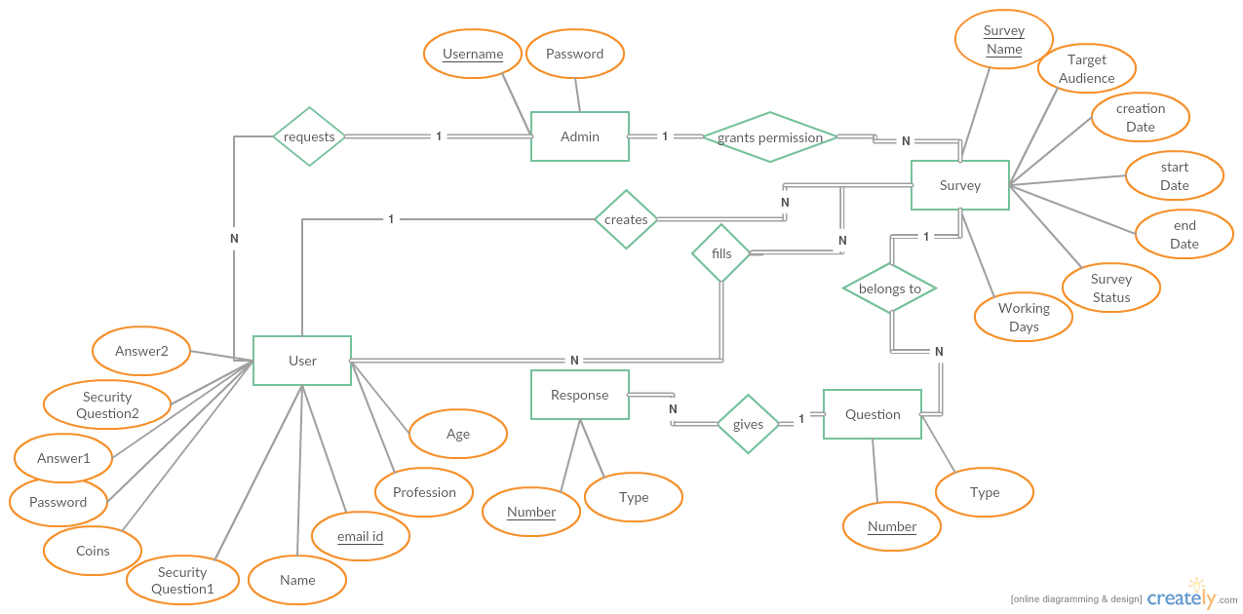

2.USER

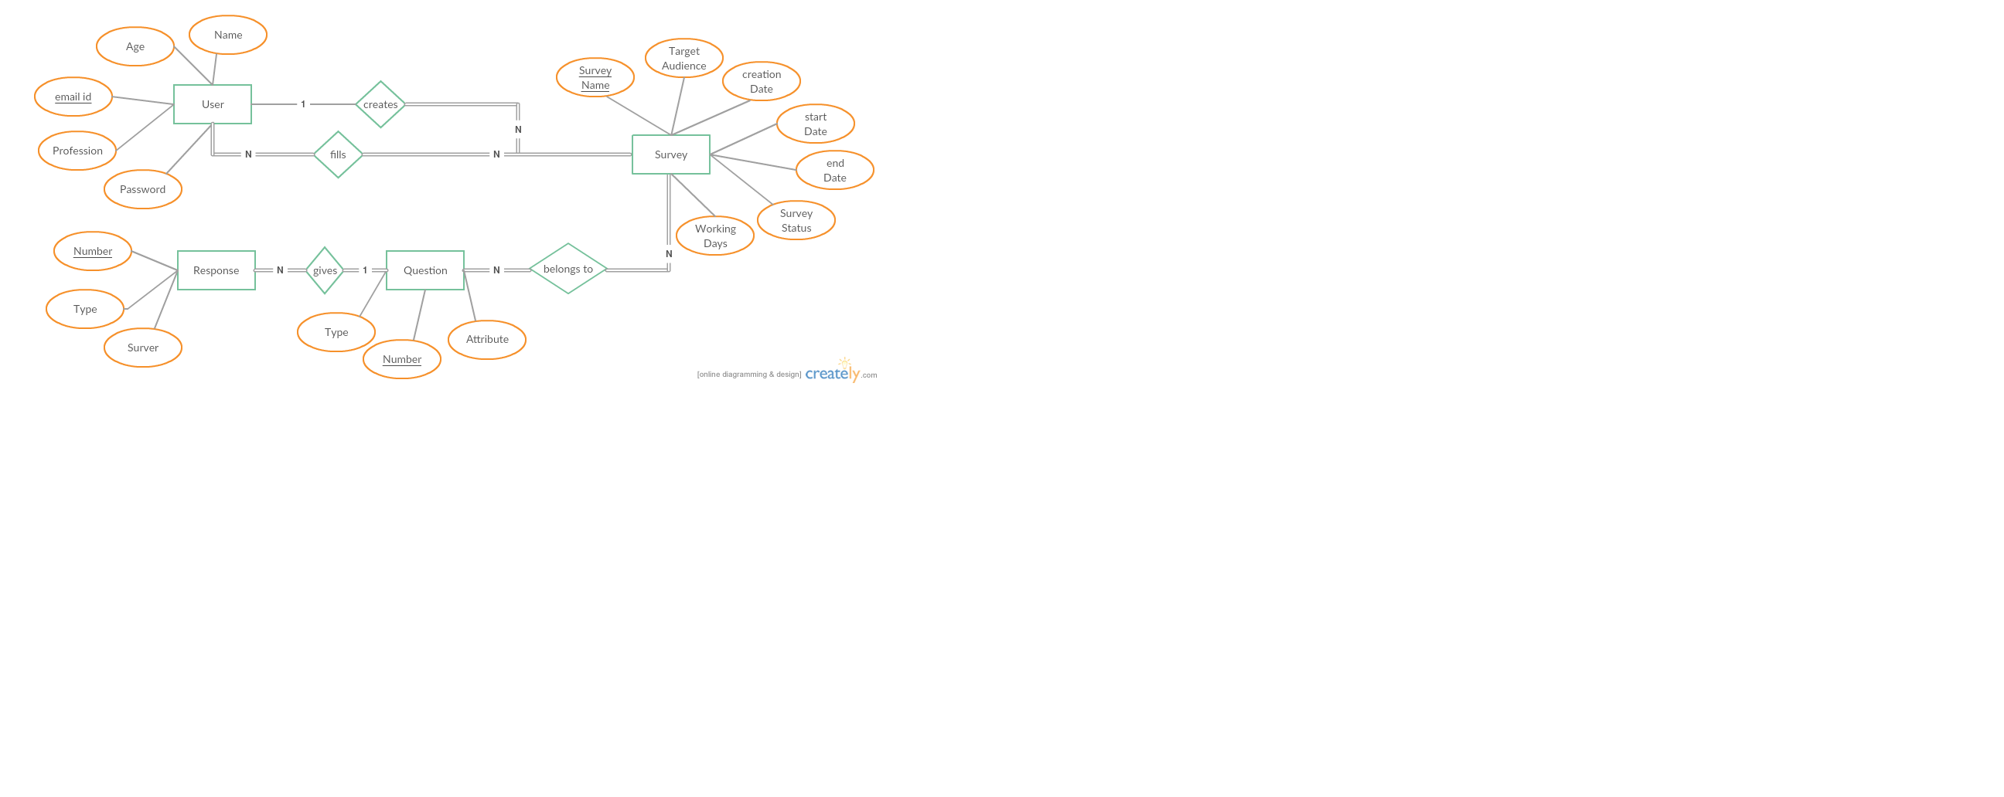

Basic flow of events: <a specific sequence of actions and interactions between actors and the system being discussed (happy path Or basic course of action)>
Line |  | System Actor Action |  | System Response
 | Admin Manages(Deletes User, Modifies User Details, Responses to Requests) |  |  | Users
 | Admin Uploads |  |  | Survey
 | Survey stores |  |  | Questions
 | Question has |  |  | Answer
 | Login-Login successful or Login Failed: Re-enter your username and password. |  |  | Test Case
 | Search-Search Results not found. Please modify your search. |  |  | Test Case
 | Register-Successfully registered or you are already a member.
 | Uploading-Successfully uploaded or Failed to upload or you have slow Internet Connection.

Screen ID: SURVEYKSHAN HOME PAGE


Screen ID: SURVEYKSHAN LOGIN PAGE

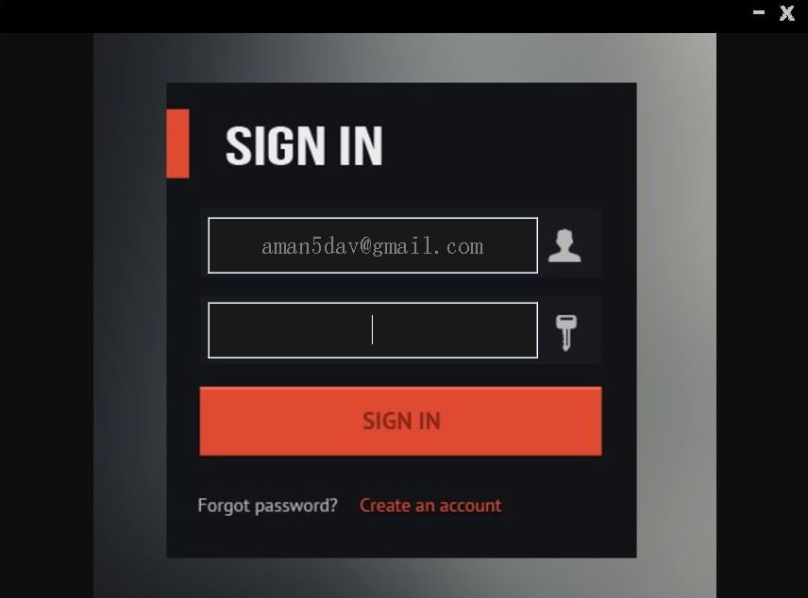

Screen ID: SURVEYKSHAN ADMIN HOME PAGE

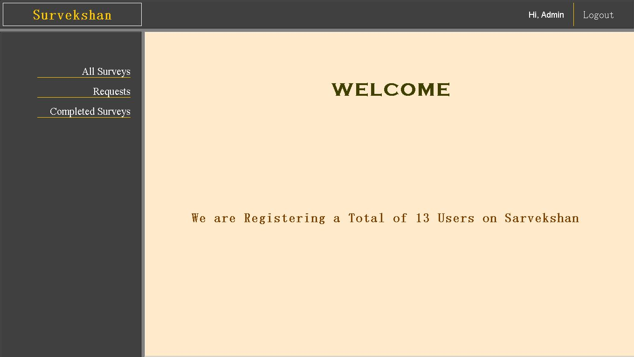

Screen ID: SURVEYKSHAN USER HOME PAGE

