Project name: SURVEYKSHAN

Database Design Specification

DOCUMENT VERSION HISTORY

Document Version | Date Issued | Comments
1.0 | 14-07-2017 | First version of the system

Table of Contents

Table of Contents 2
1 Introduction 3
2 Conventions followed 3
3 Abbreviations used 3
4 Entity Relationship Diagram 4
5 Tables 5

Introduction

The object/relationship pair is the cornerstone of the data model. These pairs can be represented graphically using the entity/relationship diagram. The ERD (Entity-Relationship Diagram) was originally proposed by Peter Chen. The primary purpose of the ERD is to represent entities (data objects) and their relationships with one another.
The ER Diagram of the assigned project SURVEYKSHAN has two major entities namely: Admin and User. These entities have their respective attributes enlisted with them. To make the working more clear few more entities have been added in this diagram namely, User Info, Survey, Questions and Answers.
The Admin as stated manages the operations such as Update, Manages, and Receive Payments. These operations are stated as relations and as applicable are joined to their respective entities to perform operations.
The User have major operations of Creating a Survey, filling a Survey and making for Payments for filling and creating a survey. These operations are stated as relations and as applicable are joined to their respective entities to perform operations.

Conventions followed

HUNGARIAN CONVENTION

Abbreviations used

Sample abbreviations listed below -

- PK – Primary Key
- FK – Foreign Key
- AI – auto-incremented, the seed and increment values are 1 unless specified.
- Def – default value
- NN – Not Null (Required)
- UC – Unique Constraint
- SLT – Single Line of Text
- MLT – Multiple Lines of Text
- PG – Person or Group
- Yes/No (checkbox) – Yes/No
- CK-Composite Key
- AI-Auto Increment

Entity Relationship Diagram

  - ADMIN

1.1ADMIN manages:

    - Users
    - Surveys
    - Question
    - Answer

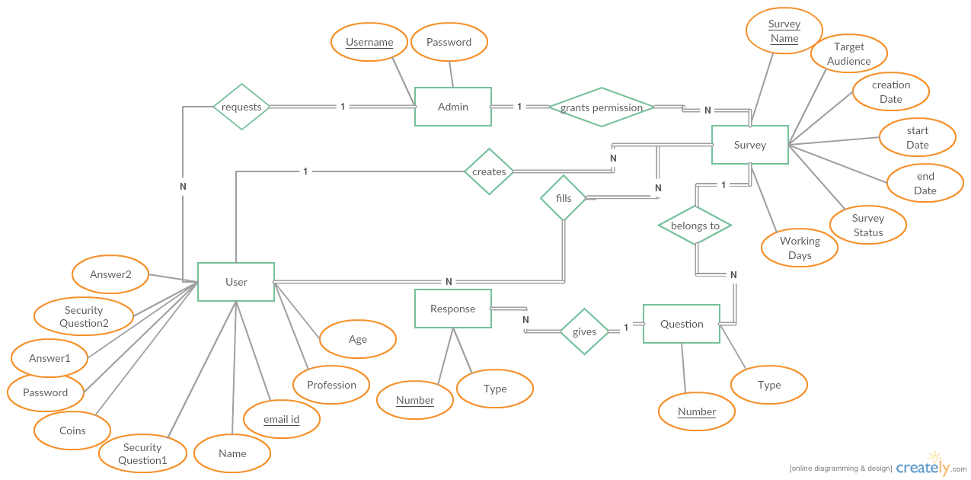

2.USER

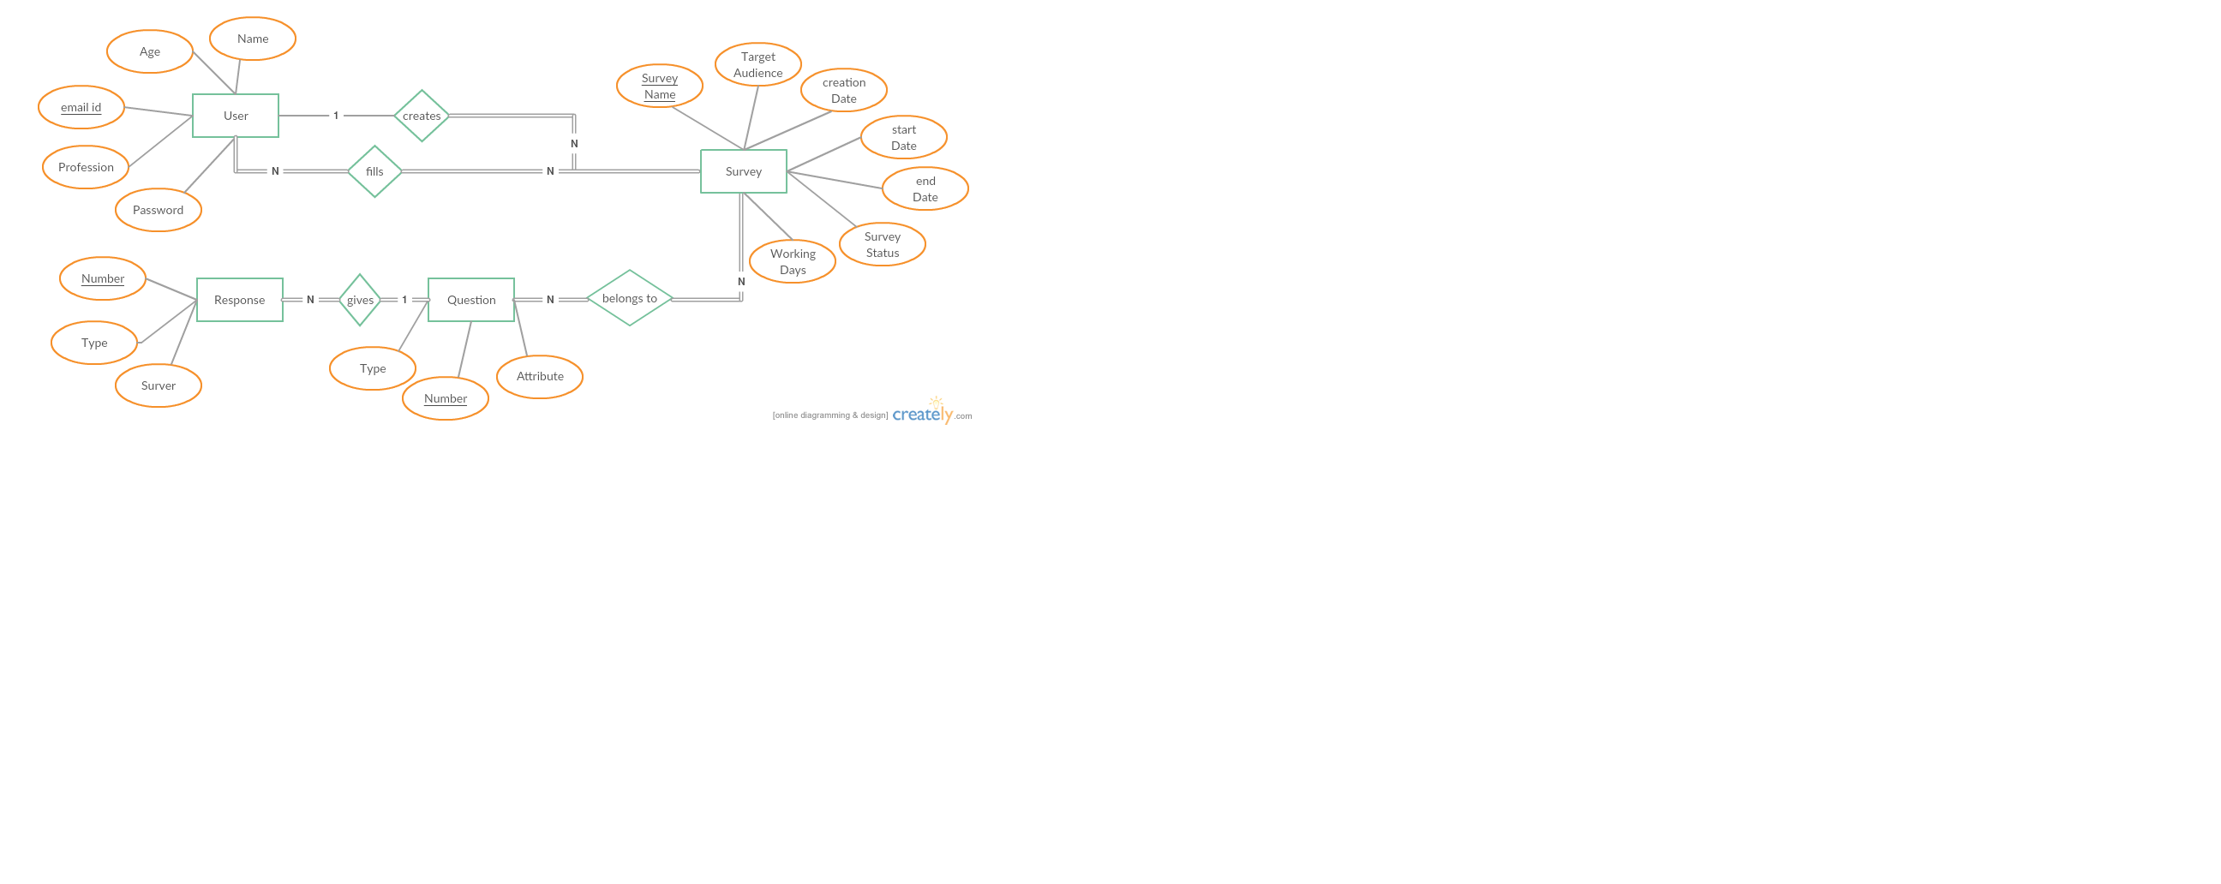

Tables

Tables are listed below –

USER INFO

Table Name | USER INFO
Description | This table will contain the basic information about the users.
Primary Keys | EMAIL
Foreign Keys
Field Name | Data type | Constraints | Comments
NAME | varchar2(20) |  | Name of the User.
GENDER | varchar2(6) |  | Gender of the User.
SECURITYQ1 | varchar2(100) |  | Question for security purpose.
SECURITYQ2 | varchar2(100) |  | Question for security purpose.
SECURITYA1 | varchar2(20) |  | Answer which the user knows.
SECURITYA2 | varchar2(20) |  | Answer which the user knows.
PROFESSION | varchar2(20) |  | Profession of the User.
STATE | varchar2(20) |  | State where the User lives.
AGE | varchar2(3) |  | Age of the User.
EMAIL | varchar2(30) | NN, PK | EmailId of the User.
Password | varchar2(20) |  | Password of the account which the User holds.
ACCOUNT_BALANCE | varchar2(6) |  | Balance of the account of the User.

SURVEY

Table Name | SURVEY
Description | This table holds the information about the Surveys which are going on currently.
Primary Keys | SURVEY_NAME
Foreign Keys
Field Name | Data type | Constraints | Comments
SURVEY_NAME | Varchar2(40) | PK, NN | Holds the name of Survey.
EMAIL_ADDRESS | Varchar2(40) |  | Holds the Email ID.
TARGET_AUDIENCE | Varchar2(10) |  | Targeting the Audience.
CREATION_DATE | Date(7) |  | Date when survey gets created.
SURVEY_STARTDATE | Date(7) |  | Date when survey gets started.
SURVEY_ENDDATE | Date(7) |  | Date when survey gets ended.
SURVEY_STATUS | Varchar2(2) |  | Holds the Status of the Survey.
WORKING_DAYS | Varchar2(5) |  | How many days the Survey is going
CREATION_AMOUNT | Varchar2(6) |  | Amount of creation.
REWARD_AMOUNT | Varchar2(4) |  | Amount of reward.

5.3 QUESTIONS

Table Name | QUESTIONS
Description | This table holds the information about the Questions which has been added to a particular survey.
Primary Keys
Foreign Keys
Field Name | Data type | Constraints | Comments
QUESTION | Varchar2(500) |  | Holds the Questions
TYPE | Varchar2(50) |  | Holds the type of the question
VALUE | Varchar2(500) |  | Holds the options in the checkbox.

ANSWER

Table Name | ANSWER
Description | This table holds the data about the answers which are given by the user for a particular survey.
Primary Keys | USER_EMAIL_ADD
Foreign Keys
Field Name | Data type | Constraints | Comments
USER_EMAIL_ADD | Varchar2(250) | PK, NN | Holds the Email address of User.
Q1 | Varchar2(50) |  | Holds the question 1.
Q2 | Varchar2(50) |  | Holds the question 2.
Q3 | Varchar2(50) |  | Holds the question 3.
Q4 | Varchar2(50) |  | Holds the question 4.

