CONFIDENTIAL

Project name: SURVEYKSHAN

Class Design Specification

DOCUMENT VERSION HISTORY

Document Version | Date Issued | Comments
1.0 | 14-07-17 | First version of the desktop application

Table of Contents

Table of Contents 2
Class Design
1 Introduction 3
2 Conventions followed 3
3 Class Diagrams 4

Introduction

The class diagram is the main building block of object oriented modelling. It is used both for general conceptual modelling of the systematics of the application, and for detailed modelling translating the models into programming code. Class diagrams can also be used for data modeling. The classes in a class diagram represent both the main objects and or interactions in the application and the objects to be programmed. In the class diagram these classes are represented with boxes which contain three parts:
A class with three sections:
- The upper part holds the name of the class
- The middle part contains the attributes of the class
- The bottom part gives the methods or operations the class can take or undertake

Conventions followed

Hungarian Convention

Class Diagrams

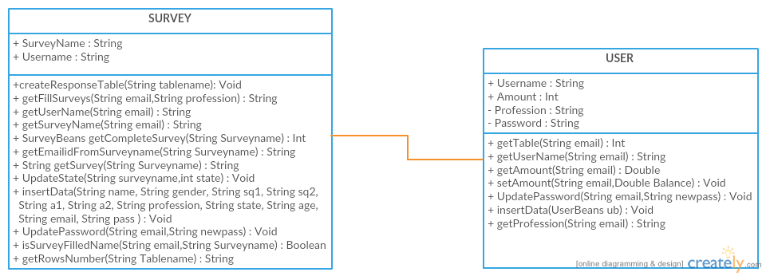

Classes

Survey:

Class Description :
The Survey Class defines the working of the whole Application from Table creation to the Filling of the Survey , Updating the information of the user, Ensuring each User must fill a Survey only once, tells the current status of the Survey etc…

Methods
 | Function | OutPut Parameters | Description
1 | createResponseTable(String tablename) | Void | This function creates the table in the database
2 | getFillSurveys(String email,String profession) | String | Fills the survey choosen from the existing surveys in the portal
3 | getUserName(String email) | String | Gets the username from the user which will act as a primary key
4 | getSurveyName(String email) | String | Displays the name of all the surveys present on the portal
5 | SurveyBeans getCompleteSurvey(String Surveyname) | Int | All the questions Survey will get displayed
6 | getEmailidFromSurveyname(String Surveyname) | String | Displays the information of the user who has created the survey
7 | String getSurvey(String Surveyname) | String | Displays the title of the survey
8 | UpdateState(String surveyname,int state) | Void | Tells you the current status of the survey
9 | UpdateDates(String surveyname) | Void | Regulates the starting and ending date of the survey
10 | insertData(String name, String gender, String sq1, String sq2, String a1, String a2, String profession, String state, String age, String email, String pass ) | Void | All the information of the user
11 | UpdatePassword(String email,String newpass) | Void | Helps to reset the password in case the user forgets his/her information
12 | isSurveyFilledName(String email,String Surveyname) | Boolean | Ensuring that each user fills a survey only once
13 | getRowsNumber(String Tablename) | String | Counts the number of rows  In the program

USER:

Class Description :
The User Class defines all the information provided by the User at the time of Registration such as Username, Password, Profession, Amount etc…

Methods
1 | getTable(String email) | Int | authenticates the user to login
2 | getUserName(String email) | String | Takes the username of the user
3 | getAmount(String email) | Double | Displays the amount present in the User’s account
4 | setAmount(String email,Double Balance) | Void | Sets the amount in User’s account
5 | UpdatePassword(String email,String newpass) | Void | Helps in resetting the password
6 | insertData(UserBeans ub) | Void | Insert all the information of the User in the database
7 | getProfession(String email) | String | Get the profession of the User

