“SURVEYKSHAN”

A MINOR PROJECT REPORT

Submitted by

Amandeep Rikhi | - 11020802714
Nancy Hada | - 06920802714
Ritu Gaba | - 05620803114
Shubham Gosain | - 11720802714
Umang Gupta | - 11620802714

in partial fulfillment for the award of the degree

of

BACHELOR OF TECHNOLOGY



BHAGWAN PARSHURAM INSTITUTE OF TECHNOLOGY
Rohini Sec-17, Delhi

July-2017

CERTIFICATE

This is to certify that the Minor Project report entitled “Surveykshan” submitted by Amandeep Rikhi, Nancy Hada, Ritu Gaba, Shubham Gosain, Umang Gupta has been carried out under my guidance & supervision. The project report is approved for submission towards partial fulfillment of the requirement for the award of degree of BACHELOR OF TECHNOLOGY from “BHAGWAN PARSHURAM INSTITUTE OF TECHNOLOGY, ROHINI SEC-17, DELHI”

(Mr. Akhilesh Kumar Soni) (Mrs. Lata Verma)

Project Guide Coorporate Java Trainer

Centum Foundations Centum Foundations

CERTIFICATE

This is to certify that the Major Project report entitled “SURVEYKSHAN” is submitted by Amandeep Rikhi, Nancy Hada, Ritu Gaba, Shubham Gosain, Umang Gupta for the partial fulfillment of the requirement for the award of degree of BACHELOR OF TECHNOLOGY from “BHAGWAN PARSHURAM INSTITUTE OF TECHNOLOGY, ROHINI SEC-17, DELHI”

Mrs. Lata Verma Mr. Akhilesh Kumar Soni

Centum Foundations Centum Foundations

Coorporate Java Trainer External Examiner
Date : 14/07/2017 Date : 14/07/2017

DECLARATION

We hereby declare that the project entitled “SURVEYKSHAN” which is being submitted in partial fulfillment of the requirement for award of the Degree of Bachelor of Technology to “BHAGWAN PARSHURAM INSTITUTE OF TECHNOLOGY” is an authentic record of our own work done under the guidance of Mrs. Lata Verma.

The matter reported in this Project has not been submitted earlier for the award of any other degree.

Dated : 14/07/2017 Amandeep Rikhi

Place : DELHI Nancy Hada
Ritu Gaba
Shubham Gosain
Umang Gupta

ACKNOWLEDGEMENT

We sincerely express indebtedness to esteemed and revered guide “Mrs. Lata Verma”, Coorporate JAVA Trainer, for her invaluable guidance, supervision and encouragement throughout the work. Without her kind patronage and guidance the project would not have taken shape.

We take this opportunity to express deep sense of gratitude to “Dr.Babita Kataria and Dr.Gopal Kataria” for their encouragement and kind approval. Also we thank them in providing the computer lab facility. We would like to express our sincere regards to them for advice and counseling from time to time.

We owe sincere thanks to all the lecturers in “Bhagwan Parshuram Institute Of Technology” for their advice and counseling time to time.

Dated : 14/07/2017 Amandeep Rikhi

Place : DELHI Nancy Hada
Ritu Gaba
Shubham Gosain
Umang Gupta

TABLE OF CONTENTS

1.Introduction…………………………………………………...7-8
2.Problem Definition…………………………………………...9
3.Requirements………………………………………………..10-12
4.Design………………………………………………………..13-15
5.Tables………………………………………………………..16-18
6.Cost Estimation.…………………………………………….18-19
7.Implemention…………………………………………….....19-20
8.Coding……………………………………………………….21-99
7.Application…………………………………………………..99-106
8.Conclusion…………………………………………………..106
9.Future Scope………………………………………………..106

References
Bibliography

Chapter Details of Project
- Introduction

Surveykshan is a full featured survey application, intended to be used for creating and publishing surveys, collect responses and export statistics. Its purpose is to accommodate a large user base with diverse needs so there is an abundance of features and settings at the users disposal.
The prominent of these features is the API which facilitates the connectivity with other web applications. It was a challenging endeavour, not only because of the complexity of the functionality required for the evaluation framework, but also due to the breadth and complexity of the organization it was addressing.
To make the long story short, either due to cost or scalability issues, we decided to drop clickers and scanners as tools to gather peoples’ feedback. Questionnaires proved to be the best solution for us.
We decided to go with Surveykshan as it had a good track record of deployments, it was widely used in academia and above all it was open source software. The advantage of an open source based solution was the fact that it would allow us to adapt it to our needs both in terms of integration and functionality and hopefully contribute our work back to the community.
.

Objectives:-

- Creating or importing a survey.
- Editing survey properties.
- Manipulating multi-language survey properties.
- Adding group and questions to existing surveys.
- Activating surveys.
- Getting survey submission summary.
- Exporting parts or complete surveys statistics.
- Export responses.
- Insert responses.
- Exporting time-line of survey submissions
Limitations of the existing System:-

The existence survey portals are mostly web based none of them is desktop based. Also either those systems don’t provide users the permission to create their own surveys, to choose how long their survey should run, and for which tym of audience. Or if they allow then there is no restriction on the user or no one is there to check whether the survey creator hasn’t enter something that might would offend someone or the other. Also there is no limit on the users for how many surveys they cn create.

- Problem Definition

The sole aim of this project is to create a survey for specific audience for a fixed duration. Until the Admin permite the survey , it can’t be present on the portal.

The main purposes of this project are:-

- To provide a list of available surveys to the searching User.
- To provide them with the ability of creating their own surveys.
- To charge a nominal fees depending upon the payment to be made for creating and filling surveys.
- To provide authentic ways to the admin for updating user’s details and receiving payments.
- To promote new surveys.

Benefits of the Project:
The system includes the Admin and the User. Benefits to each of these are described below.

Benefit to User:
User is highly benefitted as he gets the opportunity to choose the Audiemce for his/her Survey filling. Also can gain back the money what he/she has spent in Survey creation by Filling their specifiv surveys.

Benefit to Admin:
Admin has the benefit that he/she can evaluates any new survey and without his/her permission none of the new survey will be available for the choosen audience. Also he/she has the power to see which survey is running or pending or completed.

3.Requirements

  - Functional Requirements

1. The first functional requirement is to input values in the database and store them there for future use. To implement the security and to ensure that no android is filling in the registration forms, id specific for the user who is registering will be generated and user will have to enter the id to login. If any field is left to provide the data, the system will prompt the user by using the code and will not submit the data until corrections/data entries are made completely.

2. The second functional requirement is to only grant access to users that are listed in the database. The customer will have to provide his username, id, and password. To implement the security must check the database to see if the Username, Password and Category are valid. If they are not, the user will receive an “Incorrect username and password” as a response.

3. The third functional requirement is to suggest users a list of available surveys according to the Survey creator’s wish. The user will then upon his sole discretion will select a suitable survey for him/her and will proceed to it. Also after filling each survey he/she will gain some amount of money into their wallet.

4. The forth functional requirement is related to the user for the creation of survey. Before creating any survey a user must have the minimum amount (¥15) in his/her account. Then depending upon the number of questions he/she has entered, number of days he/she has choosen for his/her survey.

5. The fifth functional requirement is to make comments and review them accordingly.

3.2 System Requirements
3.2.1 Hardware Requirements
A minimum of 40GB of HDD, with Pentium IV processor, a minimum of 256MB of RAM so that a suitable OS (Windows XP, Windows 7, Windows 8 and Windows 10 ) may be installed, and a reliable internet connection is required for the client side/user side so that may be accessed easily.

3.2.2 Software Requirements

3.2.2.1 Software Interface

The system uses:

IDE Eclipse Neon3.0: IDE Eclipse Neon3.0 is a platform framework for Java desktop applications.

Oracle 10g: It is a object-Relational Database Management System. The Oracle DBMS can store and execute stored procedures and functions within itself.

3.3 Technologies Used

Operating System: | Windows 10
Language Requirements: | Java EE
Database Technology: | Oracle 10g
Tools & Development: | IDE Eclipse Neon 3.0

3.4 Operating Environment

Technologies to be used

Programming languages
- JAVA EE: Java Enterprise Edition is a programming platform— part of the Java Platform-for developing and running distributed multi-tier architecture Java applications, based largely on modular software components running on an application server.

Tools & Development Environment
ECLIPSE: The Eclipse Marketplace Client will provide links to browse for more solutions or Learn more. Clicking these links will cause the Eclipse Marketplace Client to close and the Marketplace to be opened in a web browser. Browse the marketplace website, and when ready press the Install button to reopen the Eclipse Marketplace Client

3.5 High-Level Requirements

The following table presents the requirements that the project’s product, service or result must meet in order for the project objectives to be satisfied.

Req. # | I Requirement Description
Registration | To Provide complete access to the users i.e.to become a valid user.
Transaction | Details of addition and deduction of the Virtual money provided to  each user.
Availability Of Surveys | Each survey will be available only for the specific period time.
Permission granted by the  Admin | Admin will evaluated the survey and then only grants permission  for allowing the particular survey to be available on the portal.

- Design

4.1 Architectural Design

4.1.1 Use case Diagram

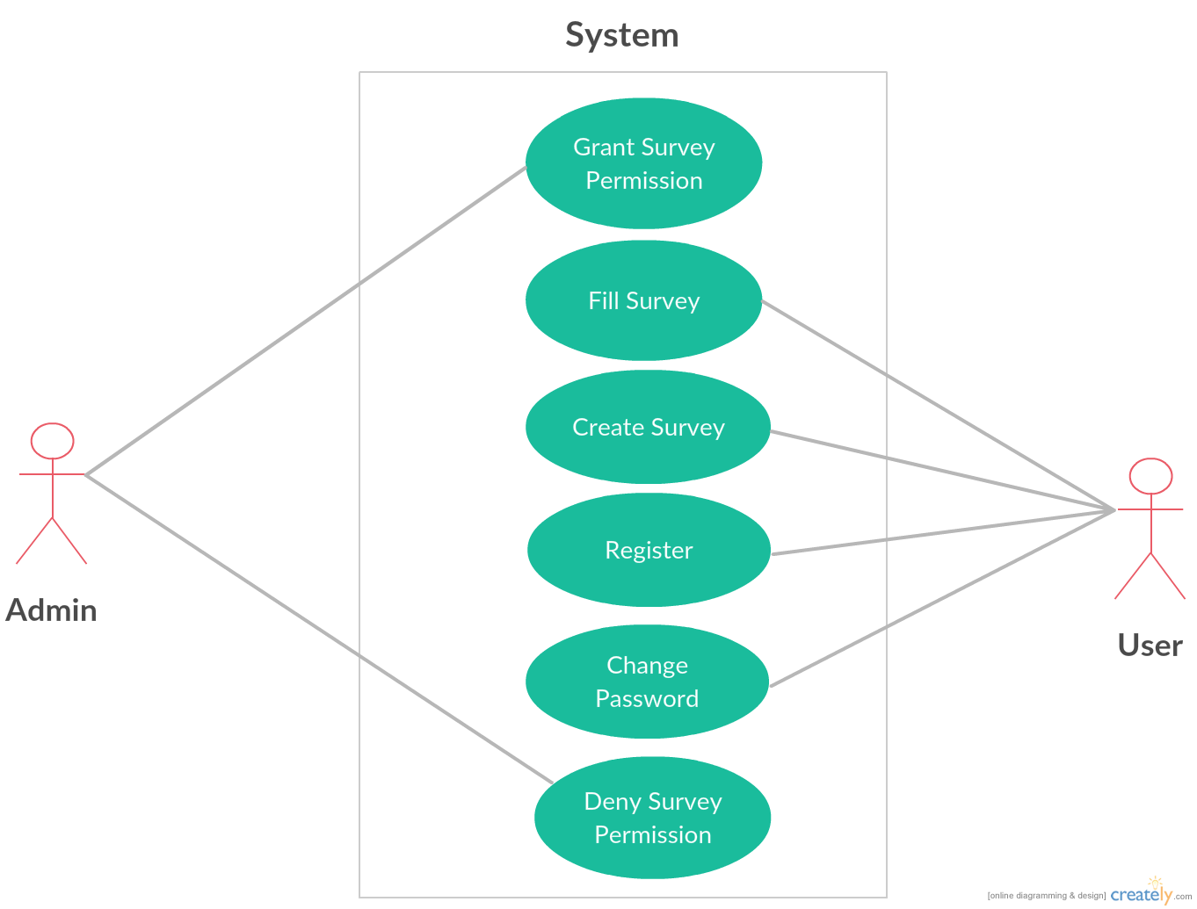

  - Detailed Design

4.2.1 ER Diagram

1. ADMIN

1.1ADMIN Manages Users, Surveys, Question, Answer

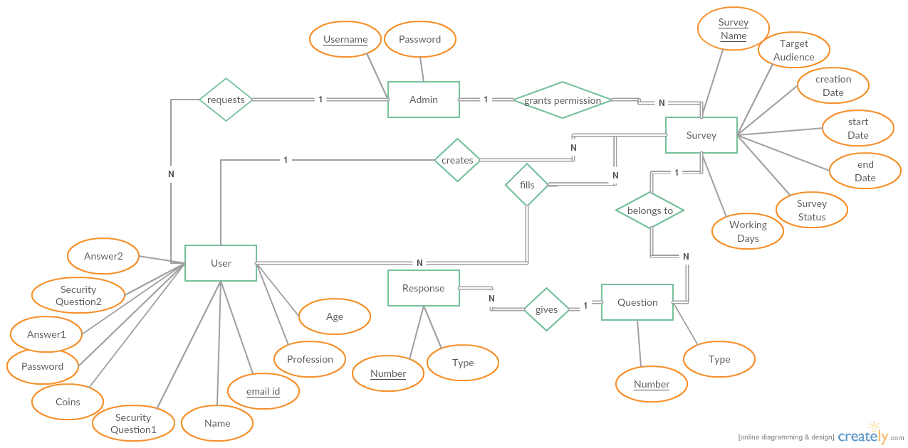

2.STUDENT

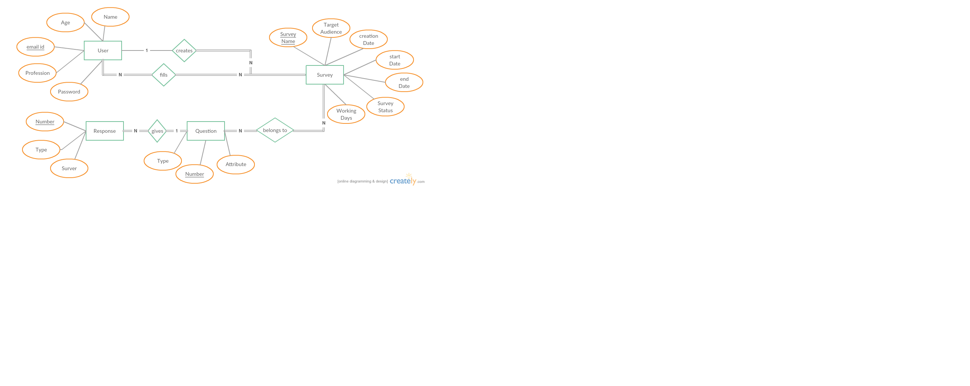

Tables

Tables are listed below –

USER INFO

Table Name | USER INFO
Description | This table will contain the basic information about the users.
Primary Keys | EMAIL
Foreign Keys
Field Name | Data type | Constraints | Comments
NAME | varchar2(20) |  | Name of the User.
GENDER | varchar2(6) |  | Gender of the User.
SECURITYQ1 | varchar2(100) |  | Question for security purpose.
SECURITYQ2 | varchar2(100) |  | Question for security purpose.
SECURITYA1 | varchar2(20) |  | Answer which the user knows.
SECURITYA2 | varchar2(20) |  | Answer which the user knows.
PROFESSION | varchar2(20) |  | Profession of the User.
STATE | varchar2(20) |  | State where the User lives.
AGE | varchar2(3) |  | Age of the User.
EMAIL | varchar2(30) | NN, PK | EmailId of the User.
Password | varchar2(20) |  | Password of the account which the User holds.
ACCOUNT_BALANCE | varchar2(6) |  | Balance of the account of the User.

SURVEY

Table Name | SURVEY
Description | This table holds the information about the Surveys which are going on currently.
Primary Keys | SURVEY_NAME
Foreign Keys
Field Name | Data type | Constraints | Comments
SURVEY_NAME | Varchar2(40) | PK, NN | Holds the name of Survey.
EMAIL_ADDRESS | Varchar2(40) |  | Holds the Email ID.
TARGET_AUDIENCE | Varchar2(10) |  | Targeting the Audience.
CREATION_DATE | Date(7) |  | Date when survey gets created.
SURVEY_STARTDATE | Date(7) |  | Date when survey gets started.
SURVEY_ENDDATE | Date(7) |  | Date when survey gets ended.
SURVEY_STATUS | Varchar2(2) |  | Holds the Status of the Survey.
WORKING_DAYS | Varchar2(5) |  | How many days the Survey is going
CREATION_AMOUNT | Varchar2(6) |  | Amount of creation.
REWARD_AMOUNT | Varchar2(4) |  | Amount of reward.

1.3 QUESTIONS

Table Name | QUESTIONS
Description | This table holds the information about the Questions which has been added to a particular survey.
Primary Keys
Foreign Keys
Field Name | Data type | Constraints | Comments
QUESTION | Varchar2(500) |  | Holds the Questions
TYPE | Varchar2(50) |  | Holds the type of the question
VALUE | Varchar2(500) |  | Holds the options in the checkbox.

ANSWER

Table Name | ANSWER
Description | This table holds the data about the answers which are given by the user for a particular survey.
Primary Keys | USER_EMAIL_ADD
Foreign Keys
Field Name | Data type | Constraints | Comments
USER_EMAIL_ADD | Varchar2(250) | PK, NN | Holds the Email address of User.
Q1 | Varchar2(50) |  | Holds the question 1.
Q2 | Varchar2(50) |  | Holds the question 2.
Q3 | Varchar2(50) |  | Holds the question 3.
Q4 | Varchar2(50) |  | Holds the question 4.

4.2.2 Class Diagram

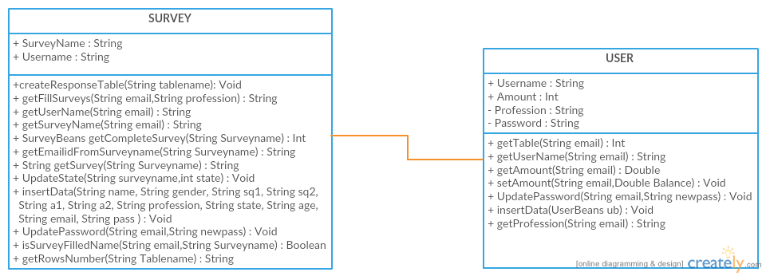

  - Cost Estimation
(Identify the financials related to the project by calculating lines of code and complexity of the system)

Cost estimation is calculated through the COCOMO technique.
SURVEYKSHAN project comes in the category of organic software development.

Characteristics of Organic software develpoment:
- Well understood application program.
- Size of development team is small.
- Team member s are experience in developing sismilar type of project.
- Requirements are already known.

Formula used:

- effort = a1 * ( KLOC) ^{a2} PM
- T_{dev} = b1 * ( effort ) ^{b2} month

Where
KLOC: kilo lines of codes.
T_{dev} : total development time
PM : PM(person month) is the unit of effort

Values of constants
a1=2.4 b1=2.5
a2=1.05 b2=0.38

by substituting the value of constants and KLOC( kilo lines of code in the project) formula given above , the total cost can be calculated.

  - Implementation

The developed system has the following salient features as below:-

- The developed system assist the new user whether Student, Engineer, Teacher etc to
register with the system and be its member.

- Also each user gets an initial amount in his/her amount i.e, ¥100.

- The Id of the new user registering is generated automatically by the system and the
user must use it to Login into the portal.

- The user gets updated about the the information of the Latest Surveys added in the
portal, in a way promoting the them.

- Admin gets the notification of the new requests. Then evaluates the New Survey and
accordingly grant or deny the permission.

- Without Admin’s permission the survey will not be available on the portal.

- After getting the permission the user will be charged according to the number of
questions he has added and the duration of days he/she wants the survey to be active.

- The users who are filling the survey will earn some amount on each survey filling.

- The portal provides a way of feedback by providing its users to comment on the
performance and view the comments done by the other users.

- The portal provides security to the user by authenticating and authorizing the
username, password and the id provided by the portal at the time of login and
connecting the user to his account only.

- Incase any user forgets his credentials then he can get to the “Forget Password” menu
where he has to enter the answer of the same Security Questions that he/she has
choosen at the time of registration. By doing so he/she will be able to access his
account again with a new password.

CODING OF MODULES

The developed system can be divided into four major modules namely:
1. Administrator
2. User

Each of these modules has certain specific functionality related to them and are described below:-
- Administrator
The Administrator or the Admin is an important module of the project SURVEYKSHAN and has many important functions to perform. Some of them are:

- Login: The administrator logs into the system

Code:-
jLogin.addMouseListener(new java.awt.event.MouseAdapter(){
public void mouseClicked(java.awt.event.MouseEvent evt){

if(jusername.getText().equals("admin")&&jpassword.getText().equals("admin"))
EventQueue.invokeLater(new Runnable() {
public void run() {
try {
Admin frame = new Admin();
frame.setVisible(true);
jframe1.dispose();
} catch (Exception e) {
e.printStackTrace();
}
}
});
else
CheckLogin();
System.out.println("clicked login");
}

});

Deleting A Survey: A Survey can be deleted from the list of Surveys.
Code:-
public void DeleteSurvey()
{
SurveyDAOImplements sdao=new SurveyDAOImplements();
try {
int dialogResult = JOptionPane.showConfirmDialog (null, "Are You Sure You Want to Delete Survey","Warning",JOptionPane.YES_OPTION);
if(dialogResult == 0){
sdao.DeleteSurvey(Surveyname);
JOptionPane.showMessageDialog(null,"Survey is Succesfully Removed");
dispose();
}

} catch (ClassNotFoundException e1) {
// TODO Auto-generated catch block
e1.printStackTrace();
} catch (SQLException e1) {
// TODO Auto-generated catch block
e1.printStackTrace();
}
}

-Passing Survey Requests: Pass the Surveys Requests generated by users
Code:
jdirectrequest.addMouseListener(new java.awt.event.MouseAdapter()
{
public void mouseClicked(java.awt.event.MouseEvent evt)
{
SurveyDAOImplements sdao=new SurveyDAOImplements();
try {
String email=sdao.getEmailidFromSurveyname(name);
UserDAOImplements udao=new UserDAOImplements();
try {
udao.setAmount(email, udao.getAmount(email)-sdao.getCreationAmount(name));
} catch (ClassNotFoundException e1) {
// TODO Auto-generated catch block
e1.printStackTrace();
} catch (SQLException e1) {
// TODO Auto-generated catch block
e1.printStackTrace();
}
sdao.UpdateState(name,1);

JOptionPane.showMessageDialog(null,"Request Accepted");
dispose();
} catch (ClassNotFoundException e) {
// TODO Auto-generated catch block
e.printStackTrace();
} catch (SQLException e) {
// TODO Auto-generated catch block
e.printStackTrace();
}

}});

-Discard Requests: Discard the Survey Request and change its state
Code:-
discardbutton.addMouseListener(new java.awt.event.MouseAdapter()
{
public void mouseClicked(java.awt.event.MouseEvent evt)
{
//Survey_db sdb=new Survey_db();
SurveyDAOImplements sdao=new SurveyDAOImplements();
try {
sdao.UpdateState(name,3);
JOptionPane.showMessageDialog(null,"Survey Request has been Discarded");
dispose();
} catch (ClassNotFoundException e) {
// TODO Auto-generated catch block
e.printStackTrace();
} catch (SQLException e) {
// TODO Auto-generated catch block
e.printStackTrace();
}
}});

- Survey Results: Admin can see the results of all completed Surveys
Code:
jResults.addMouseListener(new java.awt.event.MouseAdapter()
{
public void mouseClicked(java.awt.event.MouseEvent evt)
{

EventQueue.invokeLater(new Runnable() {
public void run() {
try {
GetSurveyResult frame=new GetSurveyResult(Surveyname);
frame.setVisible(true);

} catch (Exception e) {
e.printStackTrace();
}
}
});
}}
);

public GetSurveyResult(String Surveyname) {

setDefaultCloseOperation(JFrame.DISPOSE_ON_CLOSE);
setBounds(screenwidth-700, screenHeight-400,1400, 800);
JPanel contentPane = new JPanel();
contentPane.setBorder(new EmptyBorder(5, 5, 5, 5));
setContentPane(contentPane);
contentPane.setLayout(null);

JScrollPane scrollPane = new JScrollPane();
scrollPane.setCursor(Cursor.getPredefinedCursor(Cursor.HAND_CURSOR));
scrollPane.setBounds(6, 6, 1400, 820);
contentPane.add(scrollPane);

SurveyDAOImplements sdb=new SurveyDAOImplements();

try {
count=Integer.parseInt(sdb.getRowsNumber(Surveyname));
} catch (NumberFormatException e) {
// TODO Auto-generated catch block
e.printStackTrace();
} catch (ClassNotFoundException e) {
// TODO Auto-generated catch block
e.printStackTrace();
} catch (SQLException e) {
// TODO Auto-generated catch block
e.printStackTrace();
}

String[] columns = new String[count+1];
columns[0]="Email Address ";
for(int i=1;i<=count;i++)
{
columns[i]="Question "+(i);
}

System.out.println(count);
table = new JTable();
table.setModel(new javax.swing.table.DefaultTableModel(
new Object [][] {

},
columns
){
boolean[] canEdit = new boolean [] {
false, false, false, false, false, false, false, false
};

public boolean isCellEditable(int rowIndex, int columnIndex) {
return canEdit [columnIndex];
}
});

String query="Select * from "+Surveyname+"answer";
try {
DefaultTableModel model = (DefaultTableModel)table.getModel();
pstmt=DataSource.con.prepareStatement(query);
rs=pstmt.executeQuery();
Object[] o=new Object[count+1];
while(rs.next())
{
String data;
for (int i=0;i<=count;i++)
{
o[i]=rs.getString(i+1);
System.out.println(o[i]);
}
model.addRow(o);
}
table.setModel(model);

} catch (SQLException e1) {
// TODO Auto-generated catch block
e1.printStackTrace();
}
table.setRowHeight(24);
table.setAlignmentX(JTable.CENTER_ALIGNMENT);
table.setFont(new Font("Simsun", Font.BOLD,22 ));
table.setBorder(BorderFactory.createLineBorder(Color.BLACK));

scrollPane.setViewportView(table);

}

- USER
The User is the other module of the project SURVEYKSHAN and has many important functions to perform. Some of them are:
-Login: The USER logs into the Survey Engine.
Code:
private void CheckLogin()
{

String query="Select * from LOGIN where USERNAME='"+jusername.getText()+"' and PASSWORD='"+jpassword.getText()+"'";
try{
ps=DataSource.con.prepareStatement(query);
rs=ps.executeQuery();
if(rs.next())
{
Username=rs.getString(1);
jframe1.dispose();
SuccessfullyLoginMesssage sfm=new SuccessfullyLoginMesssage(Username);
sfm.WelcomeMessage();
}
else JOptionPane.showMessageDialog(null,"Incorrect Email Address or Password");
}
catch (SQLException sqe)
{

}
}

-Register:- The new user is registered into engine via this.
Code:
RegisterButton.addMouseListener(new MouseAdapter() {
@Override
public void mouseClicked(MouseEvent arg0)
{
UserBeans ub=new UserBeans();
ub.setName(txtFirstName.getText()+" "+txtLastName.getText());
ub.setSq1(sq1.getSelectedItem().toString());
ub.setSq2(sq2.getSelectedItem().toString());
ub.setPassword(passwordField.getText().toString());
ub.setEmail(txtemail.getText());
ub.setAge(txtAge.getText());
ub.setProfession(profession.getSelectedItem().toString());
ub.setState(state.getSelectedItem().toString());
ub.setAmount("100");
ub.setA1(a1.getText());
ub.setA2(a2.getText());
if (Female.isSelected())
{
ub.setGender("Female");
}
else
{
ub.setGender("Male");
}

UserDAOImplements udao=new UserDAOImplements();
try {
if(udao.insertData(ub))
{System.out.println("Data inserted");
JOptionPane.showMessageDialog(null,"Successfully Registered");
}
} catch (ClassNotFoundException e) {
// TODO Auto-generated catch block
e.printStackTrace();
} catch (SQLException e) {
// TODO Auto-generated catch block
e.printStackTrace();
}
frame.dispose();
UserLogin u=new UserLogin();
}
});

-Forget Password: User can change his password on the basis of security Questions.
Code:-

submit.addMouseListener(new java.awt.event.MouseAdapter() {
public void mouseClicked(java.awt.event.MouseEvent evt) {
try {
checkAccount(email_text.getText());
}
catch (ClassNotFoundException e) {
// TODO Auto-generated catch block
e.printStackTrace();
} catch (SQLException e) {
// TODO Auto-generated catch block
e.printStackTrace();
}
}
});

confirm.addMouseListener(new java.awt.event.MouseAdapter() {
public void mouseClicked(java.awt.event.MouseEvent evt) {
if((a1.toLowerCase()).equals(security_answer_1.getText().toLowerCase())&&(a2.toLowerCase()).equals(security_answer_2.getText().toLowerCase()))
{panel1.setVisible(false);
panel2.setVisible(true);}
else JOptionPane.showMessageDialog(null,"Wrong Answers....Pls Enter Correct Responses");

// changePassword(email);
}});

done.addMouseListener(new java.awt.event.MouseAdapter() {
public void mouseClicked(java.awt.event.MouseEvent evt) {

if((pass1.getText().length()>2)&&(pass1.getText().equals(pass2.getText())))
{
try {
changePassword(pass1.getText());
} catch (ClassNotFoundException e) {
// TODO Auto-generated catch block
e.printStackTrace();
} catch (SQLException e) {
// TODO Auto-generated catch block
e.printStackTrace();
}
}
else JOptionPane.showMessageDialog(null,"Password Didn't Matched");

// changePassword(email);
}});

void checkAccount(String email) throws ClassNotFoundException, SQLException
{
UserDAOImplements udao=new UserDAOImplements();
UserBeans ub=new UserBeans();

ub=udao.getTable(email);
emailaddress=email;
if(ub.getEmail().equals(""))
JOptionPane.showMessageDialog(null,"No such Email Adress Found");
else
{
security_ques_1.setText(ub.getSq1());
security_ques_2.setText(ub.getSq2());
a1=ub.getA1();
a2=ub.getA2();
panel1.setVisible(true);
submit.setVisible(false);
}

}

void changePassword(String newpass) throws ClassNotFoundException, SQLException
{

UserDAOImplements udao=new UserDAOImplements();
if(udao.UpdatePassword(emailaddress,newpass))
{
JOptionPane.showMessageDialog(null,"Sucessfully Updated Password");
new UserLogin();
dispose();
}

}
Usernew.java: User Interface to do all the functions
Code:

package Login;
import java.awt.Color;
import java.awt.Font;
import java.awt.Toolkit;
import java.sql.SQLException;

import javax.swing.ImageIcon;
import javax.swing.JFrame;
import javax.swing.JLabel;
import javax.swing.JOptionPane;
import javax.swing.JPanel;
import javax.swing.JScrollPane;
import javax.swing.JSplitPane;
import javax.swing.JTextField;
import javax.swing.RepaintManager;
import javax.swing.SwingUtilities;

import DAO.SurveyDAOImplements;
import DAO.UserDAOImplements;
import createsurvey.SurveyName;
import fill.Survey_db;

public class usernew {

JFrame jframe4;
JSplitPane jsp,jsprightvertical;
JPanel panel1,jpaneladdnewForm,jPanelfill,initialrightupper;
JLabel jleftcreate1,jleftcreate2,jbackground,jclose,initialrightLAbel;
JScrollPane jScroll;
User1LoginDisplay initalrightlower;
String emailid;
JLabel amountlabel;
int screenwidth=Toolkit.getDefaultToolkit().getScreenSize().width/2;
int screenHeight=Toolkit.getDefaultToolkit().getScreenSize().height/2;

private String name;
private double amount;
public usernew(String emailid,String name)
{
this.emailid=emailid;
this.name=name;

}
public usernew(String emailid)
{

}

public void implement()
{
jframe4=new JFrame();
jframe4.setLayout(null);
jframe4.setUndecorated(true);
jframe4.setExtendedState(JFrame.DISPOSE_ON_CLOSE);
jframe4.setBounds(screenwidth-683,screenHeight-384,1366,768);
jframe4.setVisible(true);

jbackground=new JLabel();
jbackground.setBounds(0,0,1366,768);
ImageIcon ic=new ImageIcon("src/Images/Background_result.jpg");
jbackground.setIcon(ic);
jframe4.setContentPane(jbackground);

jsp=new JSplitPane();
jsp.setBounds(0,0,1366,768);
jsp.setDividerLocation(300);
jsp.setDividerSize(5);
jsp.setOpaque(false);
jframe4.add(jsp);

initialrightLAbel=new JLabel();
initialrightLAbel.setOpaque(false);
jsp.setRightComponent(initialrightLAbel);

jsprightvertical=new JSplitPane();
jsprightvertical.setOrientation(javax.swing.JSplitPane.VERTICAL_SPLIT);
jsprightvertical.setOpaque(false);
jsprightvertical.setDividerLocation(200);
jsprightvertical.setDividerSize(1);
jsp.setRightComponent(jsprightvertical);

initialrightupper=new JPanel();
initialrightupper.setLayout(null);
initialrightupper.setOpaque(false);
JLabel rupeeicon=new JLabel();
rupeeicon.setBounds(780,20,64, 64);
rupeeicon.setIcon(new ImageIcon("src/Images/rupeeicon.png"));
rupeeicon.setOpaque(false);
initialrightupper.add(rupeeicon);

getUserValues();

amountlabel=new JLabel("Amount");
amountlabel.setBounds(860,20,250, 64);
amountlabel.setOpaque(false);
amountlabel.setText(Double.toString(amount));
amountlabel.setFont(new Font("Simsun",Font.BOLD,50));
amountlabel.setForeground(Color.ORANGE);
initialrightupper.add(amountlabel);
jsprightvertical.setLeftComponent(initialrightupper);

initalrightlower=new User1LoginDisplay();
initalrightlower.setOpaque(false);
jsprightvertical.setRightComponent(initalrightlower);
panel1=new JPanel();
panel1.setOpaque(false);
panel1.setLayout(null);
jsp.setLeftComponent(panel1);
jsp.setDividerLocation(300);
jsprightvertical.setDividerLocation(200);

JLabel userdisplay=new JLabel();
userdisplay.setForeground(Color.ORANGE);
userdisplay.setFont(new Font("Simsun",Font.BOLD , 34));
userdisplay.setBounds(0,90,300,50);
userdisplay.setHorizontalAlignment(JLabel.CENTER);
userdisplay.setText(name);
panel1.add(userdisplay);

jleftcreate1 =new JLabel();
jleftcreate1.setForeground(Color.WHITE);
jleftcreate1.setFont(new Font("Simsun",Font.PLAIN , 24));
jleftcreate1.setBounds(20,270,200,30);
jleftcreate1.setText("SURVEY");
panel1.add(jleftcreate1);

JLabel refreshicon=new JLabel();
refreshicon.setBounds(20,470,64, 64);
refreshicon.setIcon(new ImageIcon("src/Images/refresh.png"));
refreshicon.setOpaque(false);
panel1.add(refreshicon);

jleftcreate2 =new JLabel();
jleftcreate2.setForeground(Color.WHITE);
jleftcreate2.setText("FILL SURVEY");
jleftcreate2.setFont(new Font("Simsun",Font.PLAIN , 24));
jleftcreate2.setBounds(20,370,200,50);
panel1.add(jleftcreate2);

jleftcreate1.addMouseListener(new java.awt.event.MouseAdapter(){
public void mouseClicked(java.awt.event.MouseEvent evt){

MainSurveyPanel();
}

});
refreshicon.addMouseListener(new java.awt.event.MouseAdapter(){
public void mouseClicked(java.awt.event.MouseEvent evt){
getUserValues();
amountlabel.setText(Double.toString(amount));

}});

jleftcreate2.addMouseListener(new java.awt.event.MouseAdapter(){
public void mouseClicked(java.awt.event.MouseEvent evt){

FillForm();

}});

jclose=new JLabel();
jclose.setForeground(Color.LIGHT_GRAY);
jclose.setBounds(20,670,200, 50);
jclose.setText("LOGOUT");
jclose.setFont(new Font("Simsun",Font.BOLD , 24));
panel1.add(jclose);

jclose.addMouseListener(new java.awt.event.MouseAdapter(){
public void mousePressed(java.awt.event.MouseEvent evt){
jframe4.dispose();
UserLogin ul=new UserLogin();

}});

}

public void getUserValues()
{

UserDAOImplements udao=new UserDAOImplements();
try {
amount=udao.getAmount(emailid);
} catch (ClassNotFoundException e) {
// TODO Auto-generated catch block
e.printStackTrace();
} catch (SQLException e) {
// TODO Auto-generated catch block
e.printStackTrace();
}

}

public void MainSurveyPanel()
{
jpaneladdnewForm=new JPanel();
jpaneladdnewForm.setLayout(null);
jpaneladdnewForm.setOpaque(false);
JLabel addnew=new JLabel("Add a New Survey");
addnew.setBounds(50,50,150,50);
addnew.setFont(new Font("Arial",Font.PLAIN,18));
addnew.setForeground(Color.WHITE);
jpaneladdnewForm.add(addnew);

JLabel mysurvey=new JLabel("My Surveys");
mysurvey.setBounds(50,130,150,50);
mysurvey.setFont(new Font("Arial",Font.PLAIN,18));
mysurvey.setForeground(Color.WHITE);
jpaneladdnewForm.add(mysurvey);

jsprightvertical.setRightComponent(jpaneladdnewForm);
jsprightvertical.setDividerLocation(200);

addnew.addMouseListener(new java.awt.event.MouseAdapter(){
public void mousePressed(java.awt.event.MouseEvent evt){

if(amount<15)
{
JOptionPane.showMessageDialog(null,"You Dont have Enough Balance , Minimum of Rs 15 is required");

}
else{
SurveyName n=new SurveyName(emailid);
n.setVisible(true);
}
}});

mysurvey.addMouseListener(new java.awt.event.MouseAdapter(){
public void mouseClicked(java.awt.event.MouseEvent evt){
String allmysurvey="";
SurveyDAOImplements sdb=new SurveyDAOImplements();
try {
allmysurvey=sdb.getSurveyName(emailid);
} catch (ClassNotFoundException e) {
// TODO Auto-generated catch block
e.printStackTrace();
} catch (SQLException e) {
// TODO Auto-generated catch block
e.printStackTrace();
}
if(allmysurvey.equals(""))
JOptionPane.showMessageDialog(null,"You Dont have any Created Survey now");
else{
MySurveys ms=new MySurveys(emailid,allmysurvey);
jsprightvertical.setRightComponent(ms);
}
}});

}

public void FillForm()
{
SurveyFilling ms=new SurveyFilling(emailid);
jsprightvertical.setRightComponent(ms);

jsprightvertical.setDividerLocation(200);
jframe4.repaint();
}
}

CheckBox_Panel.java: To Generete CheckBox
Code:

package createsurvey;
import java.awt.Color;
import java.awt.Font;
import java.awt.Frame;
import javax.swing.BorderFactory;
import javax.swing.JFrame;
import javax.swing.JLabel;
import javax.swing.JPanel;
import javax.swing.JTextArea;
import javax.swing.JTextField;
import javax.swing.border.Border;

public class CheckBox_Panel extends JPanel {

JTextField question;
JTextArea checkboxdata;

public CheckBox_Panel() {
setBorder(BorderFactory.createLineBorder(Color.BLACK));
setBounds(45,50,1260,570);
setLayout(null);
add(addquestion());

question.addMouseListener(new java.awt.event.MouseAdapter(){
public void mousePressed(java.awt.event.MouseEvent evt){
if(question.getText().equals("Enter your question here"))
question.setText("");
}

});

JLabel hint=new JLabel("<html>Enter all the CheckBox Fields with a Delimiter( ; ) in between <br>(Maximum of 5 options)</html>");
hint.setBounds(50,100, 1160, 60);
hint.setFont(new Font("Simsun",Font.ITALIC,22));
add(hint);
add(providecheckboxdata());
setVisible(true);
}

public JTextField addquestion(){
question=new JTextField();
question.setText("Enter your question here");
question.setBounds(50,50,1160,50);
question.setFont(new Font("Simsun",Font.BOLD,26));
return question;

}

public JTextArea providecheckboxdata(){

checkboxdata=new JTextArea();
checkboxdata.setText("item1;item2;item3;item4");
checkboxdata.setBounds(50,250,1160,250);
checkboxdata.setFont(new Font("Simsun",Font.BOLD,26));
return checkboxdata;

}

}

MCQ_Panel.java: To Create MCQ type Question
Code:

package createsurvey;
import java.awt.Color;
import java.awt.Font;

import javax.swing.BorderFactory;
import javax.swing.JButton;
import javax.swing.JLabel;
import javax.swing.JPanel;
import javax.swing.JTextArea;
import javax.swing.JTextField;

public class MCQ_Panel extends JPanel {

JTextField question;
JTextArea MCQdata;

public MCQ_Panel(){
setBorder(BorderFactory.createLineBorder(Color.BLACK));
setBounds(45,50,1240,500);
setLayout(null);
add(addquestion());

question.addMouseListener(new java.awt.event.MouseAdapter(){
public void mousePressed(java.awt.event.MouseEvent evt){
if(question.getText().equals("Enter your question here"))
question.setText("");
}

});

JLabel hint=new JLabel("<html>Enter all the Choices Fields with a Delimiter ( ; ) in between (Maximum of 5 choices )</html>");
hint.setBounds(50,100, 1160, 60);
hint.setFont(new Font("Simsun",Font.ITALIC,22));
add(hint);
add(provideMCQdata());

setVisible(true);

}

public JTextField addquestion(){
question=new JTextField();
question.setBounds(50,50,1160,50);
question.setFont(new Font("Simsun",Font.BOLD,26));
question.setText("Enter your question here");

return question;

}

public JTextArea provideMCQdata(){
MCQdata=new JTextArea();
MCQdata.setText("choice1;choice2;choice3;choice4");
MCQdata.setBounds(50,200,1160,250);
MCQdata.setFont(new Font("Simsun",Font.BOLD,26));
return MCQdata;

}
}

DropDown_Panel.java: To Create DropDown type Question
Code:

package createsurvey;
mport java.awt.Color;
import java.awt.Dimension;
import java.awt.Font;
import java.awt.event.ActionEvent;
import java.awt.event.ItemEvent;
import java.awt.event.ItemListener;

import javax.swing.BorderFactory;
import javax.swing.JComboBox;
import javax.swing.JLabel;
import javax.swing.JPanel;
import javax.swing.JTextArea;
import javax.swing.JTextField;

public class DropDown_Panel extends JPanel {
JTextField question;
JTextArea dropDowndata;
public DropDown_Panel() {

setBorder(BorderFactory.createLineBorder(Color.BLACK));
setBounds(45,50,1260,570);
setLayout(null);
add(addquestion());

question.addMouseListener(new java.awt.event.MouseAdapter(){
public void mousePressed(java.awt.event.MouseEvent evt){
if(question.getText().equals("Enter your question here"))
question.setText("");
}

});

JComboBox comboBox = new JComboBox();
add(comboBox);
comboBox.setBounds(50,150, 556, 40);

comboBox.addItem("Select Type");
comboBox.addItem("Age");
comboBox.addItem("States");
comboBox.addItem("Custom");
comboBox.setFont(new Font("Simsun",Font.ITALIC,26));

dropDowndata=new JTextArea();
dropDowndata=provideDropDowndata();
dropDowndata.setText("a");

JLabel hint=new JLabel("<html>Enter all the Choices Fields with a Delimiter( ; ) in between </html>");
hint.setBounds(50,200, 1160, 60);
hint.setFont(new Font("Simsun",Font.ITALIC,26));
hint.setVisible(false);

comboBox.addItemListener(new ItemListener() {
@Override
public void itemStateChanged(ItemEvent e) {
if(e.getItem().equals("Custom"))
{
hint.setVisible(true);

dropDowndata.setText("value1;value2;value3;value4");
dropDowndata.setEditable(true);
}
else{
if(e.getItem().equals("Age"))
dropDowndata.setText("a");
else if(e.getItem().equals("States"))
dropDowndata.setText("s");
dropDowndata=provideDropDowndata();
hint.setVisible(false);

}

}
});

add(hint);
add(provideDropDowndata());
setVisible(true);

}

public JTextField addquestion(){
question=new JTextField();
question.setText("Enter your question here");
question.setBounds(50,50,1160,50);
question.setFont(new Font("Simsun",Font.BOLD,26));

return question;

}

public JTextArea provideDropDowndata(){
dropDowndata.setEditable(false);
dropDowndata.setBounds(50,330,1160,200);
dropDowndata.setFont(new Font("Simsun",Font.BOLD,26));
return dropDowndata;

}
}

TextField_Panel.java: To Create Paragraph type Question
Code:

package createsurvey;
import javax.swing.JPanel;
import javax.swing.JTextArea;
import javax.swing.JTextField;

import java.awt.Color;
import java.awt.Font;

import javax.swing.BorderFactory;
import javax.swing.JLabel;

public class Textfield_Panel extends JPanel {

JTextField question;
JTextArea textAreaInfo;

public Textfield_Panel() {
setBorder(BorderFactory.createLineBorder(Color.BLACK));
setBounds(45,50,1260,570);
setLayout(null);
add(addquestion());

question.addMouseListener(new java.awt.event.MouseAdapter(){
public void mousePressed(java.awt.event.MouseEvent evt){
if(question.getText().equals("Enter your question here"))
question.setText("");
}

});

JLabel hint=new JLabel("<html>Provide the information about the answer you need<br><br>No Of lines in answer field you need (Maximum 10) and Size of the font <br>seprated with ( ; ) in between</html>");
hint.setBounds(50,100, 1160, 150);
hint.setFont(new Font("Simsun",Font.ITALIC,22));
add(hint);
add(provideTextAreaInfo());
setVisible(true);
}

public JTextField addquestion(){
question=new JTextField();
question.setText("Enter your question here");
question.setBounds(50,50,1160,50);
question.setFont(new Font("Simsun",Font.BOLD,26));
return question;

}

public JTextArea provideTextAreaInfo(){

textAreaInfo=new JTextArea();
textAreaInfo.setText("5;18");
textAreaInfo.setBounds(50,280,1160,250);
textAreaInfo.setFont(new Font("Simsun",Font.BOLD,26));
return textAreaInfo;

}

}

Create Survey: Enables the User to create new Surveys
Code:

private void CreateQuestion() {

String query="insert into "+Tablename+" values(?,?,?)";
System.out.println(query);
try {
ps=DataSource.con.prepareStatement(query);

switch (current) {
case "m":ps.setString(1,m.question.getText());
ps.setString(3,m.MCQdata.getText());
break;

case "c":ps.setString(1,c.question.getText());
ps.setString(3,c.checkboxdata.getText());
break;

case "d":ps.setString(1,d.question.getText());
ps.setString(3,d.dropDowndata.getText());

break;

case "t":ps.setString(1,t.question.getText());
ps.setString(3,t.textAreaInfo.getText());
break;

}
ps.setString(2,current);

ps.executeUpdate();
System.out.println("Successfully inserted");
} catch (SQLException e) {
e.printStackTrace();
}

System.out.println("2");
}

public int CreateSurvey(Panel end) {

System.out.println("1");
System.out.println(end.comboBox.getSelectedItem().toString());
System.out.println(end.checkvalue().length());
SurveyCreationAmount=(nooOfQuestons*(Double.parseDouble(end.comboBox.getSelectedItem().toString())+end.checkvalue().length()*5+5)) +5;
System.out.println("ErrorHandling");
System.out.println(SurveyCreationAmount);

if(SurveyCreationAmount<=Balance)
{
try {
String query="insert into Survey values(?,?,?,?,?,?,?,?,?,?)";
ps=DataSource.con.prepareStatement(query);
ps.setString(1, Tablename);
ps.setString(2, emailid);
ps.setString(3, end.checkvalue());
ps.setDate(4, getdate());
ps.setDate(5,null);
ps.setDate(6,null);
ps.setString(7,"0");
ps.setString(8,end.comboBox.getSelectedItem().toString());
ps.setString(9,Double.toString(SurveyCreationAmount));
Fillingreward=SurveyCreationAmount/20;
System.out.println(Fillingreward);
ps.setString(10,Double.toString(Fillingreward));

ps.executeUpdate();
return 1;

} catch (SQLException e) {
e.printStackTrace();
}
}
else return 0;
return 0;
}

-Fill Survey: User can Fill the Surveys sent to him
Code:
public FillSurvey(String Surveyname,String emailid) {
this.Surveyname=Surveyname;
this.emailid=emailid;
setDefaultCloseOperation(JFrame.DISPOSE_ON_CLOSE);
contentPane = new JPanel();
contentPane.setBorder(new EmptyBorder(5, 5, 5, 5));
setContentPane(contentPane);
contentPane.setLayout(null);
previouspanel=new JPanel();
setBounds(screenwidth-680,screenHeight-384,1360,768);
setResizable(false);
//setUndecorated(true);
contentPane.setBackground(new Color(255, 204, 128));

try {
getSurvey(Surveyname);
} catch (ClassNotFoundException e1) {
// TODO Auto-generated catch block
e1.printStackTrace();
} catch (SQLException e1) {
// TODO Auto-generated catch block
e1.printStackTrace();
}
JLabel l=new JLabel("Question:");
l.setBounds(20,50,150,50);
contentPane.add(l);
l.setFont(new Font("Tahoma",Font.ITALIC,28));
l.setForeground(Color.DARK_GRAY);

qLabel = new JLabel("Enter question here..");
qLabel.setBounds(200,50,1060,50);
contentPane.add(qLabel);
qLabel.setFont(new Font("Tahoma",Font.PLAIN,26));

StringTokenizer st=new StringTokenizer(question[currentqueston],"~~");
getquestionresponse(st.nextToken(),st.nextToken(),st.nextToken());
currentqueston++;

JButton btnNext = new JButton("NEXT");
btnNext.addActionListener(new ActionListener() {
public void actionPerformed(ActionEvent e) {
RESPONSE+=checktype()+";";
if(currentqueston<questionno)
{
StringTokenizer st=new StringTokenizer(question[currentqueston],"~~");
getquestionresponse(st.nextToken(),st.nextToken(),st.nextToken());
currentqueston++;
}
else
{
try {

SurveyDAOImplements sdao=new SurveyDAOImplements();
sdao.InsertUserResponse(Surveyname,questionno,RESPONSE,emailid);

} catch (ClassNotFoundException e1) {
// TODO Auto-generated catch block
e1.printStackTrace();
} catch (SQLException e1) {
// TODO Auto-generated catch block
e1.printStackTrace();
}
ThankYou();
}

}
});
btnNext.setBounds(45,620 , 150, 50);
btnNext.setFont(new Font("Simsun",Font.BOLD,26));

contentPane.add(btnNext);
}

public void getSurvey(String Surveyname) throws SQLException, ClassNotFoundException
{
this.Surveyname=Surveyname;

pstmt=DataSource.con.prepareStatement("Select count(*) from "+Surveyname);
rs=pstmt.executeQuery();
if(rs.next())
{
questionno=rs.getInt(1);
}
question = new String[questionno];

pstmt=DataSource.con.prepareStatement("Select * from "+Surveyname);
rs=pstmt.executeQuery();
int i=0;
while(rs.next())
{

question[i]=rs.getString(1)+"~~"+rs.getString(2)+"~~"+rs.getString(3);
i++;
}

}

public void getquestionresponse(String q,String type,String value)
{
previoustype=type;
System.out.println("Wallah "+type);

switch(type)
{
case "t":{
check1=new TextField_Panel(value);

previouspanel.setVisible(false);
previouspanel=check1;
contentPane.add(check1);
check1.setVisible(true);
qLabel.setText(q);
break;
}

case "c":{
check2=new checkBoxPanel(value);
previouspanel.setVisible(false);
previouspanel=check2;
contentPane.add(check2);
check2.setVisible(true);
qLabel.setText(q);

break;
}

case "d":{
check3=new comboBoxPanel(value);

previouspanel.setVisible(false);
previouspanel=check3;
contentPane.add(check3);
check3.setVisible(true);
qLabel.setText(q);
break;
}

case "m":{
check4=new radioButtonPanel(value);

previouspanel.setVisible(false);
previouspanel=check4;
contentPane.add(check4);
check4.setVisible(true);
qLabel.setText(q);
break;
}

}}

public String checktype()
{

System.out.println(previoustype);
String response="";
switch(previoustype)
{
case "t":{
response=check1.showstate();
break;
}

case "c":{

response= check2.showstate();
break;
}

case "d":{
response=check3.showstate();

break;
}

case "m":{
response=check4.showstate();
break;
}
}
System.out.println("********************"+response);
return response;
}

void ThankYou()
{
JPanel p=new JPanel();

p.setLayout(null);
p.setBounds(100, 100, 670, 450);
p.setVisible(true);
p.setBackground(new Color(255,235,204));

JLabel complete=new JLabel();
complete.setBounds(50,15,568,40);
complete.setText("Your Response is submitted.....");
complete.setFont(new Font("Simsun",Font.BOLD,26));
contentPane.setVisible(false);
p.add(complete);
setContentPane(p);
JButton jb=new JButton("Continue");
jb.setBounds(50,160,100,50);
p.add(jb);
jb.addMouseListener(new java.awt.event.MouseAdapter(){
public void mouseClicked(java.awt.event.MouseEvent evt){
dispose();

}});
}
My Suveys:displays the Survey List and their information created by User
Code:
comboBox.addItemListener(new ItemListener() {
@Override
public void itemStateChanged(ItemEvent e) {

panel.setVisible(true);

SurveyDAOImplements sdao=new SurveyDAOImplements();
SurveyBeans sb=new SurveyBeans();
try {

sb=sdao.getCompleteSurvey(e.getItem().toString());
lblCreationDateR.setText(sb.getCreationDate().toString());
lblStartDateR.setText(sb.getStartDate().toString());
lblEndDateR.setText(sb.getEndDate().toString());
lblSurveyStatusR.setText(returnstatus(sb.getSurveyStatus()));
lblTargetAudienceR.setText(targetAudience(sb.getTargetAudience()));
panel.setBorder(new TitledBorder(BorderFactory.createLineBorder(Color.black),sb.getSurveyName()));
lblNoOfResponsesR.setText(sdao.getRowsNumber(sb.getSurveyName()+"answer"));
} catch (ClassNotFoundException e1) {
// TODO Auto-generated catch block
e1.printStackTrace();
} catch (SQLException e1) {
// TODO Auto-generated catch block
e1.printStackTrace();
}
}
});

RESULTS: User can see the Responses received to its own survey
Code:
jResults.addMouseListener(new java.awt.event.MouseAdapter()
{
public void mouseClicked(java.awt.event.MouseEvent evt)
{

EventQueue.invokeLater(new Runnable() {
public void run() {
try {
GetSurveyResult frame=new GetSurveyResult(Surveyname);
frame.setVisible(true);

} catch (Exception e) {
e.printStackTrace();
}
}
});
}}
);

public GetSurveyResult(String Surveyname) {

setDefaultCloseOperation(JFrame.DISPOSE_ON_CLOSE);
setBounds(screenwidth-700, screenHeight-400,1400, 800);
JPanel contentPane = new JPanel();
contentPane.setBorder(new EmptyBorder(5, 5, 5, 5));
setContentPane(contentPane);
contentPane.setLayout(null);

JScrollPane scrollPane = new JScrollPane();
scrollPane.setCursor(Cursor.getPredefinedCursor(Cursor.HAND_CURSOR));
scrollPane.setBounds(6, 6, 1400, 820);
contentPane.add(scrollPane);

SurveyDAOImplements sdb=new SurveyDAOImplements();

try {
count=Integer.parseInt(sdb.getRowsNumber(Surveyname));
} catch (NumberFormatException e) {
// TODO Auto-generated catch block
e.printStackTrace();
} catch (ClassNotFoundException e) {
// TODO Auto-generated catch block
e.printStackTrace();
} catch (SQLException e) {
// TODO Auto-generated catch block
e.printStackTrace();
}

String[] columns = new String[count+1];
columns[0]="Email Address ";
for(int i=1;i<=count;i++)
{
columns[i]="Question "+(i);
}

System.out.println(count);
table = new JTable();
table.setModel(new javax.swing.table.DefaultTableModel(
new Object [][] {

},
columns
){
boolean[] canEdit = new boolean [] {
false, false, false, false, false, false, false, false
};

public boolean isCellEditable(int rowIndex, int columnIndex) {
return canEdit [columnIndex];
}
});

String query="Select * from "+Surveyname+"answer";
try {
DefaultTableModel model = (DefaultTableModel)table.getModel();
pstmt=DataSource.con.prepareStatement(query);
rs=pstmt.executeQuery();
Object[] o=new Object[count+1];
while(rs.next())
{
String data;
for (int i=0;i<=count;i++)
{
o[i]=rs.getString(i+1);
System.out.println(o[i]);
}
model.addRow(o);
}
table.setModel(model);

} catch (SQLException e1) {
// TODO Auto-generated catch block
e1.printStackTrace();
}
table.setRowHeight(24);
table.setAlignmentX(JTable.CENTER_ALIGNMENT);
table.setFont(new Font("Simsun", Font.BOLD,22 ));
table.setBorder(BorderFactory.createLineBorder(Color.BLACK));

scrollPane.setViewportView(table);

}

  - Application

Here the brief description about how to use the system should be given. It is basically the user manual to understand the interface and operation.

7.1 Product Features

- It is easy to use the product with the easy designing.
- The Admin and User can access the portal with simple registration.
- The product enables the User to choose whether he want to create or fill a survey.
- User can make use of his/her Coins present in his account for the creation of the Survey.
- The product provides Users the opportunity to choose the Audience for his/her survey and also the number of days he wants the survey to be active.
- User can check the Result of his Survey given by the different users in a tabular form.

7.2 Design and Implementation Constraints

- User cannot generate a Survey unless he has the minimum amount of coins required.
- No multilingual support
- User do not have the rights to publish his/her survey without the Admin’s permission.

7.3 Assumptions and Dependencies

- The details related to the Users, Surveys, Questions, Virtual Coins are maintained separately in the database.
- Administrator is created in the system already.
- Roles and tasks are predefined.
- Roles and responsibilities are already established.

7.5 User Interface Description

Output Screens

7.5.1Admin

7.5.1.1 The Admin Login Page

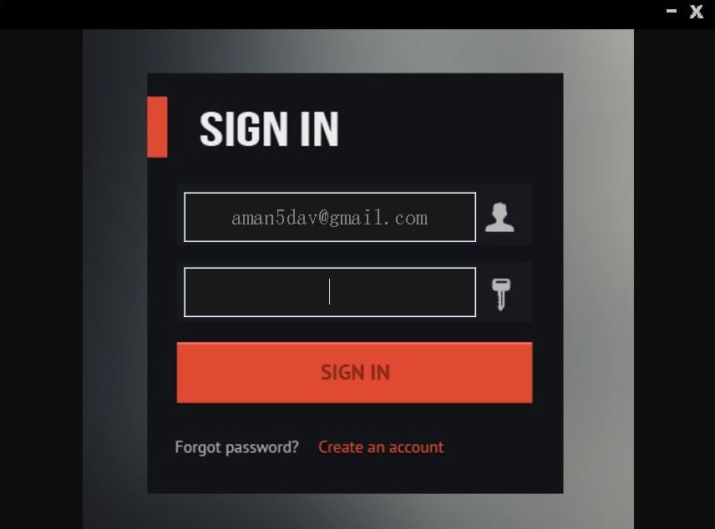

7.5.1.2 The Admin Home Page

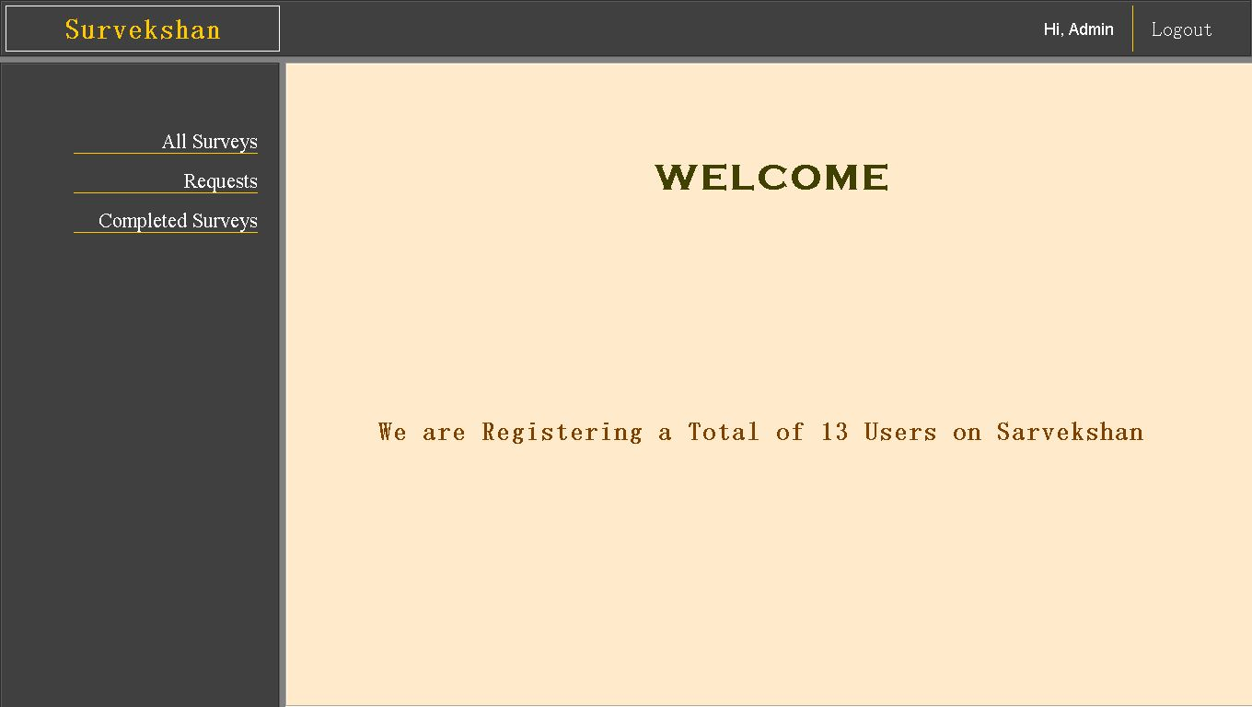

7.5.1.3 All Surveys

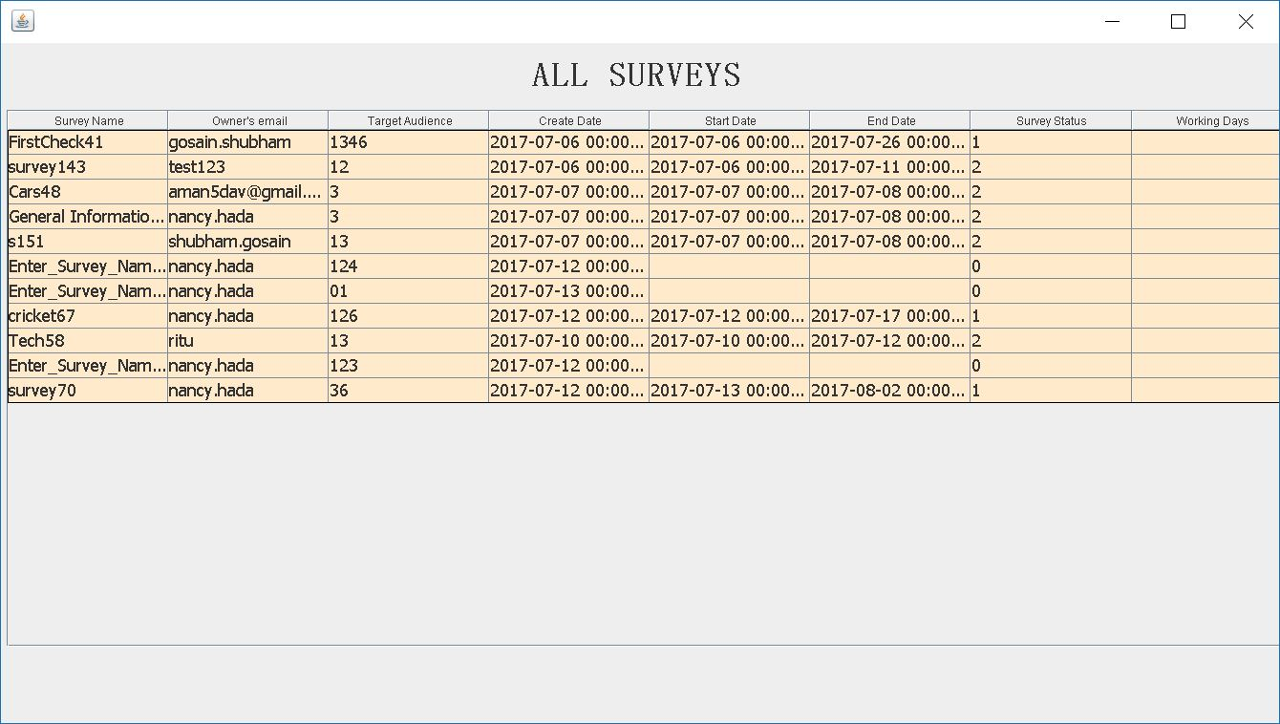

7.5.1.4 Survey Requests Page 1

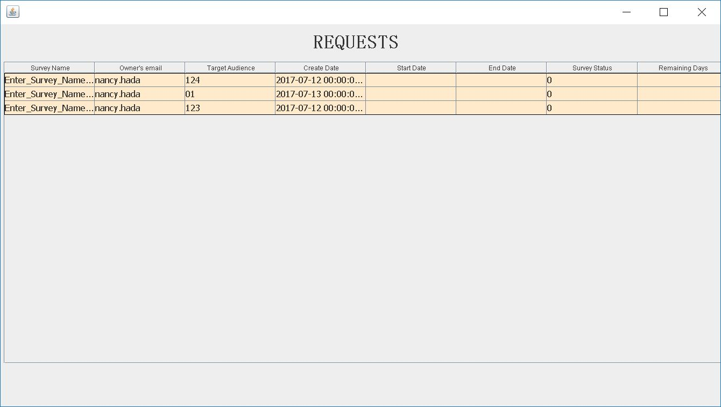

7.5.1.5 Survey Requests Page 2

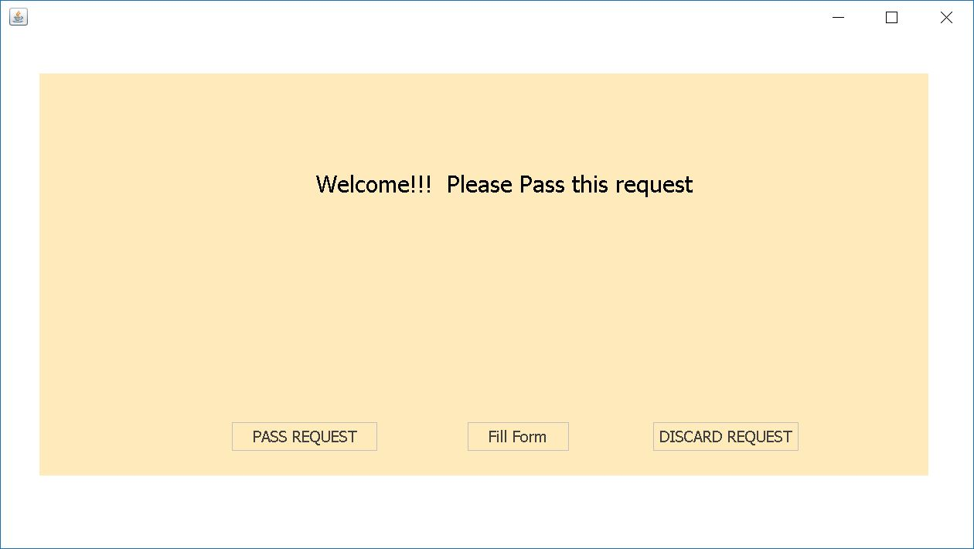

7.5.1.6 Completed Survey Page 1

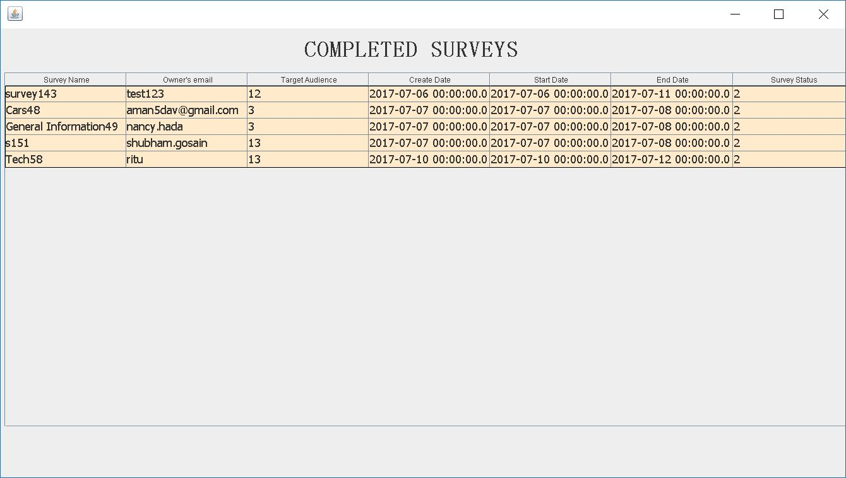

7.5.1.7 Completed Survey Page 2

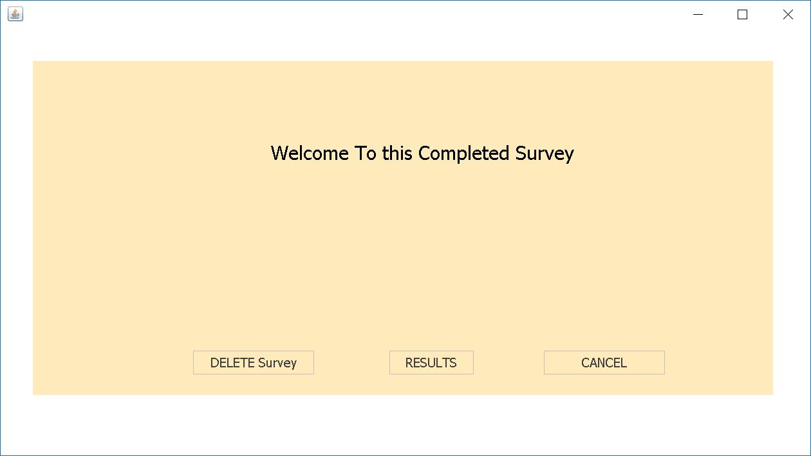

7.5.2 USER

7.5.2.1 The User’s LogIn Page

7.5.2.2 The User’s Homepage

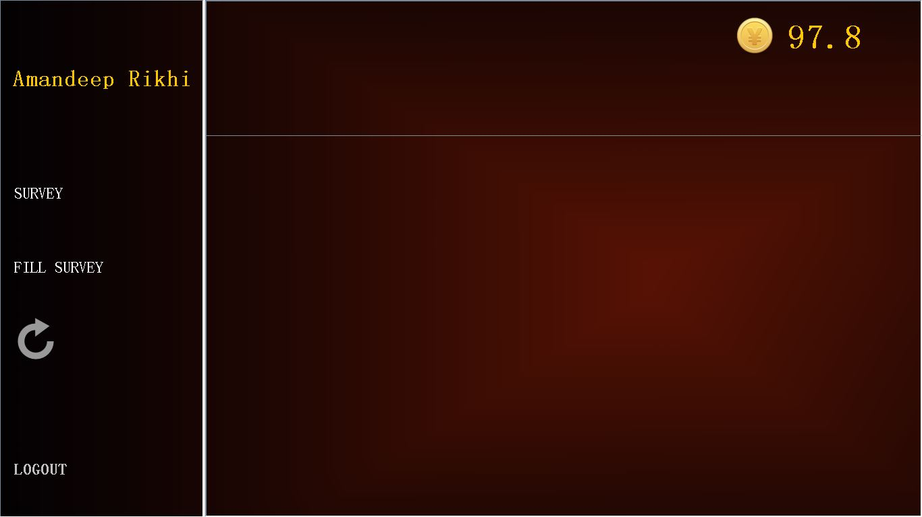

7.5.2.3 The User can Create and See his created Surveys on Clicking “SURVEY”

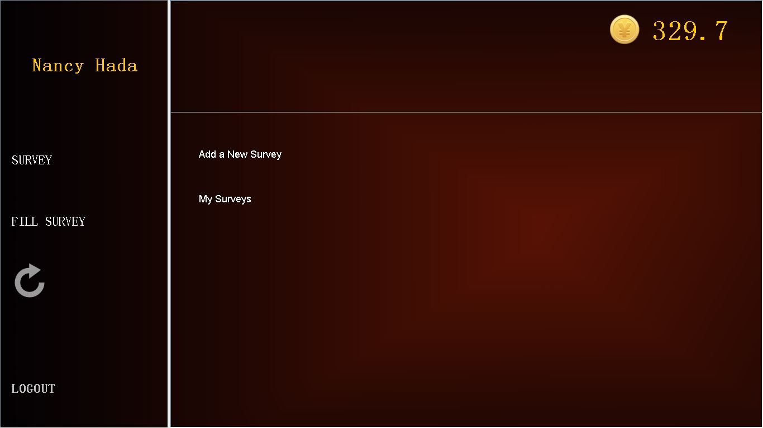

7.5.2.4.1 Add a New Survey

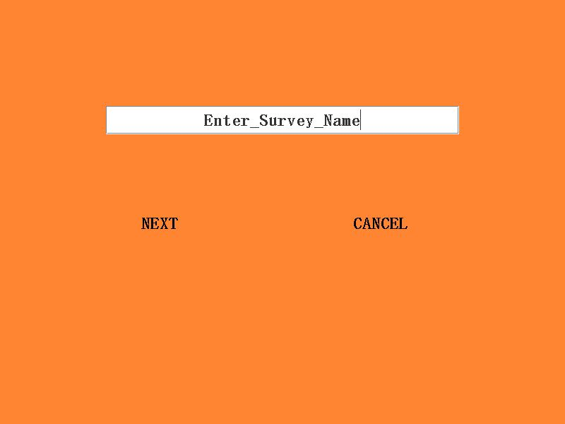

7.5.2.4.2 Create Survey Questions

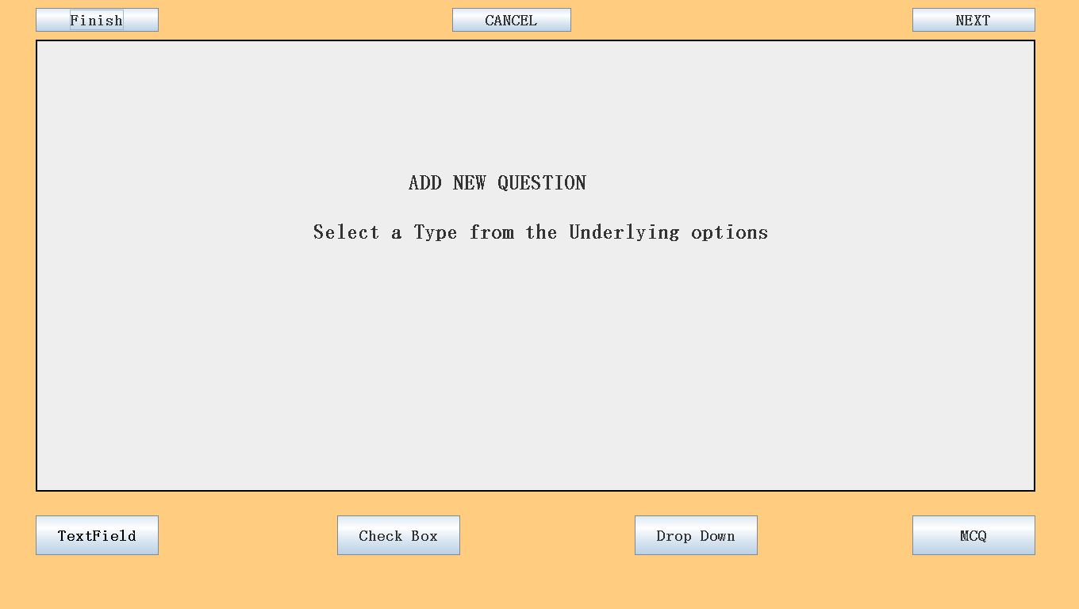

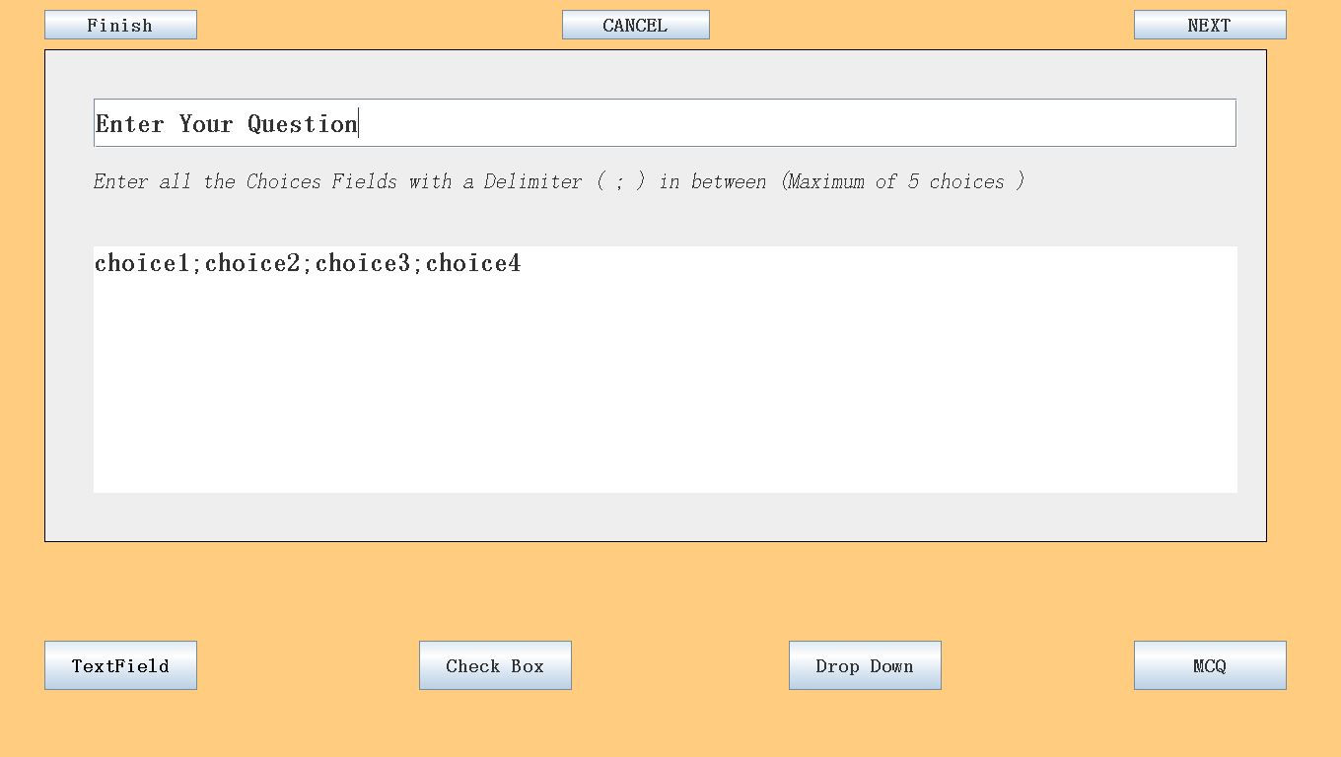

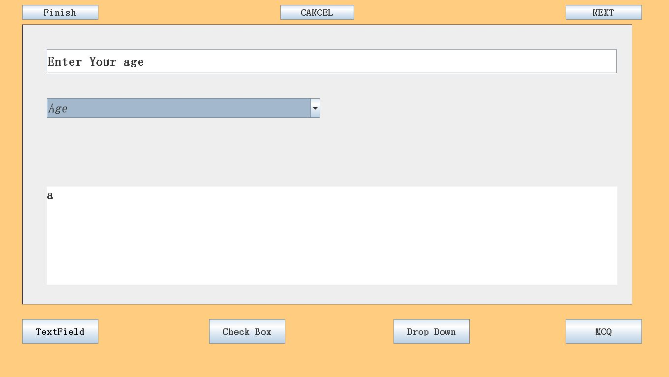

7.5.2.4.3 Select Target Audience And Number Of Days For Which Survey Works

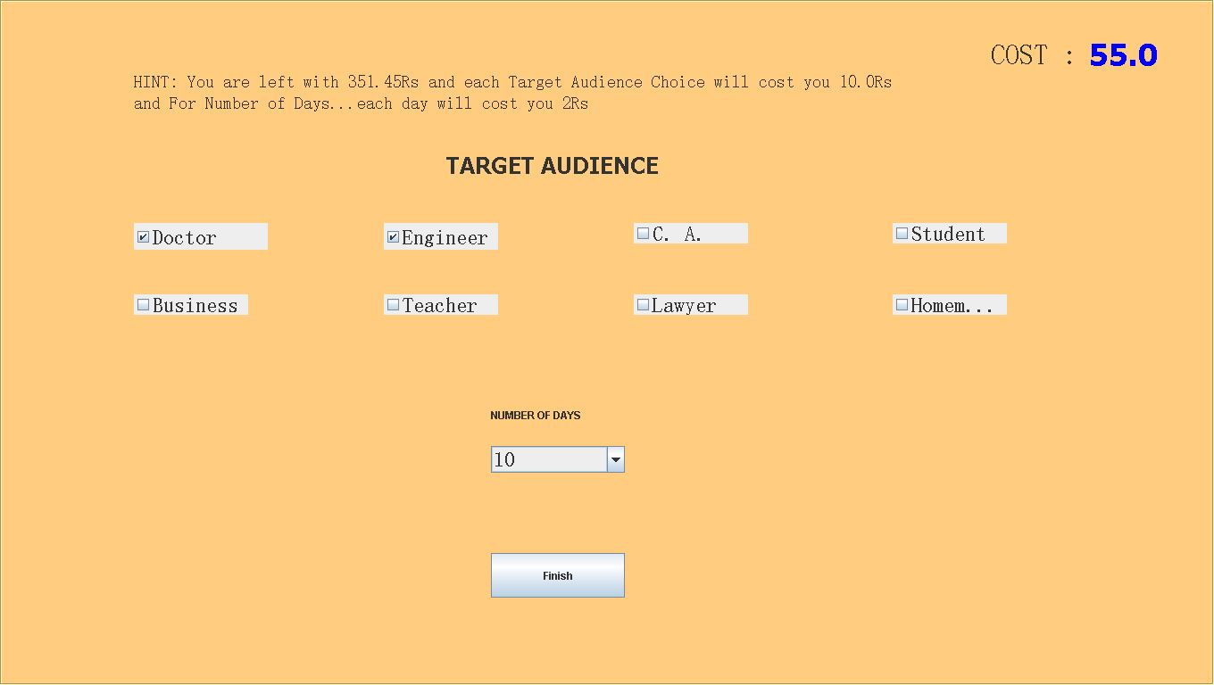

7.5.2.5 .1 My Surveys by Clicking on “My Surveys” from user menu

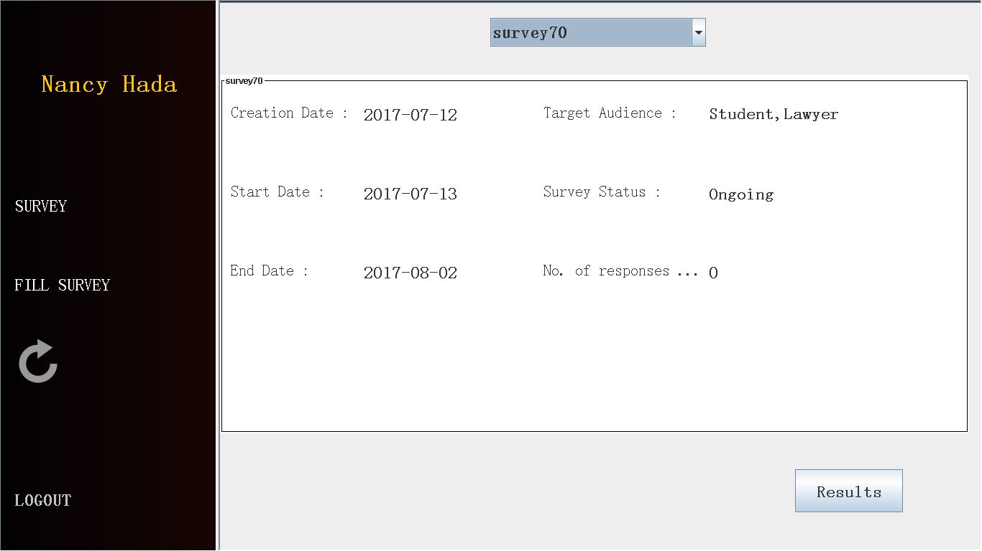

7.5.2.5.2 Results

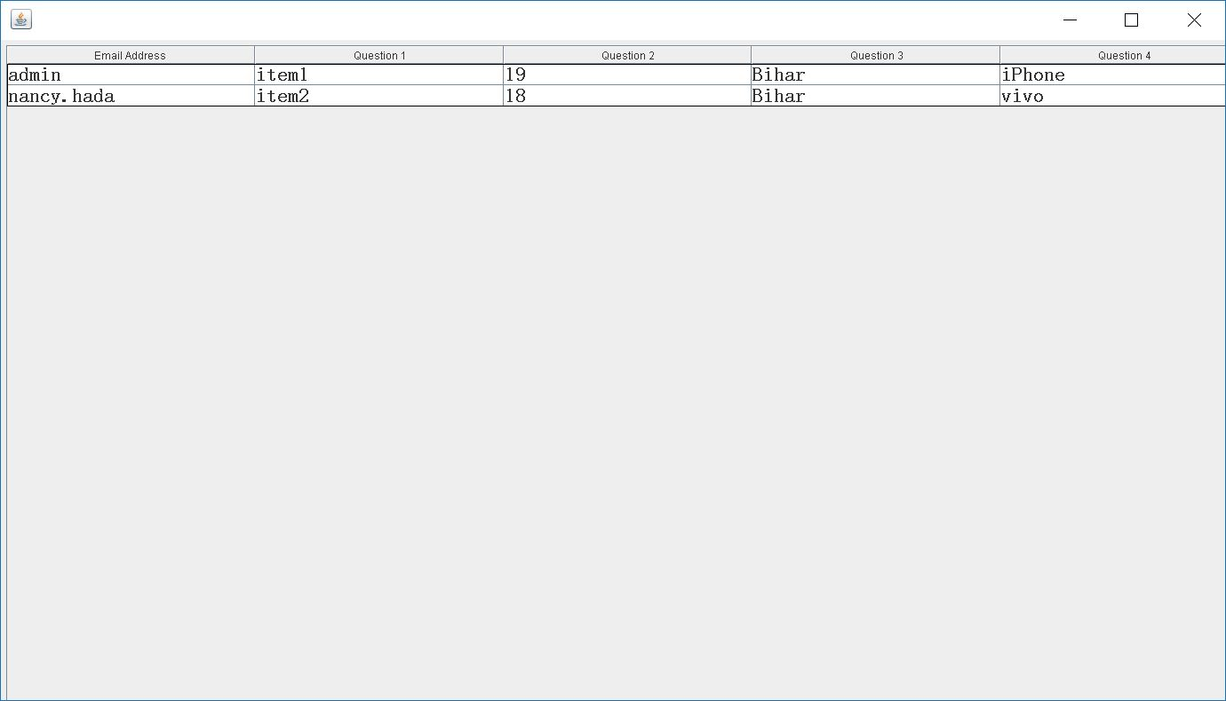

7.5.2.6.1 Fill Available Survey

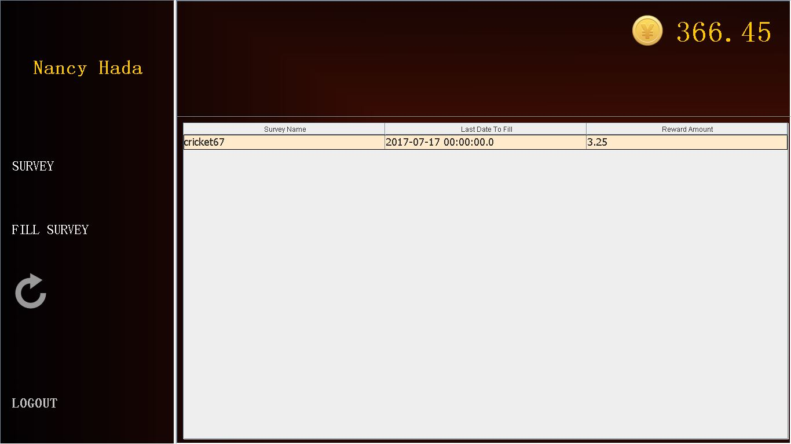

7.5.2.6.2 Fill Available Survey – Page 2

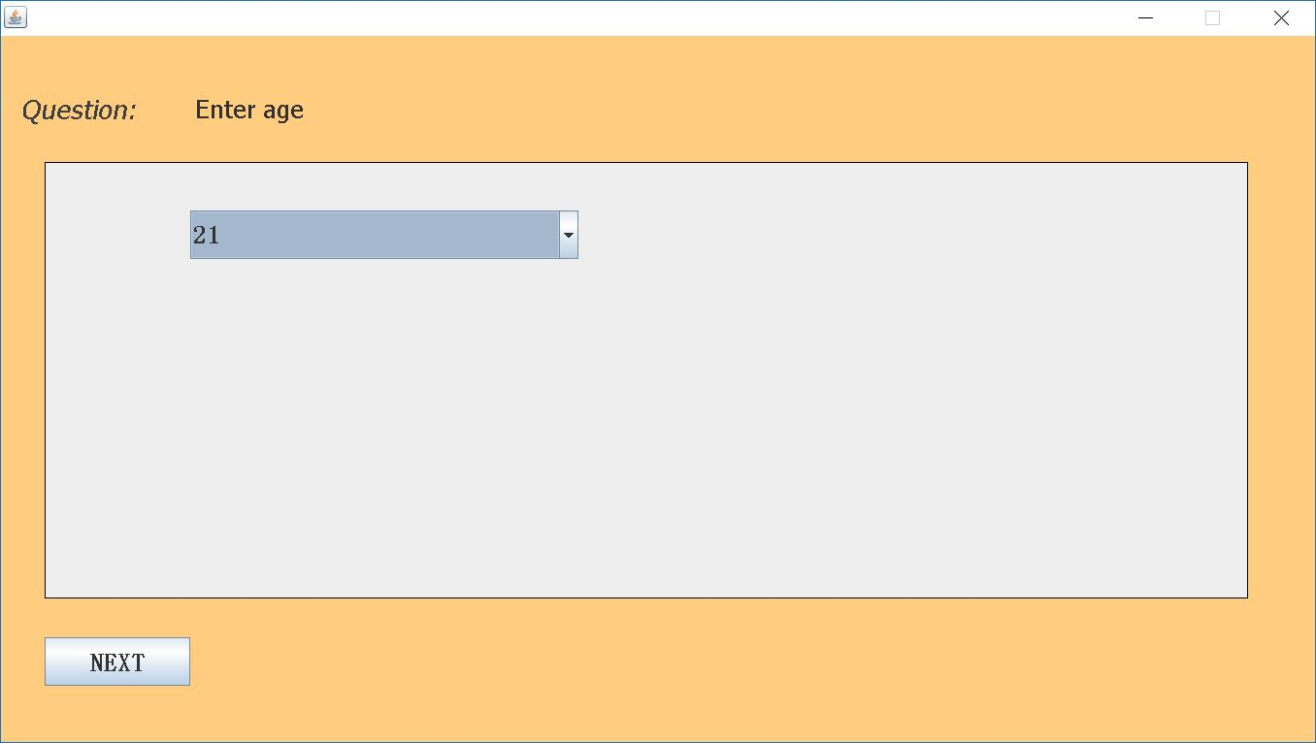

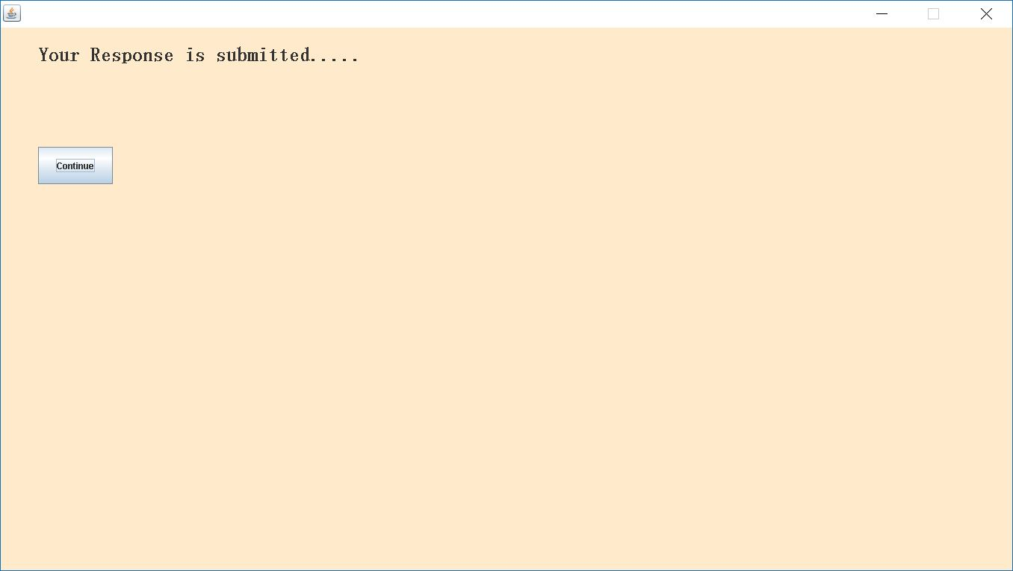

  - Conclusion

From the analysis of the above positive points and both advantages and the disadvantages of the existing system and the developed system, it can be concluded that the developed system performs satisfactorily as compared to the contemporary systems.

  - Future Enhancement

Since this system has been generated by using Object Oriented programming, there are many chances of reusability of the codes in other environment even in different platforms. Also its present features can be enhanced by some simple modification in the codes so as to reuse it in the changing scenario.
The application is made in all possible ways to meet the basic functional requirements of
filling or creating the Surveys by the Users. However, as needs of the users grow in future, some more functionalities like adding a way to get the credit amount from the Admin in case of the insufficient Amount in the account. Also, can generate the filled Survey Report diagrammatically. All such advancements can be made in “SURVEYKSHAN”.

Bibliography

Books:-
  - Fundamentals of Software Engineering – Rajib Mall
  - Basics of Database by Navathe
  - Java 2 The Complete Reference 5th Ed-Herbert Schildt
Websites:-
- www.google.com
- en.wikipedia.com
- www.tutorialspoint.com
- docs.oracle.com

