**Task No.1 :-**

Given program uses **“Euclidean Distance**” as a Heuristic Function. which gives the straight line distance between Other node and Goal node.

|  |  |  |  |  |  |  |  |  |  |  |  |  |
| --- | --- | --- | --- | --- | --- | --- | --- | --- | --- | --- | --- | --- |
| 12 | 10.8103 | 10.2956 | 9.4340 | 8.6023 | 7.8102 | 7.0711 | 6.4031 | 5.8310 | 5.3852 | 5.0.990 | 5 | 5.0990 |
| 11 | 10.7703 | 9.8489 | 8.9444 | 8.0623 | 7.2111 | 6.4031 | 5.6569 | 5 | 4.4721 | 4.1231 | 4 | 4.1231 |
| 10 | 10.4403 | 9.4868 | 8.5440 | 7.6158 | 6.7082 | 5.8310 | 5 | 4.2426 | 3.6056 | 3.1623 | 3 | 3.1623 |
| 9 | 10.1980 | 9.2195 | 8.2446 | 7.2801 | 6.3246 | 5.3853 | 4.4721 | 3.6056 | 2.8284 | 2.2361 | 2 | 2.2361 |
| 8 | 10.499 | 9.0554 | 8.0623 | 7.0711 | 6.0828 | 5.0990 | 4.1231 | 3.1623 | 2.2361 | 1.1442 | 1 | 1.1442 |
| 7 | 10 | 9 | 8 | 7 | 6 | 5 | 4 | 3 | 2.0 | 1 | Goal | 1 |
| 6 | 10.0499 | 9.0554 | 8.0623 | 7.0711 | 6.0828 | 5.0990 | 4.1231 | 3.1623 | 2.2361 | 1.4142 | 1 | 1.4142 |
| 5 | 10.1980 | 9.2195 | 8.2462 | 7.2801 | 6.3246 | 5.3852 | 4.4721 | 3.6056 | 2.8284 | 2.2361 | 2 | 2.2361 |
| 4 | 10.4403 | 9.4868 | 8.5440 | 7.6158 | 6.7082 | 5.8310 | 5 | 4.2426 | 3.6056 | 3.1623 | 3 | 3.1623 |
| 3 | 10.7703 | 9.8489 | 8.9443 | 8.0623 | 7.2111 | 6.4031 | 5.6569 | 5 | 4.4721 | 4.1231 | 4 | 4.1231 |
| 2 | 11.8103 | 10.2956 | 9.4340 | 8.6023 | 7.8102 | 7.0711 | 6.4031 | 5.8310 | 5.3852 | 5.0990 | 5 | 5.0990 |
| 1 | Start | 10.8167 | 10 | 9.2195 | 8.4853 | 7.8102 | 7.211 | 6.7082 | 6.3246 | 6.0828 | 6 | 6.0828 |
|  | 1 | 2 | 3 | 4 | 5 | 6 | 7 | 8 | 9 | 10 | 11 | 12 |

Euclidean distance as a heuristic Function:-

Given action (single step in North, South, East,West) set is,

|  |  |  |  |
| --- | --- | --- | --- |
| 1 |  | North (0,1) |  |
| 0 | West (-1, 0) |  | East (1,0) |
| -1 |  | South (0,-1) |  |
|  | -1 | 0 | 1 |

With this action set and Euclidean distance as a heuristic function we get,

Path No.1

***Elapsed time is 12.787118 seconds.***

***Path length is :16***

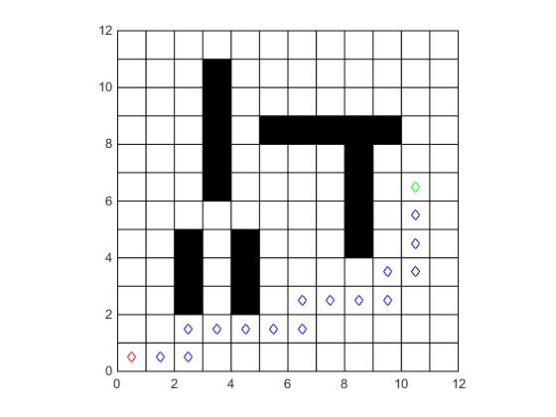

Path No.2

***Elapsed time is 13.266499 seconds.***

***Path length is :16***

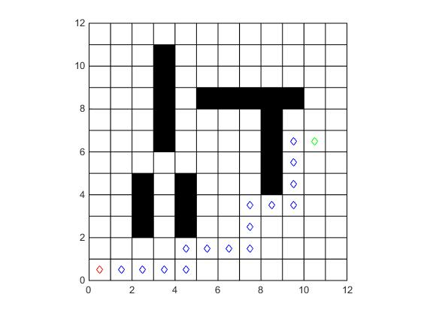

**Task No. 1 (A):-**

Change the actions from existing (single step in North, South, East,West) to (a) single step in North, North East, East, South East, South, South West,West, North West

|  |  |  |  |
| --- | --- | --- | --- |
| 1 | North-West (-1,1) | North (0,1) | North-East(1,1) |
| 0 | West (-1, 0) |  | East (1,0) |
| -1 | South-West (-1,-1) | South (0,-1) | South-East (1,-1) |
|  | -1 | 0 | 1 |

With this action set and Euclidean distance as a heuristic function we get,

***Path No.1***

Elapsed time is 0.583687 seconds.

Path length is :13.0711

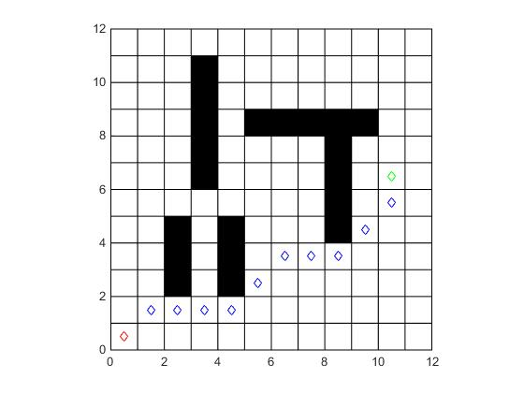

***Path No.2***

Elapsed time is 0.370111 seconds

Path length is :13.0711

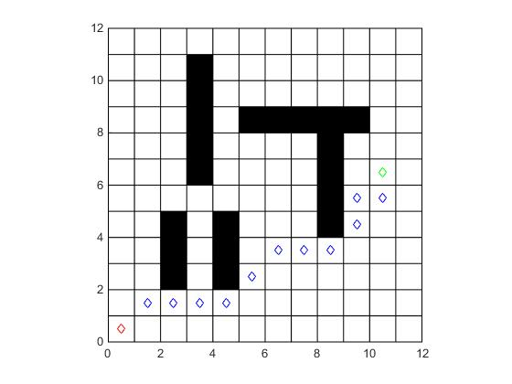

**Task No. 1(B):-**

Both Single and double steps in North, North East, East, South East, South, South West, West, North West directions (account for the g cost in each case).

|  |  |  |  |  |  |
| --- | --- | --- | --- | --- | --- |
| 2 | North-West (-2,2) |  | North(0,2) |  | North-East(2,2) |
| 1 |  | North-West (-1,1) | North (0,1) | North-East(1,1) |  |
| 0 | West (-2,0) | West (-1, 0) |  | East (1,0) | East (2,0) |
| -1 |  | South-West (-1,-1) | South (0,-1) | South-East (1,-1) |  |
| -2 | South-West (-2,-2) |  | South (0,-2) |  | South-East (2,-2) |
|  | -2 | -1 | 0 | 1 | 2 |

With this action set and Euclidean distance as a heuristic function we get,

***Path No.1***

Elapsed time is 0.668523 seconds.

Path length is :12.4853

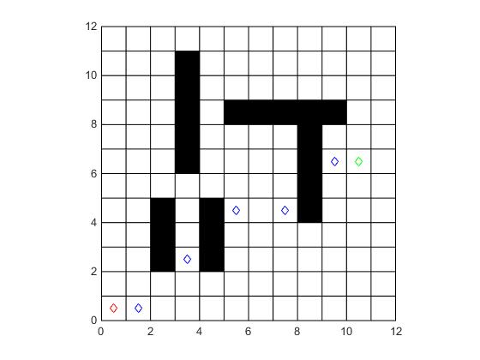

***Path No.2***

Elapsed time is 0.481030 seconds.

Path length is :12.4853

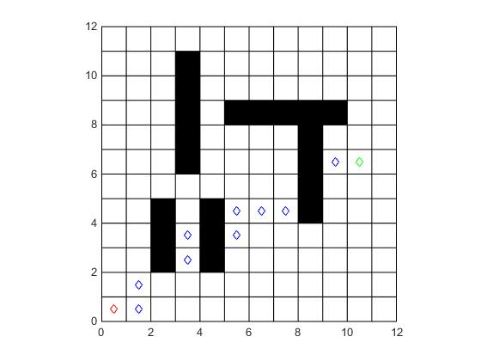

**Conclusion And Obervation:-**

* Path length is reduced with increase in number of actions.
* For same action different number of paths are obtained but all the path have same path length in case of 4 action (North, South, East,West), 8 action (North, North East, East, South East, South, South West,West, North),16 action (double steps in North, North East, East, South East, South, South West, West, North West) path length is 16, 13.0711, 12.4853.
* For same actions Elapsed time is different path length is same.

Task No.2

Instead of existing heuristic implement Manhattan distance based heuristics - What happens and why?

Use **“Manhattan distance**” as a Heuristic Function in the program.

|  |  |  |  |  |  |  |  |  |  |  |  |  |
| --- | --- | --- | --- | --- | --- | --- | --- | --- | --- | --- | --- | --- |
| 12 | 15 | 14 | 13 | 12 | 11 | 10 | 9 | 8 | 7 | 6 | 5 | 6 |
| 11 | 14 | 13 | 12 | 11 | 10 | 9 | 8 | 7 | 6 | 5 | 4 | 5 |
| 10 | 13 | 12 | 11 | 10 | 9 | 8 | 7 | 6 | 5 | 4 | 3 | 4 |
| 9 | 12 | 11 | 10 | 9 | 8 | 7 | 6 | 5 | 4 | 3 | 2 | 3 |
| 8 | 11 | 10 | 9 | 8 | 7 | 6 | 5 | 4 | 3 | 2 | 1 | 2 |
| 7 | 10 | 9 | 8 | 7 | 6 | 5 | 4 | 3 | 2 | 1 | Goal(0) | 1 |
| 6 | 11 | 10 | 9 | 8 | 7 | 6 | 5 | 4 | 3 | 2 | 1 | 2 |
| 5 | 12 | 11 | 10 | 9 | 8 | 7 | 6 | 5 | 4 | 3 | 2 | 3 |
| 4 | 13 | 12 | 11 | 10 | 9 | 8 | 7 | 6 | 5 | 4 | 3 | 4 |
| 3 | 14 | 13 | 12 | 11 | 10 | 9 | 8 | 7 | 6 | 5 | 4 | 5 |
| 2 | 15 | 14 | 13 | 12 | 11 | 10 | 9 | 8 | 7 | 6 | 5 | 6 |
| 1 | Start(16) | 15 | 14 | 13 | 12 | 11 | 10 | 9 | 8 | 7 | 6 | 7 |
|  | 1 | 2 | 3 | 4 | 5 | 6 | 7 | 8 | 9 | 10 | 11 | 12 |

Manhattan distance as a heuristic Function:-

Given action (single step in North, South, East,West) set is,

|  |  |  |  |
| --- | --- | --- | --- |
| 1 |  | North (0,1) |  |
| 0 | West (-1, 0) |  | East (1,0) |
| -1 |  | South (0,-1) |  |
|  | -1 | 0 | 1 |

***Path No.1***

Elapsed time is 0.365204 seconds.

Path length is :16

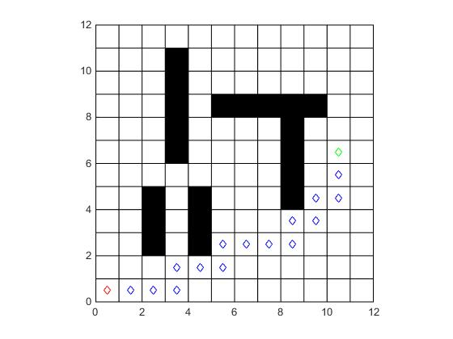

***Path No.2***

Elapsed time is 0.173199 seconds.

Path length is :16

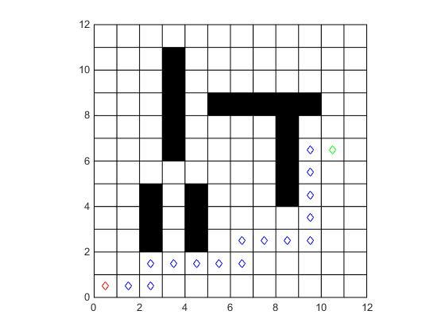

**Task No. 2 (A):-**

Change the actions from existing (single step in North, South, East,West) to (a) single step in North, North East, East, South East, South, South West,West, North West

|  |  |  |  |
| --- | --- | --- | --- |
| 1 | North-West (-1,1) | North (0,1) | North-East(1,1) |
| 0 | West (-1, 0) |  | East (1,0) |
| -1 | South-West (-1,-1) | South (0,-1) | South-East (1,-1) |
|  | -1 | 0 | 1 |

With this action set and Manhattan distance as a heuristic function we get,

***Path No.1***

Elapsed time is 0.570110 seconds.

Path length is :13.0711

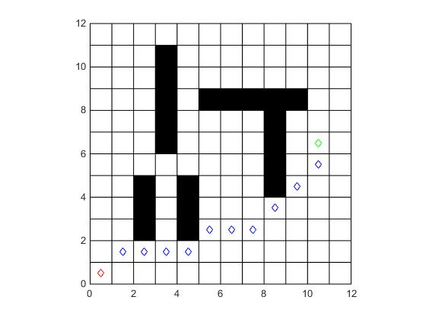

***Path No.2***

Elapsed time is 0.316841 seconds.

Path length is :13.0711

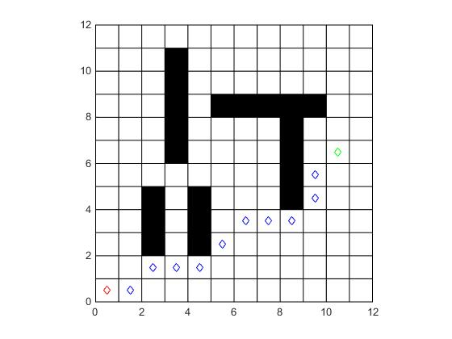

**Task No. 1(B):-**

Both Single and double steps in North, North East, East, South East, South, South West, West, North West directions (account for the g cost in each case).

|  |  |  |  |  |  |
| --- | --- | --- | --- | --- | --- |
| 2 | North-West (-2,2) |  | North(0,2) |  | North-East(2,2) |
| 1 |  | North-West (-1,1) | North (0,1) | North-East(1,1) |  |
| 0 | West (-2,0) | West (-1, 0) |  | East (1,0) | East (2,0) |
| -1 |  | South-West (-1,-1) | South (0,-1) | South-East (1,-1) |  |
| -2 | South-West (-2,-2) |  | South (0,-2) |  | South-East (2,-2) |
|  | -2 | -1 | 0 | 1 | 2 |

With this action set and Manhattan distance as a heuristic function we get,

***Path No.1***

Elapsed time is 1.548701 seconds.

Path length is :14.2426

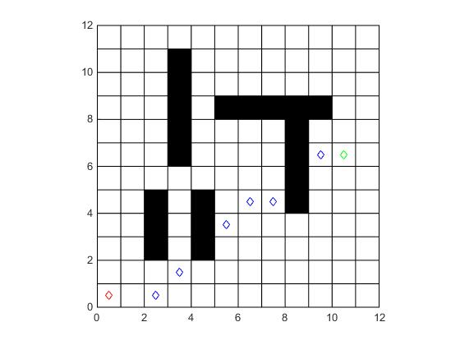

***Path No.2***

Elapsed time is 1.548701 seconds.

Path length is :14.2426

