Android app to check the authenticity of the product

User Manual for app

Table of Content:

1-What is the app about?

1. What You Can Do with the app?
2. Before Using This Application

1.b) Connecting Your Android Device to a Wi-Fi Network

2.b) Connecting a Device to a Network

2-Starting the application

1. Main Menu

3- Getting Started

1. Follow the instructions to get started with the app.

4- Troubleshooting

1. What is the app about?

1. What You Can Do with the app?

The app has the following features:

* Scan any product’s bar-code / qr-code.
* Check the authenticity of the product
* Add a product if it is unregistered.

1. Before Using This Application

1) Connecting your Android Device to a Wi-Fi Network:

* On your Android device, tap [Settings], [Wireless & Networks] and [Wi-Fi].
* Select and configure your Wi-Fi network according to your environment.
* Connect to the Wi-Fi network.

2) Connecting a Device to a Network

* Enable the Mobile data of your phone to use the application.

Note: For details about the network settings, contact your network administrator.

2-Starting the application.

1. Main Menu.

When you start the application by logging into the app, the following screen appears.

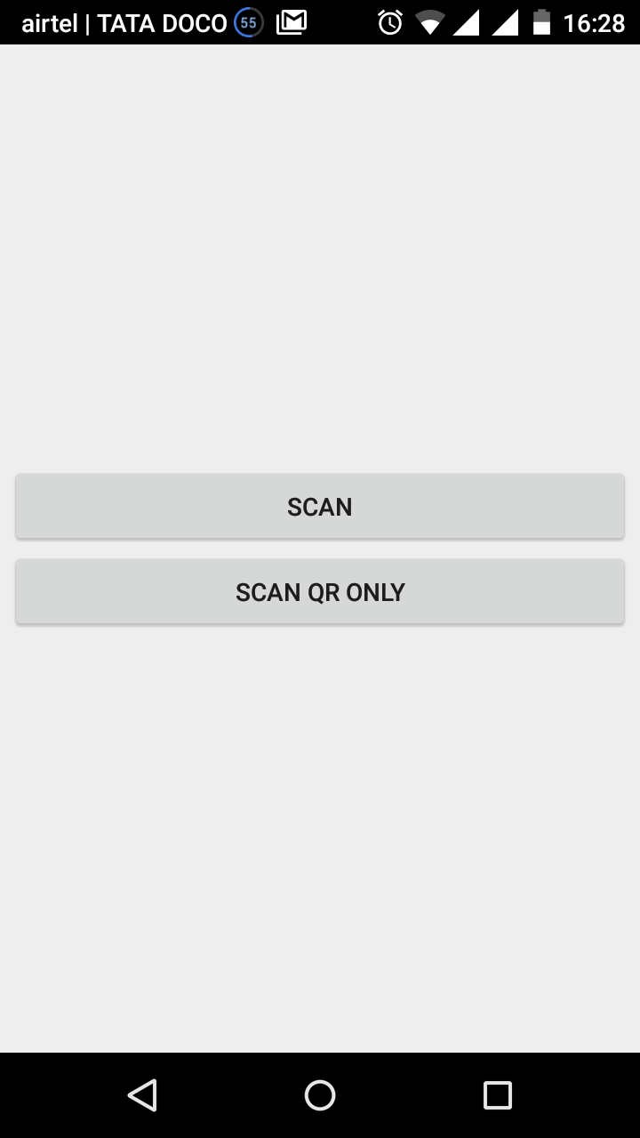

The following menu items are available:

* Scan: For scanning the bar-code of the product.
* Scan QR only: For scanning the qr-code of the product.

3- Getting Started.

Follow the instructions to get started with the app.

1. Signing-Up (as a new user).

* Fill the username text-field.
* Fill the password text-field.
* Click the sign-up button on the screen.

1. Logging-in for using the device.

After successfully signing-up for the application , login into the system.

* Fill the username text-field.
* Fill the password text-field.
* Click the login button on the screen.

1. Click on “Scan” Button on the screen in order to scan the bar-code on the product.

To scan the qr-code, click on “Scan QR only” Button on the screen.

1. Scan the product in the following way

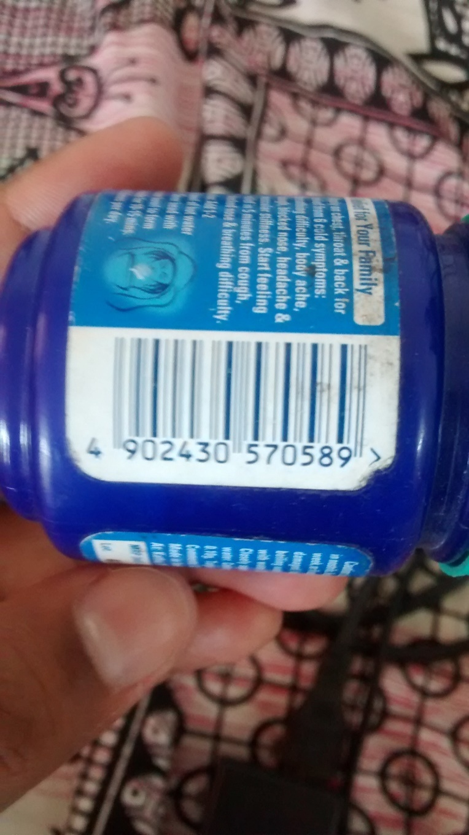

1. After successfully scanning the product the following screen appears.

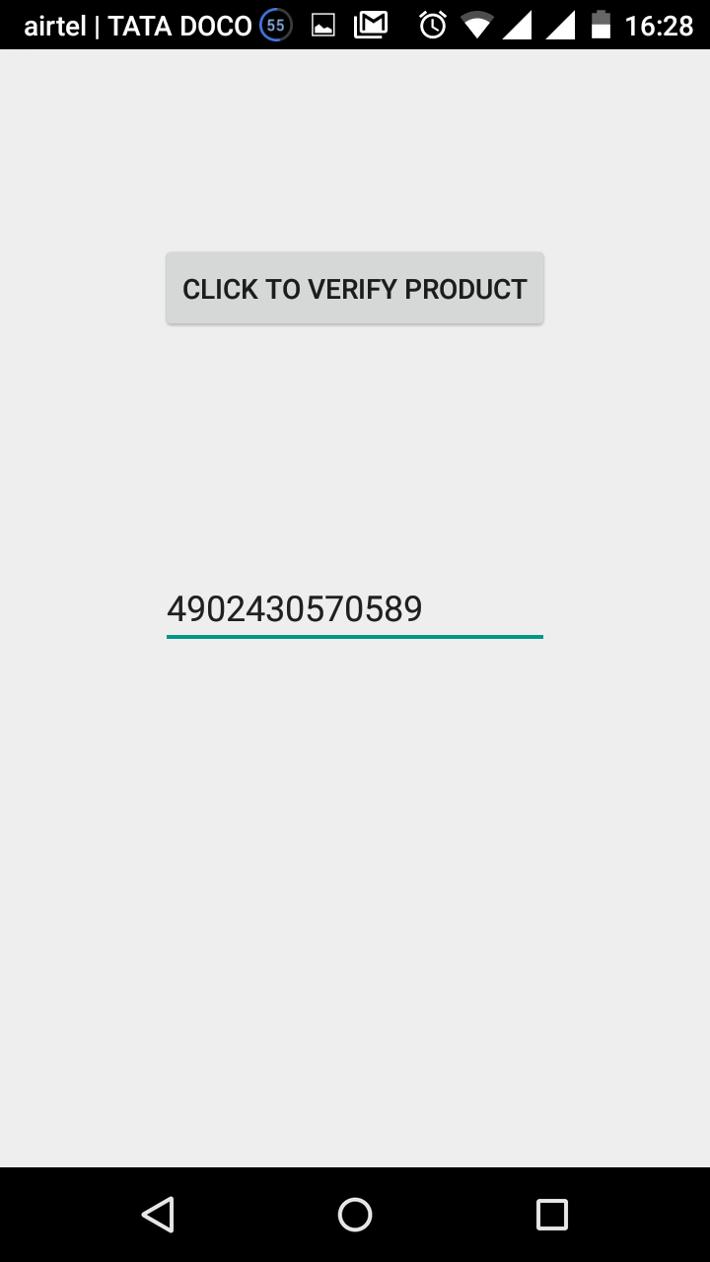

Click on “Click to Verify Product” Button to check its authenticity.

4- Troubleshooting.

If a Message is displayed.

This section describes messages displayed for troubles that may occur while you use Smart Device. Also, it describes the causes of and solutions to those troubles.

|  |  |  |
| --- | --- | --- |
| Message | Cause | Solution |
| “Please complete the sign-up form” | Either of the username text-field or password text-field is unfilled | Completely fill-up the sign-up form. |
| “Sign-Up Error” | Error associated with the username , already used username | enter a unique username |
| “Error” | • There was no response  from the cloud storage.  • An error has occurred with  the cloud storage. | • Check that there is a  connection to the internet.  • Check that the cloud  storage service is not  stopped. |
| “IO exception trying to get address” | System is unable to track your location | Check your phones gps and assist to enable the app to get the current location |
| “Rear facing camera unavailable” | Unavailability of rear facing camera | App won’t be able to scan without rear facing camera. |