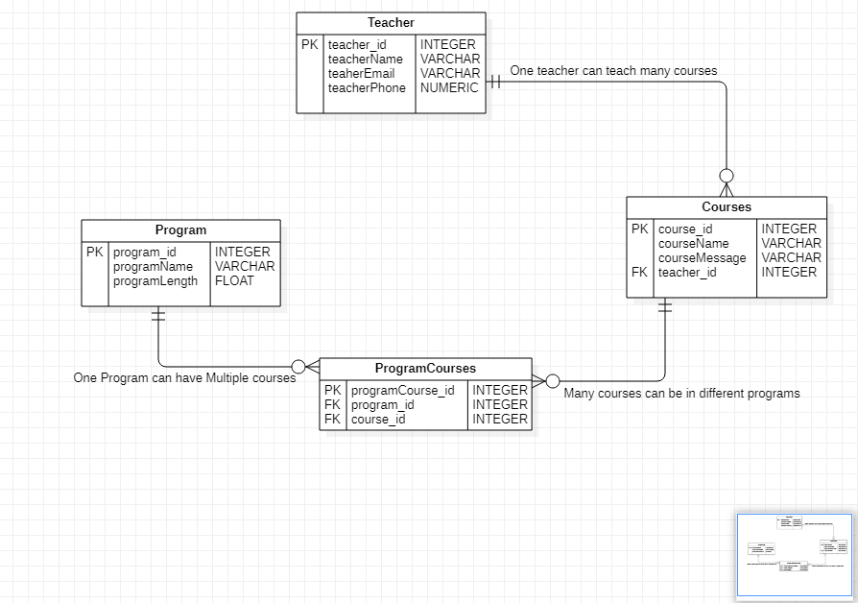

Wireframe version1.0

Teacher: Teacher is an entity which consists of Name, email and Phone. There is a relationship between teachers and courses. In this scenario, the relation is one teacher can teach many courses. There is restriction while inserting teacher values. Teacher cannot decide which course she can select. While creating new course, there is a drop down which allows to select any one teacher.

There are certain validation while inserting teacher data. Name is mandatory field, email field should have proper authenticated mail id, phone number has limit for 10 digits only and no characters are allowed.