Godrej

Hierarchy solution — how it works
Move from the per-manager agency interim model, configure who sees which cases, how teams and sub-tenants appear in dropdowns, how allocation works, and how we roll out phase by phase.
Tenant: Godrej · Identity: Database profiles · Branch: Optional / future-ready · Apps: Web · Manager · Field

Key flows

1. Three layers
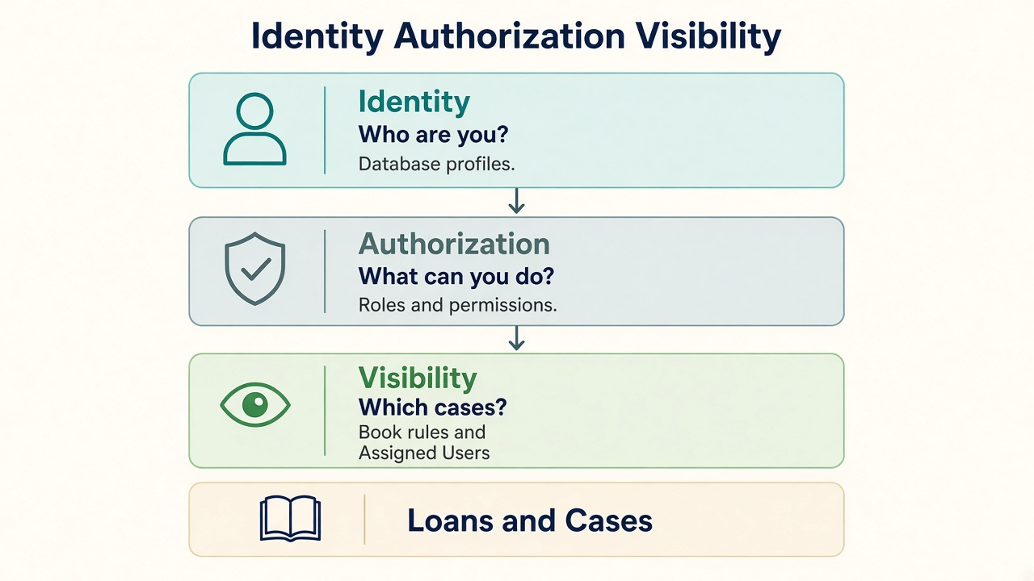
Identity = who you are. Authorization = what you may do. Visibility = which loans appear.
ACCESS = Identity + Permission + Matching Visibility

2. Today vs target
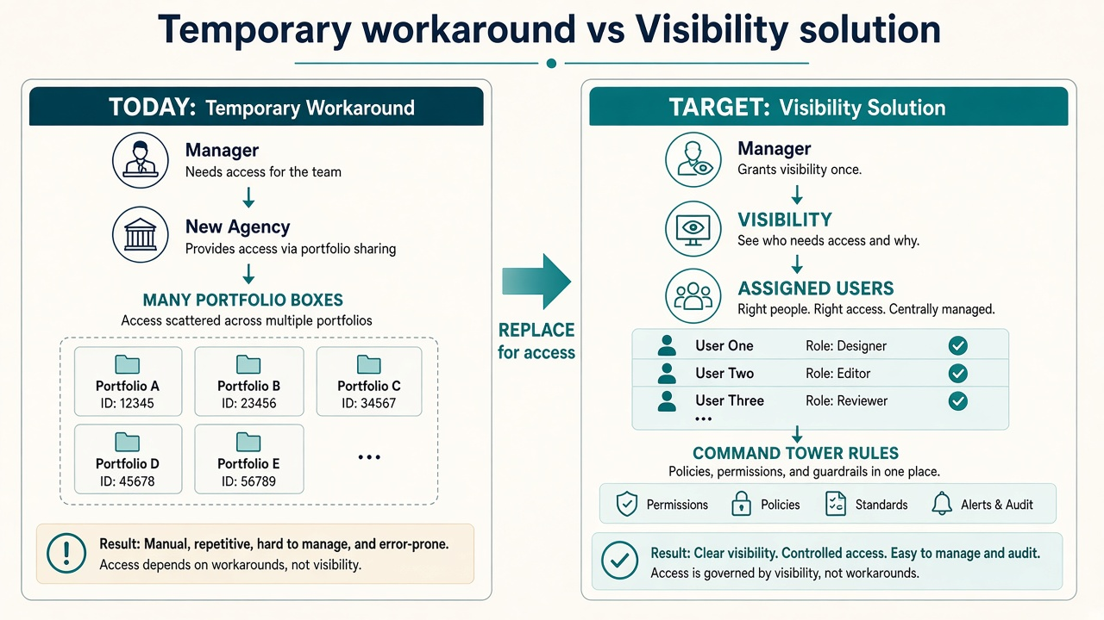
Today: agency per manager → portfolios multiply. Target: Visibility (team + Command Tower rules) — no agency-per-manager for access.

3. Command Tower rules vs team rules
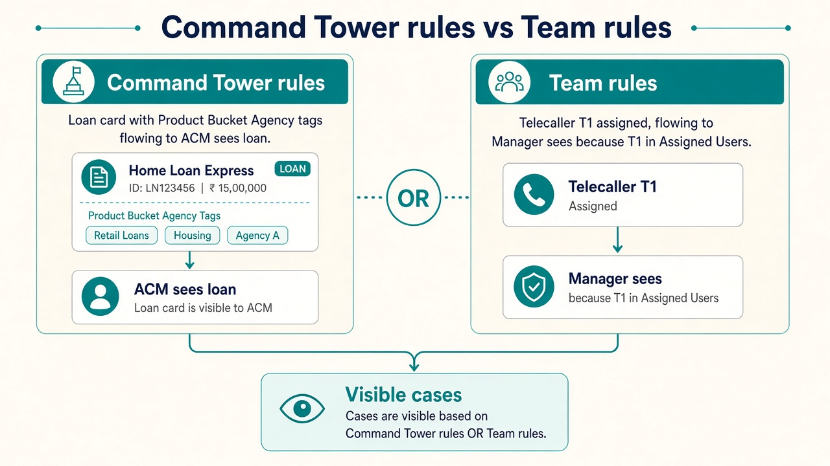
Command Tower rules = Product/Bucket/Agency on the loan (from CT map). Team rules = Assigned Users / Self. Same user can have both (OR).

4. How a loan becomes visible after allocation
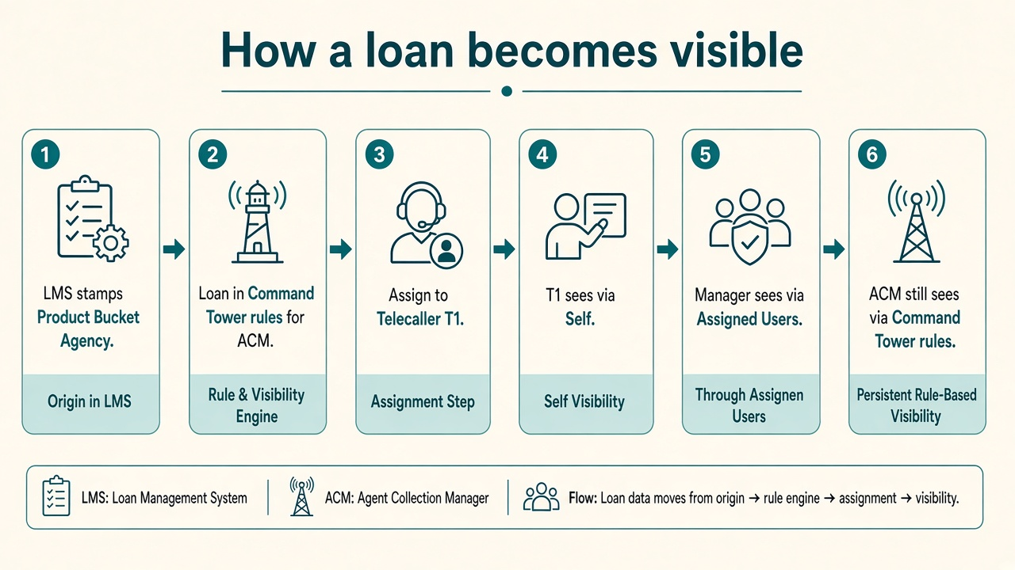
Assign the worker only (TC/FA). Managers/ACMs see via Visibility — not dual assignees on the loan. LMS = loan details only; Agency defaults to Inhouse.

5. Who appears in dropdowns
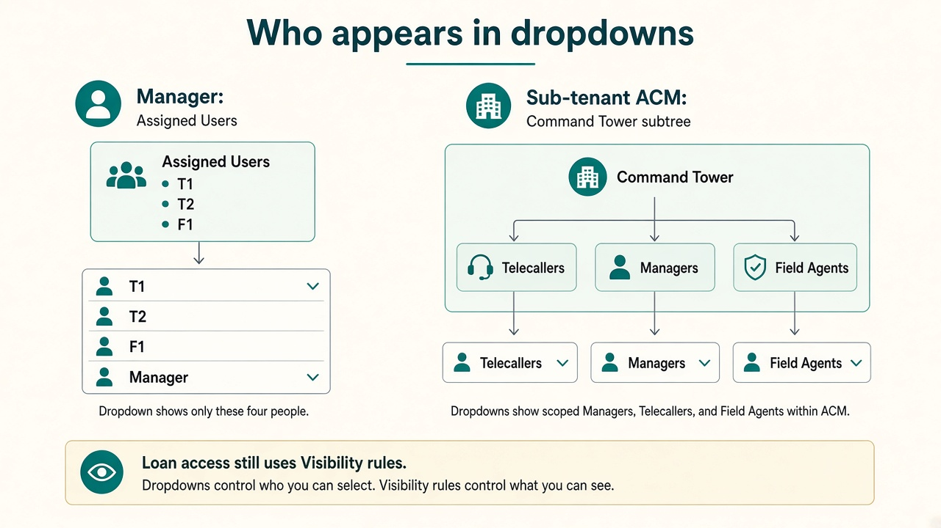
Manager = Assigned Users only. Sub-tenant = Command Tower scope + people resolver (+ direct Assigned Users if no manager).

6. Runtime check on every screen
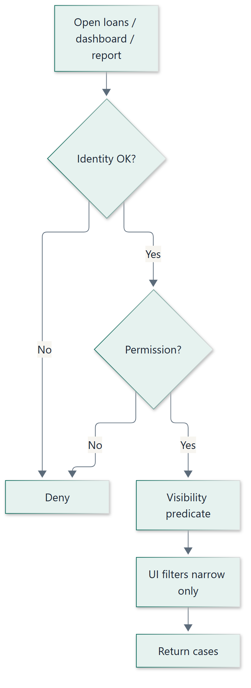

7. Publish configuration
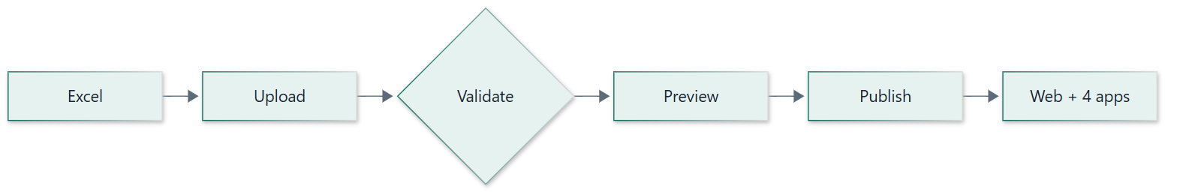

1. Executive summary
Godrej needs a clear collection hierarchy. Today an interim model creates a separate agency for each manager, so portfolios multiply as managers × product/bucket.
To solve this hierarchy issue for Godrej, we implement Identity, Authorization, and Visibility so the per-manager agency pattern is no longer required for access control.
Identity

Who are you?
Profiles and sessions in the database.
Authorization

What can you do?
Role → permissions.
Visibility

Which cases?
Command Tower rules + team rules + Self / All Cases.
ACCESS = Authenticated Identity + Required Permission + Matching Visibility

2. Problem statement

2.1 Intended Godrej hierarchy (business)
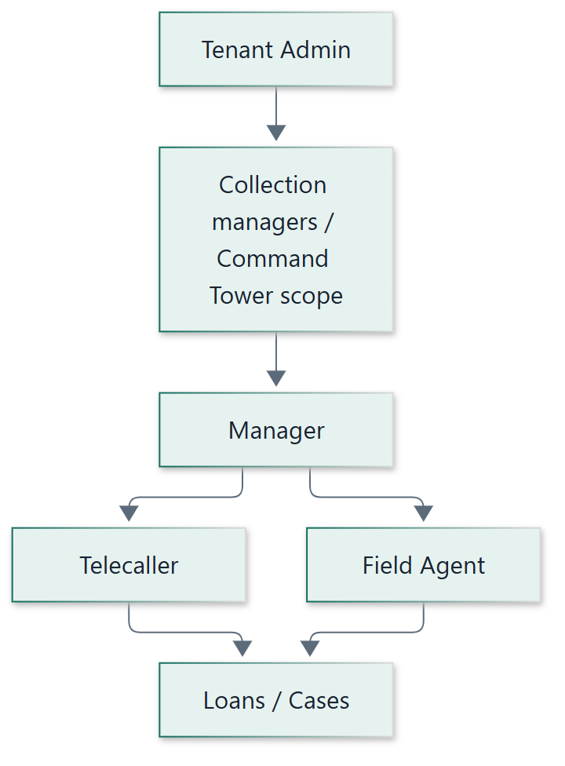
Business needs include: manager sees their team’s cases; telecaller/field agent see assigned cases; admins see wider Command Tower scope; mixed product/bucket under one manager without inventing fake agencies.

2.2 Current interim model
Temporary solution:
a
separate agency is created for each manager
so that manager’s telecallers and field agents (and portfolios) sit under that agency.
Mechanism | Effect
One agency per manager | Isolates each manager’s team
Portfolio = Agency × Product × Bucket | Same product/bucket repeated under every manager agency
Net result | Managers × portfolios  to create and maintain
Command Tower / CM filters | Often used alongside this to filter by Command Tower rules on web/reporting

2.3 What breaks or becomes hard
- Onboarding a manager means agency + many portfolios + people membership
- Moving a telecaller/field agent means portfolio/agency maintenance
- Dashboards, loan lists, reports, and mobile apps all inherit the same structure
- LMS loan ingest (replacing import) must not recreate the same agency explosion
- No clean model for “this manager sees T1, T2, F1” without agency isolation

3. Solution architecture
Visibility is configured case scope, not “simulate hierarchy with agencies.” Hierarchy-like outcomes (manager team, Command Tower scope, admin all-cases) are expressed as rules.
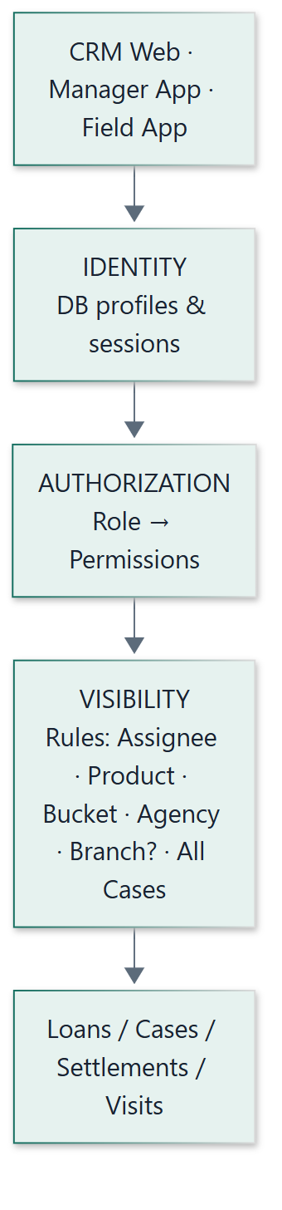

3.1 Visibility rule semantics
Pattern | Meaning | Example
Same column, multiple values | OR | Bucket B1 | B2
Different columns, one row | AND | Product PL AND Agency Inhouse
Multiple rows, same user | OR | Team assignees OR Command Tower product scope

3.2 Dimensions for Godrej
Dimension | Godrej now | Notes
Assignee | Primary | Self for TC/FA; lists for managers
Product | Primary | From LMS loan details
Bucket | Primary | From LMS loan details
Agency | Supported | Default = Inhouse  (not from LMS). Not one agency per manager. Future external agencies via Agency Allocation page
Branch | Optional | Not used by Godrej today; column present, non-mandatory
All Cases | Admin | Explicit tenant-wide for primary Tenant Admin

3.3 What this deliberately separates

Visibility (this solution)
Which loans appear on lists, dashboards, reports, mobile home screens.

Worker assignment
Who is allocated to work a loan (TC/FA). After assign, SELF visibility applies.

Agency allocation
Which agency owns the loan. Default Inhouse. New page for future external agencies — not driven by LMS.
LMS boundary:
LMS sends
loan details only
(product, bucket, balances, customer fields, etc.). It does
not
allocate agency. Agency is set in Collekto:
Inhouse by default
; when Godrej later onboards an external agency, ops use the
Agency Allocation
page to move loans to that agency. Today’s multi-agency setup exists only because of the per-manager agency interim model — that goes away with Visibility.

4. Implementations & flows this solves
Flow / module | Problem today | How the solution fixes it
Manager onboarding | New agency + portfolios per product/bucket | Create manager profile + visibility rows (Assigned Users / Product+Bucket)
TC / FA onboarding | Add to manager agency portfolios | Create profile + Self Assigned; optionally add to manager’s Assigned Users
Loan list / All Cases | Scoped by portfolio membership / manager agency | Backend Visibility predicate on every query
Loan detail | May open cases outside intended Command Tower scope | Deny if case fails visibility
Dashboards | KPI totals follow wrong agency/portfolio set | Same visibility predicate on aggregates
Reports / MIS | Row scope tied to the interim hierarchy model | Report queries use Visibility Context
Filters (multi-select) | Agency/portfolio driven; inconsistent multi-select | Multi-select Product/Bucket/Agency/Assignee ∩ visibility
Loan assignment | Confused with portfolio membership | Assign updates assignee; visibility SELF for worker; manager sees via Assigned Users
Settlement list / approve | Often portfolio-linked | Scope via loan visibility + permission to settle/approve
Field Agent app | Requires portfolioId as access key | SELF visibility; portfolio picker demoted
Manager app | Team loans via manager agency portfolios | Assigned Users / dimension rules
LMS loan ingest | Risk of recreating agency×portfolio explosion; agency tied to multi-agency interim model | LMS = loan details only; agency defaults to  Inhouse  ; no per-manager agency on ingest
Agency allocation | Agency chosen via multi-agency / portfolio model today | New  Agency Allocation  page; keep Inhouse by default; assign to external agencies when Godrej brings them in
SMS / Payment callbacks | May assume portfolio/agency context | Operate on loan id; hierarchy not required for callback
Command Tower rules | Mixed as security + org map | CT remains org/reference; security = Visibility (seeded from CT where useful)

5. How user onboarding changes

5.1 Today (interim model)
1
Create agency for the manager
2
Create portfolios for each Product × Bucket under that agency
3
Create manager / TC / FA profiles under that agency
4
Attach people to portfolios so they can see loans

5.2 Target onboarding (Visibility model)
1
Identity:
Create user in database with role (Tenant Admin / Manager / Telecaller / Field Agent / …)
2
Authorization:
Role grants permissions (what screens/actions)
3
Visibility:
Add rule rows for that user (Self / Assigned Users / Product+Bucket / Agency / All Cases)
4
Publish:
Validate and activate visibility version — user can now see the correct cases

5.3 Role-wise onboarding checklist
Role | Create profile | Visibility seed | No longer required
Primary Tenant Admin | Yes | All Cases = Yes | —
Manager | Yes (shared/inhouse agency ok) | Assigned Users = their TC/FA;  Product+Bucket (+ Agency Inhouse) required if they allocate unassigned loans | Retire dedicated agency + portfolio fan-out
Telecaller | Yes | Self Assigned = Yes; ensure manager’s Assigned Users includes them | Membership on many portfolios for access
Field Agent | Yes | Self Assigned = Yes; ensure manager’s Assigned Users includes them | Portfolio picker as security
Area / Command Tower admin (NCM/ZCM/RCM/ACM style) | Yes + permissions | Product/Bucket/Agency (and later Branch) rows = Command Tower rules for their scope | Assuming title alone grants loan filter

Default automation:
on create of Telecaller / Field Agent, system auto-adds
Self Assigned = Yes
into a draft visibility set (still published with audit). Manager team links are maintained via Assigned Users on the manager’s rules.
Managers who allocate:
Assigned Users alone only shows loans already assigned to that manager’s TC/FA. Unassigned loans have no assignee, so they never match Assigned Users. A manager who needs to pick up and allocate unassigned loans
must
also have
Product + Bucket
(and typically Agency = Inhouse) Command Tower rule rows — otherwise they cannot see those loans to assign them. Assigned Users-only is enough only for managers who only supervise already-assigned team work.

5A. Who appears in dropdowns — Managers vs Sub-tenant roles
There are two related but different questions:

Case visibility
Which loans/cases appear on lists, dashboards, and reports.

People visibility (dropdowns)
Which managers / telecallers / field agents appear when a user opens a filter or assignment dropdown.
Both are driven by configuration — not by creating a separate agency per manager. Case visibility uses Visibility rules. People dropdowns use the team roster derived from those rules and, for sub-tenant roles, from Command Tower rules.

5A.1 Manager — only assigned telecallers & field agents
Rule:
A manager’s TC/FA dropdowns show
only
the users listed in that manager’s Visibility
Assigned Users
configuration — not every telecaller/field agent in the tenant.

How it is configured
User ID | Assigned Users | Self | Meaning
M1 | T1 | T2 | F1 | F2 |  | M1’s team roster = T1, T2, F1, F2
T1 |  | Y | T1 sees only self-assigned cases
F1 |  | Y | F1 sees only self-assigned cases

What the manager sees where
Surface | Behaviour
Telecaller dropdown (filters / assign / reports) | Only T1, T2 (from M1 Assigned Users who are telecallers)
Field Agent dropdown | Only F1, F2
Loan list / Manager App team loans | Assigned team work:  assignee ∈ {T1, T2, F1, F2}.  Unassigned pool (to allocate):  only if M1 also has Product+Bucket (+ Agency) Command Tower rows — Assigned Users alone cannot surface unassigned loans.
Another manager M2 | Does  not  see T1/T2/F1/F2 unless those ids are also on M2’s Assigned Users

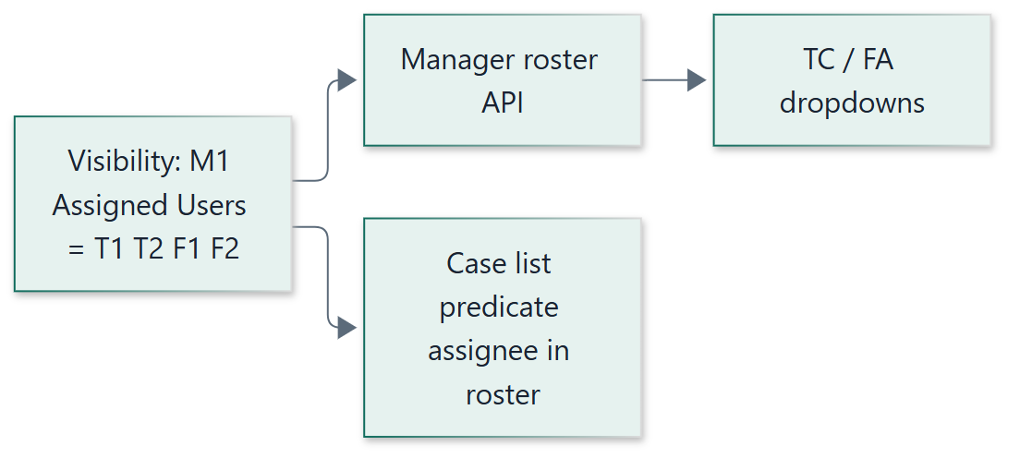

How the roster is loaded at runtime
1
Manager logs in → Identity resolves profile M1.
2
System loads M1’s
active Visibility rules
and reads
Assigned Users
.
3
Roster API returns only those profile ids, split by role (Telecaller vs Field Agent).
4
UI dropdowns bind to that roster. No portfolio membership and no “all users in my agency” query.

Adding or removing someone from a manager’s team
- Add: put the TC/FA id into M1’s Assigned Users → publish Visibility → dropdown and case scope update together.
- Remove: delete id from Assigned Users → publish → they disappear from M1’s dropdowns and from M1’s assignee-based case scope.
- TC/FA keep Self visibility for their own cases regardless of which manager lists them.
Multi-manager teams:
If both M1 and M2 must supervise the same people, list the same TC/FA ids on both managers’ Assigned Users rows. That replaces sharing one agency.

Direct report to ACM / RCM (no manager in between)
Yes — this is supported. Assigned Users is not limited to the Manager role. A telecaller or field agent can report directly to an ACM or RCM (or ZCM/NCM) without a manager profile.
Need | How it is configured
ACM/RCM sees those people’s  cases | On ACM/RCM Visibility:  Assigned Users = T1 | F1 | …  (same column as for managers)
ACM/RCM sees those people in  dropdowns | People resolver includes profiles listed on that CM’s Assigned Users  and/or  mapped under their Command Tower scope without requiring a manager node
TC/FA own app / lists | Still  Self Assigned = Y  — unchanged
Optional Command Tower rules overlap | ACM can also keep Command Tower rules (Product/Bucket/Agency from CT); Assigned Users covers the direct-report people path

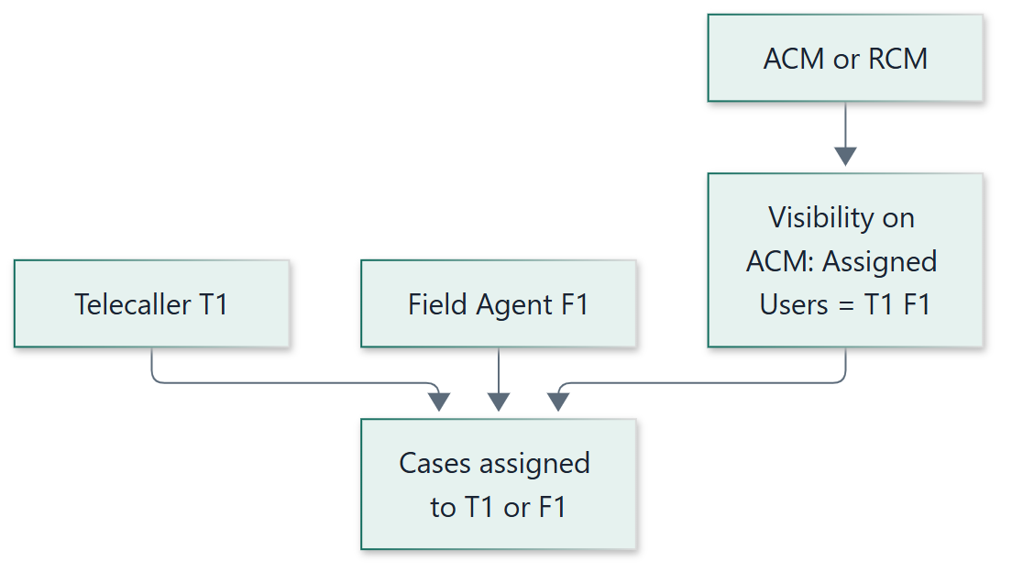
- Solved: no need to invent a dummy manager or a per-manager agency just to hang TC/FA under ACM/RCM.
- Mixed teams: same ACM can have some people via managers (CT scope → manager → Assigned Users) and some via direct Assigned Users on the ACM.
- Command Tower: may still map ACM → Agency → Product/Bucket for the Command Tower scope; people without a manager are attached via Visibility Assigned Users on the ACM/RCM, not forced through a manager row in CT.

5A.2 Sub-tenant roles (NCM / ZCM / RCM / ACM) — dropdowns & Command Tower
Sub-tenant users are Tenant Admin–class profiles with a Command Tower scope (often aligned to NCM → ZCM → RCM → ACM). They need dropdowns for child CMs, managers, telecallers, and field agents that sit under their Command Tower scope — not the entire tenant directory.

What Command Tower contributes
Command Tower stores the org map, for example:
NCM → ZCM → RCM → ACM → Agency → Product → Bucket
For a logged-in sub-tenant user, Command Tower answers: “Which agencies / products / buckets (and child CM ids) sit under my node?”

How dropdown population works by sub-role
Logged-in sub-role | Command Tower scope | Dropdowns they see
NCM | All ZCMs (and below) under this NCM in CT | ZCM list from CT;  RCM / ACM cascaded from selected ZCM;  Managers / TC / FA = profiles whose work sits in agencies / Command Tower scope under that CT subtree
ZCM | RCMs under this ZCM | RCM → ACM cascade; Managers / TC / FA under that subtree only
RCM | ACMs under this RCM | ACM list; Managers / TC / FA under those ACMs’ agencies / Command Tower scope
ACM | Agencies (and product/bucket) under this ACM | Managers / TC / FA linked to those agencies or to managers in that Command Tower scope — not tenant-wide
Primary Tenant Admin  (no sub-role) | Full CT optional for filters | Can load full NCM→… cascade and wider people search (still subject to All Cases for  loans  )

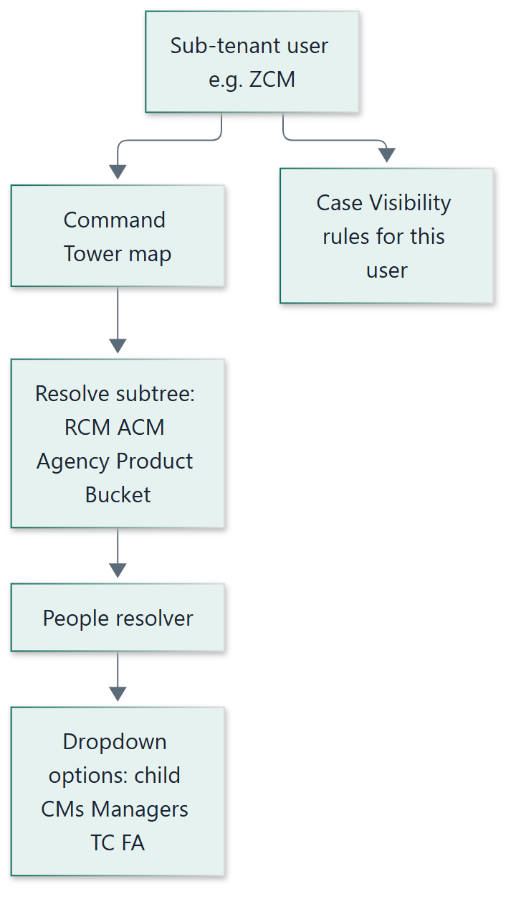

Two-step resolve (important)
1
Scope from Command Tower:
from the logged-in CM id, read CT to get child CM ids + Agency (+ Product/Bucket) set for that subtree.
2
People from profiles:
return Managers / Telecallers / Field Agents in that Command Tower scope — (a) managers under the CT agencies, (b) TC/FA on those managers’ Assigned Users, and (c) TC/FA listed
directly
on the logged-in CM’s Assigned Users (no manager required).
3
Cases from Visibility:
loan lists for the sub-tenant still use their published Visibility rules (often Agency/Product/Bucket Command Tower rules seeded from the same CT map). Selecting a person in a dropdown only
narrows
further; it cannot expand beyond Visibility.

Example
User | CT says | Dropdown result | Cases
ZCM-West | RCM-North, RCM-South → ACM-A, ACM-B → Agency Inhouse + Product PL… | Only those RCMs/ACMs; managers M1,M2 in that Command Tower scope; TC/FA on M1/M2 teams | Visibility rules for ZCM-West (seeded from same agencies/products/buckets)
ACM-A | Agency set under ACM-A only | Managers/TC/FA in ACM-A Command Tower scope only — not RCM-South’s people | Narrower Command Tower rules

Cascade behaviour in UI (multi-select)
- NCM selects one or more ZCMs → RCM options reload from CT under those ZCMs
- RCM selection → ACM options reload
- ACM / agency selection → Manager and TC/FA dropdowns reload from the people resolver
- All cascades are scoped to the logged-in sub-tenant’s CT subtree (they never see another NCM’s tree)

5A.3 Summary matrix
Viewer | TC/FA in dropdown | Managers in dropdown | Child CMs in dropdown | Source of truth
Manager | Only Assigned Users | Usually N/A or limited | N/A | Visibility Assigned Users
ACM / RCM / ZCM / NCM | TC/FA under their Command Tower scope | Managers under their Command Tower scope | Child CMs from CT cascade | Command Tower subtree + people resolver
Primary Tenant Admin | Configurable / wider | Wider | Full CT cascade optional | Admin scope + CT for filters

Security reminder:
Dropdown membership controls
who you can pick
. Loan rows are still enforced by Visibility. A crafted API call cannot fetch cases outside Visibility even if someone guesses another user’s id.

6. How hierarchy / visibility data is input
Business users do not maintain policy engines. They maintain a workbook (and/or admin UI that produces the same model).

6.1 Visibility workbook (primary input)
User ID | Branch | Product | Bucket | Agency | Assigned Users | Self | All Cases
ADMIN1 | optional |  |  |  |  |  | Y
M1 |  |  |  |  | T1|T2|F1|F2
M1 |  | PL | B1|B2 | INHOUSE
T1 |  |  |  |  |  | Y
F1 |  |  |  |  |  | Y
ACM1 |  |  |  | AG_A|AG_B

For Godrej today, leave Branch blank. Column remains so Branch can be enabled later without redesign.

6.2 Ingest pipeline
- Validate: user exists, product/bucket/agency exist, assigned users exist
- Branch: if blank → ignored; if filled → must exist when Branch master is enabled
- Nothing goes live until full-file validation succeeds
- Each publish creates a version (ACTIVE / PREVIOUS) for audit and rollback

6.3 Other inputs that feed hierarchy behaviour
Input | Source | Used for
User profile + role | CRM registration (DB) | Identity + Authorization
Visibility rules | Excel / Visibility Admin | Case scope
Loan attributes | LMS sync (loan details) + Agency Allocation | Match Product/Bucket/Agency/(Branch)/Assignee — Agency defaults Inhouse, not from LMS
Command Tower map | Existing CT / SEAM uploads | Org reference + optional seed of Command Tower rules
Assignment actions | Allocator / manager in CRM or app | Updates assignee → SELF visibility

7. How Command Tower is taken into account
Position:
Command Tower remains Godrej’s
organisational / mapping
artefact (NCM → ZCM → RCM → ACM → Agency → Product → Bucket). It is
not
the runtime security engine. Visibility rules are the runtime security engine.

7.1 Roles of the two systems

Command Tower
- Org / Command Tower map
- Useful for reporting drill-downs and ops reference
- Can inform what Product/Bucket/Agency belong to a CM Command Tower scope
- May continue to be uploaded/maintained as today for reporting

Visibility Service
- Authoritative for “which cases can this user access?”
- Enforced on CRM, Manager App, Field App APIs
- Configured via Excel / Admin publish
- Fail closed; versioned; cached

7.2 How CT feeds the hierarchy solution
1
Discovery:
Export current Command Tower mappings (CM → agencies → products/buckets).
2
Seed:
Generate Visibility workbook rows for CM/manager users from CT (Agency / Product / Bucket sets).
3
Team rules:
Add Manager Assigned Users from current manager↔TC/FA relationships (not from CT alone).
4
Cut over:
Loan/dashboard/report APIs enforce Visibility. CT filters on UI become optional convenience only.
5
Steady state:
Day-2 access changes go through Visibility publish. CT updates for org analytics can continue in parallel without granting access by themselves.

7.3 Command Tower and people dropdowns (sub-tenant)
For sub-tenant roles, Command Tower is the directory scope for cascading filters and for deciding which managers / telecallers / field agents appear in dropdowns (see §5A). Visibility remains the case scope.
Need | Use Command Tower? | Use Visibility?
Which ZCM/RCM/ACM options to show | Yes  — cascade from logged-in CM | No
Which agencies/products/buckets are in my Command Tower scope | Yes  — map | Also seeded into Visibility for case queries
Which TC/FA appear for a manager | No | Yes  — Assigned Users
Which TC/FA/managers appear for a ZCM/ACM | Yes  — subtree → people resolver | Cases still Visibility
Which loans appear | Not as ACL | Yes  — authoritative

7.4 What we will not do
- Will not make Command Tower the sole ACL for case lists
- Will not require CT sync on every page load for security of loan rows
- Will not block hierarchy go-live on rebuilding CT as a full hierarchy engine
- Will not show tenant-wide TC/FA lists to managers or to sub-tenants outside their Command Tower scope
If Godrej later wants automatic sync “CT change → Visibility draft,” that can be a later phase (integration), after the Visibility engine is live.

8. Branch dimension — non-mandatory for Godrej now
Godrej does not operate a branching model in Collekto today. The Visibility model still includes Branch as a first-class dimension in the workbook and data model so it can be enabled later without redesign.
Aspect | Now (Godrej) | Future (if Branch adopted)
Workbook column | Present, left blank | Filled with branch codes
Validation | Blank allowed | Value must exist in branch master
Loan attribute | Not required | LMS/sync stamps branch_id
UI filters | Hidden or disabled | Multi-select Branch filter
Visibility rules | Ignore empty Branch | AND with other dimensions as configured

Design principle:
Branch is
optional infrastructure
, not a Godrej go-live dependency.

9. How the whole solution works for Godrej

9.1 Target operating picture
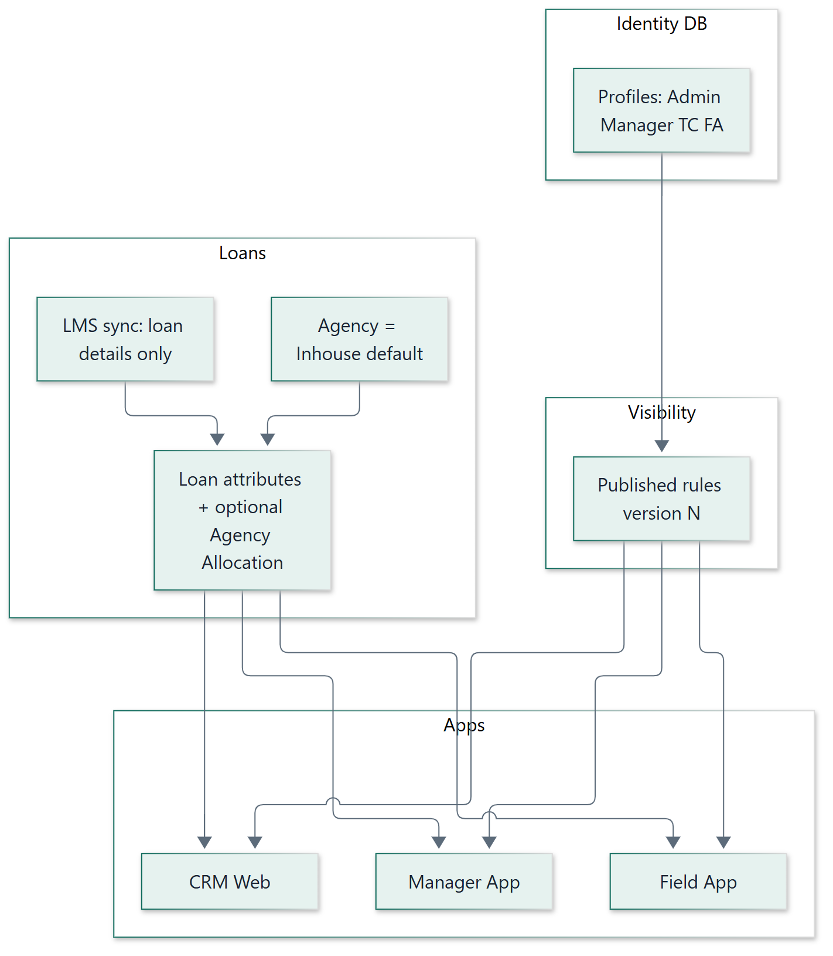

9.2 One agency (Inhouse) — ACM / manager scope
Godrej operates with one agency: Inhouse. All agents and managers sit under that agency. Agency is not used to isolate ACM or manager teams. Management scope comes from Visibility Assigned Users.
Layer | Godrej reality
Agency | One value —  Inhouse  — on (almost) every loan. Shared by everyone.
Who sees what | Visibility rules — mainly  Assigned Users  (and Self for TC/FA).
ACM management view | Only their assigned managers and/or TC/FA — configured on that ACM’s Assigned Users list.
Manager team | Same pattern one level down: manager Assigned Users = their TC/FA.
Old interim | Separate agency per manager →  Retire. Everyone stays under Inhouse.

Do not
give an ACM only
Agency = Inhouse
(or tenant-wide Product/Bucket). With a single agency that is effectively everyone. For ACM management view,
Assigned Users is the primary scope
.
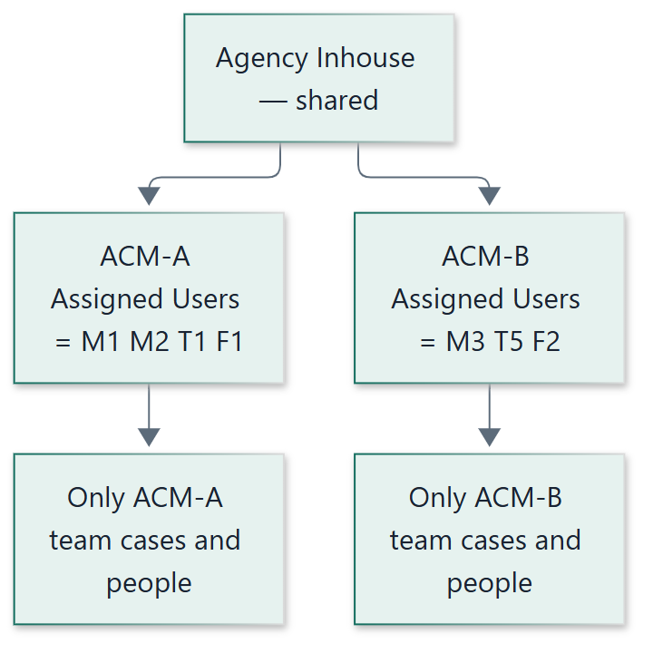

9.3 First-level allocation — who assigns, flow to agent
For Godrej day-1 ops, first-level allocation = assign the loan to a worker (TC/FA). Agency is already Inhouse on LMS ingest — there is no agency hop in normal ops.
Need | Who | What they must have
Permission | Manager / ACM / Admin (whichever roles are granted) | Assign permission (e.g.  CASE_ASSIGN  )
See unassigned pool | Same person | Visibility  Product + Bucket  (+ Agency Inhouse) — Assigned Users alone cannot surface unassigned loans
Pick the worker | Same person | Assign dropdown = their  Assigned Users  roster only
Receive work | Telecaller / Field Agent | Self Assigned = Yes — they do not allocate the pool

1
LMS sync:
loan details (product, bucket, …); Agency = Inhouse;
Assignee empty
→ unassigned pool.
2
Allocator
(Manager or ACM with assign rights) opens CRM / Manager App → sees unassigned loans matching their Product+Bucket rules.
3
Assign:
dropdown shows only their Assigned Users (TC/FA). Loan assignee stamped to the
worker only
— not dual-assignee with Manager/ACM.
4
After assign:
agent sees via Self; their manager/ACM sees via Assigned Users; agent works disposition / visit / payment / settlement.
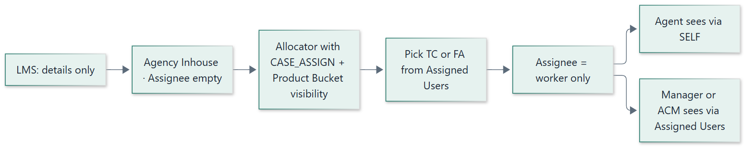
Not first-level allocation:
Agency Allocation page (stays Inhouse for normal Godrej); Visibility publish (sets who may see / allocate — does not put a loan on an agent); putting ACM/Manager as loan assignee (they supervise via Visibility).

9.4 Day in the life
User | Opens | System behaviour
Field Agent | Pending / PTP / visits | Auth ok → Visibility SELF → only assigned loans
Telecaller | All Cases / dialer lists | Visibility SELF → assigned loans
Manager | Team loans / allocate / Manager App | Assigned Users for team cases; Product+Bucket (+ Agency) required to see unassigned loans to allocate
ACM | Management view / allocate (if granted) | Assigned Users = their managers and/or TC/FA only — not all of Inhouse; Product+Bucket if they allocate unassigned
Tenant Admin | Dashboards / reports | All Cases → full tenant (explicit)
Any user | Applies multi-select filters | Filters ∩ Visibility — never expands scope

9.5 What Godrej stops doing
- Creating a new agency for every new manager (for access)
- Creating Product×Bucket portfolios under each manager agency only to grant access
- Treating portfolio membership as the ACL for people
- Using Agency = Inhouse alone to define ACM / manager management scope

9.6 What Godrej continues doing
- Maintaining product/bucket masters
- Using LMS as loan-details source (replacing import) — agency not from LMS
- Assigning collectors/field agents to loans (first-level allocation)
- Keeping Agency = Inhouse by default; Agency Allocation page ready for future external agencies
- Optionally keeping Command Tower for org/reporting maps
- Publishing Visibility workbooks when teams or Command Tower rules change

10. Detailed operational flows

10.1 Runtime access (every list / detail / dashboard / report)
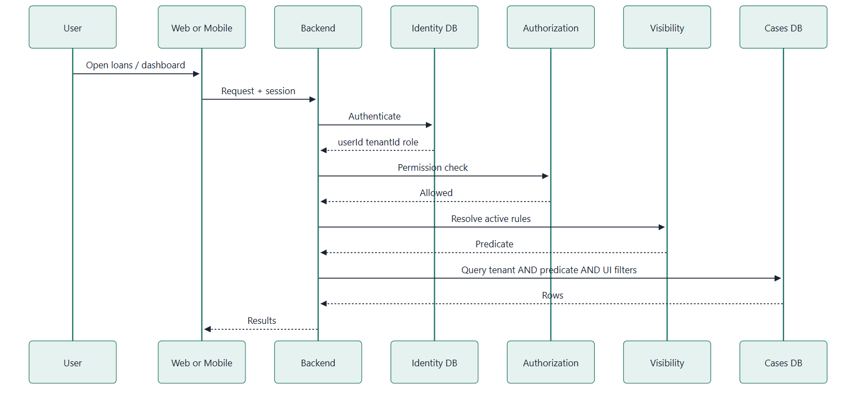

10.2 Publish visibility configuration
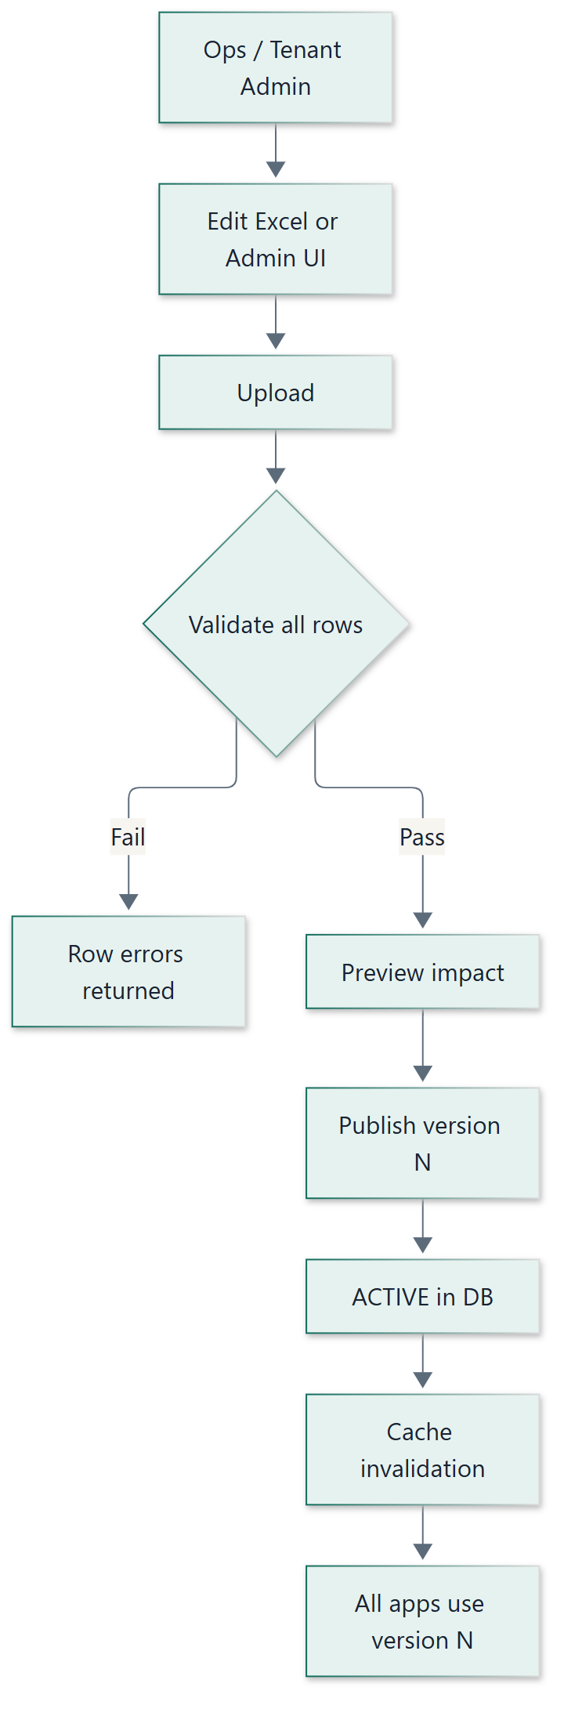

10.3 Manager team change
1
Move telecaller T1 from manager M1 to M2 in ops process
2
Update Visibility: remove T1 from M1 Assigned Users; add T1 to M2
3
Publish → M1/M2 loan lists update; T1 SELF unchanged
4
No agency/portfolio recreation required for access

10.4 LMS loan arrives (replaces import)
LMS scope:
LMS provides
loan details only
. Agency is
not
allocated from LMS.
1
LMS upserts loan by external id with loan details (product, bucket, customer, balances, etc.)
2
Collekto sets
Agency = Inhouse
by default (no per-manager agency)
3
Assignee empty until worker assignment (TC/FA) in CRM / apps
4
Visible automatically to users whose Visibility rules match attributes / assignees
5
Do not
create agencies or portfolios as part of LMS ingest

10.4a Agency Allocation page (new)
Today, Godrej runs a multiple-agency model as part of the per-manager interim model. With Visibility, that goes away for access: keep a single shared agency — Inhouse — as the default on loans.
1
Introduce an
Agency Allocation
page in CRM (separate from Visibility and from TC/FA assignment)
2
Steady state: loans stay on
Inhouse
; no allocation hop required for normal Godrej ops
3
Future: if Godrej onboards an external agency, ops use Agency Allocation to move selected loans to that agency
4
Visibility Command Tower rules can still match on Agency when external agencies exist — without recreating per-manager agencies
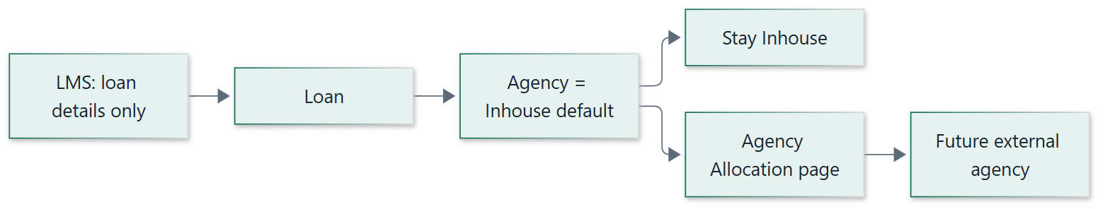

10.5 Assignment then collection
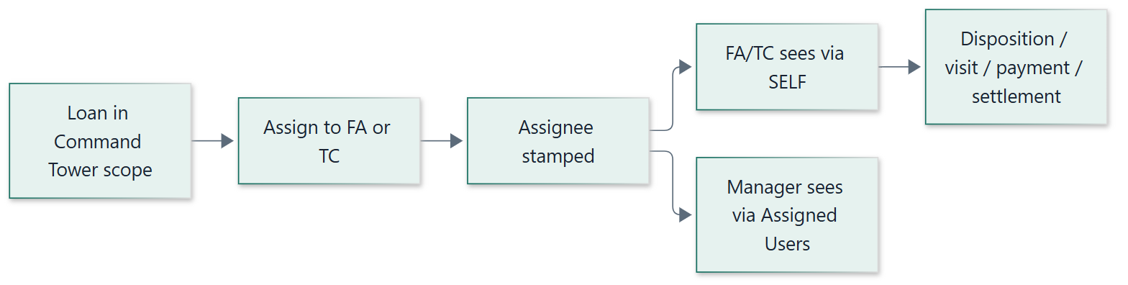

10.6 Manager opens TC / FA dropdown
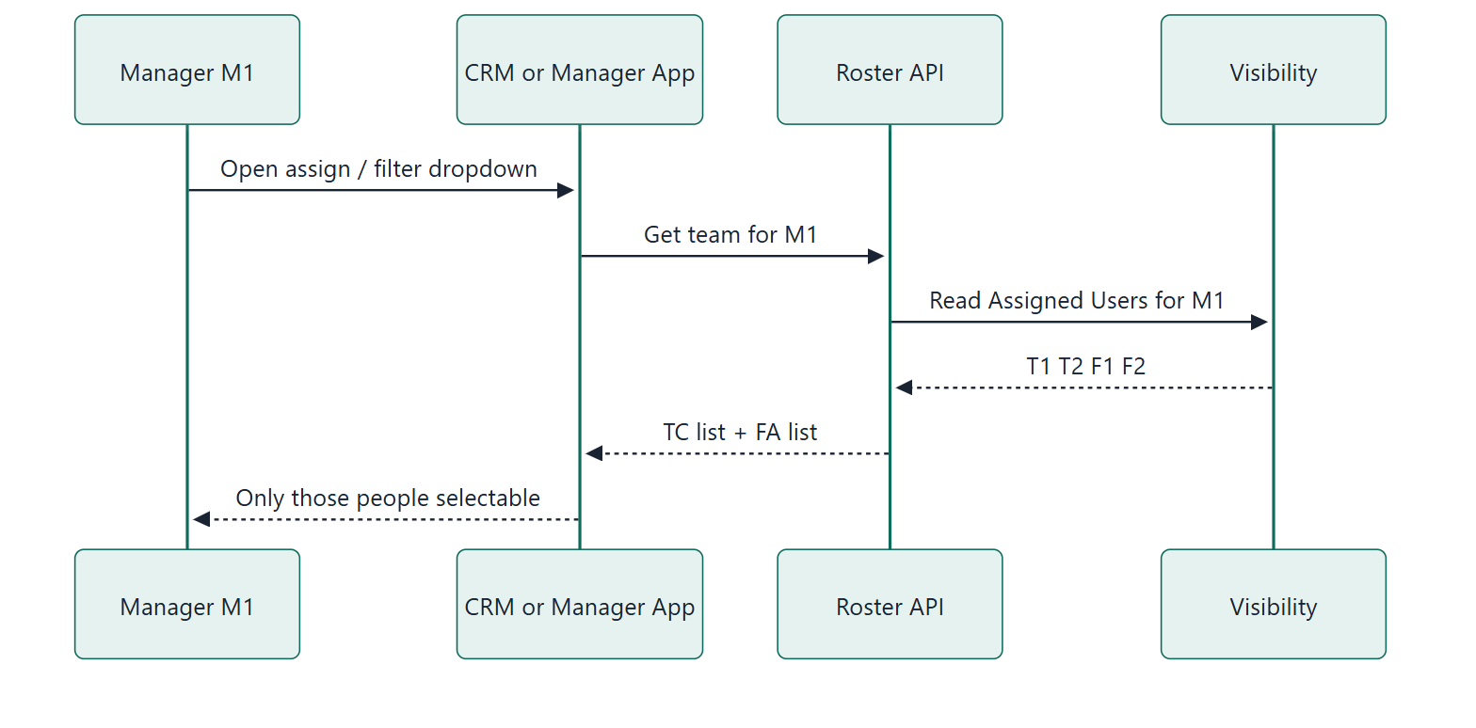

10.7 Sub-tenant opens people / CM dropdowns
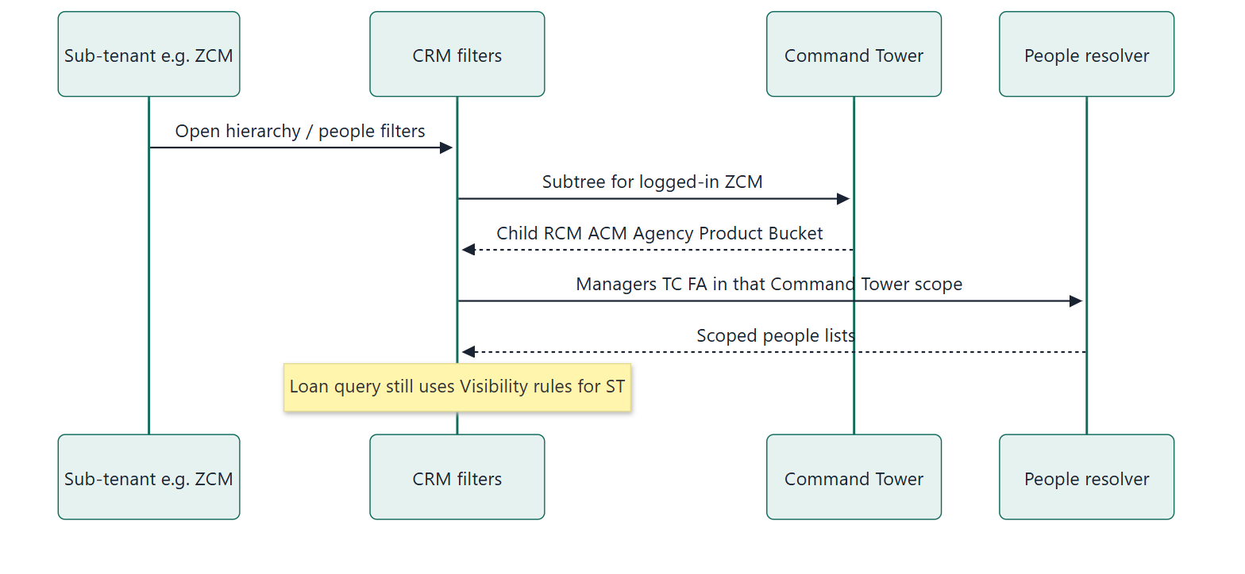

11. Phase-wise rollout into the system
Rollout is incremental so Godrej keeps operating while the interim agency model is retired.

Phase 0 — Align & inventory Prep
- Confirm roles, sample manager teams, product/bucket masters
- Inventory Command Tower usage vs portfolio/agency interim model
- Inventory APIs: loan list, dashboard, reports, mobile, settlement, integrations
- Agree Branch remains optional / unused at go-live

Phase 1 — Visibility foundation Build
- Visibility schema, resolver, cache, versioning, fail closed
- Excel upload → validate → preview → publish
- Visibility Admin screens in CRM
- Branch column present but non-mandatory

Phase 2 — Seed from current Godrej reality Migrate
- Generate workbook from: Self for TC/FA, Assigned Users for managers, Product+Bucket for managers who allocate, All Cases for primary admin
- Enrich CM/manager Command Tower rules from Command Tower Product/Bucket/Agency maps where applicable
- Dry-run publish; reconcile sample user case counts vs old behaviour

Phase 3 — Enforce on operational CRM Cutover
- Loan pages (list + detail), search/filters (multi-select ∩ visibility)
- Dashboards aggregates
- Assignment remains separate but only on visible loans
- Settlement list/approve scoped via loan visibility

Phase 4 — Mobile apps Apps
- Shared mobile APIs rewired to Visibility
- Field Agent Android + iOS: SELF; portfolio access demoted
- Manager Android + iOS: Assigned Users / dimension rules
- Coordinated app release with backend

Phase 5 — Reports, jobs, integrations hardening Harden
- MIS/report row security on Visibility
- Batch jobs that assume per-manager agency reviewed
- SMS / Payment / LMS posting: loan-id based; remove brittle portfolio assumptions
- LMS ingest: loan details only; Agency = Inhouse default; no per-manager agency side effects
- Agency Allocation page: ship for future external-agency moves (steady state = Inhouse)

Phase 6 — Retire interim hierarchy model Retire
- Stop creating agencies per manager for access
- Collapse to Inhouse as the default agency; use Agency Allocation only when external agencies exist
- Command Tower remains optional for org/reporting only
- Document steady-state onboarding SOP for Godrej ops
Parallel run:
Phases 2–3 may briefly compare old vs new counts. Security authority switches to Visibility at the agreed cutover; interim agency model is then frozen for access.

12. Module-by-module implementation notes
Module | Implementation
Dashboard | All widgets query with Visibility Context; multi-select filters only narrow
Loan pages | List/detail/search enforce Visibility; remove portfolio membership as ACL
Loan assignment | Separate APIs; assignee stamp (TC/FA); manager assign limited to visible loans + permitted targets
Agency Allocation | New page; default Inhouse on LMS ingest; assign to external agency when Godrej brings one in — not from LMS
Reporting | Row scope = Visibility; formula changes only where business requires
Filters | Multi-select Product/Bucket/Agency/Assignee; Branch hidden until enabled; ∩ Visibility
Settlement | Create on visible loan; lists/approvals via Visibility + AuthZ
SMS / Payment | Trigger from allowed loan actions; callbacks by payment/loan id
LMS | Loan details only; no agency allocation from LMS; Inhouse default in Collekto; no per-manager agency side effects
Command Tower | Seed + reporting reference; not runtime ACL

Collekto — Godrej Hierarchy

