Developer Guide:

Functions, which will process the data for the output of this application are most important part of this project.

Function:

1. Get_Countries():

This function iterates through the data set and appends the “visitor_country” value to a list named “countries”. Then we made a set named “countries_set” to remove repetitions from the list. After this, we made a list called “countries_weights” for storing the number of repetitions of each country.

These pieces of data are arguments to another function called “show_countries_hist()” which is responsible for setting up the histogram.

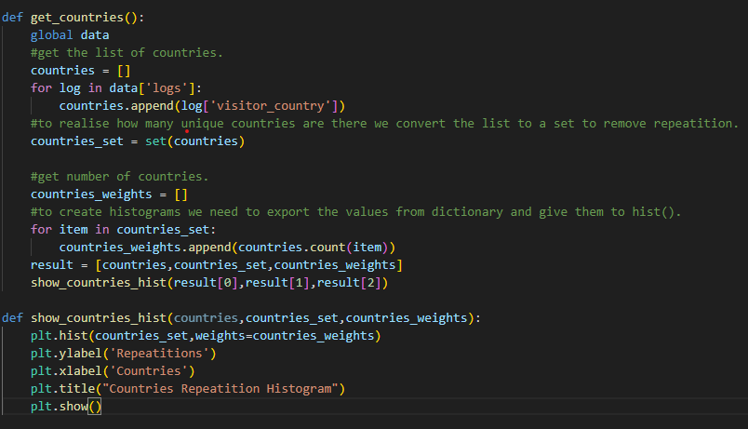

1. Get_Browsers():

This function starts another iteration in the data set and collects the “visitor_useragent” value of each log and inserts it to a list called “browsers”. During this iteration, it also slices the string from beginning to the index of first “/”. This is because we wanted to remove the rest of the string and only have name of the browser in the list. After this, we created a set called “browsers_set” and removed the repeated items from the list. after this, we made another list called “browsers_weights” to store the number of repetitions for each country.

These pieces of data are arguments to another function called “show_browsers_hist()” which is responsible for setting up the histogram.

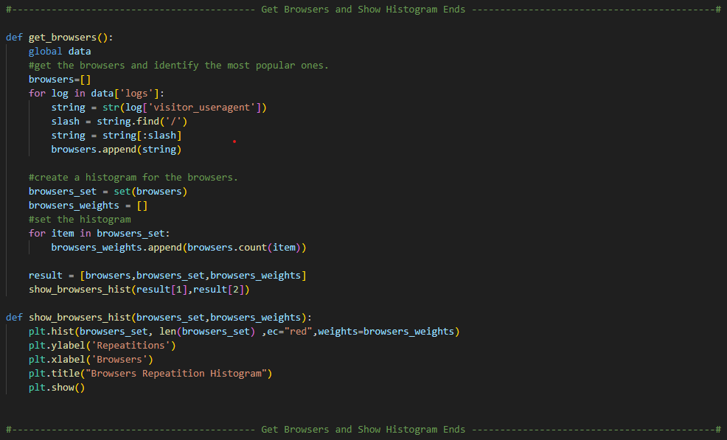

1. user_timeSpent():

This function also iterates through the data set and collects “event_readtime” value of users. For this function we used a dictionary to prevent the extra loops. Each user that have spent some time reading documents, will have a key and value (equal to sum of reading times) in the “users_time” dictionary.

At the end, we have used this dictionary to return top 10 reader of our data set.

1. Also_likes():

This functionality is consisted of 3 functions, “also_like_user()”, “also_likes_doc()”, and “also_likes()”. Also_likes_user gets a user uuid and returns the whole documents that the user have read. Also_likes_doc get a document uuid and returns all the users who have read this document. Also_likes function uses these two functions to work. It takes a document uuid and (optionally) a user uuid and return a list of other documents as suggestion. These documents are coming from other users who have read the document and also read other documents.

