Codeceptjs-Skeleton

Problem which we were facing in general skeleton :-
- We were not able to handle different environments and also unable to handle different URLs. Now this can be handled in env.js
- There was no possible way to apply conditions on I.see and I.wait methods .
- We have created custom helpers for that by using generic functions like isVisible(), isEnable() etc.
- Earlier we were unable to set environment through Command Line.Now we can pass different env through Command Line: For Windows: (SET e2e_env=dev) && codeceptjs run --steps For Linux : (e2e_env=dev) && codeceptjs run --steps
- Previously there were many Lines of Code in codecept.cofig.js. Now this has been made easy to understand and manageable by splitting config file into multiple js files and grouping them into the config folder.
- Previously we were not able to handle static strings in different language
- Now this can be handled by using string.js and static string folder
- Use CMS for static content and for locators to if content change in feature than it does not effect on script.
- Now we also add some preferences in webdriver to download files in project directory under output folder.
- GraphQL Automation
- Create some generic methods which use in all over the project.
- Also created some handlers to handel (csv,excel) and helpers(mongooseHelper and datepicker)

Codeceptjs-Skeleton Structure :-
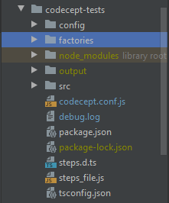

Codecept Structure contains the following folders at base level :-

src :-
  - queries
  - services
  - features
  - model
  - pages
  - step_definition

Config :-
  - bddConfig
  - envConfig
  - webHelpersConfig

Factories :-
  - ApiHelper.js
  - CMSContent.js
  - dateP.js icker.js
  - fileHandeler
  - genericFuctions.js
  - mongooHelper.js
  - MyHelper.js

config folder contains all the config files (helper,cucumber config and envConfig files ) which are used in codecept.config.js .
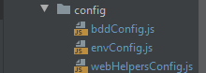

envConifg.js file is used to manage :-
- All the urls with different env(dev,test...)
- envURL[envURL.env].web.HOST_URL
- Also we add some static variables like market_Code ,client_Code, etc

And define your envConfig.js like this :-
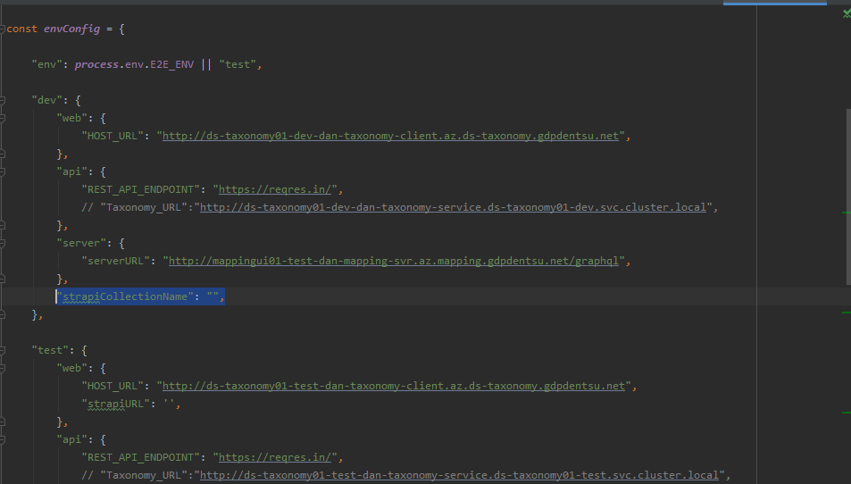
factories folder contain all the folders ,files or function which can be used in all over the framework like :-
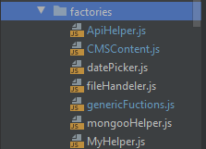
- datePicker.js :- This contains generic date picker function which pick date for components which use in component library
- fileHandeler.js :- This contains function which is used to handle excel and csv file.
- genericFuctions.js :- This file contains generic function like :- (transformTable() ,getOktaToken(),getCMSContentFromGraphQL())
- mongooHelper.js :-
- MyHelper.js :- Contains function which return status of the locator that is locator visible, is locator enable . Return type is Boolean
- CMSContent.js :- This file contains all the CMS static string to manage automation for different language as well.
- ApiHelper.js :- Contains different function which returns different base api urls.

features folder contains folder feature vise which contains all cucumber files having .feature extension

model contains all the models which can be used in API as request model or in web automation to store dynamic data if needed and also create an index file for export all the models at ones.
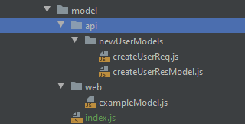

output contains all the output like screenshots and xml files and also contains all downloaded files which are downloaded in between the scenarios.

pages contain all the page object(locators) and their relative functions and also contains an index.js file which is use to export all page file outside the page directory. (Like step_defination).
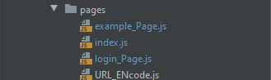

step_definitions contains all the definition of the steps which are specified in the feature file for both web and API.

services contains function which is use to hit different end point from different micro services and services and also create an index.js file use to export .
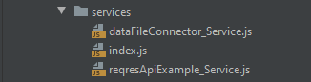

queries contains function which to hit different graphQL queries for different modules and also contain index.js file which is use to export different queries modules in different other folders (like pages and step_defination)

Do’s And Don'ts :-

Do’s
- Use index.js file to export and import files or modules from one directory to another.
- Use camel Casing for file name
- Create locators in different object like fields.
- Use cmsContent file to store all the static strings which comes from CMS.
- Try to use ternary operator instead of if-else.
- Replace for loop to for each.
- Use models for storing data instead of creating variables in different js file.
- Use encrypted URLs so that URLs not exposed over repo.
- Use ApiHelper for creating URIs instead of require envConfig in ever service file.
- Use backticks (``) for string and for concatenation use ${arg}
eg :- let arg = `first`;
console.log(`here is the first ${arg} example`);
- Use CMSContent for those locators who’s contains cms string. Like this
characterRemoval: () => `//p[text()="${CmsContext.result.removeCharacterSubTitle}"]`,
- Use ES6 concept of JavaScript like destructing , object cloning etc.
- Use dynamic wait before energy action.
- Create action function for every locator and call them instead of creating one function with all the action.
- Use GraphQL query for getting data instead of APIs to verify UI.

Don'ts
- Name the functions short but with something relevant, same with parameters.
- Function name not more than 20 charactor.
- Don't repeat code, if you have to do it, write a function.
- Don't be afraid to refactor, and do it as soon as you notice you need it.
- Code line should not be too large
- Don’t import page file directly use index.js file for that.
const {
validationRulesPage,
characterRemoval,
unexpectedLineBreak
} = require('../../pages/index');
- Don’t import one page file to another page file use step file for integrating steps.
- LOC (line of code) of a function is not more than 20.
- Don’t use await everywhere use only with (grab function ,REST function, queries function and parent function of having some await and async )
- Don’t require I in step_defination
- Don’t use static wait

How to run ?
We can directly run scripts without changing the env by executing below command: npm run test:e2e This will execute on test env by default.

In order to execute script on different environment (SET AppEnv=dev) && npm run test:e2e This will execute on dev environment.

Alternatively, user can execute scripts directly from codecept by below command: codeceptjs run --plugin allure --steps For more details click on Link

Frame Work Link :- https://gitea-tooling.az.devops.gdpdentsu.net/global-client-reporting/dentsu-bdd-js-boilerplate/

