**ASSIGNMENT-1**

**Q1. Create a view to get a count of how many employees are in organization at each level of salary.**

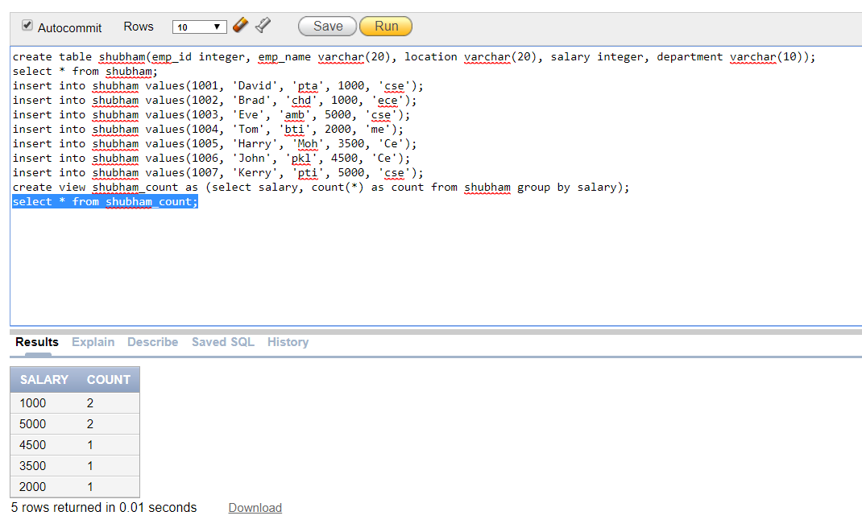

**Q2. Create a forced view?**

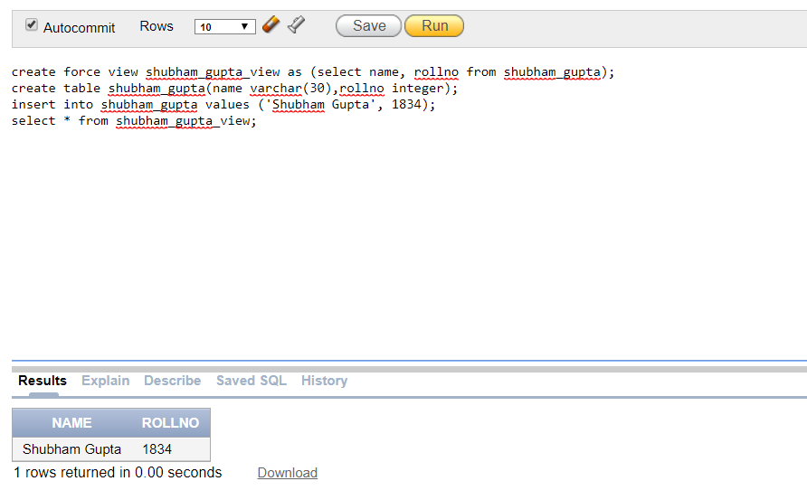

**Q3. Create a cluster of EMP and DEPT tables in which the DEPTNO will be cluster key.**

