**AIM-**Design a system with two buttons such that

1. red light when any button is pressed during night. b. green light when both buttons are pressed during night.

**Circuit :**

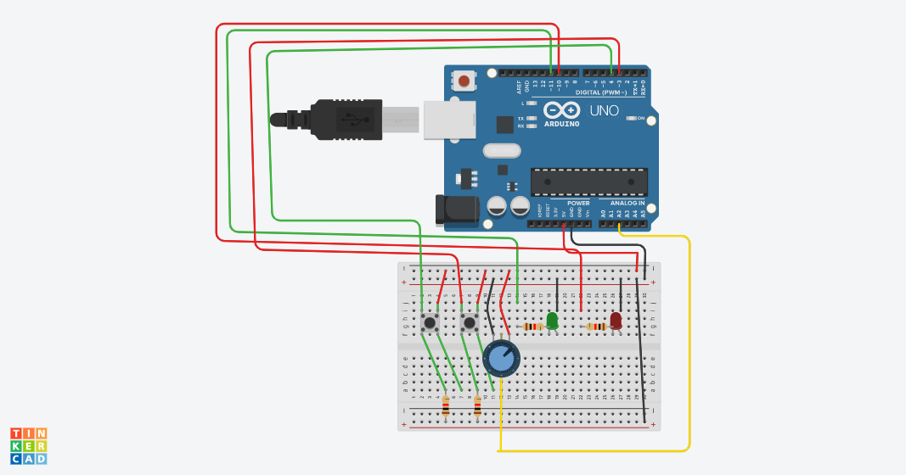

THEORY-

**Concept used :**

The pushbutton is a component that connects two points in a circuit when you press it. The example turns on an LED when you press the button. We connect three wires to the Arduino board. The first goes from one leg of the pushbutton through a pull-up resistor (here 2.2 KOhms) to the 5 volt supply.

**Learning outcomes:**

This allows convenient prototyping without soldering, which you will **learn** how ... You will be using digital input and output to write your first **Arduino** progam. **Learn** how to use logical operators by example as the semester progresses.

**Problems & Troubleshooting:**

For starters what I want to do is have two push buttons hooked up to two inputs and when I press one button, I want it to loop a function indefinitely until the other button is pressed at which point I want another separate function to loop indefinitely.

**Precautions:**

Is there a document that lists the basic **precautions** that should be followed in order to prevent design errors, or just inadvertent errors

**Learning Outcomes:**

**I** have learned about buttons when pressed how the different led are blinking and comes to know about the Arduino .