**Project Name:- Sentiment Analysis Using Deep Learning**

**About**

In this sentiment analysis using deep learning project,we can develop a system that predict the sentiments of text as well as emoji that taken as input.On the basis of the sentiment score we can analysis the various factors of the input such as high frequently use words in the input,ratio of the positive and negative sentiments.We can use the nltk(Natural language processing toolkit) and LSTM(Long Short term memory)Algorithm.We can use the common reviews dataset of the IMDB movies reviews.

**Sample Photos**

1.User Site

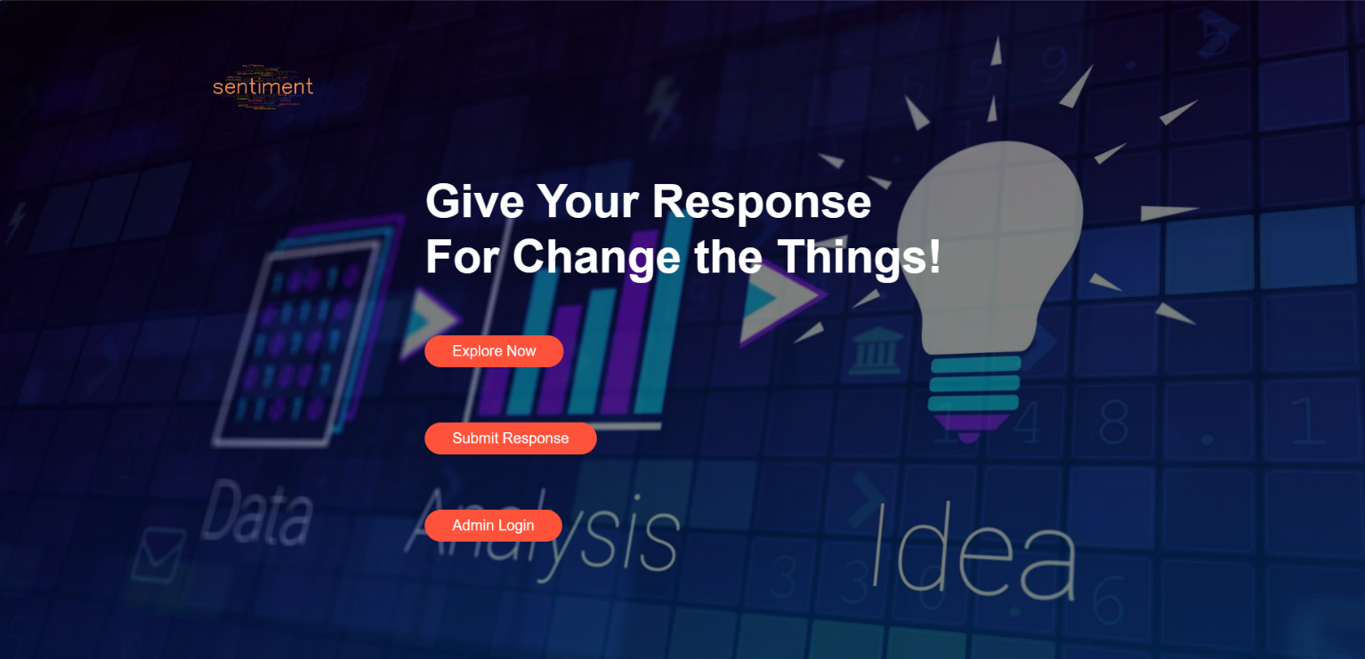

2.User site for sumbit response

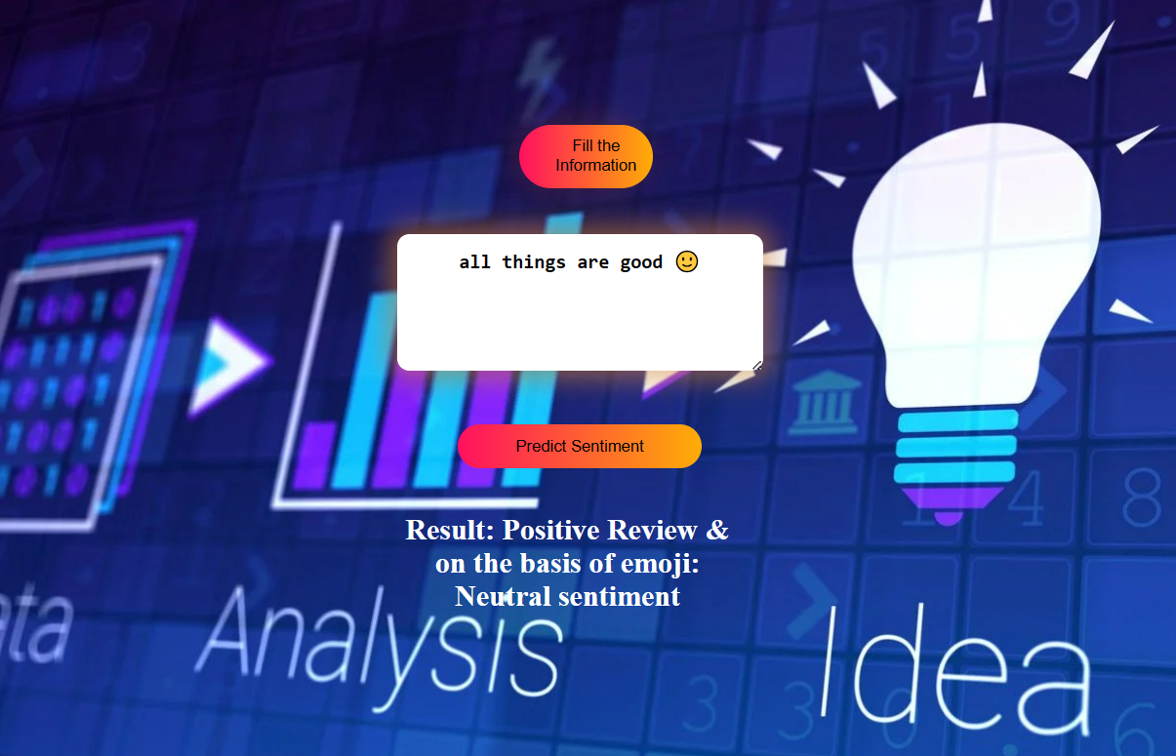

3.Admin Dashboard

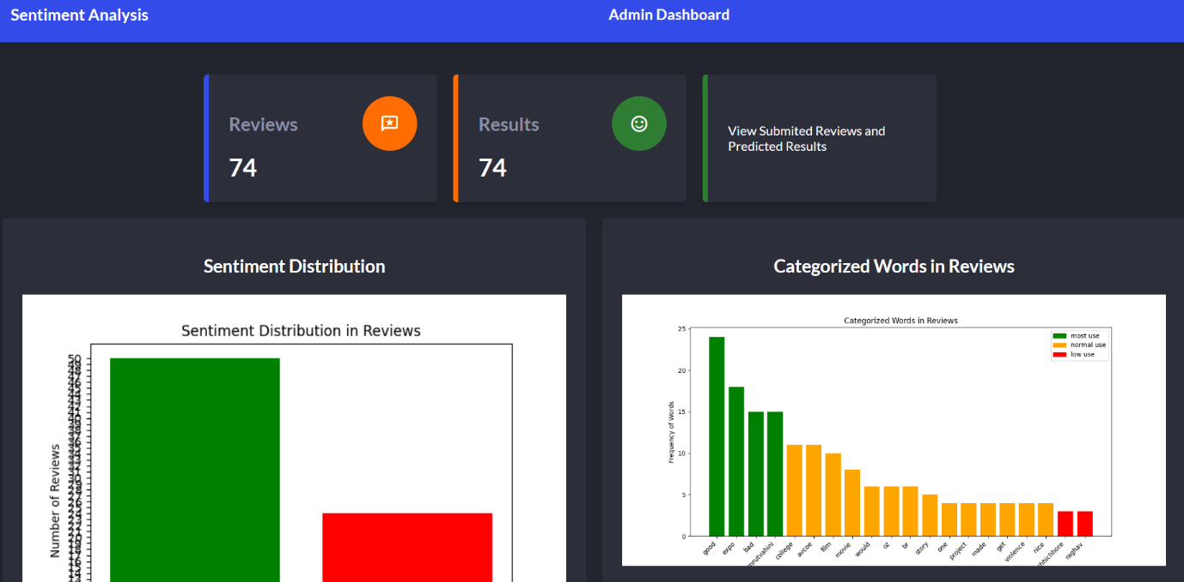

**Visit**

We can check the project on https://sentimentgroup18.pythonanywhere.com/ this website is under development at time user can only submit the response their result not be display on the website.