SINGH ANUPRIYA DEEPAK KUMAR SINGH

15BCE0483

HUMAN COMPUTER INTERACTION

DA2

Perform GOMS analysis and Keyboard Analysis for any online applications of your choice. Evaluate the same using Shneiderman's eight golden rules, Norman's Sever principles, Norman's model of interaction.

Application: Plagiarism Checker

https://smallseotools.com/plagiarism-checker/

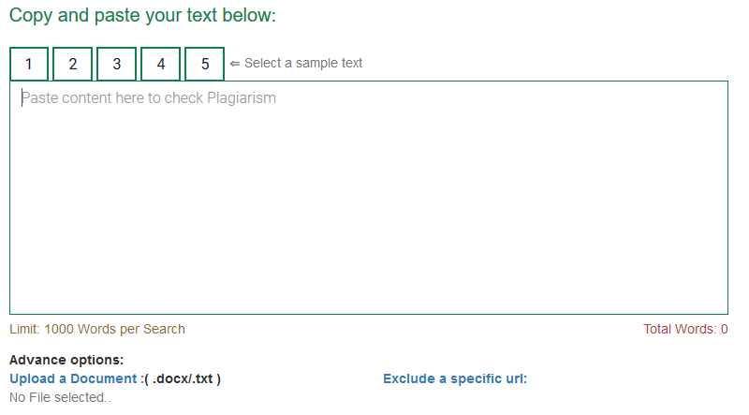



**Eight Golden Rules**

|  |  |  |
| --- | --- | --- |
| Rules | Evaluation | Remarks |
| 1. Strive for Consistency | Present | Consistent sequences of actions are followed every time you visit the website. |
| 1. Cater to universal Usability | Absent | No shortcuts available, same steps for both novice and expert. |
| 1. Offer informative feedback | Present | Remarks are given for every action. E.g.: if the word limit if the text increases 1000 words, a remark s given. |
| 1. Design dialogs to yield closure | Present | After every action, the user is informed about the result. E.g.: if the document to is uploaded the user is notified upload successful or when the text is being evaluated for plagiarism it shows the percent of document checked. |
| 1. Prevent errors | Presence | The web page informs the user that if he wants to upload a file it has to be doc or text and if the user wants to type text it should not exceed 1000 words so that the user doesn’t not make these mistakes. |
| 1. Permit easy reversal of actions | Present | The actions can be easily reversed. |
| 1. Support internal locus of control | Present | Only the user asks the webpage to perform the task the web page performs it so the user is in charge. |
| 1. Reduce short-term memory load | Present | The web page is easy to use. |

**Norman’s Seven Principles**

|  |  |  |
| --- | --- | --- |
| Principles | Evaluation | Reason |
| 1. Use both knowledge in the world and knowledge in the head. | Present | The information required to complete the task is readily available and steps are easy for the user to perform. |
| 1. Simplify the structure of tasks. | Present | The webpage is very simple to use and not complex. |
| 1. Make things visible. | Present | The steps to be carried are clearly mentioned. Links and buttons are used for the same. |
| 1. Get the mappings right. | Present | The buttons perform the task that they are made for. They are properly mapped to the task they are created for. |
| 1. Exploit the power of constraints, both natural and artificial. | Present | Constraints are available to ensure that the word limit is not more than 1000 words and in case of uploading the file is doc or text. |
| 1. Design for error. | Present | If a user does a mistake he is notified about the same and can correct it. |
| 1. When all else fails, standardize. | Present |  |

**Norman's model of interaction**

1. Forming the goal: To check plagiarism of a document

2. Forming the intention: A set of words within the limit of 1000 words or a document is needed in the format of .doc or .text.

3. Specifying an action: Paste the text in the text box making sure it is within 1000 words to check plagiarism or select the files to be uploaded in either .doc or .text format.

4. Executing the action: Click on the check plagiarism.

5. Perceiving the state of the world: The response that the web page gives for every input of user like uploading document, checking plagiarism.

6. Interpreting the state of the world: The outcome given by the system for every action like file uploaded, plagiarism checked.

7. Evaluating the outcome: To test whether the goal has been achieved and plagiarism percentage has been calculated.

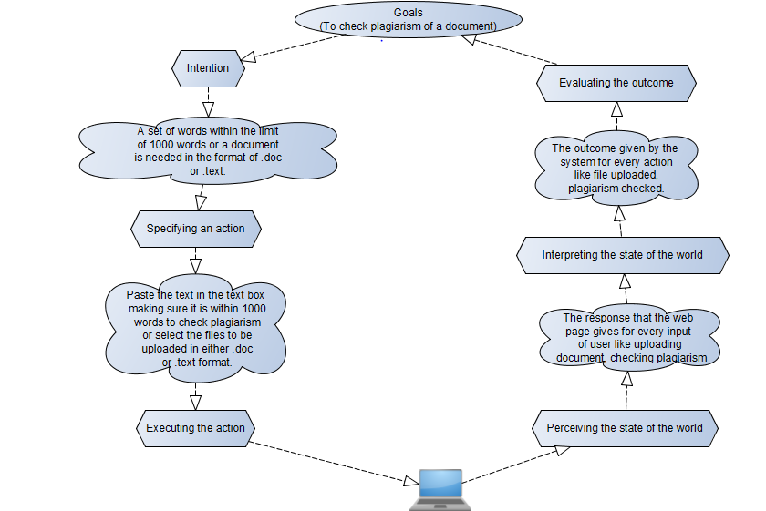

Keystroke Analysis

|  |  |  |  |  |  |
| --- | --- | --- | --- | --- | --- |
| Method 1 (entering text in text box and checking plagiarism) | Symbol | Time | Method 2 (uploading a file and checking plagiarism) | Symbol | Time |
| 1. Mental preparation. 2. Homing – moving hand towards the mouse/ touch pad. 3. Position control to text box. 4. Mouse click to select text box. 5. Enter characters    1. Let x be the number of characters. (maximum limit of x is 1000)    2. Key Press x times. 6. Position control to check plagiarism button. 7. Mouse click to select check plagiarism button. | M  H  P  B  Kx  P  B | 1.35s  .405s  1.10s  .15s  0.28s  1.10s  .15s  Total time:  4.535s | 1. Mental preparation. 2. Homing – moving hand towards the mouse/ touch pad. 3. Position control to upload file. 4. Mouse click to upload file. 5. Look for the file to upload. (Mental preparation) 6. Position control to the file to be uploaded. 7. Mouse click to select the file. 8. Position control to open. 9. Mouse click to select open. 10. Position Control to check plagiarism button. 11. Mouse click to select check plagiarism button. | M  H  P  B  M  P  B  P  B  P  B | 1.35s  .405s  1.10s  .15s  1.35s  1.10s  .15s  1.10s  .15s  1.10s  .15s  Total time:  8.1s |

Method 1- MHPBKxPB

Method 2- MHPBMPBPBPB