**Data Profiling Using Alteryx**

Time each profiling job takes:

1. Motor-Vehicle-Collisions Crashes

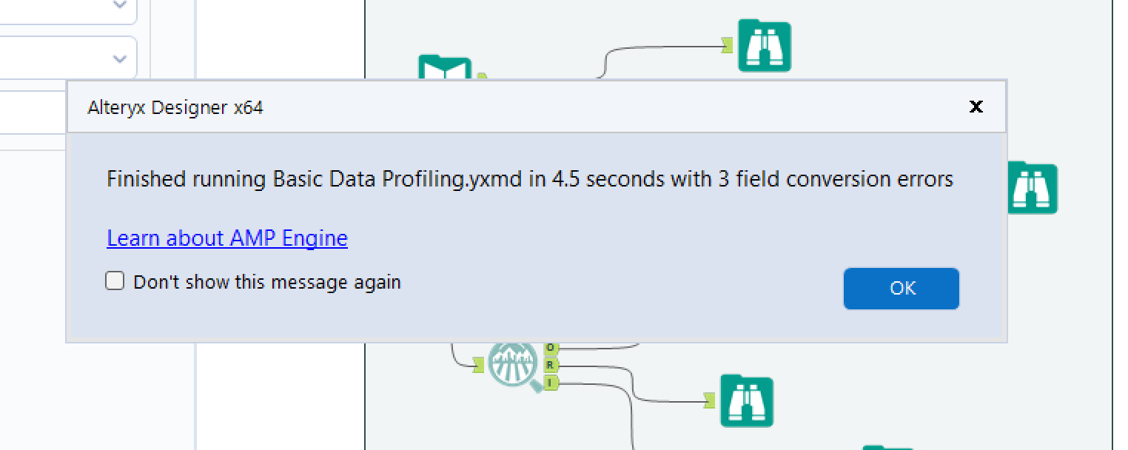

1. Motor-Vehicle-Collisions Vehicles

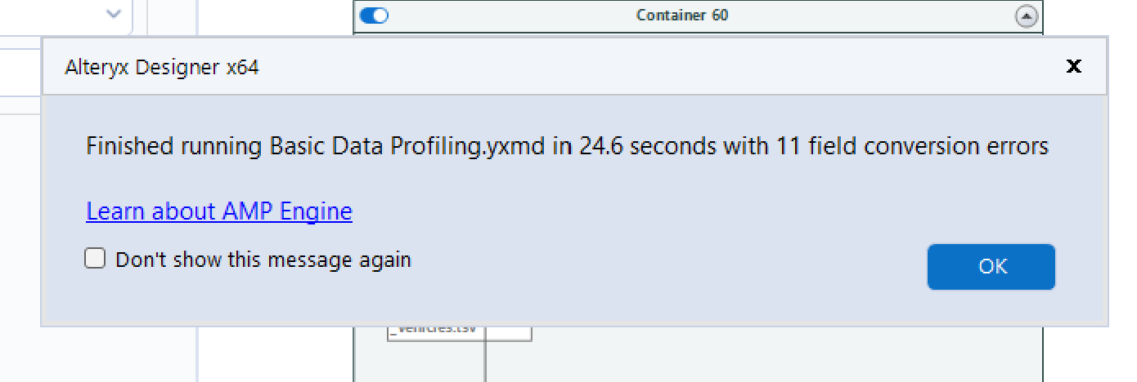

3)Motor-Vehicle-Collisions Person

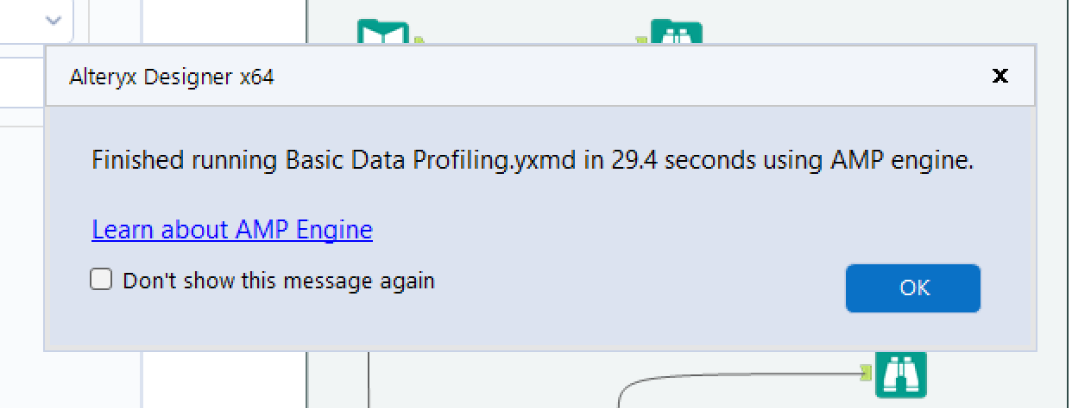

**Screen shots of completed profiling.**

1. Motor-Vehicle-Collisions Crashes

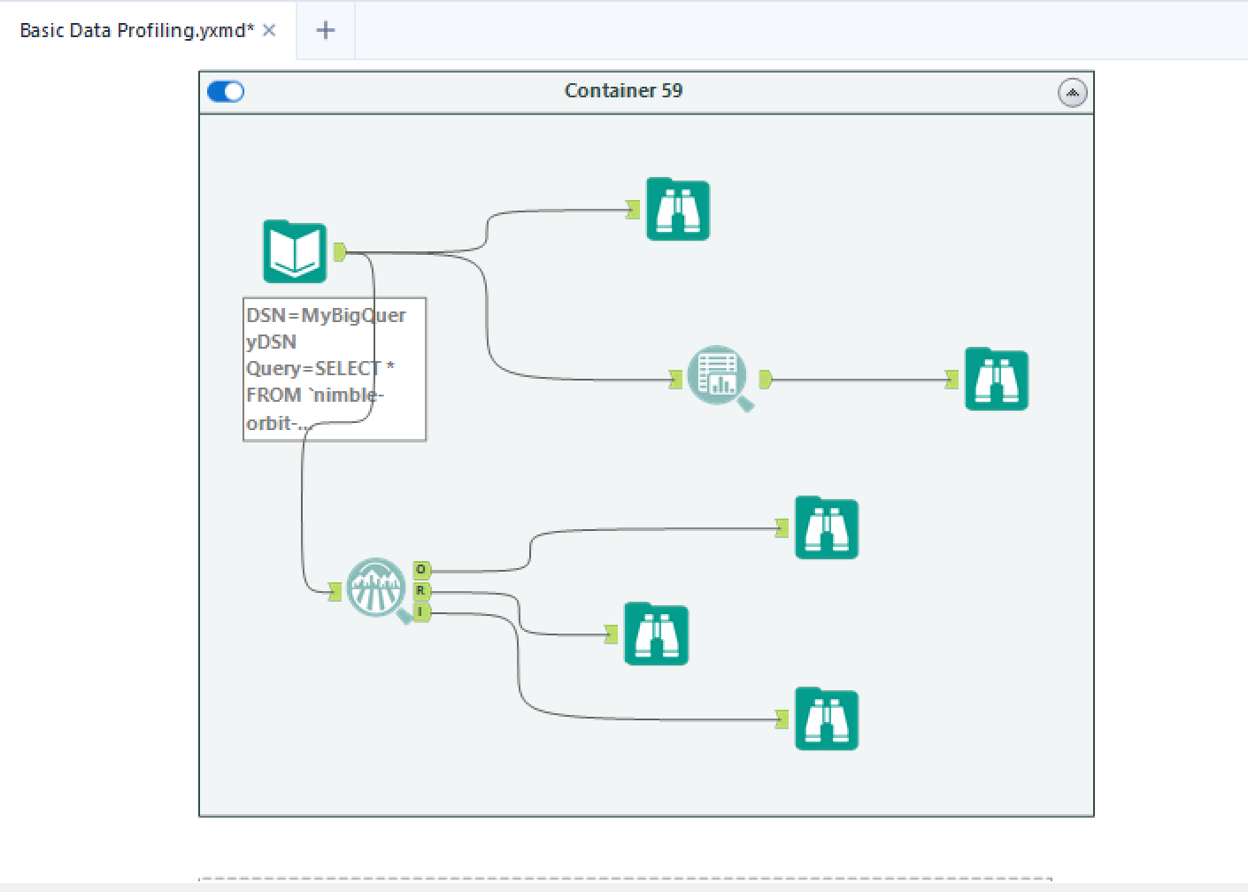

2)Motor-Vehicle-Collisions Vehicles

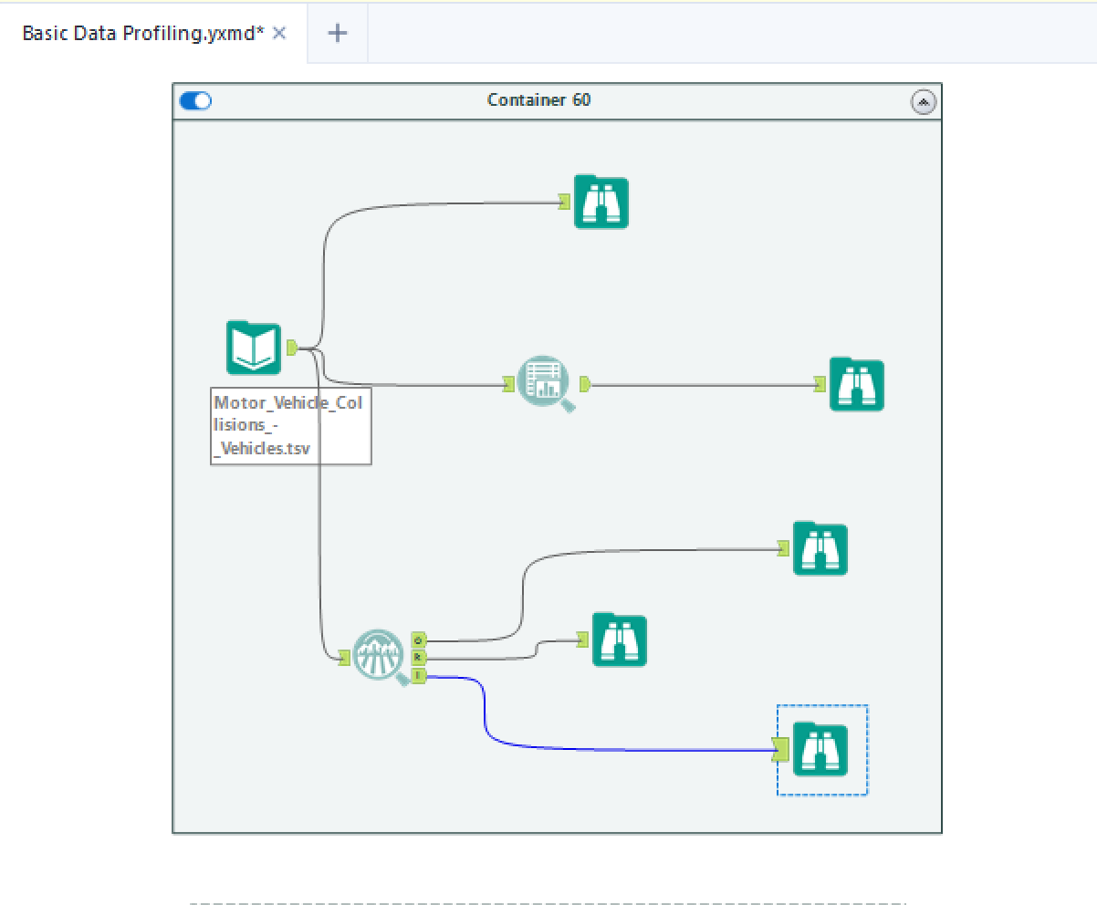

3)Motor-Vehicle-Collisions Person

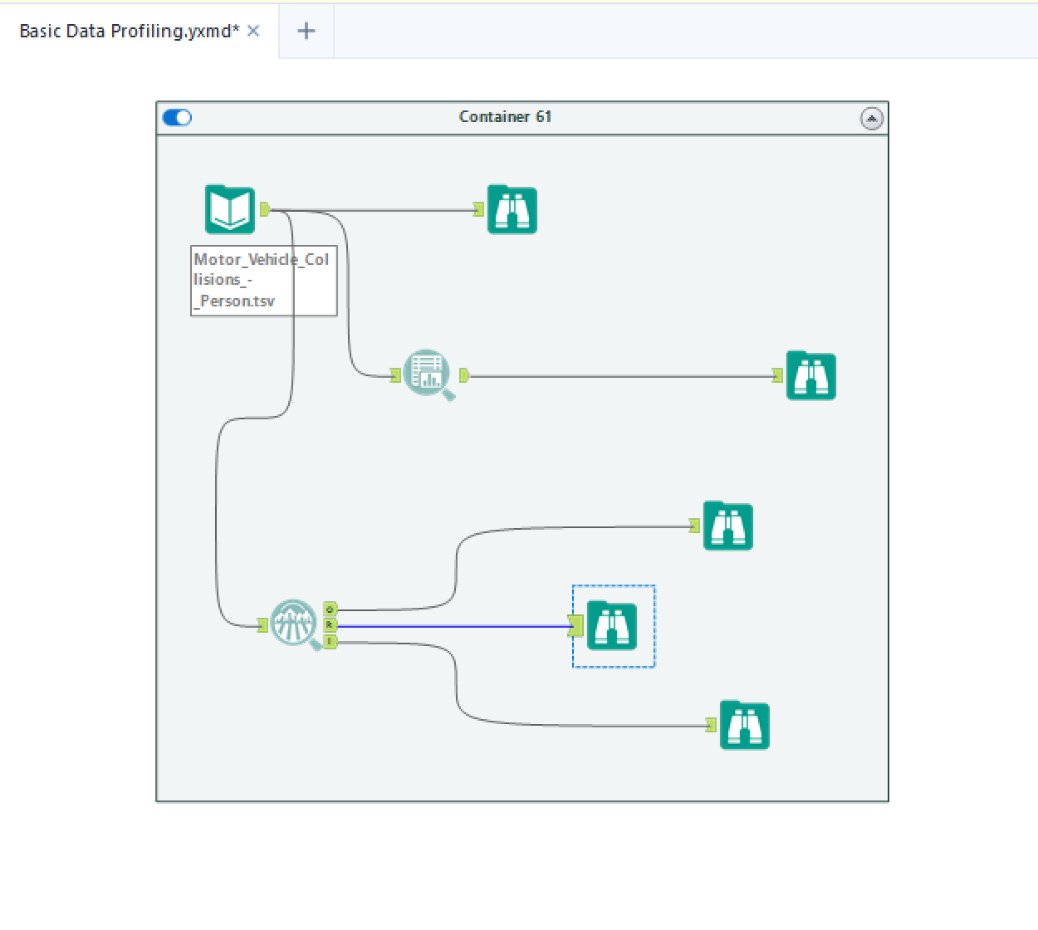

**Talend**

Screen shots of completed jobs:

1)Motor-Vehicle-Collisions Person

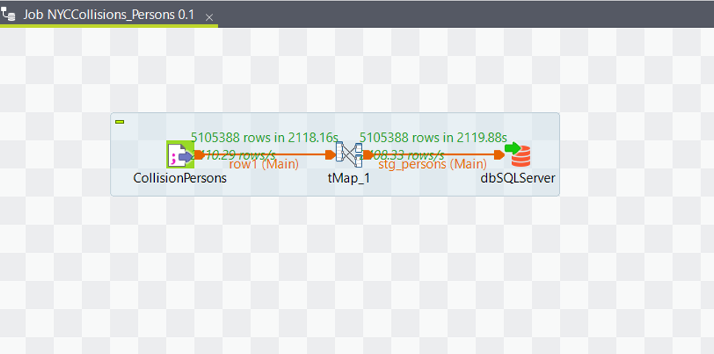

2)Motor-Vehicle-Collisions Vehicles

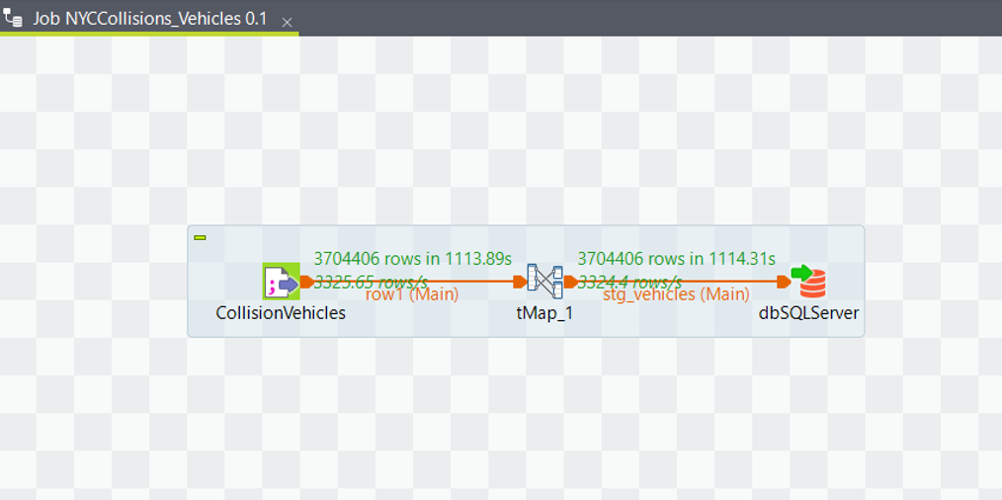

3)Motor-Vehicle-Collisions Crashes

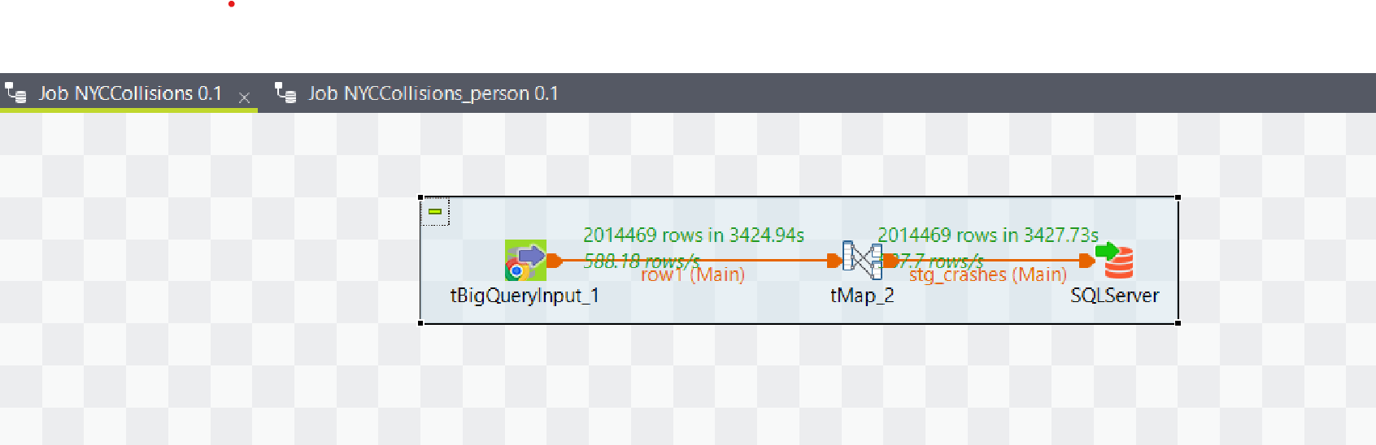

List of tables with rows counts.

Name of Table: stg_nyc_mv_collisions_BigQuery

Number of Roles: 3704406

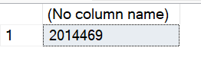

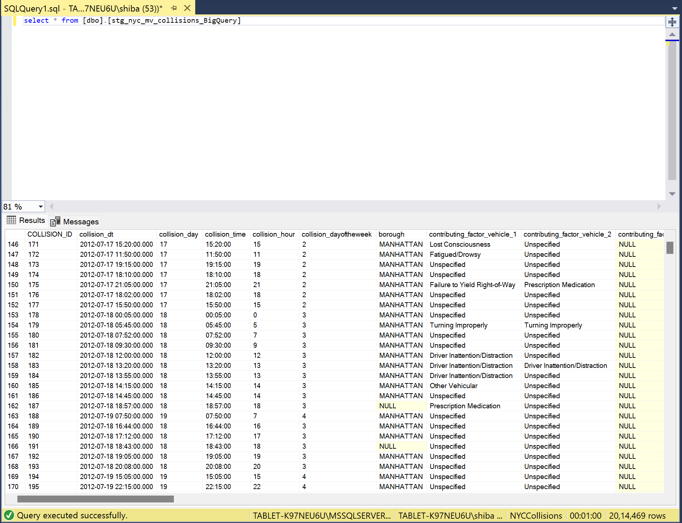

Name of Table: [dbo].[stg_persons]

Number of Roles: 5105388

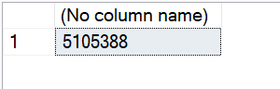

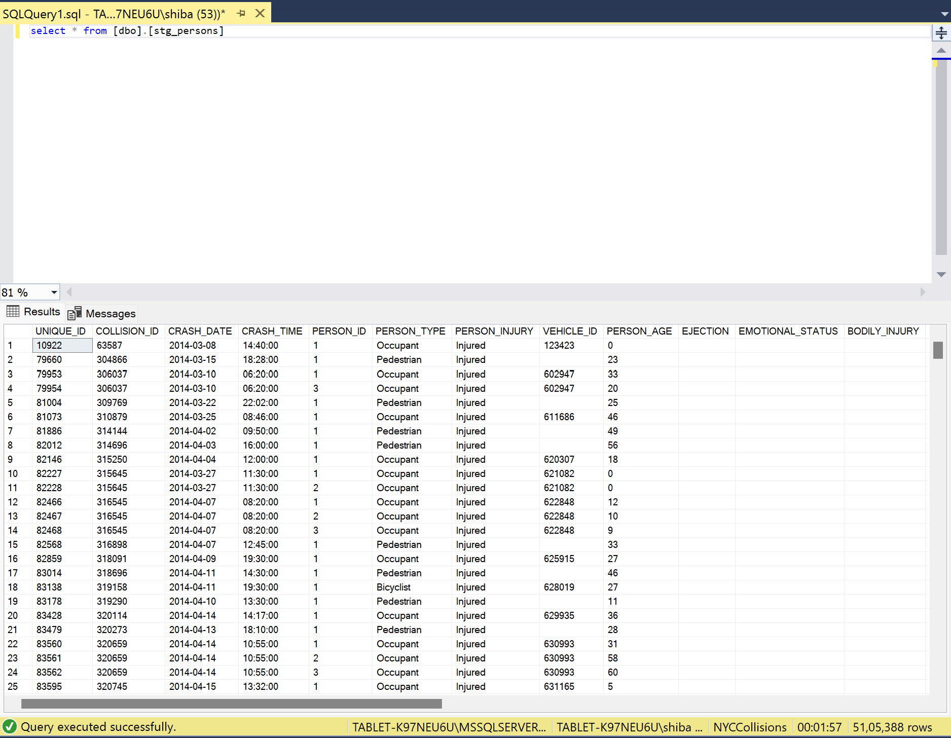

Name of Table: [dbo].[stg_vehicles]

Number of Roles: 3704406

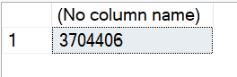

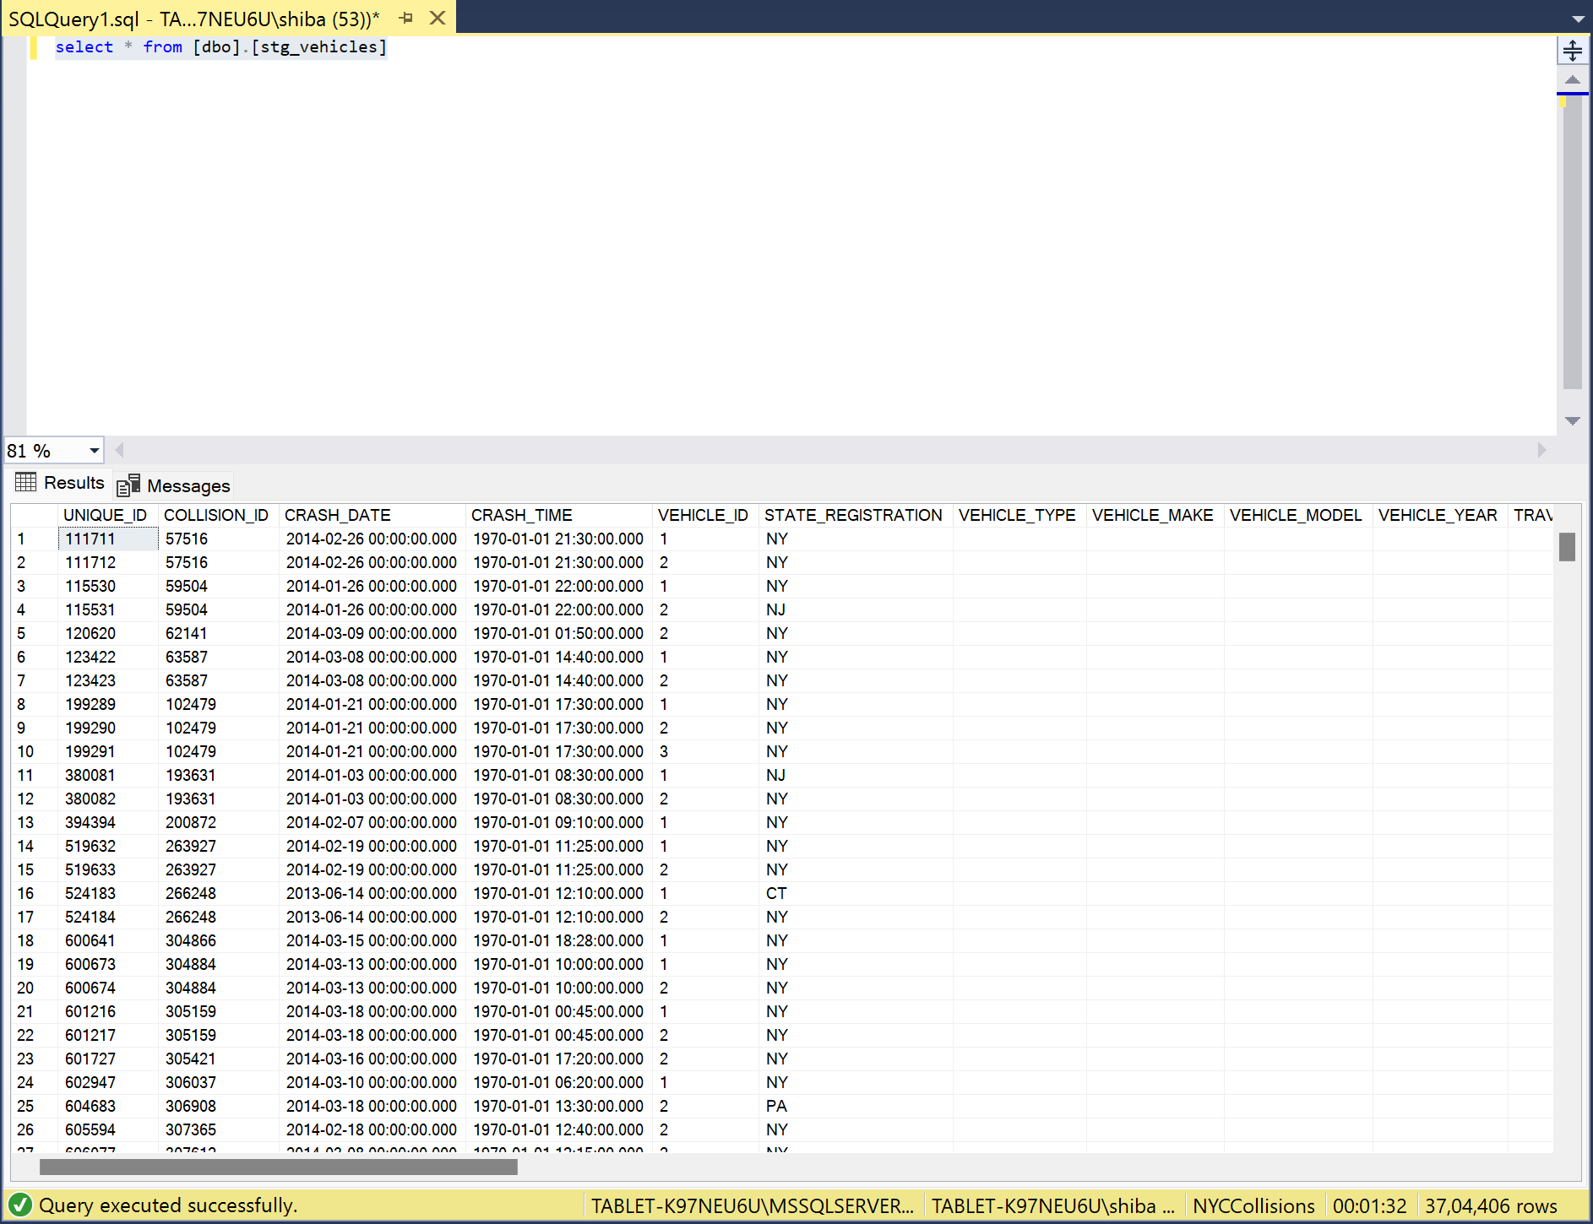

List of Fact and Dimension Tables:

Fact Tables:

fct_collision_crashes

fct_Collisions_Vehicles

fct_Collision_crashes_vehicles

fct_Collision_Vehicles_Contributing_Factors

fct_Collision_Vehicles_Vehicles_Damage

fct_Collision_persons_Contributing_Factors

fct_collision_persons

Dimension Tables:

dim_POINT_OF_IMPACT  
dim_PRE_CRASH  
dim_STATE_REGISTRATION  
dim_DRIVER_LICENSE_JURISDICTION  
dim_DRIVER_LICENSE_STATUS  
dim_VEHICLE_MAKE  
dim_VEHICLE_MODEL  
dim_PUBLIC_PROPERTY_DAMAGE  
dim_PED_ACTION  
dim_SAFETY_EQUIPMENT  
dim_POSITION_IN_VEHICLE  
dim_PERSON_EMOTIONAL_STATUS  
dim_PED_LOCATION  
dim_PED_ROLE  
dim_PERSON_SEX  
dim_BODILY_INJURY  
dim_PERSON_EJECTION  
dim_CONTRIBUTING_FACTOR  
dim_arrest_borough  
dim_VEHICLE_TYPE_CODE  
dim_VEHICLE_DAMAGE  
stg_nyc_mv_collisions_BigQuery  
dim_ERR_PERSON_AGE  
  
stg_persons  
stg_vehicles  
dim_VEHICLE_TYPE  
dim_Complaint  
dim_TRAVEL_DIRECTION  
Dim_PersonType  
dim_PERSON_INJURY

**SQL Scripts for staging tables: link**

https://northeastern-my.sharepoint.com/:u:/g/personal/ramteke_s_northeastern_edu/ETY_rrvfTl1Lt58ogzt5faoBouGIRpJ4DJ3F05rnXwgXbw?e=N6L4ku