Title: A novel approach for the prediction of species-specific biotransformation of xenobiotic/drug molecules by human gut microbiota
Authors: Ashok K. Sharma*, Shubham K. Jaiswal*, Nikhil Chaudhary, Vineet K. Sharma

S1 Text. Description of Upsampling strategy
Up-sampling in the datasets was implemented using upSample function of caret package in R. It is described in detail in the following text.

https://rdrr.io/cran/caret/man/downSample.html
http://finzi.psych.upenn.edu/R/library/caret/html/downSample.html

Random sampling with replacement, which is carried out during upsampling, is a known statistical re-sampling method where the term ‘random sampling’ implies that each individual data point of the dataset has an equal chance of being selected, and ‘sampling with replacement’ implies that each data point of the dataset can be selected more than once. Therefore, random sampling with replacement collectively implies that during re-sampling each data point has equal probability to get selected and each data point can be selected multiple numbers of times. The number of instances are increased by selecting the same data points multiple number of times, and this is done randomly to remove any biasness due to the selection of a particular data point multiple of times.
In this work, upsampling of the minority classes was carried out to make the number of instances in those classes equal to the highest represented class to resolve the class imbalance issue.
Up-sampling/Over-sampling is a well-known strategy to remove data imbalance problem. Several previous studies have utilized it for different kinds of datasets, such as a) cases versus control data in the autism prediction, b) on cardiovascular medical data to predict the risk of cardiovascular failure or related disease, c) behavioural data for the acoustic emotion recognition, d) pixels data for the image restoration with convolutional networks. The references for these studies are mentioned in the following text. (http://www.nature.com/tp/journal/v2/n4/full/tp201210a.html, http://www.ijmlc.org/papers/307-K0020.pdf, http://citeseerx.ist.psu.edu/viewdoc/download?doi=10.1.1.364.4889&rep=rep1&type=pdf, http://ieeexplore.ieee.org/xpl/login.jsp?tp=&arnumber=4408909&url=http%3A%2F%2Fieeexplore.ieee.org%2Fxpls%2Fabs_all.jsp%3Farnumber%3D4408909).

Performance of undersampling methodology
The performance of RF model on the dataset using random undersampling of the majority classes using the ‘downSample’ function of the caret package in R was also examined. At the optimized parameters, the CV-10 fold classification performance obtained using under-sampled data was lower (MCC = 0.39) in comparison to the original data (MCC =0.49, Table 1), and was much lower in comparison to the up-sampled data (MCC =0.89, Table 1). Thus, the undersampling was not considered in the subsequent analysis.
S2 Text. Details of modules construction
After obtaining a set of substrate molecules for all gut microbial metabolic enzymes, the first step is the construction of prediction models to predict the EC class and subclass capable of carrying out the biotransformation of a query molecule. Machine learning implemented using Random Forest (RF) was used to construct the prediction module and similarity searching module was implemented using Open Babel. The two modules were used serially where the output of machine learning based module was used as the input for similarity searching module. The inputs and outputs of RF modules are described below.

RF module 1
This module was trained on fingerprints derived from all substrate molecules present in the substrate database of all six EC classes. The details of fingerprints calculation are provided in Figure S5 and manuscript text.
This module predicts the EC class capable of carrying out the biotransformation of a query molecule.
RF module 2
RF modules were constructed for each of the EC classes, and were trained on fingerprints of substrate molecules belonging to specific EC subclass.
This module predicts the EC subclass capable of carrying out the biotransformation of a query molecule.
The output of RF modules is EC class and subclass from which the enzymes are capable of carrying out the biotransformation of a drug molecule. Finally, the four-digit EC number of the metabolizing enzymes is found using similarity search by Open Babel which compares the structure of a given query molecule with all substrate structures known for the enzymes of the predicted EC subclass.

S3 Text. Selection of threshold values for the prediction of EC class and EC subclass
Prediction of EC class and EC subclass is carried out in the first two steps of DrugBug approach based on a probability score provided by random forest. The web server provides the user with an option to choose a probability threshold value, else the default value of 0.5 is used. If the predictions are below the threshold, the program will pause with a warning message that the prediction probability is below the selected threshold value. However, at this step the user is also provided with an option to proceed further with the analysis.

At the similarity search step also, the user has the option to select a particular tanimoto coefficient threshold value so that only the results above this value are displayed at the result page. Thus, the user has options to select the custom threshold values at all three steps of DrugBug which allows the user to decide upon the likelihood of the metabolism of the drug through the different resultant enzymes. In general, higher the prediction probability and the tanimoto coefficient value, the higher will be the likelihood of the resultant enzyme to act on the input drug molecule.
However, for cases where the prediction probability values at the first two steps which determine the EC class and subclass, and the tanimoto coefficient value at the similarity search step are too low, it is likely that the input drug molecule may not be metabolized through the gut bacterial enzymes.

Table S1. Number of selected attributes using Weka from each fingerprint for the construction of hybrid set.
Fingerprints | Important attributes
AD2D | 8
APC2D | 15
Estate | 8
Finger Printer | 51
GraphFP | 27
KRFP | 34
MACCSFP | 23
Pubchem | 24
SubFP | 13
SubFPC | 16

Table S2. Performance comparison of different machine learning methods using Weka.
Methods | Total instances | Correctly classified instances (%)
Naïve Bayes | 1609 | 52.14
AdaBoost | 1609 | 48.85
Bagging | 1609 | 63.57
IBk | 1609 | 63.57
MultiClass classifier | 1609 | 54.44
Random Forest | 1609 | 64.57
SVM | 1609 | 55.06

Table S3. Optimization of ntree value for the construction of RF models.
Ntree | % OOB
100 | 8.52
200 | 8.61
300 | 8.55
400 | 8.44
500 | 8.42

Table S4. List of 491 gut bacterial genomes which were used for the construction of metabolic enzyme and substrate databases.
Bacterial Genome | Source
Bacteroides_dorei_5_1_36/D4 | HMP Gastrointestinal Tract
Bacteroides_fragilis_NCTC_9343 | NCBI/PMC4822603/
Bacteroides_fragilis_YCH46 | NCBI/doi:10.1371/journal.pone.005382
Bacteroides_vulgatus_ATCC_8482 | NCBI/PMID: 27040269
Bifidobacterium_adolescentis_ATCC_15703 | NCBI/JGI-GOLD(Gp0000246)
Bifidobacterium_animalis_subsp._lactis_AD011 | EMBL-EBI/doi:10.1128/JB.01515-08
Bifidobacterium_longum_DJO10A | NCBI/UniProt(UP000002419)
Bifidobacterium_longum_NCC2705 | NCBI/PMID: 19534605
Butyrivibrio_fibrisolvens_16/4 | HMP Gastrointestinal Tract
Clostridiales_butyrate-producing_bacterium_SM4/1 | HMP Gastrointestinal Tract
Clostridiales_butyrate-producing_bacterium_SS3/4 | HMP Gastrointestinal Tract
Clostridiales_butyrate-producing_bacterium_SSC/2 | HMP Gastrointestinal Tract
Clostridium_sp._M62/1 | HMP Gastrointestinal Tract
Clostridium_sp._SS2/1 | HMP Gastrointestinal Tract
Coprococcus_catus_GD/7 | HMP Gastrointestinal Tract
Coprococcus_sp._ART55/1 | HMP Gastrointestinal Tract
Enterococcus_casseliflavus_EC20 | NCBI/tRNADB-CE(ACAO01000051)
Escherichia_coli_536 | NCBI/doi:10.1371/journal.pone.00060
Escherichia_coli_APEC_O1 | NCBI/doi:10.1371/journal.pone.00060
Escherichia_coli_ATCC_8739 | NCBI/doi:10.1371/journal.pone.00060
Escherichia_coli_CFT073 | NCBI/doi:10.1371/journal.pone.00060
Escherichia_coli_ED1a | NCBI/doi:10.1371/journal.pone.00060
Escherichia_coli_HS | NCBI/doi:10.1371/journal.pone.00060
Escherichia_coli_IAI39 | NCBI/doi:10.1371/journal.pone.00060
Escherichia_coli_O127:H6_str._E2348/69 | EMBL-EBI/doi:10.1371/journal.pone.00060
Escherichia_coli_S88 | NCBI/doi:10.1371/journal.pone.00060
Escherichia_coli_UTI89 | NCBI/doi:10.1371/journal.pone.00060
Eubacterium_rectale_M104/1 | HMP Gastrointestinal Tract
Eubacterium_siraeum_70/3 | HMP Gastrointestinal Tract
Faecalibacterium_prausnitzii_M21/2 | HMP Gastrointestinal Tract
Faecalibacterium_prausnitzii_SL3/3 | HMP Gastrointestinal Tract
Klebsiella_pneumoniae_342 | NCBI/PMID: 1865463
Klebsiella_pneumoniae_subsp._pneumoniae_MGH_78578 | EMBL-EBI/doi:10.1371/journal.pone.00060
Lactobacillus_acidophilus_NCFM | NCBI/PMID: 23363771
Lactobacillus_brevis_ATCC_367 | NCBI/doi: 10.1371/journal.pone.0060521
Lactobacillus_casei_ATCC_334 | NCBI/PMID: 23363771
Lactobacillus_casei_BL23 | NCBI/PMID: 23363771
Lactobacillus_gasseri_ATCC_33323 | NCBI/PMID: 23363771
Lactobacillus_helveticus_DPC_4571 | NCBI/doi:10.3389/fmicb.2012.0
Lactobacillus_johnsonii_NCC_533 | NCBI/PMID: 23363771
Lactobacillus_plantarum_WCFS1 | NCBI/doi:10.1128/JB.06275-11
Lactobacillus_reuteri_DSM_20016 | NCBI/PMID: 23363771
Lactobacillus_sakei_subsp._sakei_23K | EMBL-EBI/UniProt(UP000002707)
Lactobacillus_salivarius_UCC118 | NCBI/doi:10.1371/journal.pone.00060
Megamonas_hypermegale_ART12/1 | HMP Gastrointestinal Tract
Roseburia_intestinalis_M50/1 | HMP Gastrointestinal Tract
Ruminococcus_sp._SR1/5 | HMP Gastrointestinal Tract
Acidaminococcus_sp._D21 | HMP Gastrointestinal Tract
Acidaminococcus_sp._HPA0509 | HMP Gastrointestinal Tract
Acinetobacter_junii_SH205 | HMP Gastrointestinal Tract
Acinetobacter_radioresistens_SH164 | HMP Gastrointestinal Tract
Actinomyces_odontolyticus_ATCC_17982 | NCBI/JGI-GOLD(Gp0000877)
Actinomyces_sp._HPA0247 | HMP Gastrointestinal Tract
Akkermansia_muciniphila_ATCC_BAA-835 | EMBL-EBI/DOI10.1099/ijs.0.02873-0
Alistipes_indistinctus_YIT_12060 | HMP Gastrointestinal Tract
Alistipes_putredinis_DSM_17216 | HMP Gastrointestinal Tract
Alistipes_shahii_WAL_8301 | HMP Gastrointestinal Tract
Anaerobaculum_hydrogeniformans_ATCC_BAA-1850 | HMP Gastrointestinal Tract
Anaerococcus_hydrogenalis_DSM_7454 | HMP Gastrointestinal Tract
Anaerofustis_stercorihominis_DSM_17244 | HMP Gastrointestinal Tract
Anaerostipes_caccae_DSM_14662 | HMP Gastrointestinal Tract
Anaerostipes_hadrus_DSM_3319 | HMP Gastrointestinal Tract
Anaerostipes_sp._3_2_56FAA | HMP Gastrointestinal Tract
Anaerotruncus_colihominis_DSM_17241 | HMP Gastrointestinal Tract
Arcobacter_butzleri_JV22 | HMP Gastrointestinal Tract
Bacillus_smithii_7_3_47FAA | HMP Gastrointestinal Tract
Bacillus_sp._7_6_55CFAA_CT2 | HMP Gastrointestinal Tract
Bacteroides_caccae_ATCC_43185 | HMP Gastrointestinal Tract
Bacteroides_cellulosilyticus_DSM_14838 | HMP Gastrointestinal Tract
Bacteroides_clarus_YIT_12056 | HMP Gastrointestinal Tract
Bacteroides_coprocola_DSM_17136 | HMP Gastrointestinal Tract
Bacteroides_coprophilus_DSM_18228_=_JCM_13818 | HMP Gastrointestinal Tract
Bacteroides_dorei_DSM_17855 | HMP Gastrointestinal Tract
Bacteroides_eggerthii_1_2_48FAA | HMP Gastrointestinal Tract
Bacteroides_eggerthii_DSM_20697 | HMP Gastrointestinal Tract
Bacteroides_finegoldii_DSM_17565 | HMP Gastrointestinal Tract
Bacteroides_fluxus_YIT_12057 | HMP Gastrointestinal Tract
Bacteroides_fragilis_3_1_12 | HMP Gastrointestinal Tract
Bacteroides_intestinalis_DSM_17393 | HMP Gastrointestinal Tract
Bacteroides_oleiciplenus_YIT_12058 | HMP Gastrointestinal Tract
Bacteroides_ovatus_3_8_47FAA | HMP Gastrointestinal Tract
Bacteroides_ovatus_ATCC_8483 | HMP Gastrointestinal Tract
Bacteroides_ovatus_SD_CMC_3f | HMP Gastrointestinal Tract
Bacteroides_pectinophilus_ATCC_43243 | HMP Gastrointestinal Tract
Bacteroides_plebeius_DSM_17135 | HMP Gastrointestinal Tract
Bacteroides_salyersiae_WAL_10018_=_DSM_18765_=_JCM_12988 | HMP Gastrointestinal Tract
Bacteroides_sp._1_1_14 | HMP Gastrointestinal Tract
Bacteroides_sp._1_1_30 | HMP Gastrointestinal Tract
Bacteroides_sp._1_1_6 | HMP Gastrointestinal Tract
Bacteroides_sp._2_1_16 | HMP Gastrointestinal Tract
Bacteroides_sp._2_1_22 | HMP Gastrointestinal Tract
Bacteroides_sp._2_1_33B | HMP Gastrointestinal Tract
Bacteroides_sp._2_1_56FAA | HMP Gastrointestinal Tract
Bacteroides_sp._2_2_4 | HMP Gastrointestinal Tract
Bacteroides_sp._3_1_19 | HMP Gastrointestinal Tract
Bacteroides_sp._3_1_23 | HMP Gastrointestinal Tract
Bacteroides_sp._3_1_33FAA | HMP Gastrointestinal Tract
Bacteroides_sp._3_1_40A | HMP Gastrointestinal Tract
Bacteroides_sp._3_2_5 | HMP Gastrointestinal Tract
Bacteroides_sp._4_1_36 | HMP Gastrointestinal Tract
Bacteroides_sp._4_3_47FAA | HMP Gastrointestinal Tract
Bacteroides_sp._9_1_42FAA | HMP Gastrointestinal Tract
Bacteroides_sp._D1 | HMP Gastrointestinal Tract
Bacteroides_sp._D20 | HMP Gastrointestinal Tract
Bacteroides_sp._D22 | HMP Gastrointestinal Tract
Bacteroides_sp._HPS0048 | HMP Gastrointestinal Tract
Bacteroides_stercoris_ATCC_43183 | HMP Gastrointestinal Tract
Bacteroides_thetaiotaomicron_VPI-5482 | EMBL-EBI/PMID: 12663928
Bacteroides_uniformis_ATCC_8492 | HMP Gastrointestinal Tract
Bacteroides_vulgatus_PC510 | HMP Gastrointestinal Tract
Bacteroides_xylanisolvens_SD_CC_1b | HMP Gastrointestinal Tract
Bacteroides_xylanisolvens_SD_CC_2a | HMP Gastrointestinal Tract
Bacteroides_xylanisolvens_XB1A | HMP Gastrointestinal Tract
Barnesiella_intestinihominis_YIT_11860 | HMP Gastrointestinal Tract
Bifidobacterium_adolescentis_L2-32 | HMP Gastrointestinal Tract
Bifidobacterium_angulatum_DSM_20098_=_JCM_7096 | HMP Gastrointestinal Tract
Bifidobacterium_bifidum_NCIMB_41171 | HMP Gastrointestinal Tract
Bifidobacterium_breve_DSM_20213_=_JCM_1192 | HMP Gastrointestinal Tract
Bifidobacterium_breve_HPH0326 | HMP Gastrointestinal Tract
Bifidobacterium_catenulatum_DSM_16992_=_JCM_1194_=_LMG_11043 | HMP Gastrointestinal Tract
Bifidobacterium_dentium_ATCC_27678 | HMP Gastrointestinal Tract
Bifidobacterium_gallicum_DSM_20093_=_LMG_11596 | HMP Gastrointestinal Tract
Bifidobacterium_longum_subsp._infantis_157F | HMP Gastrointestinal Tract
Bifidobacterium_longum_subsp._infantis_ATCC_15697_=_JCM_1222_=_DSM_20088 | HMP Gastrointestinal Tract
Bifidobacterium_longum_subsp._infantis_CCUG_52486 | HMP Gastrointestinal Tract
Bifidobacterium_longum_subsp._longum_2-2B | HMP Gastrointestinal Tract
Bifidobacterium_longum_subsp._longum_44B | HMP Gastrointestinal Tract
Bifidobacterium_longum_subsp._longum_ATCC_55813 | HMP Gastrointestinal Tract
Bifidobacterium_longum_subsp._longum_F8 | HMP Gastrointestinal Tract
Bifidobacterium_longum_subsp._longum_JCM_1217 | HMP Gastrointestinal Tract
Bifidobacterium_pseudocatenulatum_DSM_20438_=_JCM_1200_=_LMG_10505 | HMP Gastrointestinal Tract
Bifidobacterium_sp._12_1_47BFAA | HMP Gastrointestinal Tract
Bilophila_sp._4_1_30 | HMP Gastrointestinal Tract
Bilophila_wadsworthia_3_1_6 | HMP Gastrointestinal Tract
Blautia_hansenii_DSM_20583 | HMP Gastrointestinal Tract
Blautia_hydrogenotrophica_DSM_10507 | HMP Gastrointestinal Tract
Burkholderiales_bacterium_1_1_47 | HMP Gastrointestinal Tract
Butyricicoccus_pullicaecorum_1.2 | HMP Gastrointestinal Tract
Butyrivibrio_crossotus_DSM_2876 | HMP Gastrointestinal Tract
Campylobacter_coli_JV20 | HMP Gastrointestinal Tract
Campylobacter_sp._10_1_50 | HMP Gastrointestinal Tract
Campylobacter_upsaliensis_JV21 | HMP Gastrointestinal Tract
Catenibacterium_mitsuokai_DSM_15897 | HMP Gastrointestinal Tract
Cedecea_davisae_DSM_4568 | HMP Gastrointestinal Tract
Citrobacter_freundii_4_7_47CFAA | HMP Gastrointestinal Tract
Citrobacter_sp._30_2 | HMP Gastrointestinal Tract
Citrobacter_youngae_ATCC_29220 | HMP Gastrointestinal Tract
Clostridiales_bacterium_1_7_47FAA | HMP Gastrointestinal Tract
Clostridium_asparagiforme_DSM_15981 | HMP Gastrointestinal Tract
Clostridium_bolteae_ATCC_BAA-613 | HMP Gastrointestinal Tract
Clostridium_celatum_DSM_1785 | HMP Gastrointestinal Tract
Clostridium_cf._saccharolyticum_K10 | HMP Gastrointestinal Tract
Clostridium_citroniae_WAL-17108 | HMP Gastrointestinal Tract
Clostridium_clostridioforme_2_1_49FAA | HMP Gastrointestinal Tract
Clostridium_hathewayi_DSM_13479 | HMP Gastrointestinal Tract
Clostridium_hathewayi_WAL-18680 | HMP Gastrointestinal Tract
Clostridium_hiranonis_DSM_13275 | HMP Gastrointestinal Tract
Clostridium_hylemonae_DSM_15053 | HMP Gastrointestinal Tract
Clostridium_leptum_DSM_753 | HMP Gastrointestinal Tract
Clostridium_methylpentosum_DSM_5476 | HMP Gastrointestinal Tract
Clostridium_perfringens_WAL-14572 | HMP Gastrointestinal Tract
Clostridium_scindens_ATCC_35704 | HMP Gastrointestinal Tract
Clostridium_sp._7_2_43FAA | HMP Gastrointestinal Tract
Clostridium_sp._7_3_54FAA | HMP Gastrointestinal Tract
Clostridium_sp._D5 | HMP Gastrointestinal Tract
Clostridium_sp._HGF2 | HMP Gastrointestinal Tract
Clostridium_spiroforme_DSM_1552 | HMP Gastrointestinal Tract
Clostridium_sp._L2-50 | HMP Gastrointestinal Tract
Clostridium_sporogenes_ATCC_15579 | HMP Gastrointestinal Tract
Clostridium_symbiosum_WAL-14163 | HMP Gastrointestinal Tract
Clostridium_symbiosum_WAL-14673 | HMP Gastrointestinal Tract
Collinsella_aerofaciens_ATCC_25986 | HMP Gastrointestinal Tract
Collinsella_intestinalis_DSM_13280 | HMP Gastrointestinal Tract
Collinsella_stercoris_DSM_13279 | HMP Gastrointestinal Tract
Collinsella_tanakaei_YIT_12063 | HMP Gastrointestinal Tract
Coprobacillus_sp._29_1 | HMP Gastrointestinal Tract
Coprobacillus_sp._3_3_56FAA | HMP Gastrointestinal Tract
Coprobacillus_sp._8_2_54BFAA | HMP Gastrointestinal Tract
Coprobacillus_sp._D7 | HMP Gastrointestinal Tract
Coprococcus_comes_ATCC_27758 | HMP Gastrointestinal Tract
Coprococcus_eutactus_ATCC_27759 | HMP Gastrointestinal Tract
Coprococcus_sp._HPP0048 | HMP Gastrointestinal Tract
Coprococcus_sp._HPP0074 | HMP Gastrointestinal Tract
Corynebacterium_ammoniagenes_DSM_20306 | HMP Gastrointestinal Tract
Corynebacterium_sp._HFH0082 | HMP Gastrointestinal Tract
Dermabacter_sp._HFH0086 | HMP Gastrointestinal Tract
Desulfitobacterium_hafniense_DP7 | HMP Gastrointestinal Tract
Desulfovibrio_piger_ATCC_29098 | HMP Gastrointestinal Tract
Desulfovibrio_sp._3_1_syn3 | HMP Gastrointestinal Tract
Desulfovibrio_sp._6_1_46AFAA | HMP Gastrointestinal Tract
Dialister_succinatiphilus_YIT_11850 | HMP Gastrointestinal Tract
Dorea_formicigenerans_4_6_53AFAA | HMP Gastrointestinal Tract
Dorea_formicigenerans_ATCC_27755 | HMP Gastrointestinal Tract
Dorea_longicatena_DSM_13814 | HMP Gastrointestinal Tract
Dysgonomonas_gadei_ATCC_BAA-286 | HMP Gastrointestinal Tract
Dysgonomonas_mossii_DSM_22836 | HMP Gastrointestinal Tract
Edwardsiella_tarda_ATCC_23685 | HMP Gastrointestinal Tract
Eggerthella_sp._1_3_56FAA | HMP Gastrointestinal Tract
Eggerthella_sp._HGA1 | HMP Gastrointestinal Tract
Enterobacter_cancerogenus_ATCC_35316 | HMP Gastrointestinal Tract
Enterobacter_cloacae_subsp._cloacae_NCTC_9394 | HMP Gastrointestinal Tract
Enterobacteriaceae_bacterium_9_2_54FAA | HMP Gastrointestinal Tract
Enterococcus_faecalis_PC1.1 | HMP Gastrointestinal Tract
Enterococcus_faecalis_TX0104 | HMP Gastrointestinal Tract
Enterococcus_faecalis_TX1302 | HMP Gastrointestinal Tract
Enterococcus_faecalis_TX1322 | HMP Gastrointestinal Tract
Enterococcus_faecalis_TX1341 | HMP Gastrointestinal Tract
Enterococcus_faecalis_TX1342 | HMP Gastrointestinal Tract
Enterococcus_faecalis_TX1346 | HMP Gastrointestinal Tract
Enterococcus_faecalis_TX1467 | HMP Gastrointestinal Tract
Enterococcus_faecalis_TX2134 | HMP Gastrointestinal Tract
Enterococcus_faecalis_TX2137 | HMP Gastrointestinal Tract
Enterococcus_faecalis_TX4244 | HMP Gastrointestinal Tract
Enterococcus_faecium_PC4.1 | HMP Gastrointestinal Tract
Enterococcus_faecium_TX1330 | HMP Gastrointestinal Tract
Enterococcus_saccharolyticus_30_1 | HMP Gastrointestinal Tract
Enterococcus_sp._7L76 | HMP Gastrointestinal Tract
Erysipelatoclostridium_ramosum_DSM_1402 | HMP Gastrointestinal Tract
Erysipelotrichaceae_bacterium_21_3 | HMP Gastrointestinal Tract
Erysipelotrichaceae_bacterium_2_2_44A | HMP Gastrointestinal Tract
Erysipelotrichaceae_bacterium_3_1_53 | HMP Gastrointestinal Tract
Erysipelotrichaceae_bacterium_5_2_54FAA | HMP Gastrointestinal Tract
Erysipelotrichaceae_bacterium_6_1_45 | HMP Gastrointestinal Tract
Escherichia_coli_4_1_47FAA | HMP Gastrointestinal Tract
Escherichia_coli_D9 | HMP Gastrointestinal Tract
Escherichia_coli_MS_107-1 | HMP Gastrointestinal Tract
Escherichia_coli_MS_110-3 | HMP Gastrointestinal Tract
Escherichia_coli_MS_115-1 | HMP Gastrointestinal Tract
Escherichia_coli_MS_116-1 | HMP Gastrointestinal Tract
Escherichia_coli_MS_117-3 | HMP Gastrointestinal Tract
Escherichia_coli_MS_119-7 | HMP Gastrointestinal Tract
Escherichia_coli_MS_124-1 | HMP Gastrointestinal Tract
Escherichia_coli_MS_145-7 | HMP Gastrointestinal Tract
Escherichia_coli_MS_146-1 | HMP Gastrointestinal Tract
Escherichia_coli_MS_153-1 | HMP Gastrointestinal Tract
Escherichia_coli_MS_16-3 | HMP Gastrointestinal Tract
Escherichia_coli_MS_175-1 | HMP Gastrointestinal Tract
Escherichia_coli_MS_182-1 | HMP Gastrointestinal Tract
Escherichia_coli_MS_185-1 | HMP Gastrointestinal Tract
Escherichia_coli_MS_187-1 | HMP Gastrointestinal Tract
Escherichia_coli_MS_196-1 | HMP Gastrointestinal Tract
Escherichia_coli_MS_198-1 | HMP Gastrointestinal Tract
Escherichia_coli_MS_200-1 | HMP Gastrointestinal Tract
Escherichia_coli_MS_21-1 | HMP Gastrointestinal Tract
Escherichia_coli_MS_45-1 | HMP Gastrointestinal Tract
Escherichia_coli_MS_57-2 | HMP Gastrointestinal Tract
Escherichia_coli_MS_60-1 | HMP Gastrointestinal Tract
Escherichia_coli_MS_69-1 | HMP Gastrointestinal Tract
Escherichia_coli_MS_78-1 | HMP Gastrointestinal Tract
Escherichia_coli_MS_79-10 | HMP Gastrointestinal Tract
Escherichia_coli_MS_84-1 | HMP Gastrointestinal Tract
Escherichia_coli_MS_85-1 | HMP Gastrointestinal Tract
Escherichia_coli_SE11 | HMP Gastrointestinal Tract
Escherichia_coli_SE15 | HMP Gastrointestinal Tract
Escherichia_coli_SMS-3-5 | EMBL-EBI/doi:10.1371/journal.pone.00060
Escherichia_sp._1_1_43 | HMP Gastrointestinal Tract
Escherichia_sp._3_2_53FAA | HMP Gastrointestinal Tract
Escherichia_sp._4_1_40B | HMP Gastrointestinal Tract
Eubacterium_biforme_DSM_3989 | HMP Gastrointestinal Tract
Eubacterium_cylindroides_T2-87 | HMP Gastrointestinal Tract
Eubacterium_dolichum_DSM_3991 | HMP Gastrointestinal Tract
Eubacterium_hallii_DSM_3353 | HMP Gastrointestinal Tract
Eubacterium_rectale_DSM_17629 | HMP Gastrointestinal Tract
Eubacterium_siraeum_DSM_15702 | HMP Gastrointestinal Tract
Eubacterium_siraeum_V10Sc8a | HMP Gastrointestinal Tract
Eubacterium_sp._3_1_31 | HMP Gastrointestinal Tract
Eubacterium_ventriosum_ATCC_27560 | HMP Gastrointestinal Tract
Faecalibacterium_cf._prausnitzii_KLE1255 | HMP Gastrointestinal Tract
Faecalibacterium_prausnitzii_A2-165 | HMP Gastrointestinal Tract
Faecalibacterium_prausnitzii_L2-6 | HMP Gastrointestinal Tract
Finegoldia_magna_ATCC_29328 | HMP Gastrointestinal Tract
Flavonifractor_plautii_ATCC_29863 | HMP Gastrointestinal Tract
Fusobacterium_gonidiaformans_3-1-5R | HMP Gastrointestinal Tract
Fusobacterium_gonidiaformans_ATCC_25563 | HMP Gastrointestinal Tract
Fusobacterium_mortiferum_ATCC_9817 | HMP Gastrointestinal Tract
Fusobacterium_necrophorum_D12 | HMP Gastrointestinal Tract
Fusobacterium_necrophorum_subsp._funduliforme_1_1_36S | HMP Gastrointestinal Tract
Fusobacterium_nucleatum_subsp._animalis_11_3_2 | HMP Gastrointestinal Tract
Fusobacterium_nucleatum_subsp._animalis_21_1A | HMP Gastrointestinal Tract
Fusobacterium_nucleatum_subsp._animalis_3_1_33 | HMP Gastrointestinal Tract
Fusobacterium_nucleatum_subsp._animalis_7_1 | HMP Gastrointestinal Tract
Fusobacterium_nucleatum_subsp._animalis_ATCC_51191 | HMP Gastrointestinal Tract
Fusobacterium_nucleatum_subsp._animalis_D11 | HMP Gastrointestinal Tract
Fusobacterium_nucleatum_subsp._vincentii_4_1_13 | HMP Gastrointestinal Tract
Fusobacterium_periodonticum_1_1_41FAA | HMP Gastrointestinal Tract
Fusobacterium_periodonticum_2_1_31 | HMP Gastrointestinal Tract
Fusobacterium_ulcerans_12-1B | HMP Gastrointestinal Tract
Fusobacterium_ulcerans_ATCC_49185 | HMP Gastrointestinal Tract
Fusobacterium_varium_ATCC_27725 | HMP Gastrointestinal Tract
Gordonibacter_pamelaeae_7-10-1-b | HMP Gastrointestinal Tract
Hafnia_alvei_ATCC_51873 | HMP Gastrointestinal Tract
Helicobacter_bilis_ATCC_43879 | HMP Gastrointestinal Tract
Helicobacter_canadensis_MIT_98-5491 | HMP Gastrointestinal Tract
Helicobacter_cinaedi_CCUG_18818 | HMP Gastrointestinal Tract
Helicobacter_pullorum_MIT_98-5489 | HMP Gastrointestinal Tract
Helicobacter_pylori_35A | HMP Gastrointestinal Tract
Helicobacter_pylori_83 | HMP Gastrointestinal Tract
Helicobacter_pylori_GAM100Ai | HMP Gastrointestinal Tract
Helicobacter_pylori_GAM101Biv | HMP Gastrointestinal Tract
Helicobacter_pylori_GAM103Bi | HMP Gastrointestinal Tract
Helicobacter_pylori_GAM105Ai | HMP Gastrointestinal Tract
Helicobacter_pylori_GAM112Ai | HMP Gastrointestinal Tract
Helicobacter_pylori_GAM114Ai | HMP Gastrointestinal Tract
Helicobacter_pylori_GAM115Ai | HMP Gastrointestinal Tract
Helicobacter_pylori_GAM118Bi | HMP Gastrointestinal Tract
Helicobacter_pylori_GAM119Bi | HMP Gastrointestinal Tract
Helicobacter_pylori_GAM120Ai | HMP Gastrointestinal Tract
Helicobacter_pylori_GAM121Aii | HMP Gastrointestinal Tract
Helicobacter_pylori_GAM201Ai | HMP Gastrointestinal Tract
Helicobacter_pylori_GAM210Bi | HMP Gastrointestinal Tract
Helicobacter_pylori_GAM231Ai | HMP Gastrointestinal Tract
Helicobacter_pylori_GAM239Bi | HMP Gastrointestinal Tract
Helicobacter_pylori_GAM244Ai | HMP Gastrointestinal Tract
Helicobacter_pylori_GAM245Ai | HMP Gastrointestinal Tract
Helicobacter_pylori_GAM246Ai | HMP Gastrointestinal Tract
Helicobacter_pylori_GAM249T | HMP Gastrointestinal Tract
Helicobacter_pylori_GAM250AFi | HMP Gastrointestinal Tract
Helicobacter_pylori_GAM250T | HMP Gastrointestinal Tract
Helicobacter_pylori_GAM252Bi | HMP Gastrointestinal Tract
Helicobacter_pylori_GAM252T | HMP Gastrointestinal Tract
Helicobacter_pylori_GAM254Ai | HMP Gastrointestinal Tract
Helicobacter_pylori_GAM260ASi | HMP Gastrointestinal Tract
Helicobacter_pylori_GAM260Bi | HMP Gastrointestinal Tract
Helicobacter_pylori_GAM260BSi | HMP Gastrointestinal Tract
Helicobacter_pylori_GAM263BFi | HMP Gastrointestinal Tract
Helicobacter_pylori_GAM264Ai | HMP Gastrointestinal Tract
Helicobacter_pylori_GAM265BSii | HMP Gastrointestinal Tract
Helicobacter_pylori_GAM268Bii | HMP Gastrointestinal Tract
Helicobacter_pylori_GAM270ASi | HMP Gastrointestinal Tract
Helicobacter_pylori_GAM42Ai | HMP Gastrointestinal Tract
Helicobacter_pylori_GAM71Ai | HMP Gastrointestinal Tract
Helicobacter_pylori_GAM80Ai | HMP Gastrointestinal Tract
Helicobacter_pylori_GAM83Bi | HMP Gastrointestinal Tract
Helicobacter_pylori_GAM83T | HMP Gastrointestinal Tract
Helicobacter_pylori_GAM93Bi | HMP Gastrointestinal Tract
Helicobacter_pylori_GAM96Ai | HMP Gastrointestinal Tract
Helicobacter_pylori_GAMchJs106B | HMP Gastrointestinal Tract
Helicobacter_pylori_GAMchJs114i | HMP Gastrointestinal Tract
Helicobacter_pylori_GAMchJs117Ai | HMP Gastrointestinal Tract
Helicobacter_pylori_GAMchJs124i | HMP Gastrointestinal Tract
Helicobacter_pylori_GAMchJs136i | HMP Gastrointestinal Tract
Helicobacter_pylori_HP116Bi | HMP Gastrointestinal Tract
Helicobacter_pylori_HP250AFii | HMP Gastrointestinal Tract
Helicobacter_pylori_HP250AFiii | HMP Gastrointestinal Tract
Helicobacter_pylori_HP250AFiV | HMP Gastrointestinal Tract
Helicobacter_pylori_HP250ASi | HMP Gastrointestinal Tract
Helicobacter_pylori_HP250ASii | HMP Gastrointestinal Tract
Helicobacter_pylori_HP250BFi | HMP Gastrointestinal Tract
Helicobacter_pylori_HP250BFii | HMP Gastrointestinal Tract
Helicobacter_pylori_HP250BFiii | HMP Gastrointestinal Tract
Helicobacter_pylori_HP250BFiV | HMP Gastrointestinal Tract
Helicobacter_pylori_HP250BSi | HMP Gastrointestinal Tract
Helicobacter_pylori_HP260AFi | HMP Gastrointestinal Tract
Helicobacter_pylori_HP260AFii | HMP Gastrointestinal Tract
Helicobacter_pylori_HP260ASii | HMP Gastrointestinal Tract
Helicobacter_pylori_HP260BFii | HMP Gastrointestinal Tract
Helicobacter_pylori_HP260Bi | HMP Gastrointestinal Tract
Helicobacter_winghamensis_ATCC_BAA-430 | HMP Gastrointestinal Tract
Holdemania_filiformis_DSM_12042 | HMP Gastrointestinal Tract
Intestinibacter_bartlettii_DSM_16795 | HMP Gastrointestinal Tract
Klebsiella_pneumoniae_subsp._pneumoniae_WGLW3 | HMP Gastrointestinal Tract
Klebsiella_pneumoniae_subsp._pneumoniae_WGLW5 | HMP Gastrointestinal Tract
Klebsiella_sp._1_1_55 | HMP Gastrointestinal Tract
Klebsiella_sp._4_1_44FAA | HMP Gastrointestinal Tract
Klebsiella_sp._MS_92-3 | HMP Gastrointestinal Tract
Lachnospiraceae_bacterium_1_1_57FAA | HMP Gastrointestinal Tract
Lachnospiraceae_bacterium_1_4_56FAA | HMP Gastrointestinal Tract
Lachnospiraceae_bacterium_2_1_46FAA | HMP Gastrointestinal Tract
Lachnospiraceae_bacterium_2_1_58FAA | HMP Gastrointestinal Tract
Lachnospiraceae_bacterium_3_1_46FAA | HMP Gastrointestinal Tract
Lachnospiraceae_bacterium_3_1_57FAA_CT1 | HMP Gastrointestinal Tract
Lachnospiraceae_bacterium_4_1_37FAA | NCBI/PMID: 23363771
Lachnospiraceae_bacterium_5_1_57FAA | HMP Gastrointestinal Tract
Lachnospiraceae_bacterium_5_1_63FAA | HMP Gastrointestinal Tract
Lachnospiraceae_bacterium_6_1_37FAA | HMP Gastrointestinal Tract
Lachnospiraceae_bacterium_6_1_63FAA | HMP Gastrointestinal Tract
Lachnospiraceae_bacterium_7_1_58FAA | HMP Gastrointestinal Tract
Lachnospiraceae_bacterium_8_1_57FAA | HMP Gastrointestinal Tract
Lachnospiraceae_bacterium_9_1_43BFAA | HMP Gastrointestinal Tract
Lactobacillus_acidophilus_ATCC_4796 | HMP Gastrointestinal Tract
Lactobacillus_amylolyticus_DSM_11664 | HMP Gastrointestinal Tract
Lactobacillus_antri_DSM_16041 | HMP Gastrointestinal Tract
Lactobacillus_brevis_subsp._gravesensis_ATCC_27305 | HMP Gastrointestinal Tract
Lactobacillus_buchneri_ATCC_11577 | HMP Gastrointestinal Tract
Lactobacillus_delbrueckii_subsp._lactis_DSM_20072 | HMP Gastrointestinal Tract
Lactobacillus_fermentum_ATCC_14931 | HMP Gastrointestinal Tract
Lactobacillus_fermentum_IFO_3956 | HMP Gastrointestinal Tract
Lactobacillus_helveticus_DSM_20075 | HMP Gastrointestinal Tract
Lactobacillus_hilgardii_ATCC_8290 | HMP Gastrointestinal Tract
Lactobacillus_paracasei_subsp._paracasei_8700:2 | EMBL-EBI/PMID: 23363771
Lactobacillus_paracasei_subsp._paracasei_ATCC_25302 | HMP Gastrointestinal Tract
Lactobacillus_plantarum_subsp._plantarum_ATCC_14917_=_JCM_1149_= | HMP Gastrointestinal Tract
Lactobacillus_reuteri_CF48-3A | HMP Gastrointestinal Tract
Lactobacillus_reuteri_JCM_1112 | HMP Gastrointestinal Tract
Lactobacillus_reuteri_MM2-3 | HMP Gastrointestinal Tract
Lactobacillus_reuteri_MM4-1A | HMP Gastrointestinal Tract
Lactobacillus_reuteri_SD2112 | HMP Gastrointestinal Tract
Lactobacillus_rhamnosus_ATCC_21052 | HMP Gastrointestinal Tract
Lactobacillus_rhamnosus_GG | HMP Gastrointestinal Tract
Lactobacillus_rhamnosus_LMS2-1 | HMP Gastrointestinal Tract
Lactobacillus_ruminis_ATCC_25644 | HMP Gastrointestinal Tract
Lactobacillus_salivarius_ATCC_11741 | NCBI/doi:10.1128/genomeA.01231-13
Lactobacillus_sp._7_1_47FAA | HMP Gastrointestinal Tract
Lactobacillus_ultunensis_DSM_16047 | HMP Gastrointestinal Tract
Leuconostoc_mesenteroides_subsp._cremoris_ATCC_19254 | HMP Gastrointestinal Tract
Listeria_grayi_DSM_20601 | HMP Gastrointestinal Tract
Listeria_innocua_ATCC_33091 | HMP Gastrointestinal Tract
Marvinbryantia_formatexigens_DSM_14469 | HMP Gastrointestinal Tract
Megamonas_funiformis_YIT_11815 | HMP Gastrointestinal Tract
Methanobrevibacter_smithii_DSM_2374 | HMP Gastrointestinal Tract
Methanobrevibacter_smithii_DSM_2375 | HMP Gastrointestinal Tract
Mitsuokella_multacida_DSM_20544 | HMP Gastrointestinal Tract
Neisseria_macacae_ATCC_33926 | HMP Gastrointestinal Tract
Odoribacter_laneus_YIT_12061 | HMP Gastrointestinal Tract
Oxalobacter_formigenes_HOxBLS | HMP Gastrointestinal Tract
Oxalobacter_formigenes_OXCC13 | HMP Gastrointestinal Tract
Paenibacillus_sp._HGF5 | HMP Gastrointestinal Tract
Paenibacillus_sp._HGF7 | HMP Gastrointestinal Tract
Paenibacillus_sp._HGH0039 | HMP Gastrointestinal Tract
Paenisporosarcina_sp._HGH0030 | HMP Gastrointestinal Tract
Parabacteroides_johnsonii_DSM_18315 | HMP Gastrointestinal Tract
Parabacteroides_merdae_ATCC_43184 | HMP Gastrointestinal Tract
Parabacteroides_sp._20_3 | HMP Gastrointestinal Tract
Parabacteroides_sp._D13 | HMP Gastrointestinal Tract
Paraprevotella_clara_YIT_11840 | HMP Gastrointestinal Tract
Paraprevotella_xylaniphila_YIT_11841 | HMP Gastrointestinal Tract
Parasutterella_excrementihominis_YIT_11859 | HMP Gastrointestinal Tract
Parvimonas_micra_ATCC_33270 | HMP Gastrointestinal Tract
Pediococcus_acidilactici_7_4 | HMP Gastrointestinal Tract
Pediococcus_acidilactici_DSM_20284 | HMP Gastrointestinal Tract
Peptoclostridium_difficile_70-100-2010 | HMP Gastrointestinal Tract
Peptoclostridium_difficile_NAP07 | HMP Gastrointestinal Tract
Peptoclostridium_difficile_NAP08 | HMP Gastrointestinal Tract
Phascolarctobacterium_succinatutens_YIT_12067 | HMP Gastrointestinal Tract
Prevotella_copri_DSM_18205 | HMP Gastrointestinal Tract
Prevotella_oralis_HGA0225 | HMP Gastrointestinal Tract
Prevotella_salivae_DSM_15606 | HMP Gastrointestinal Tract
Prevotella_stercorea_DSM_18206 | HMP Gastrointestinal Tract
Propionibacterium_sp._5_U_42AFAA | HMP Gastrointestinal Tract
Propionibacterium_sp._HGH0353 | HMP Gastrointestinal Tract
Proteus_mirabilis_WGLW6 | HMP Gastrointestinal Tract
Proteus_penneri_ATCC_35198 | HMP Gastrointestinal Tract
Providencia_alcalifaciens_DSM_30120 | HMP Gastrointestinal Tract
Providencia_rettgeri_DSM_1131 | HMP Gastrointestinal Tract
Providencia_rustigianii_DSM_4541 | HMP Gastrointestinal Tract
Providencia_stuartii_ATCC_25827 | HMP Gastrointestinal Tract
Pseudoflavonifractor_capillosus_ATCC_29799 | HMP Gastrointestinal Tract
Pseudomonas_sp._2_1_26 | HMP Gastrointestinal Tract
Ralstonia_sp._5_2_56FAA | HMP Gastrointestinal Tract
Ralstonia_sp._5_7_47FAA | HMP Gastrointestinal Tract
Roseburia_intestinalis_L1-82 | HMP Gastrointestinal Tract
Roseburia_intestinalis_XB6B4 | HMP Gastrointestinal Tract
Roseburia_inulinivorans_DSM_16841 | HMP Gastrointestinal Tract
Ruminococcaceae_bacterium_D16 | HMP Gastrointestinal Tract
Ruminococcus_bromii_L2-63 | HMP Gastrointestinal Tract
Ruminococcus_champanellensis_18P13_=_JCM_17042 | HMP Gastrointestinal Tract
Ruminococcus_gnavus_ATCC_29149 | HMP Gastrointestinal Tract
Ruminococcus_lactaris_ATCC_29176 | HMP Gastrointestinal Tract
Ruminococcus_obeum_A2-162 | HMP Gastrointestinal Tract
Ruminococcus_obeum_ATCC_29174 | HMP Gastrointestinal Tract
Ruminococcus_sp._5_1_39BFAA | HMP Gastrointestinal Tract
Ruminococcus_torques_ATCC_27756 | HMP Gastrointestinal Tract
Ruminococcus_torques_L2-14 | HMP Gastrointestinal Tract
Slackia_piriformis_YIT_12062 | HMP Gastrointestinal Tract
Staphylococcus_sp._HGB0015 | HMP Gastrointestinal Tract
Streptococcus_anginosus_1_2_62CV | HMP Gastrointestinal Tract
Streptococcus_equinus_ATCC_9812 | HMP Gastrointestinal Tract
Streptococcus_infantarius_subsp._infantarius_ATCC_BAA-102 | HMP Gastrointestinal Tract
Streptococcus_sp._2_1_36FAA | HMP Gastrointestinal Tract
Streptococcus_sp._HPH0090 | HMP Gastrointestinal Tract
Streptomyces_sp._HGB0020 | HMP Gastrointestinal Tract
Streptomyces_sp._HPH0547 | HMP Gastrointestinal Tract
Subdoligranulum_sp._4_3_54A2FAA | HMP Gastrointestinal Tract
Subdoligranulum_variabile_DSM_15176 | HMP Gastrointestinal Tract
Succinatimonas_hippei_YIT_12066 | HMP Gastrointestinal Tract
Sutterella_parvirubra_YIT_11816 | HMP Gastrointestinal Tract
Sutterella_wadsworthensis_2_1_59BFAA | HMP Gastrointestinal Tract
Sutterella_wadsworthensis_3_1_45B | HMP Gastrointestinal Tract
Sutterella_wadsworthensis_HGA0223 | HMP Gastrointestinal Tract
Synergistes_sp._3_1_syn1 | HMP Gastrointestinal Tract
Tannerella_sp._6_1_58FAA_CT1 | HMP Gastrointestinal Tract
Turicibacter_sanguinis_PC909 | HMP Gastrointestinal Tract
Turicibacter_sp._HGF1 | HMP Gastrointestinal Tract
Tyzzerella_nexilis_DSM_1787 | HMP Gastrointestinal Tract
Veillonella_sp._3_1_44 | HMP Gastrointestinal Tract
Veillonella_sp._6_1_27 | HMP Gastrointestinal Tract
Veillonella_sp._HPA0037 | HMP Gastrointestinal Tract
Weissella_paramesenteroides_ATCC_33313 | HMP Gastrointestinal Tract
Yokenella_regensburgei_ATCC_43003 | HMP Gastrointestinal Tract
Methanobrevibacter_smithii_ATCC_35061 | NCBI/PMID: 23363771
Parabacteroides_distasonis_ATCC_8503 | NCBI/PMID: 23363771

Table S5. Number of molecules used as blind set for each EC class RF models.
Major EC class | Number of molecules
EC1 | 61
EC2 | 45
EC3 | 30
EC4 | 15
EC5 | 5
EC6 | 6

Figure S1. a) Distribution of substrates among six EC classes, b-g) Distribution of substrates among EC subclasses.
a)
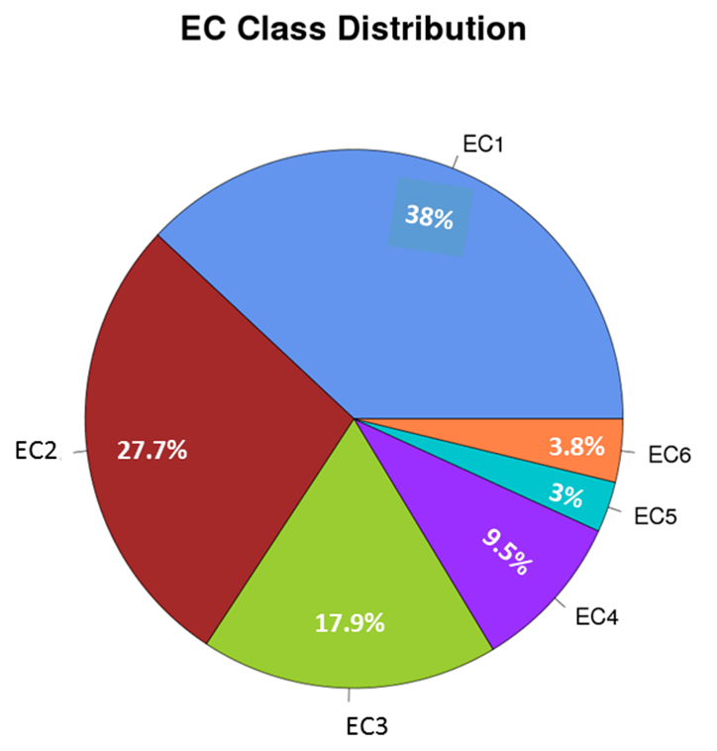

b)
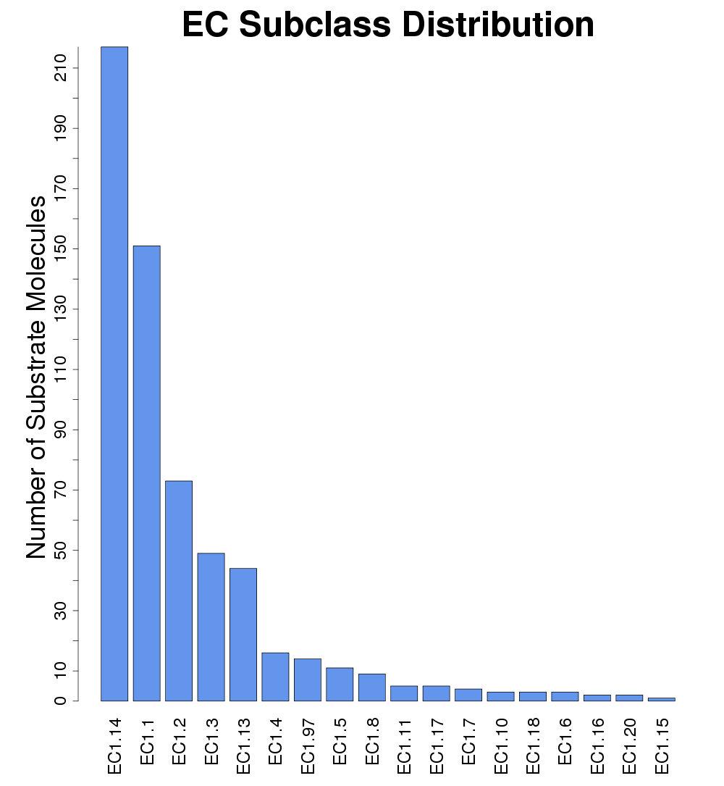

c)
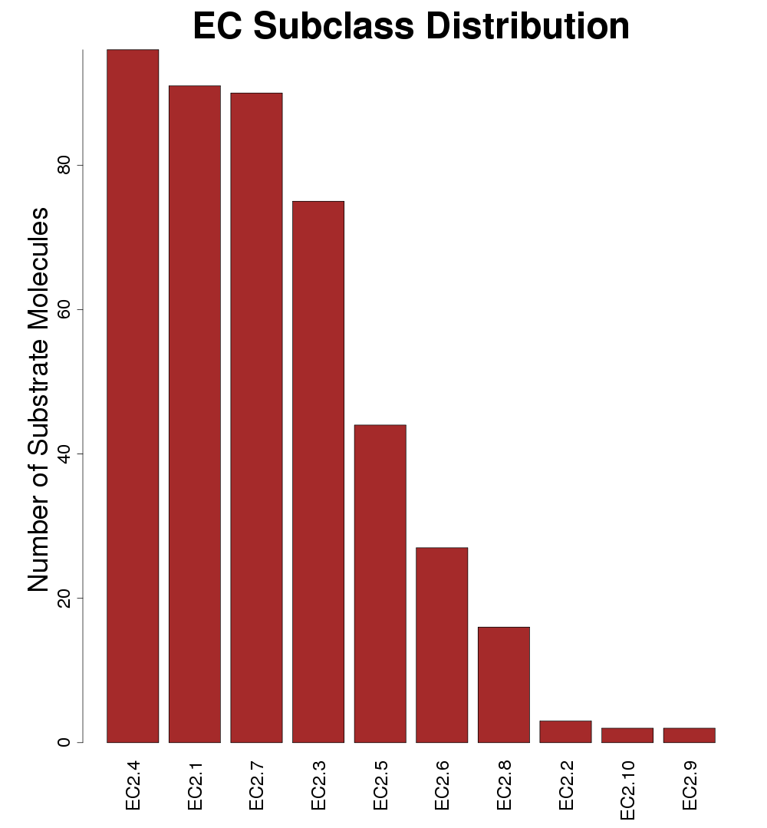
d)
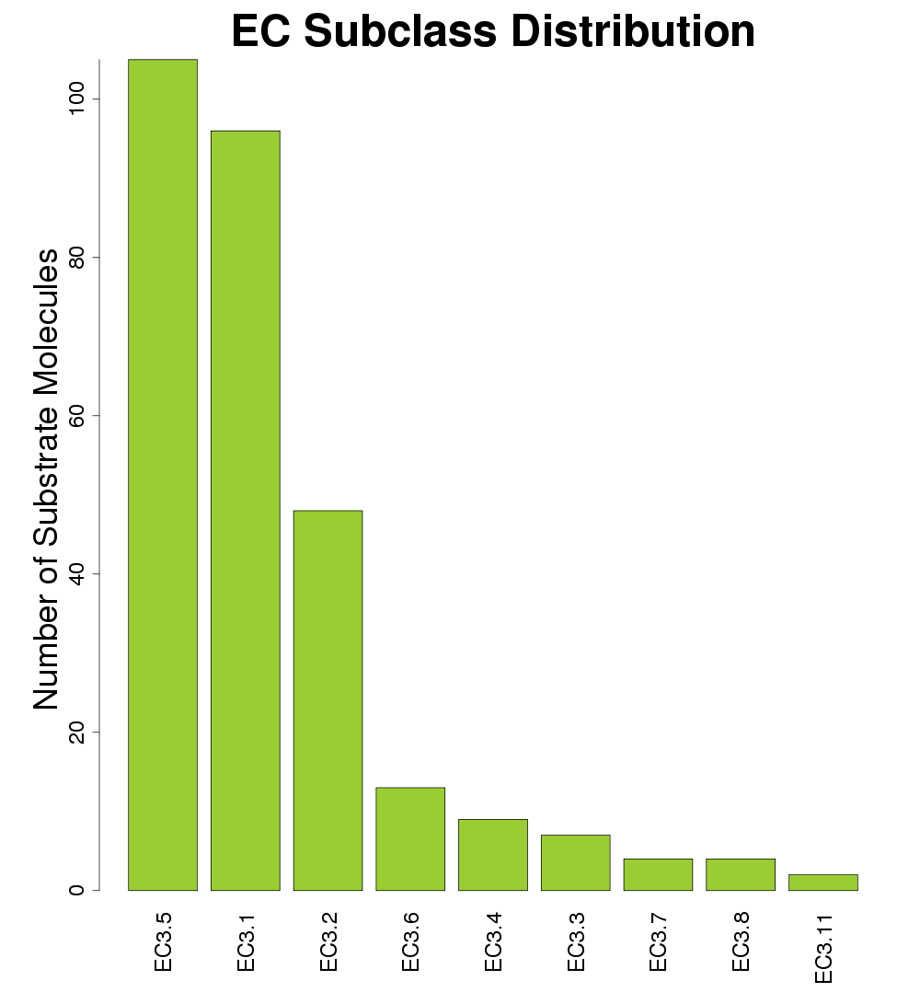

e)
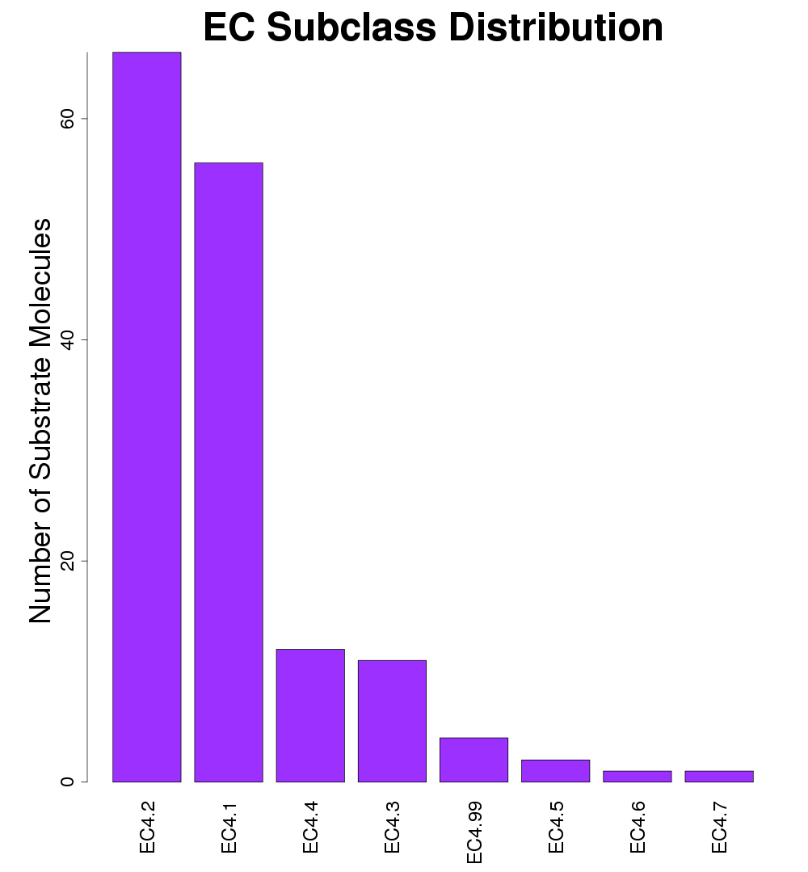

f)
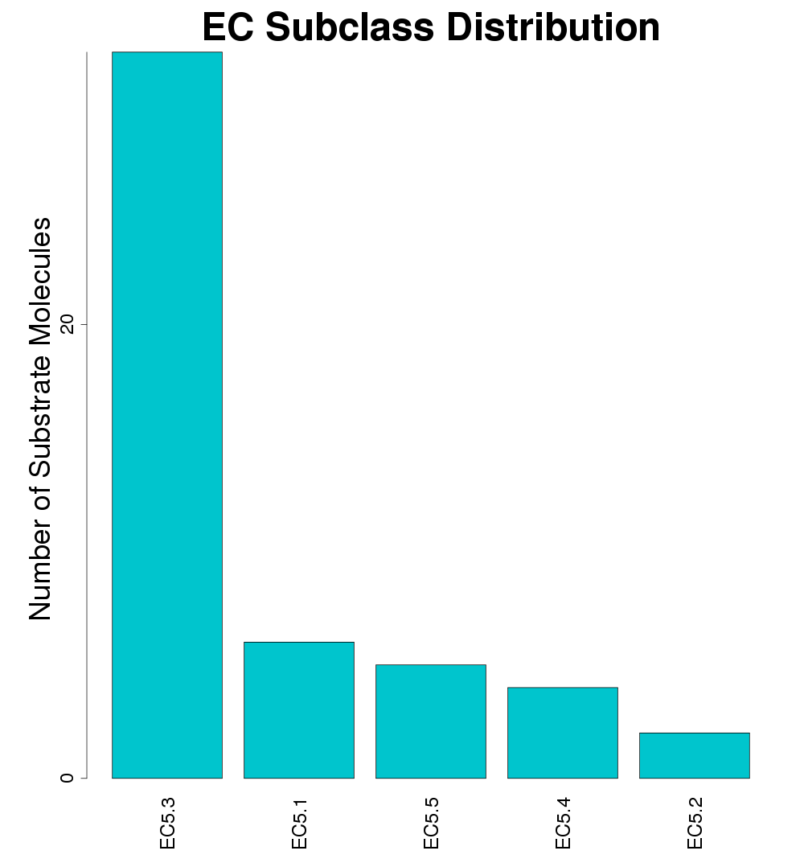

g)
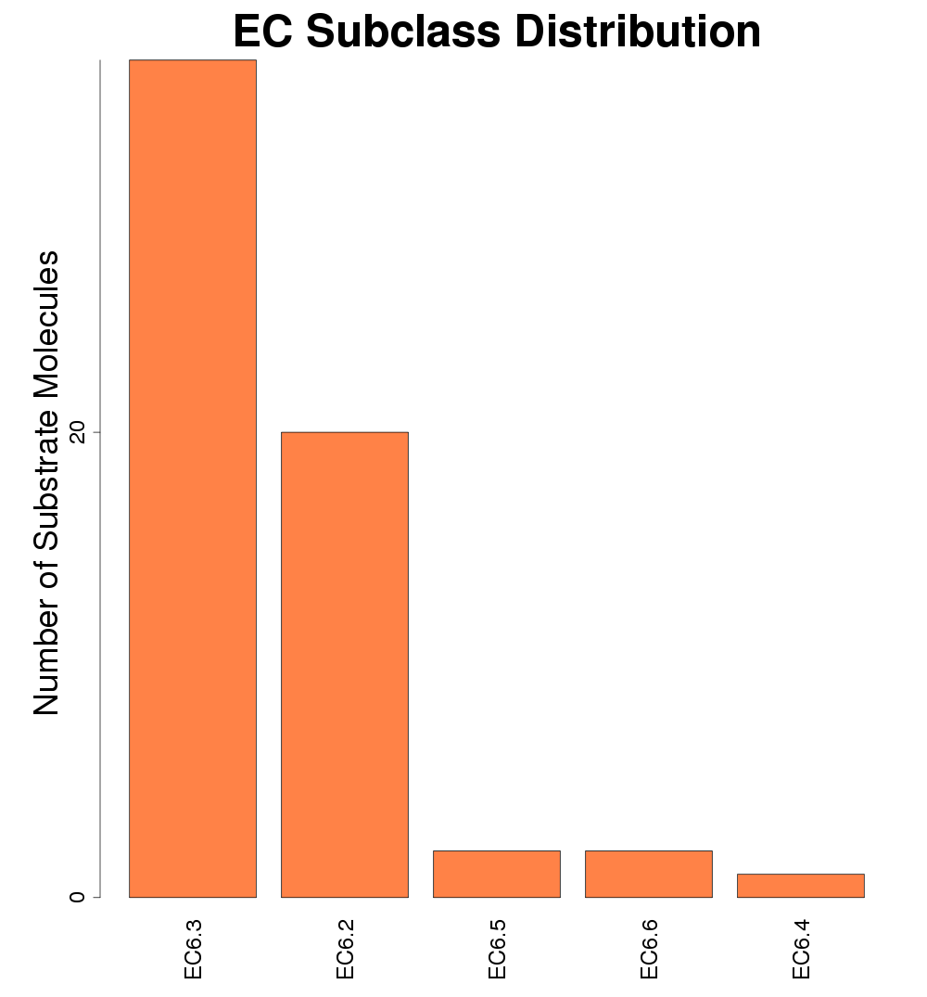

Figure S2. a) Variance of the Principal Components among the six EC classes, b) Variance of the Principal Components among EC subclasses of six EC classes.
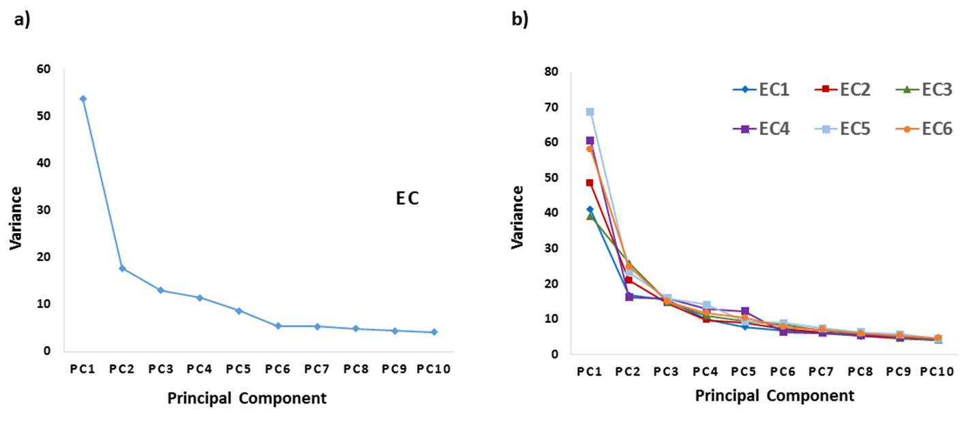

Figure S3. Principal Component Analysis showing the distribution of substrate molecules in the EC subclasses.
a)
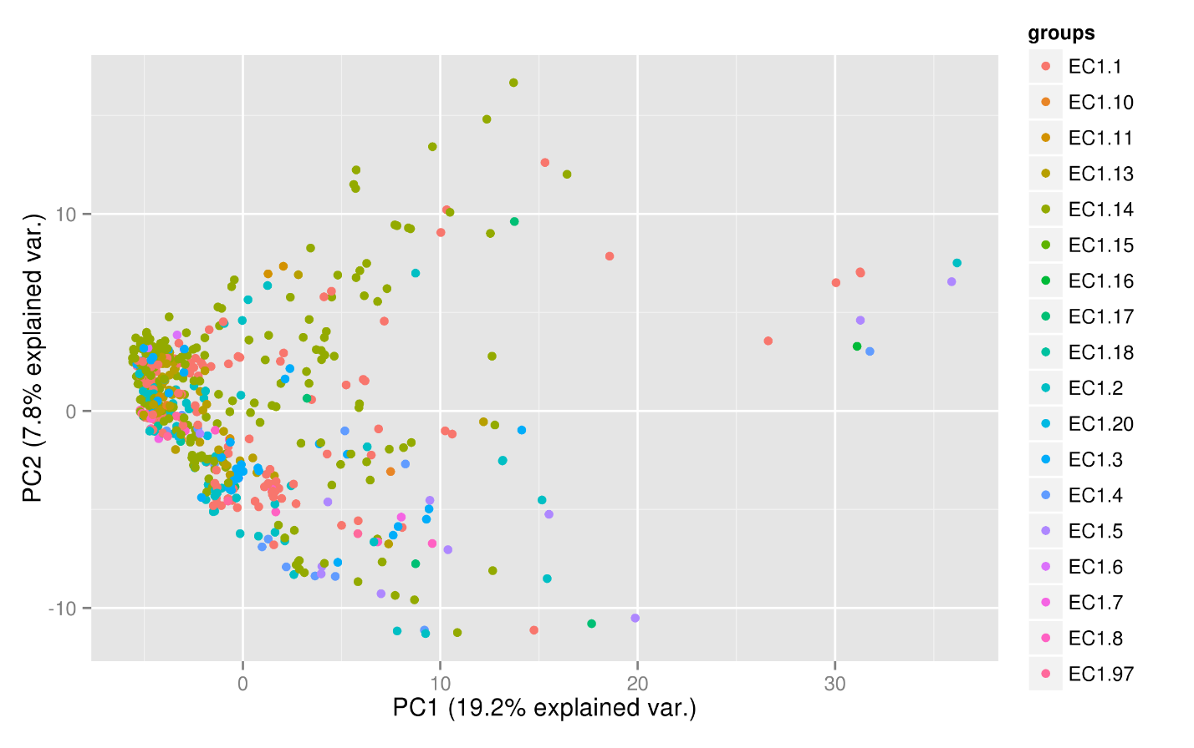
b)
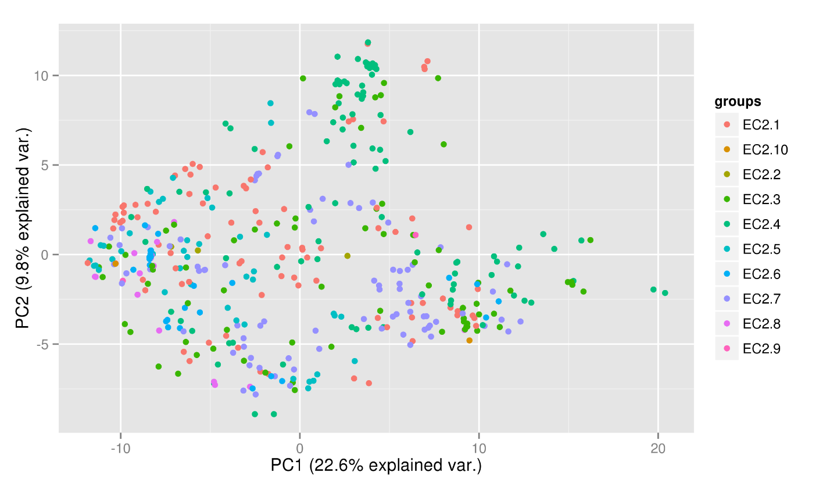

c)
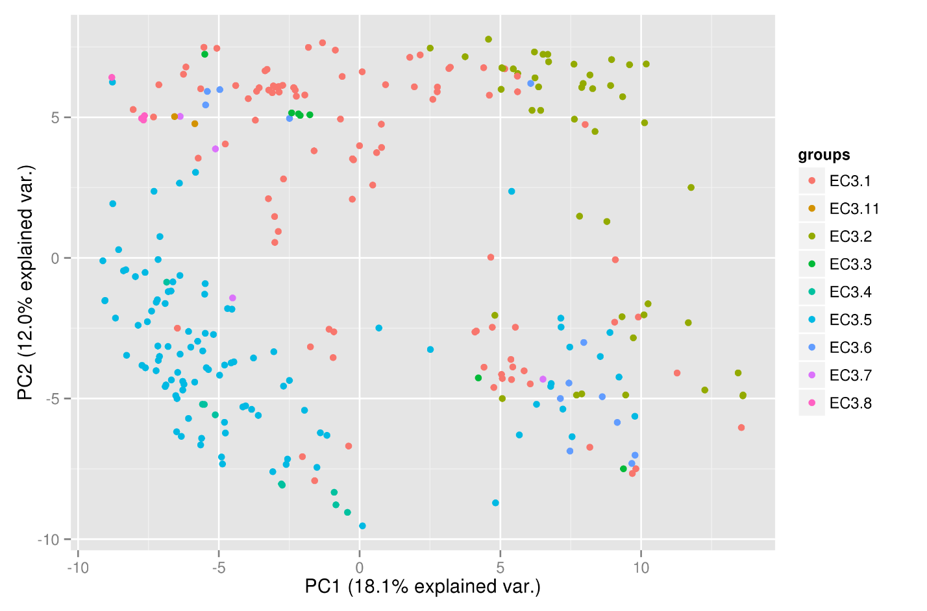

d)
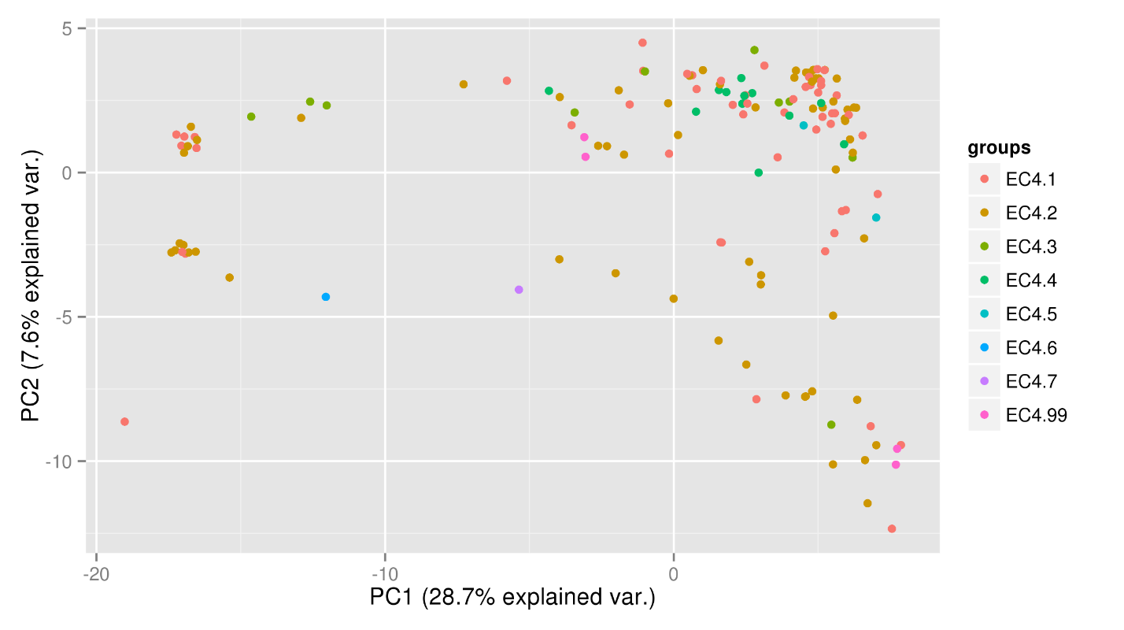

e)
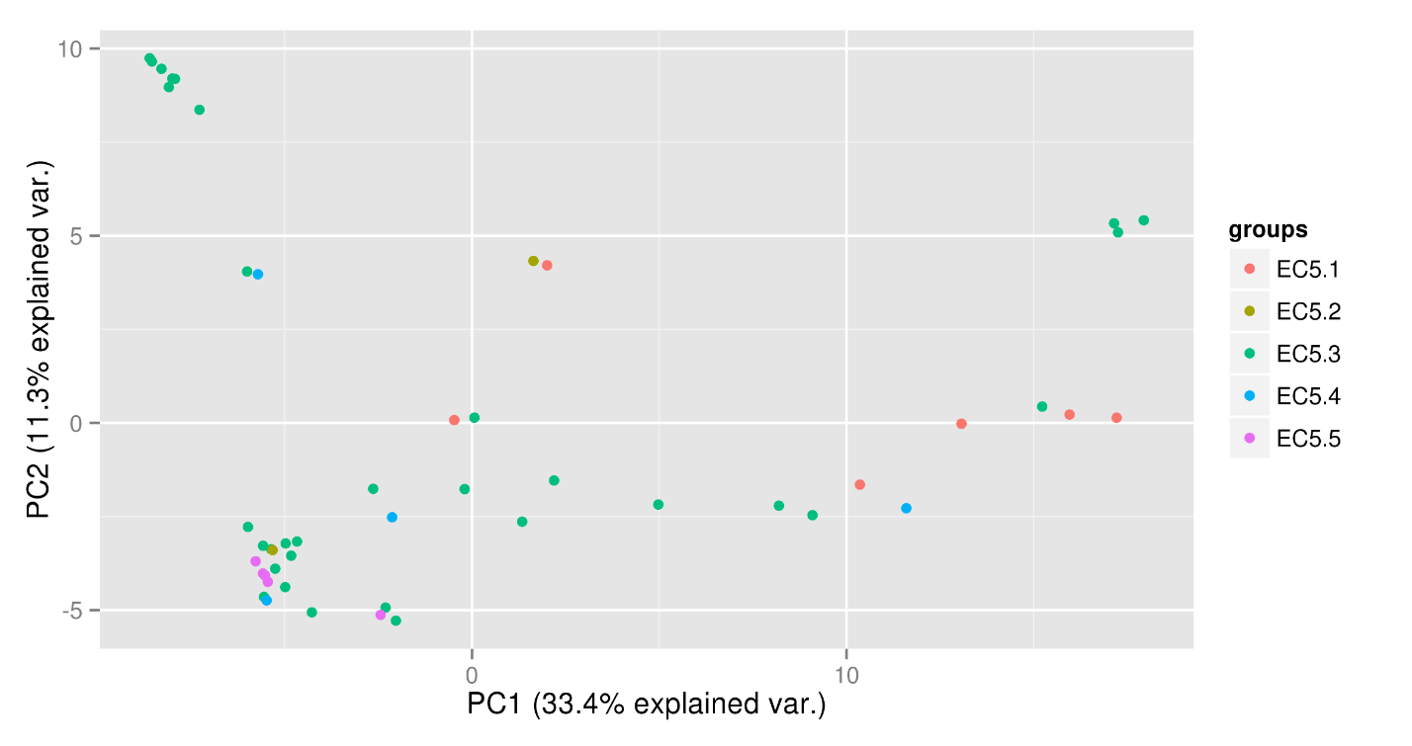

f)
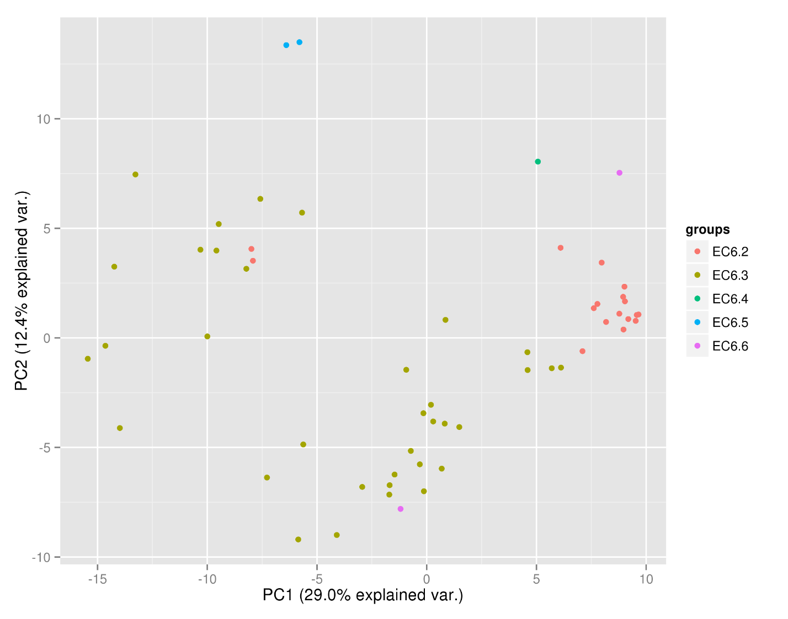

Figure S4. Optimization of parameters (mtry, fingerprint and dataset) to construct the final RF model for classification into EC subclasses.
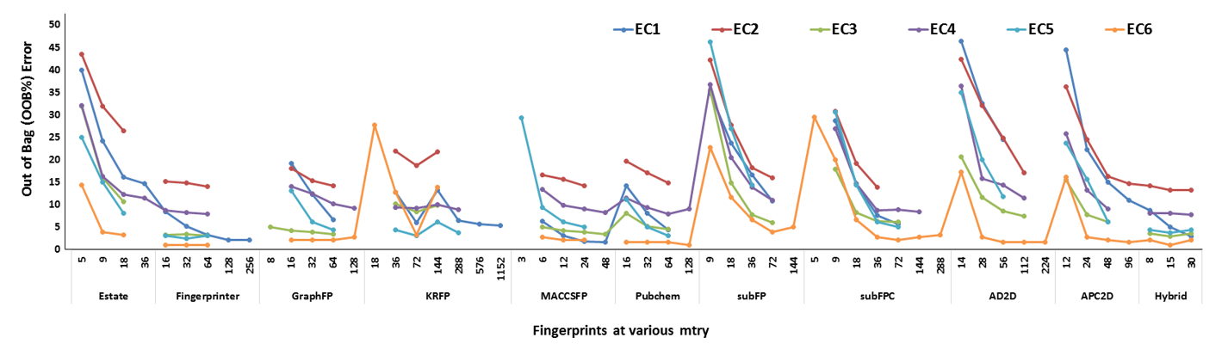

Figure S5. Construction of hybrid fingerprint using 10 standard fingerprints
